Step 1

Forget to Screenshot but did create the user Chen_Yuxuan_STSCI5060FP as you can see the following screenshot and grant all privileges by input: GRANT ALL PRIVILIGES TO Chen_Yuxuan_STSCI5060FP;

Step 2

表格

Step 9

Step 21

Based on the result, the correlation between tfedrev and tstrev is around 0.92. The correlation between tfedrev and tlocrev is around 0.82. The correlation between tstrev and tlocrev is around 0.85. They are all highly correlated. From the scatterplot, we observe that there are positive correlation between each pair of those variables.

Step 22

图表

From the analysis report, we observe that R-square is 0.85 which shows that 85.2% of the variability of the dependent variable tfedrev can be explained by the model. The p-value for tstrev and tlocrev is less that significance level 0.5 which means we reject null hypothesis that there is no relationship between rstrev and tfedrev, tlocrev and tfedrev. The coefficient for tstrev is around 0.17 which means that one unit increase in tstrev will lead to 0.17 unit increase in tfedrev. The coefficient for tlocrev is 0.03 which has the controlling effect of other variables just like the previous tstrev. Therefore, by concerning all the factors and parameters, I think it is a good model with good predictors.

Step 23

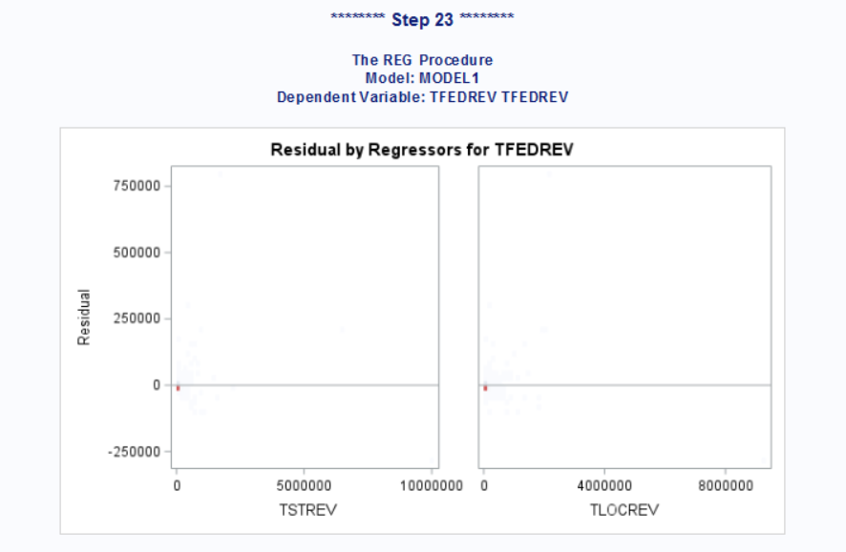

Compare to step 21 and 22, step 23 get the same result. And no there is no instance of in-database processing because Total_Rev_v is actually in oracle.

Step 25

Step 26

