Self-assembling-manifold

Rationale: this is a re-implementation of Zeng’s work on nature medicine 2022, A cellular hierarchy framework for understanding heterogeneity and predicting drug response in acute myeloid leukemia, in which he reanalyzed the LSPC (HSC-like + Prog-like) population defined in van Galen 2019 scRNA-seq dataset sample-wise. He performed self-assembling-manifold on those LSPC in each of the four representative samples ('AML921A', 'AML707B', 'AML328', 'AML916') to identify the optimal weight for each gene that capture the structure of the manifold best (loss function much like: Σ_genes Σ_cell_pairs |d_euclidean - d_manifold|²). He identified three finer classes within the LSPC group, with this weighted count matrix, which were named as LSPC-cycling, LSPC-primed, LSPC-quiescent, depending on several factors like cycling scores, and activation status gene signatures.

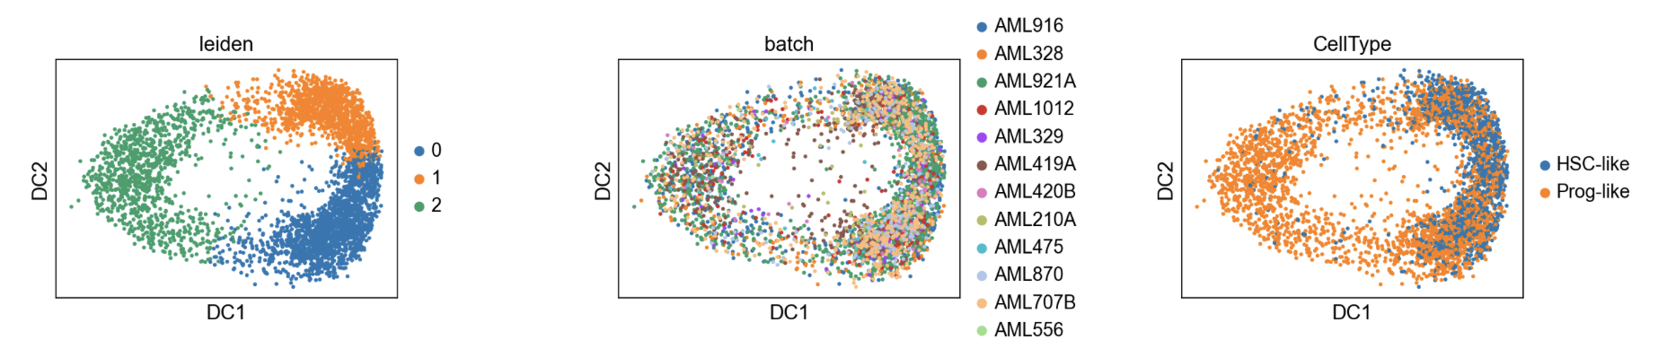
I was trying to use the same method to find the best gene weight to separate normal HSPC from malignant LSPC but wasn’t successful due to, in my opinion 1) minimal presence of normal cells in each sample (more than 1:10); 2) the van Galen label is not necessarily “true”, or not enough to address the subtle difference between groups.
sc.pp.normalize_total(samples, target_sum=1e4)
sc.pp.log1p(samples) # in Zeng’s paper, scran was used
sam_LSPC = sc.external.tl.sam(sample_data[sample_data.obs.CellType.isin(['HSC-like', 'Prog-like'])], standardization="Normalizer", inplace=True)
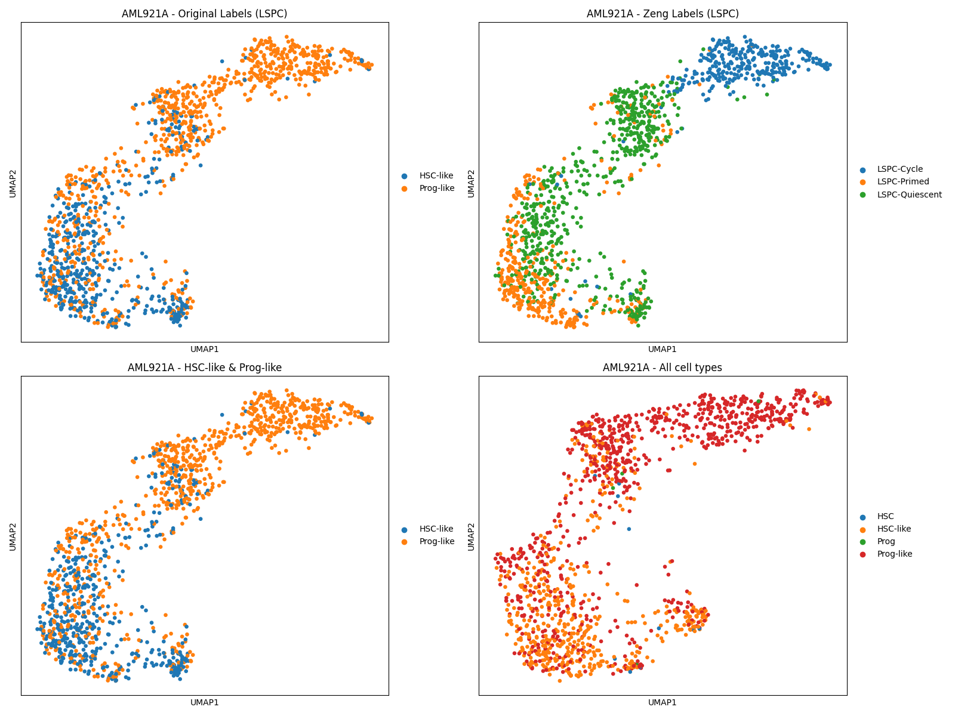
Upper panel: compare the van Galen label to Zeng’s. In Zeng’s paper, the later labels would achieve better classification performance, with the same training-test split and classification model. Bottom panel: sam applied to only LSPC (left) or to all cell types (right). The few normal cells just scatter throughout the umap.
Other settings were also experimented, but none has worked:
- Subsampling AML328 to have a balanced cell type (normal vs malignant)
- Integrating healthy bone marrow samples with AML samples with scVI

