Lib-Char-Certi — User Guide (v1.0)
A desktop tool for certifying a characterized standard-cell library against Monte-Carlo / FMC reference data. It computes pass-rate (PR) tables, flags sub-threshold corners, and lets two parties (the library team and the EDA vendor) drill into any failing point down to the source `.lib` cell and FMC input row — so an outlier can be cross-checked, not just counted.
This guide walks the whole flow on your real inputs, from Setup through the outlier cross-check.
About the screenshots in this guide. Each step has a callout that tells you exactly which screen to capture and the file name to save it under (docs/images/NN_*.png). The placeholder frames you currently see are meant to be replaced with screenshots from your own run. See §8 Adding your screenshots.

Table of contents
- Requirements
- Install
- Prepare your input folder
- Launch
- The tabs at a glance
- Step-by-step: certifying your library
- Waivers — terminology
- Adding your screenshots
- Troubleshooting

1. Requirements
Component | Requirement
Python | 3.9 or newer (developed/tested on 3.9–3.11). The repo pins requires-python = ">=3.9".
Tkinter | Required for the desktop console. It ships with most CPython builds; most EDA host Pythons already have it. Verify with python -c "import tkinter".
pandas / numpy | Required for real certification runs (parsing FMC data and computing PR).
matplotlib | *Optional* — enriches the outlier scatter. Without it the GUI falls back to a built-in Canvas plot.
EDA `ldbx` | Required only for the lib-join / combine step against real .lib decks. It is provided by your EDA environment and is not installable from PyPI.

Check your Python version before anything else:
python --version # must print 3.9.x or newer
python -c "import tkinter; print('tkinter ok')"

2. Install
From the repository root:
# Core install (editable):
pip install -e .

# With the optional scatter plotting extra:
pip install -e ".[plots]" # or simply: pip install matplotlib
On EDA hosts without PyPI access, use the interpreter your flow already provides (it normally has pandas/numpy/Tkinter and the ldbx module). You do not need to reinstall those.

3. Prepare your input folder
Put your real inputs under the input/ folder at the repo root (create it if it doesn't exist). The tool never modifies your inputs — it only reads them and writes results under ./certi_runs.
A typical layout:
input/
├── fmc/ # FMC reference data — decks to parse, or pre-parsed DFDS / SCLD
└── lib/ # the characterized .lib files to certify
You point the tool at these two directories from the Setup tab (the FMC dir and Lib dir browse buttons). The folder names above are only a suggestion — any path works, as long as you browse to it in Setup.
The FMC input mode you pick in Setup decides what the FMC dir should contain:
FMC input mode | What `input/fmc/` should hold
Decks (parse) | raw FMC decks; the tool parses them
Parsed DFDS | already-parsed DFDS output
Parsed SCLD | already-parsed SCLD golden data (note: SCLD golden is in ns)

See input/README.md for the same notes next to the data.

4. Launch
The tool is a single Tkinter process — no server, no port. It displays over X11 / Exceed like a terminal.
# From the repo root, on a host whose Python has Tkinter:
python -m cert_data_process.app # reads ./certi_runs
python -m cert_data_process.app --runs-dir /path/to/runs # custom runs root
If you see ERROR: this Python has no Tkinter, select a Python built with Tk (most EDA host Pythons have it; a stock python3 usually works).

5. The tabs at a glance
Tab | What it answers
Setup | What library / corners / FMC am I certifying? → Run certification
Pipeline | Is the run progressing? Any per-stage audit findings?
Results | For the loaded batch: does each timing type PASS (≥95%)?
PR Status | Consolidated PR pivot across all (or selected) batches
Outliers | Which (metric, corner) points are sub-95%, and how do they fail?
Common | Which cells/arcs fail across *multiple* corners or batches?
History | All past runs; select/▢-check batches to scope the other tabs
Compare | Diff metrics across batches

The Analysis (Voltage Margin) tab is intentionally hidden in v1.

6. Step-by-step: certifying your library

6.1 Setup — describe and launch the run
Open the Setup tab and fill in:
Field | Notes
Vendor | cdns or snps (sets the default lib unit)
Process / version | e.g. n2p / v1p0
Corners | add each corner; or pull from History
Timing types | delay / slew / hold / mpw
VT / RC type, Library type | metadata for the run record
FMC unit / Lib unit | inputs are converted to ps internally; defaults track vendor/format
abs_tol ps (hold) | Waiver_2. One value for all corners, or c1=19.5, c2=20. Blank = off. If you type something unparseable, the tool *warns* instead of silently disabling W2.
FMC input | Decks (parse) / Parsed DFDS / Parsed SCLD — the FMC-dir label updates to match
FMC dir / Lib dir | Browse to your input/fmc and input/lib directories

Click ▶ Run certification. Moments (meanshift / std / skew) are derived from the FMC data — no separate Full-MC run is needed.
📸 Screenshot needed → save as `docs/images/01_setup.png` Capture the Setup tab after you've filled in vendor/process/corners and browsed to your input folders, just before clicking Run certification.
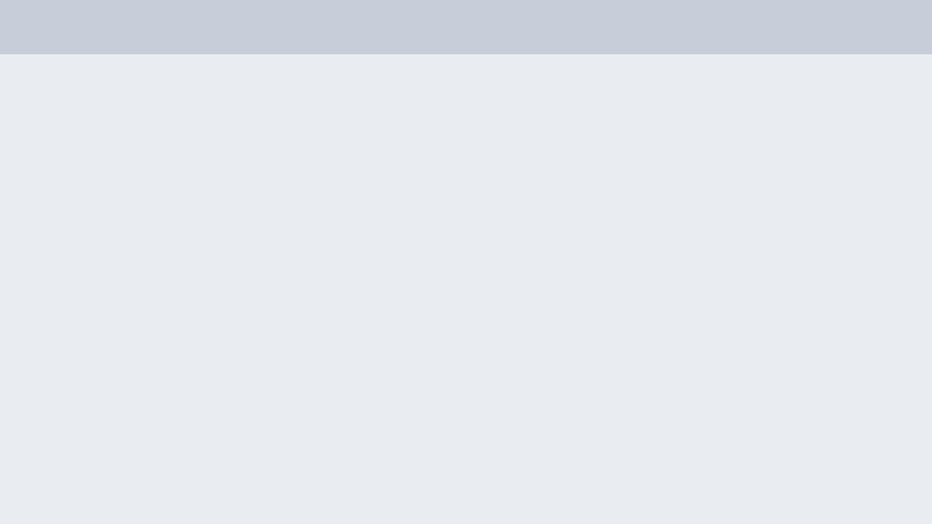

6.2 Pipeline — watch the run progress
The Pipeline tab streams each stage as it runs and surfaces any per-stage audit findings. Wait for the run to finish; results then land in Results.
📸 Screenshot needed → save as `docs/images/02_pipeline.png` Capture the Pipeline tab during or just after a run, showing the stage list and any audit findings.


6.3 Results — the verdict, and how waivers move it
The Results tab groups PR by timing type (delay / slew / hold). Cells are green ≥95%, amber 90–95%, red <95%. Toggle the basis radios at the top to see how each waiver changes the verdict:
Basis | Meaning
Base | raw pass rate, no waivers
+Waiver1 (CI +6%) | CI bounds enlarged 6%
+Waiver2 (abs_tol) | your supplied abs_tol (ps), hold Late_Sigma only, stacked on Base+W1

This is the core story: a library that fails raw can certify once the agreed waivers are applied — and the tool shows exactly which arcs each waiver rescued.
📸 Screenshot needed → save as `docs/images/03_results.png` Capture the Results tab with the basis radios visible. If your data tells a good story, grab one screenshot per basis (Base vs +Waiver1 vs +Waiver2) and add 03b_* / 03c_* files of your own.


6.4 PR Status — consolidated pivot
PR Status → Build. Rows are data-types (ocv_const_hold, ocv_delay_late, …); columns are each batch × corner. Switch basis to see waivers applied across every corner at once.
📸 Screenshot needed → save as `docs/images/04_pr_status.png` Capture the PR Status pivot after clicking Build, with a basis selected.


6.5 Outliers — what's actually failing
Outliers → Build (try the Base basis to see the most points). Each row is a sub-95% (metric, corner) with its failure breakdown: #cells, #opt (optimistic = Lib<MC, i.e. the library claims *better* than silicon), #pess, polarity, and worst error.
A ? in a breakdown column means the per-arc CSV for that corner/type wasn't found (not a failure — just no detail to expand). The hint line under the table explains this.
📸 Screenshot needed → save as `docs/images/05_outliers.png` Capture the Outliers table after Build, on the Base basis so the breakdown columns are populated.


6.6 Outlier scatter + source trace-back — the cross-check
Double-click an Outliers row to open the drill-down: a Lib-vs-MC scatter (with a residual / rel-error view and Normal/Log scale), plus ranked lists of the worst cells, table-points, and arcs. Double-click a worst-arc to open its detail:
- exact MC value, Lib value, signed error, abs error, rel-error (with the engine
denominator), and direction (optimistic / pessimistic);
- a Trace back to source panel: Copy path or Peek straight into the
source .lib cell block (the whole brace-balanced cell (…) { … }) and the FMC input rows for that cell — the exact lines both parties need to agree on.
This is the workflow two teams use to settle "is this outlier real?" without emailing files back and forth.
📸 Screenshot needed → save as `docs/images/06_outlier_drill.png` Capture the drill-down window: the Lib-vs-MC scatter plus the worst-arc / source trace-back panel.

If matplotlib isn't installed, the scatter degrades to a built-in Canvas plot — the rankings and source trace-back work either way.

6.7 Common offenders — systematic vs one-off
Common finds cells/arcs that fail across *multiple* contexts (corners/batches), grouped by cell, cell+arc, or cell+table-point. Select several batches in History first to compare recipes. Double-click an offender to see every place it fails.
📸 Screenshot needed → save as `docs/images/07_common.png` Capture the Common tab after grouping, ideally with several batches selected in History.


6.8 History — managing and scoping runs
History lists every past run. Double-click a row to load it into Results; ▢-check several rows to scope PR Status, Outliers, and Common to just those batches.
📸 Screenshot needed → save as `docs/images/08_history.png` Capture the History tab showing one or more completed runs.


7. Waivers — terminology
- Base PR — raw pass rate, no waivers.
- Waiver1 — CI bounds enlarged 6% (the engine's Waiver1_CI_Enlarged).
- Waiver2 — abs_tol (ps), hold Late_Sigma only, stacked on Base+W1; you
supply the value. The tool never invents it.
(Waiver3 is handled downstream by the separate Voltage-Margin tool and is out of scope here.)
Note the scope: "Waiver1 / Waiver2" above are the in-tool implementation columns. In the broader cert flow, everything this tool produces (Base + both in-tool waivers) is what the wider process calls waiver_1; the process-level waiver_2 (abs_tol supplied by you) and waiver_3 (Voltage Margin) are separate stages.

8. Adding your screenshots
Every figure in this guide lives in docs/images/ and is referenced with a relative path (e.g. images/01_setup.png), so the links resolve both on GitHub and in the exported Word document.
To add a real screenshot, save your capture over the matching placeholder, keeping the file name:
Step | File to replace
6.1 Setup | docs/images/01_setup.png
6.2 Pipeline | docs/images/02_pipeline.png
6.3 Results | docs/images/03_results.png
6.4 PR Status | docs/images/04_pr_status.png
6.5 Outliers | docs/images/05_outliers.png
6.6 Outlier drill-down | docs/images/06_outlier_drill.png
6.7 Common | docs/images/07_common.png
6.8 History | docs/images/08_history.png

The placeholder frames currently in those files are solid grey boxes — once you drop in a real PNG with the same name, the guide and the exported Word document pick it up automatically.

Exporting a Word document to share by email
A Word document docs/USER_GUIDE.docx is generated from this Markdown so you can attach it to an email. Regenerate it after you add your screenshots so they are embedded in the document:
python scripts/make_user_guide_doc.py
This converts docs/USER_GUIDE.md to docs/USER_GUIDE.docx, embedding the screenshots from docs/images/ directly into the file (one self-contained attachment). It uses only the Python standard library — no pandoc, LibreOffice, or pip packages required.
Need a legacy `.doc`? .docx opens in Word 2007+, Outlook's preview pane, Google Docs and LibreOffice. If a recipient specifically needs the old binary .doc, open USER_GUIDE.docx in Word and Save As → Word 97-2003 (.doc).

9. Troubleshooting
Symptom | Fix
ERROR: this Python has no Tkinter | Use a Python built with Tk: python -c "import tkinter" should succeed. Most EDA host Pythons qualify.
Run fails immediately on a real deck | Confirm pandas/numpy are importable, and for lib-join that the EDA ldbx module is on PYTHONPATH.
Outlier breakdown columns show ? | The per-arc CSV for that corner/type wasn't found — there's no detail to expand, but it's not a failure.
Scatter looks basic (no matplotlib styling) | matplotlib isn't installed; the Canvas fallback is in use. pip install matplotlib for the richer view.
Waiver2 seems ignored | Check the abs_tol ps (hold) field — blank means off; an unparseable value now raises a warning.

*Headless / scripted runs:* a command-line pipeline also exists for batch use — python -m cert_data_process.cli --help.

