
EEDG/CE 6370
0
Due Date: Sunday September 21, 11:59pm
3441
Design and Analysis or Reconfigurable Systems
Homework 1
Design of Combinational Logic Designs using Schematic entry and Verilog/VHDL using Intel Quartus Prime

Student Name: Yuyang Hsieh
Student email: yxh230019@utdallas.edu
Part I: Schematic Entry (1-bit adder)
a.) Follow the instructions in the homework sheet and design a 1-bit full adder using schematic entry show here the generated schematic (screenshot of the circuit). Create a video and upload it to your YouTube channel showing how you implemented this and that the adder works as expected. Include the link of the video here.
Marks
10

Youtube Link: https://youtu.be/VHQwCZ5SLv0
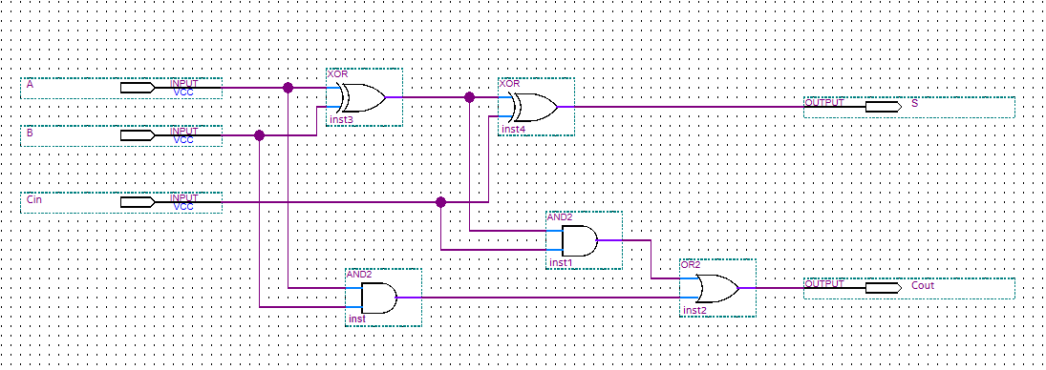
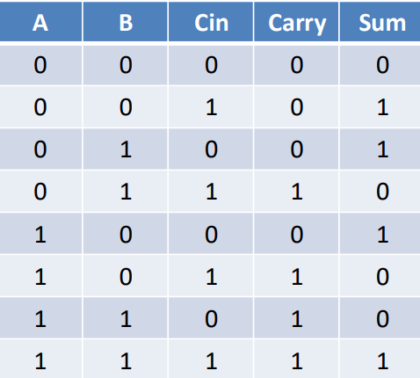

b.) Simulate the 1-bit full adder showing that it works. Include here the test vectors used and the simulation results (waveform). Clearly indicate why it is working.
Marks
4

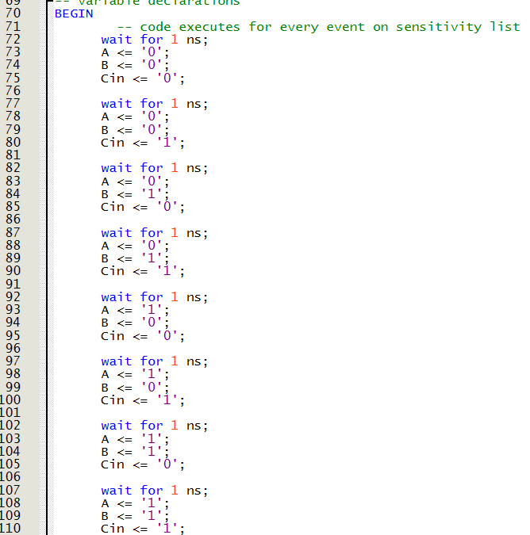
The simulation applies all 8 combinations of A, B, and Cin. At each 10 ns step, the waveform shows S = A ⊕ B ⊕ Cin and Cout = AB + ACin + BCin.

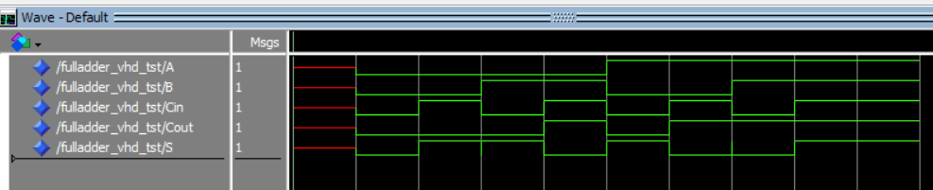

c.) What test vectors would you use in the case of having to test a 4-bit adder and an 8-bit adder? Do you foresee any problems verifying larger adders?
Marks
2
Test vector = 2^n+1
4 bit = 2^9 = 512
Input A: 4 bits → 2⁴ = 16 possible values (0 to 15)
Input B: 4 bits → 2⁴ = 16 possible values (0 to 15)
Carry-in (cin): 1 bit → 2¹ = 2 possible values (0 or 1)
8 bit = 2^17 = 131072
Testing a 4-bit adder is simple--it is easy to test all (or almost all) edge cases, such as maximum value overflow or a full carry propagation. However, when there are larger adders (for example, 8-bit or 16-bit), it becomes extremely difficult to verify their behavior because there becomes a large increase in the combination of input and outputs, making large-scale exhaustive simulation impossible. The challenges shift from making sure the logic is functional to verifying coverage based on coverage metrics with strategic directed tests, while the primary focus of the design is not on verifying input covering, but instead on closing timing on a very long critical path by using static timing analysis instead of trying to simulate with an immense state space.

d.) Report the number of ALMs, ALUTs and critical path of the design from the synthesis report. Compute the maximum frequency. Do the results match? Why yes/no? Discuss.
Marks
4

 | ALMS/ALUTs | FFs (registers) | IOs | DSPs | BRAM
1-bit adder schematic – Analysis & Synthesis Summary (resource usage report) | N/A | 0 | 5 | 0 | 0
1-bit adder schematic – Fitter (Place&Route) Summary | 2 | 0 | 5 | 0 | 0

Max Frequency = 1 /T crit, delay = 1 / 6.640ns = 0.1506 GHz
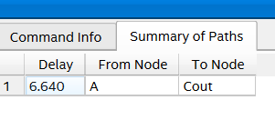
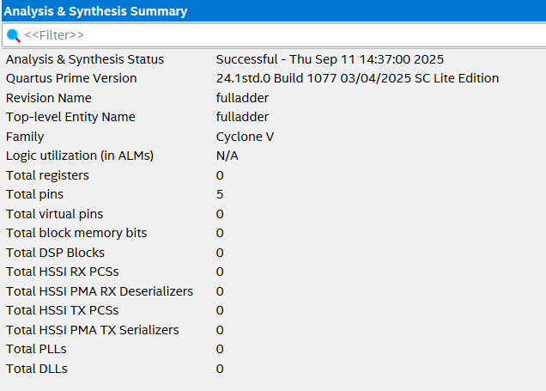
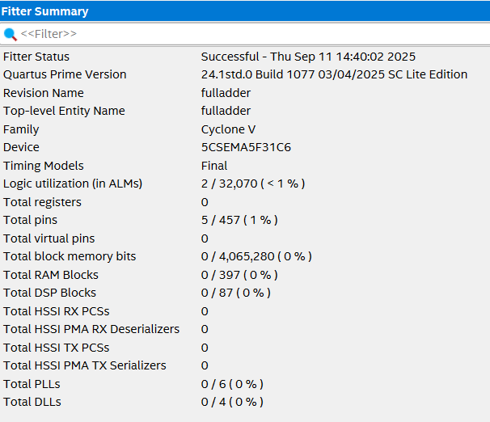
Discussion:
No, the ALMs/ALUTs fitter and analysis & synthesis report contradictory amounts in the summary. The analysis & synthesis gives you an initial, high-level estimate of the amount of resources required based on your architecture and your logic for the design.
The Fitter announces the actual, final amount of resources consumed after my design has been routed and placed onto the physical chip, and contains further optimizations.
In short
The Synthesis report provides a useful, early estimate of your resource needs. Fitter Summary is for the definitive, accurate resource utilization.

e.) ChatGPT: Ask ChatGPT to analyzes the results from this table. Annotate here the answer. Discuss if the results make sense or not.
Marks
4
ChatGPT Answer:
Interpretation of your table (1-bit full adder on Cyclone V):
- ALMs/ALUTs: Fitter shows 2 ALMs. That’s exactly what we expect: a 1-bit full adder is just Sum = A⊕B⊕Cin and Cout = AB + ACin + BCin (two XOR levels plus a small AND/OR network). On Cyclone-V devices this typically packs into ~2 ALMs after place-and-route.
Your Analysis & Synthesis row is N/A—likely you didn’t copy the Combinational ALUTs from “Analysis & Synthesis → Resource Utilization by Entity.” If you check that page you should see ~2 ALUTs (give or take 1 depending on optimization), which is consistent with the 2 ALMs post-fit.
- FFs (registers): 0 — the design is purely combinational; correct.
- IOs (pins): 5 — matches the 5 ports (A, B, Cin, Sum, Cout); correct.
- DSPs / BRAM: 0 / 0 — adders of this size use standard logic, not DSP or memory; correct.
Do the results make sense?
Yes.
A tiny combinational adder using ~2 ALMs, 0 FFs, 5 I/Os, and no DSP/BRAM is exactly what we expect. The only oddity is the N/A in the A&S row; that’s just a missing entry, not a design issue. If you record the ALUT count from A&S and the ALM count from Fitter, they won’t be identical terms (ALUT = logical LUTs before P&R; ALM = physical logic blocks after packing), but they’ll be of the same small magnitude and consistent with each other.

Part II : RTL Entry (Verilog/VHDL) (4-8-16-bit adder)
- Create a bitwidth parametrizable adder using structural and behavioral RTL (Verilog or VHDL). Annotate their resource usage and critical path from the fitter report in the table below for 4, 8 and 16 bits. You can use ChatGPT.
Use the results reported from the fitter and delay from the timing analyzer (Fmax summary)
Marks
6

 |  | ALMs/ALUTs | Critical path
4 bits | Structural | 4 | 7.985ns
4 bits | Behavioral | 3 | 8.284ns
8 bits | Structural | 9 | 12.847ns
8 bits | Behavioral | 5 | 8.460ns
16 bits | Structural | 20 | 12.552ns
16 bits | Behavioral | 9 | 12.661ns

- Discuss if the results obtained are what you expected and why yes or no.
Marks
4
For 4 bit adder
Theoretical: 4 full adders × ~2ns each = ~8ns
Actual (structural) : 7.985 ns - very close to expected
Actual (Behavior) : 8.284ns – little over but close to expected
For 8 bit adder
Theoretical: 8 full adders × ~2ns each = ~16ns
Actual (structural) : 12.847 ns – 3ns off from expected
Actual (Behavior) : 8.460ns – half of the expected
For 16 bit adder
Theoretical: 16 full adders × ~2ns each = ~32ns
Actual (structural) : 12.552 ns – 20ns off from expected
Actual (Behavior) : 12.661ns – 20ns of the expected
The significant discrepancy between theoretical and actual timing results occurs because modern FPGA synthesis tools automatically optimize adder implementations. While theoretical calculations assume simple ripple-carry adders with linear O(n) delay growth, the synthesis tool recognizes arithmetic operations and replaces them with highly optimized hardware structures. For larger adders (8-bit and 16-bit), the tool employs advanced architectures like carry-lookahead or carry-select adders with logarithmic O(log n) delay characteristics, and utilizes dedicated adder resources within the FPGA fabric. This explains why both structural and behavioral implementations show similar, dramatically improved performance compared to theoretical expectations—the tool is intelligently selecting the most efficient implementation regardless of the coding style, demonstrating that behavioral VHDL often yields optimal results by allowing the synthesis tool to apply its full optimization capabilities.

Structural fitter (4 bit adder)
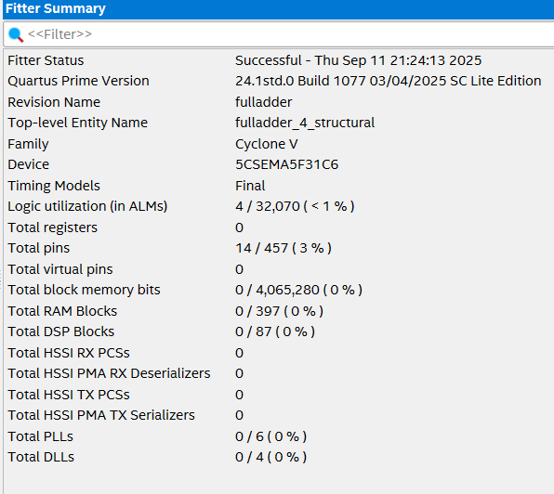
Structural critical path (4 bit adder)
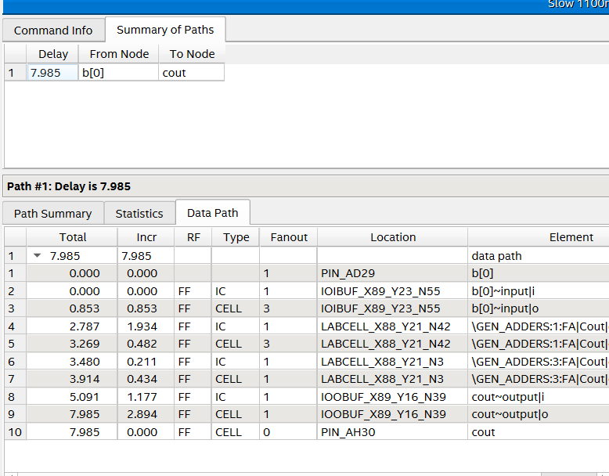
Behavior fitter (4 bit adder)
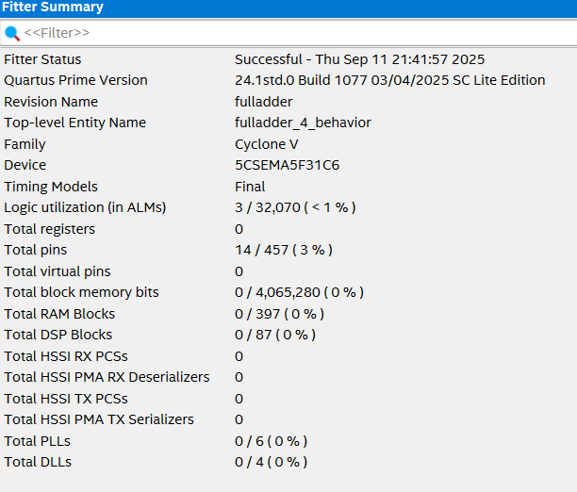
Behavior critical path (4 bit adder)
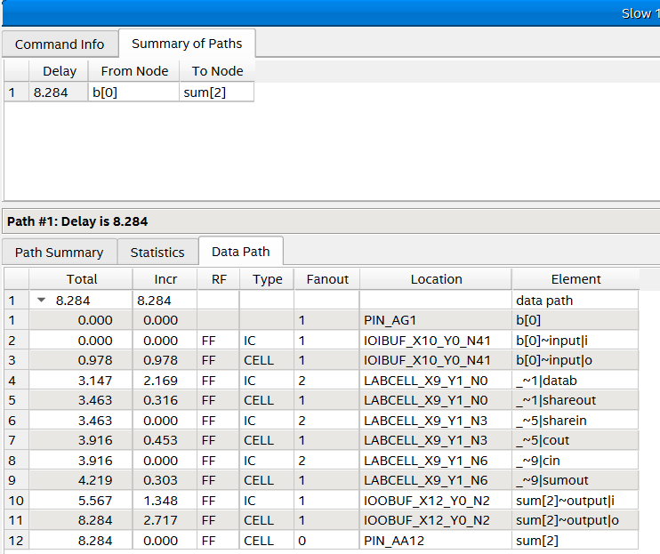
Structural Fitter(8bit full adder)
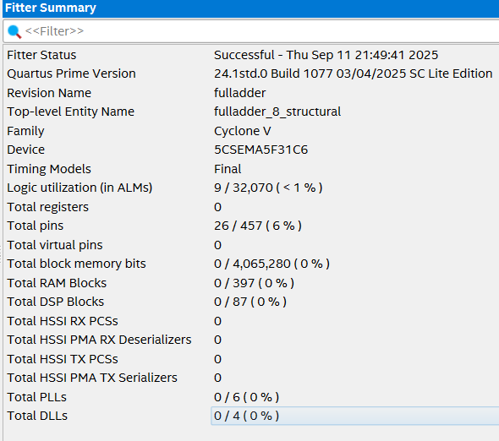
Structural Critical path (8 bit adder)
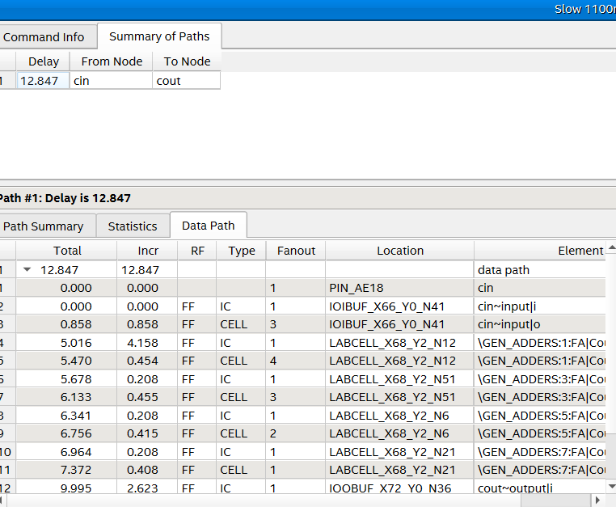
Behavior fitter (8 bit adder)
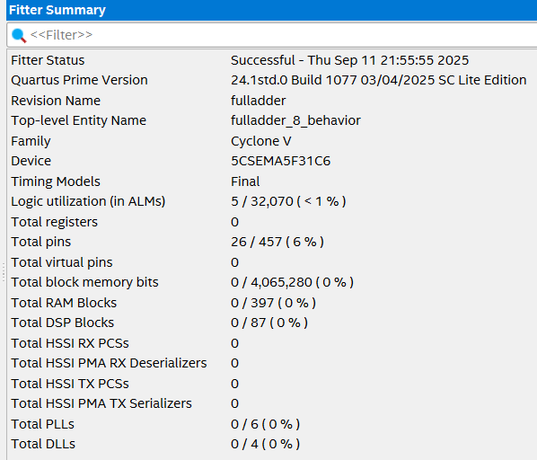
Critical Path (8 bit adder)
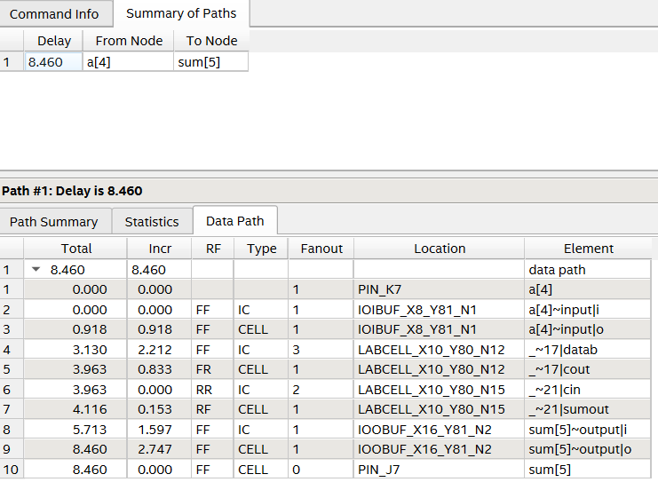
Structural fitter (16 bit adder)
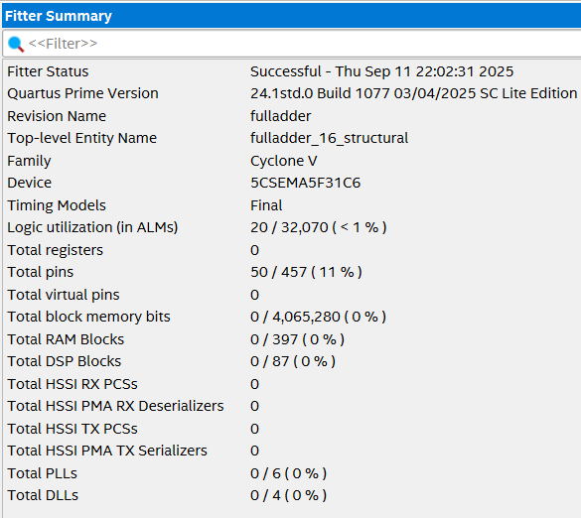
Structural Critical Path (16 bit adder)
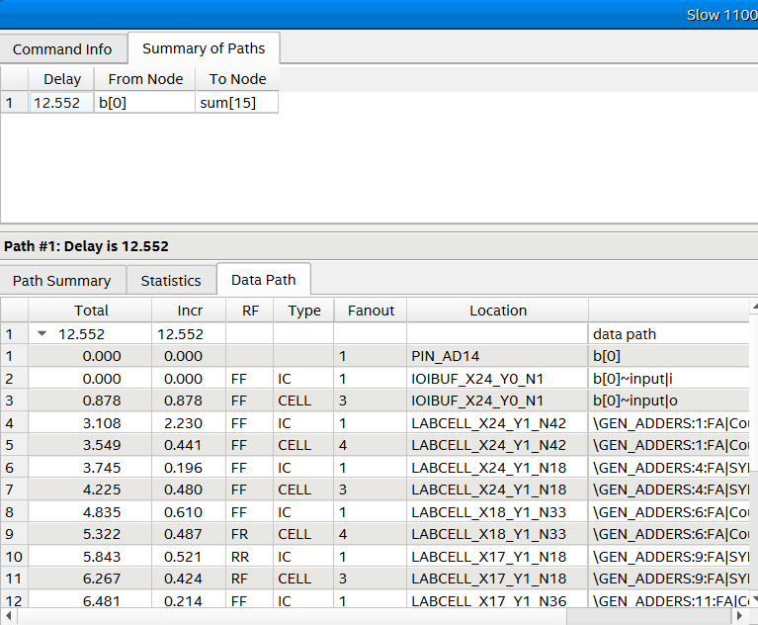
Behavior Fitter (16 bit adder)
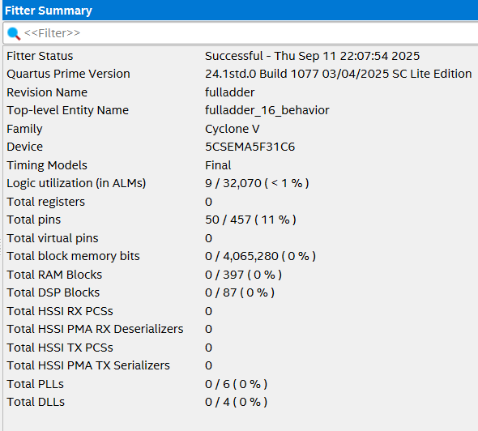
Behavior critical path (16bit adder)
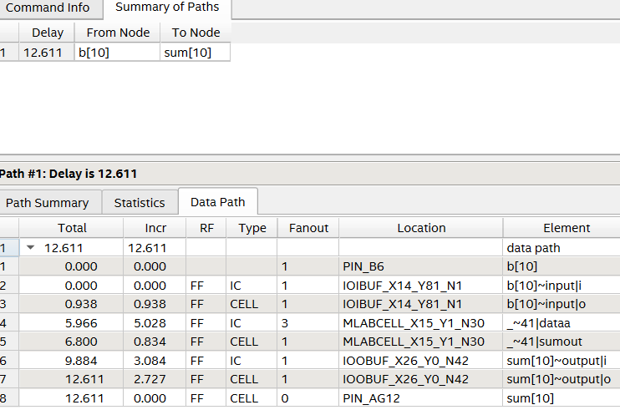

Part IV: Homework reflection
Marks
4

What do you think were the objectives of this homework?

In this HW, the goal was to become familiar with Quartus Prime and its workflow for FPGA design, starting with the creation of a simple combinational circuit—a 1-bit full adder—using both schematic entry and HDL (Verilog/VHDL). The designs were then simulated with a testbench and verified in the waveform viewer to confirm correct functionality. Additionally, synthesis, Fitter, and timing reports were analyzed to evaluate resource usage and identify the critical path and maximum frequency. Finally, the schematic and HDL implementations were compared in terms of performance, timing, and coding style, providing valuable insight into how FPGA tools optimize arithmetic logic.
For the 4-, 8-, and 16-bit adders, both the structural and behavioral RTL implementations produced nearly identical LUT/ALM usage, since Quartus infers the same carry-chain hardware in Cyclone V. The main difference lies in coding style: the structural design explicitly instantiates and connects 1-bit full adders, while the behavioral design simply describes the addition operation. Thus, resource utilization and performance are similar, but behavioral RTL is more concise, whereas structural RTL makes the underlying hardware structure more visible.

This process will help me bridge the gap between theoretical concepts and practical implementation, giving me a foundational understanding of the complete digital design workflow from code to synthesized circuit.

What conclusions have you extracted from the results obtained?

Through this homework exercise, I discovered firsthand how structural and behavioral VHDL coding styles produce dramatically different circuit implementations in practice. I found that synthesis tools are remarkably intelligent - they automatically optimized my basic ripple-carry code into much more efficient hardware structures than I had originally designed. A key finding was learning to distinguish between the resource estimates from the **Analysis & Synthesis** report and the final, accurate numbers from the **Fitter** report. The former provides an initial high-level estimate, while the latter gives the definitive resource utilization after physical placement and routing, which often includes further optimizations.

By analyzing the synthesis and timing reports, I developed crucial skills in identifying critical paths and performance bottlenecks. What surprised me most was seeing how circuit performance scaled with bit width - my 16-bit implementations didn't show the linear slowdown I expected because the tools leveraged dedicated FPGA resources like fast carry chains. I learned that modern FPGAs contain specialized hardware elements that synthesis tools cleverly utilize to dramatically improve performance beyond theoretical expectations. This practical experience, from interpreting conflicting reports to understanding final resource usage, revealed the significant gap between textbook digital design concepts and how circuits are actually implemented in modern FPGAs.
Attachments
Include the Verilog/VHDL code here. Make sure it is well formatted and include comments. Marks might get deducted if not.

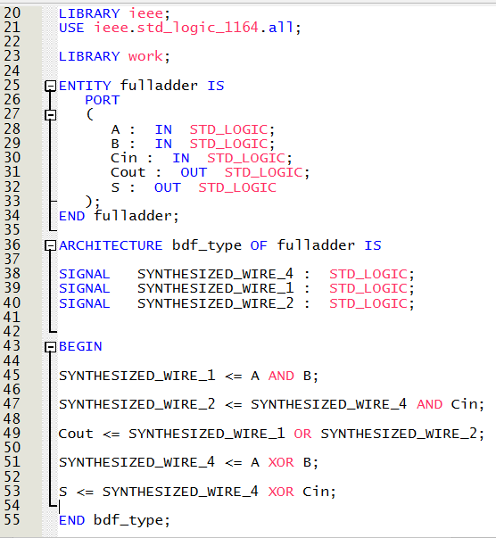
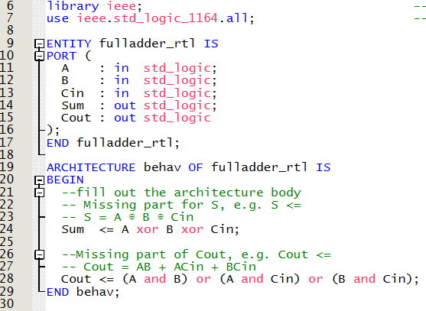
library IEEE;
use IEEE.STD_LOGIC_1164.ALL;
entity fulladder_4_structural is
Generic (
WIDTH : integer := 4 -- Default 4-bit width
);
Port (
a : in STD_LOGIC_VECTOR(WIDTH-1 downto 0);
b : in STD_LOGIC_VECTOR(WIDTH-1 downto 0);
cin : in STD_LOGIC;
sum : out STD_LOGIC_VECTOR(WIDTH-1 downto 0);
cout : out STD_LOGIC
);
end fulladder_4_structural;
architecture Structural of fulladder_4_structural is
component fulladder is
Port (
a : in STD_LOGIC;
b : in STD_LOGIC;
cin : in STD_LOGIC;
S : out STD_LOGIC;
cout : out STD_LOGIC
);
end component;
signal carry_chain : STD_LOGIC_VECTOR(WIDTH downto 0);
begin
carry_chain(0) <= cin;
-- Generate full adders for each bit
GEN_ADDERS: for i in 0 to WIDTH-1 generate
FA: fulladder
port map (
a => a(i),
b => b(i),
cin => carry_chain(i),
s => sum(i),
cout => carry_chain(i+1)
);
end generate GEN_ADDERS;
cout <= carry_chain(WIDTH);
end Structural;
library IEEE;
use IEEE.STD_LOGIC_1164.ALL;
use IEEE.STD_LOGIC_UNSIGNED.ALL;
entity fulladder_4_behavior is
Generic (
WIDTH : integer := 4 -- Default 4-bit width
);
Port (
a : in STD_LOGIC_VECTOR(WIDTH-1 downto 0);
b : in STD_LOGIC_VECTOR(WIDTH-1 downto 0);
cin : in STD_LOGIC;
sum : out STD_LOGIC_VECTOR(WIDTH-1 downto 0);
cout : out STD_LOGIC
);
end fulladder_4_behavior;
architecture Behavioral of fulladder_4_behavior is
signal temp_sum : STD_LOGIC_VECTOR(WIDTH downto 0);
begin
-- Behavioral addition with carry handling
process(a, b, cin)
variable temp : STD_LOGIC_VECTOR(WIDTH downto 0);
begin
temp := ('0' & a) + ('0' & b) + ("000" & cin);
sum <= temp(WIDTH-1 downto 0);
cout <= temp(WIDTH);
end process;
end Behavioral;
library IEEE;
use IEEE.STD_LOGIC_1164.ALL;
entity fulladder_8_structural is
Port (
a : in STD_LOGIC_VECTOR(7 downto 0);
b : in STD_LOGIC_VECTOR(7 downto 0);
cin : in STD_LOGIC;
sum : out STD_LOGIC_VECTOR(7 downto 0);
cout : out STD_LOGIC
);
end fulladder_8_structural;
architecture Structural of fulladder_8_structural is
component fulladder is
Port (
a : in STD_LOGIC;
b : in STD_LOGIC;
cin : in STD_LOGIC;
S : out STD_LOGIC;
cout : out STD_LOGIC
);
end component;
signal carry_chain : STD_LOGIC_VECTOR(8 downto 0);
begin
carry_chain(0) <= cin;
-- Generate 8 full adders
GEN_ADDERS: for i in 0 to 7 generate
FA: fulladder
port map (
a => a(i),
b => b(i),
cin => carry_chain(i),
s => sum(i),
cout => carry_chain(i+1)
);
end generate GEN_ADDERS;
cout <= carry_chain(8);
end Structural;

library IEEE;
use IEEE.STD_LOGIC_1164.ALL;
use IEEE.STD_LOGIC_UNSIGNED.ALL;
entity fulladder_8_behavior is
Port (
a : in STD_LOGIC_VECTOR(7 downto 0);
b : in STD_LOGIC_VECTOR(7 downto 0);
cin : in STD_LOGIC;
sum : out STD_LOGIC_VECTOR(7 downto 0);
cout : out STD_LOGIC
);
end fulladder_8_behavior;
architecture Behavioral of fulladder_8_behavior is
signal temp_result : STD_LOGIC_VECTOR(8 downto 0);
begin
-- Direct arithmetic operation
temp_result <= ('0' & a) + ('0' & b) + ("00000000" & cin);
sum <= temp_result(7 downto 0);
cout <= temp_result(8);
end Behavioral;

library IEEE;
use IEEE.STD_LOGIC_1164.ALL;
entity fulladder_16_structural is
Port (
a : in STD_LOGIC_VECTOR(15 downto 0);
b : in STD_LOGIC_VECTOR(15 downto 0);
cin : in STD_LOGIC;
sum : out STD_LOGIC_VECTOR(15 downto 0);
cout : out STD_LOGIC
);
end fulladder_16_structural;
architecture Structural of fulladder_16_structural is
component fulladder is
Port (
a : in STD_LOGIC;
b : in STD_LOGIC;
cin : in STD_LOGIC;
S : out STD_LOGIC;
cout : out STD_LOGIC
);
end component;
signal carry_chain : STD_LOGIC_VECTOR(16 downto 0);
begin
carry_chain(0) <= cin;
-- Generate 16 full adders
GEN_ADDERS: for i in 0 to 15 generate
FA: fulladder
port map (
a => a(i),
b => b(i),
cin => carry_chain(i),
s => sum(i),
cout => carry_chain(i+1)
);
end generate GEN_ADDERS;
cout <= carry_chain(16);
end Structural;
library IEEE;
use IEEE.STD_LOGIC_1164.ALL;
use IEEE.STD_LOGIC_UNSIGNED.ALL;
entity fulladder_16_behavior is
Port (
a : in STD_LOGIC_VECTOR(15 downto 0);
b : in STD_LOGIC_VECTOR(15 downto 0);
cin : in STD_LOGIC;
sum : out STD_LOGIC_VECTOR(15 downto 0);
cout : out STD_LOGIC
);
end fulladder_16_behavior;
architecture Behavioral of fulladder_16_behavior is
signal temp_result : STD_LOGIC_VECTOR(16 downto 0);
begin
-- Direct arithmetic operation
temp_result <= ('0' & a) + ('0' & b) + ("0000000000000000" & cin);
sum <= temp_result(15 downto 0);
cout <= temp_result(16);
end Behavioral;

