
Due Date: Sunday September 28, 11:59pm – Submit this editable Word document NOT pdf
su
0
18
EEDG/CE 6370
Design and Analysis of Reconfigurable Systems
Homework 2
Prototyping on the Terasic DE1-SoC board

Name: Yuyang Hsieh
Email: yxh230019@utdallas.edu

Part I: FPGA prototyping
a.) Follow the instructions in the lab sheet and implement the led counter example on the Terasic DE1-SoC board. Create a video and upload it to your YouTube channel showing thr it works (counting upwards and downwards). Include the link of the video here. Include the simulation results here too, clearly indicating that the design works.
Marks
4
Video Link: https://youtu.be/-V_er5Ch59w
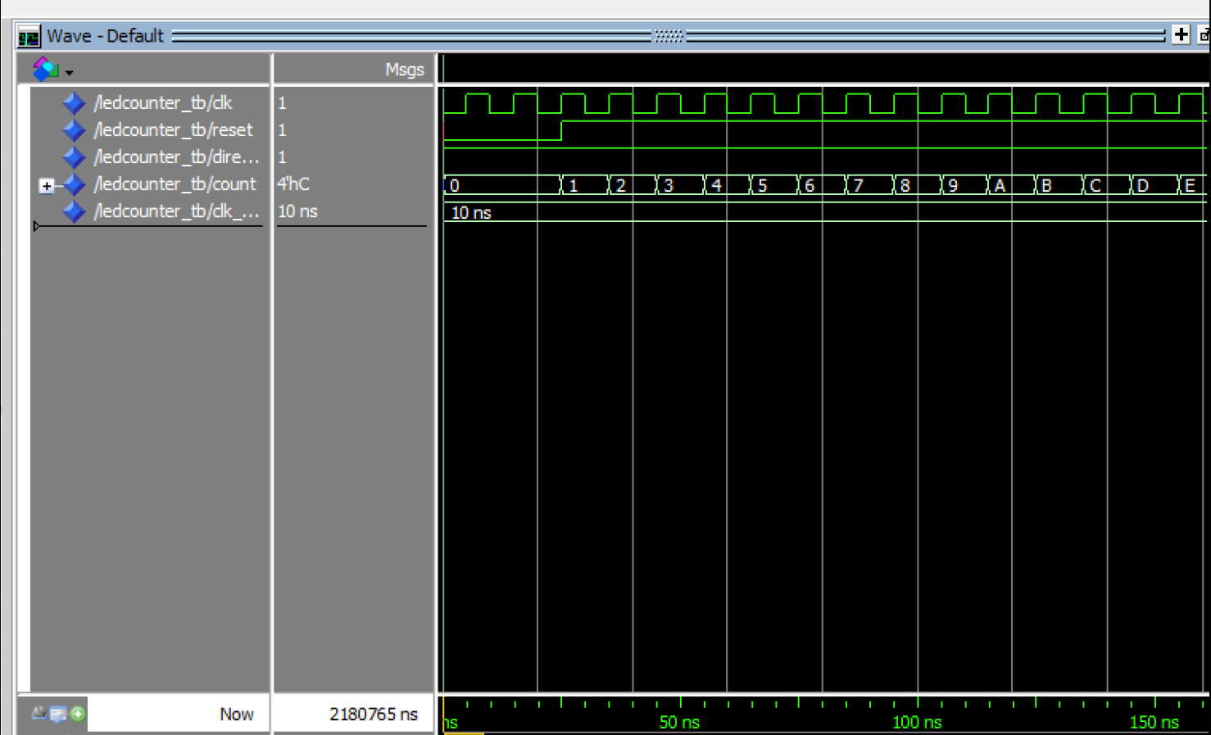
Fig1: direction = 1, counting upward from 0000 to 1111
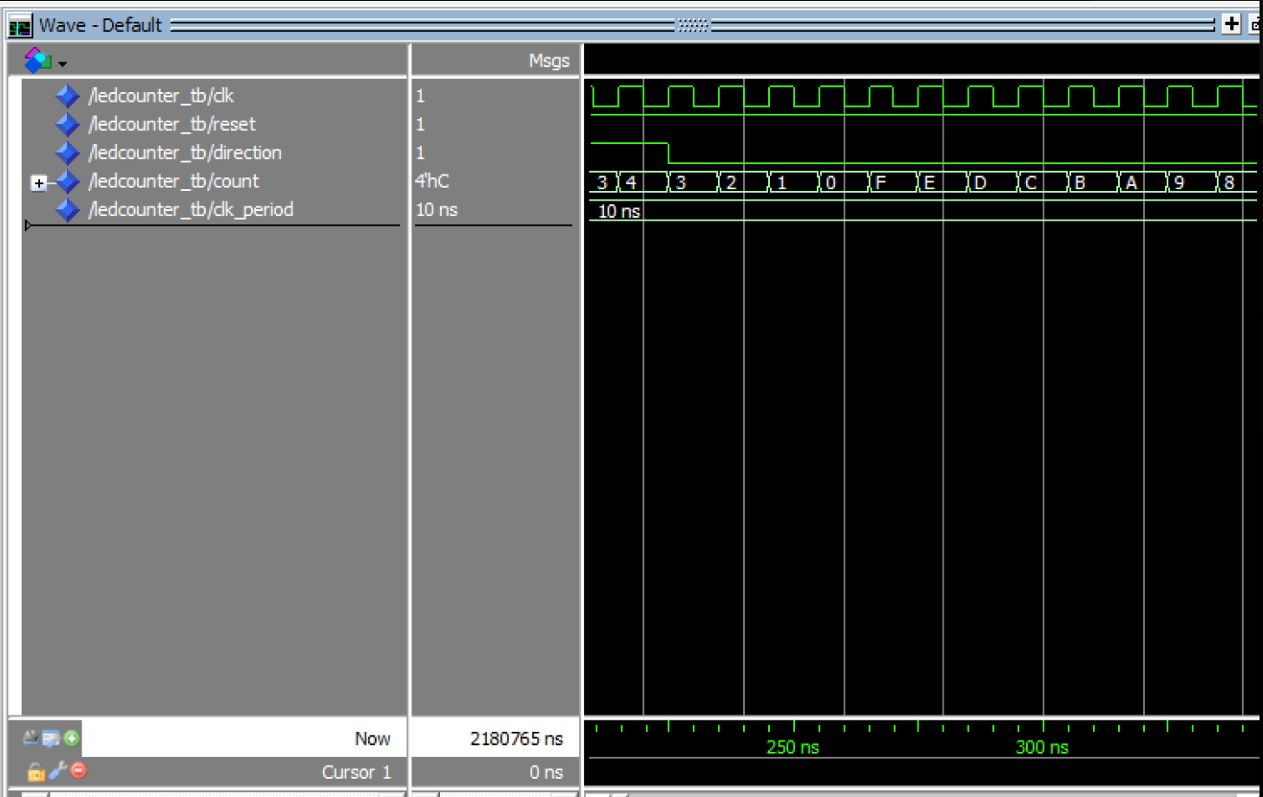
Fig2: direction = 0, counting downward from 1111 to 0000

b.) Report the number of ALMs and critical path of the design from the place and route report. Compute the maximum frequency.
Marks
2

 | ALMs | Maximum Frequency
Counter (up/down) – 4 LEDs | 17 | 1/6.240 ns = 160.3 MHz
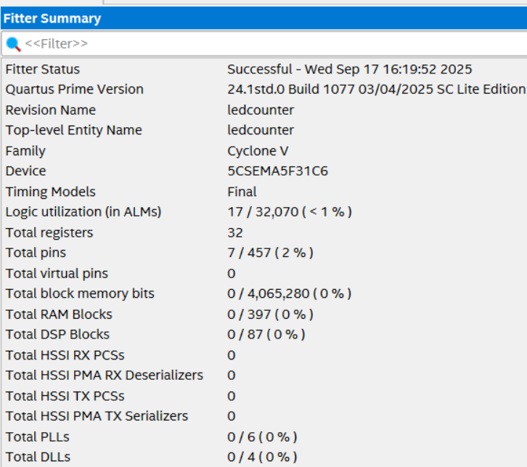
Fig3: Fitter Summary for 4 bit LEDs counter
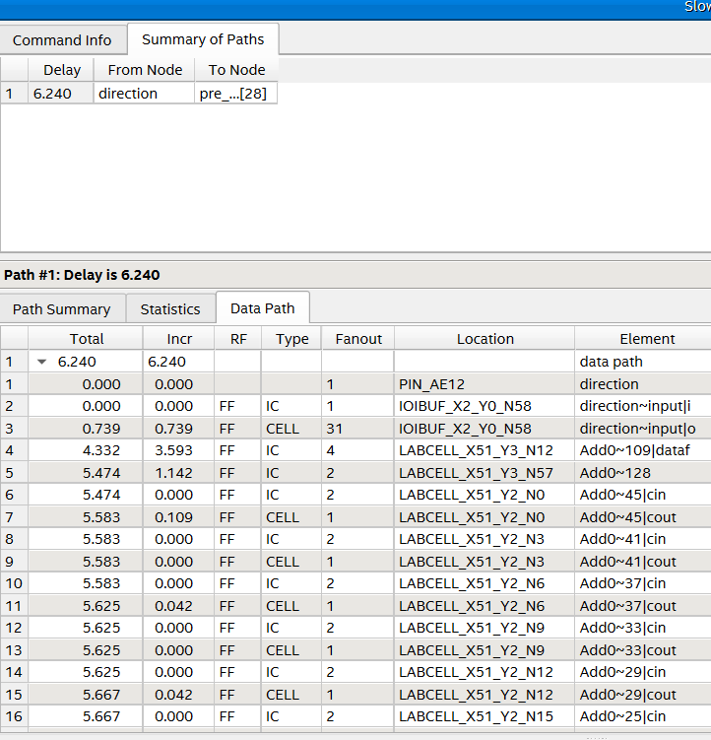
Fig4: Critical Path for 4 bits LEDs counter

c.) Modify the program such that the 10 MSB of the counter are now assigned to the 10 LEDs in the DE1-SoC board. From the board’s data sheet, we can find the pin assignments of the two pins. Create a new video and share it showing that the design works. Append here also the source code.
Marks
6

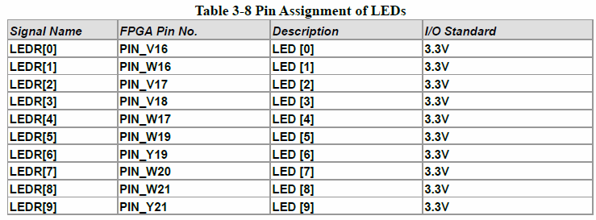
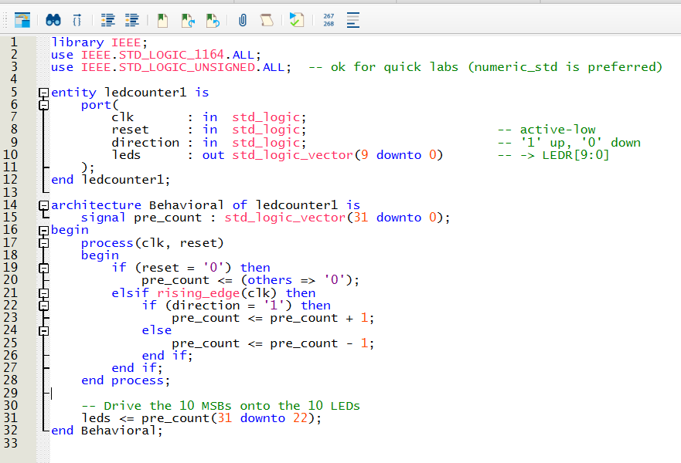
Fig 5: source code for 10 LEDs
Video Link: https://youtu.be/fiHohMb6f
d.) Report the number of ALMs and critical path of the design from the place and route report. Compute the maximum frequency. Compare with the previous design results. Disucuss the differences.
Marks
2

 | ALMs | Maximum Frequency
Counter (up/down) – 10 LEDs | 17 | 1/6.989ns = 143.08 MHz
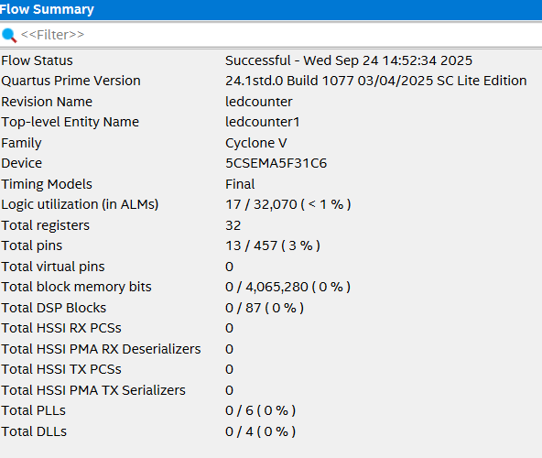
Fig 6 : Fitter Summary for 10 LEDs
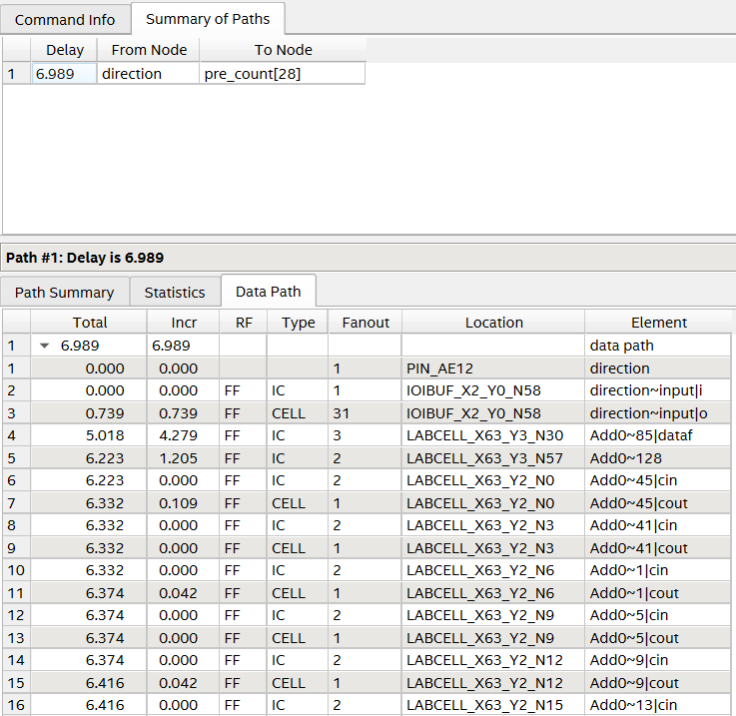
Fig7: Critical Path Delay for 10 LEDs

Part II: Homework reflection
Marks
4
What do you think were the objectives of this homework?

The objective of this lab is to develop hands-on proficiency with Intel Quartus by completing the full flow from pin assignment to on-board verification. Using the Pin Planner, you will map DE1-SoC I/O (LEDR, SW, KEY) to your design, then generate and load the bitstream with the Programmer. Functionally, you will implement a 4-bit LED counter and a 10-LED bar counter that can count upward or downward, with SW9 selecting the direction and KEY0 providing an active-low reset. By the end, you should be comfortable assigning pins, compiling, programming the FPGA, and validating correct behavior on hardware.

What conclusions have you extracted from the results obtained?
For Part 1, the 4-LED counter behaved as expected: with the initial direction set to down, it counted from 1111 to 0000; toggling SW9 changed the direction from down (1) to up (0), and after pressing reset (KEY0) the counter restarted and counted upward from 0000 to 1111. For Part 2, the 10-LED implementation on LEDR[9:0] operated similarly, using SW9 to select up/down counting and KEY0 to reset, clearly demonstrating correct direction control and reset behavior across all ten LEDs.
For ALMS, I learned that changing how many LEDs I drive doesn’t change logic utilization, because LEDs are just I/O pins. Both my “4-LED” and “10-LED” designs use the exact same 32-bit up/down counter (same adder/subtractor and flip-flops), so Quartus reports essentially the same ALM count; only the number of I/O pins used differs. To actually affect ALMs, I’d need to change the logic itself (e.g., shrink the counter width, remove the subtract path, or otherwise alter the datapath), not just expose more or fewer bits to outputs.
For Speed in sdc file, I also learned that the “speed” I see on the LEDs is determined by which counter bits I display, not by the SDC period. Higher-order bits (e.g., [31:28]) toggle much more slowly than lower ones because each bit i divides the clock by 2^(i+1); that’s why the 4-LED slice of MSBs appears slower than the 10-LED bar that includes lower, faster-toggling bits. The 20 ns constraint in the SDC only informs timing analysis (tells TimeQuest the clock is 50 MHz); it doesn’t change the actual hardware frequency coming from the board oscillator. If I want visually similar rates, I should choose bit slices with comparable significance or add a prescaler/divider to put LED updates in a human-friendly range.

