
EEDG/CE 6370
Due Date: Sunday October 5, 11:59pm – Submit this editable Word document NOT pdf
su
0
22
Design and Analysis of Reconfigurable Systems
Homework 3 – IP generator

Name: Yuyang Hsieh
Email: yxh230019@utdallas.edu
Part I – Library of Parametrized Modules (LMP) Multiplier
a.) Follow the instructions in the lab sheet. Show the simulation result of the 4x4-bit multiplier clearly indicating that the circuit works
Marks
4

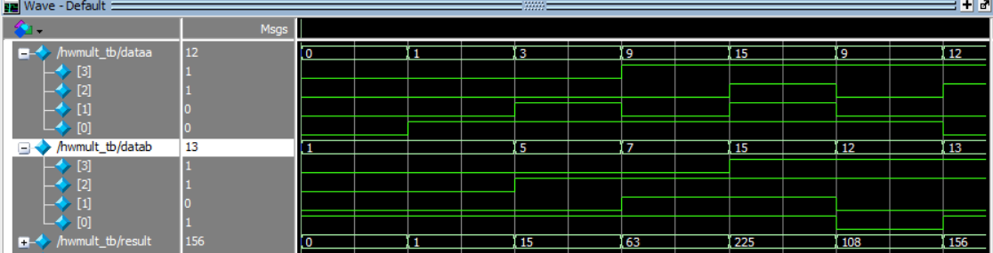
Fig1: RTL simulation for 4x4 multiplier
b.) Report the number of FPGA resources and critical path of the design from the fitter report and the maximum frequency
Marks
2

 | ALM | ALUTs | BRAM | DSPs | Freq max
Design | 9 | 18 | 0 | 0 | 72.83MHz
Max Freq: 1/13.731ns = 72.83KHz

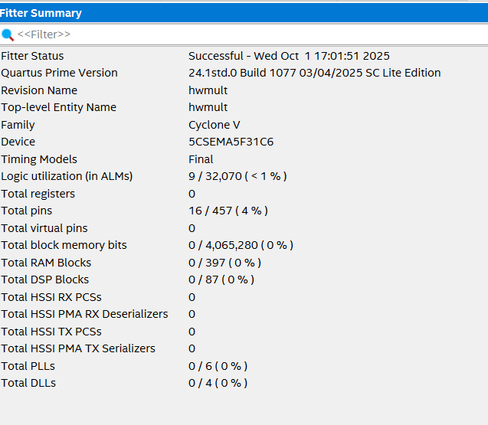
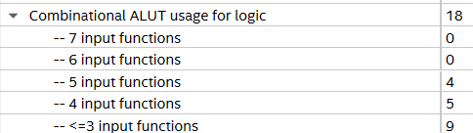
Fig2: 4x4 mult Fitter Summary
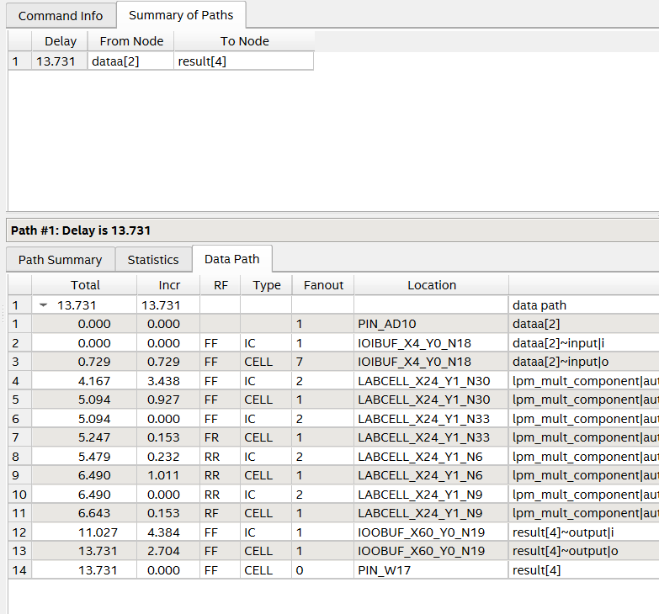
Fig3: 4x4 mult Critical Path Delay
c.) Create a short video showing that the system is successfully synthesized and prototyped on the DE1-SoC Board
Marks
2
Video Link: https://youtu.be/jMHeBINr2pU

d.) Go back to the IP generator wizard and generate the following types of multipliers. Annotate the resources and maximum frequency. Discuss the results.
Marks
6

Multiplier | ALM | ALUTs | BRAM | DSPs | Freq max
4x4 unsigned optimized for speed | 9 | 18 | 0 | 0 | 72.83MHz
8x8 unsigned optimized for speed | 1 | 1 | 0 | 1 | 74.7 MHz
16x16 unsigned optimized for speed | 1 | 1 | 0 | 1 | 68.4MHz
32x32 unsigned optimized for speed | 24 | 47 | 0 | 3 | 46.4MHz
4x4 unsigned optimized for area | 1 | 1 | 0 | 1 | 69.3MHz
8x8 unsigned optimized for area | 1 | 1 | 0 | 1 | 73.0MHz
16x16 unsigned optimized for area | 1 | 1 | 0 | 1 | 68.4MHz
32x32 unsigned optimized for area | 24 | 47 | 0 | 3 | 46.4MHz
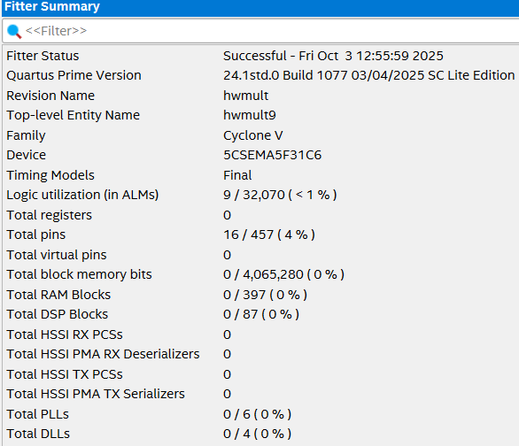
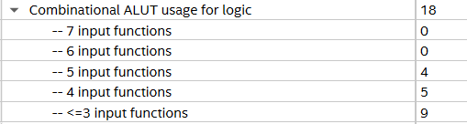
Fig4: 4x4 Mult Fitter Summary (speed)
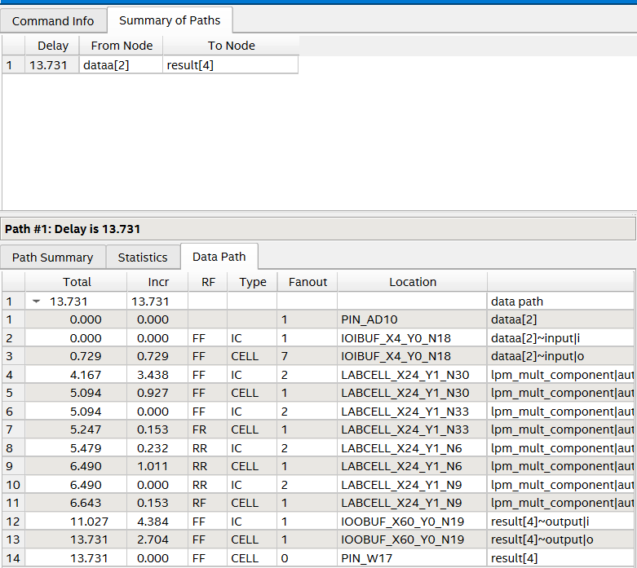
Fig5: 4x4 Mult Critical Path Delay (speed)
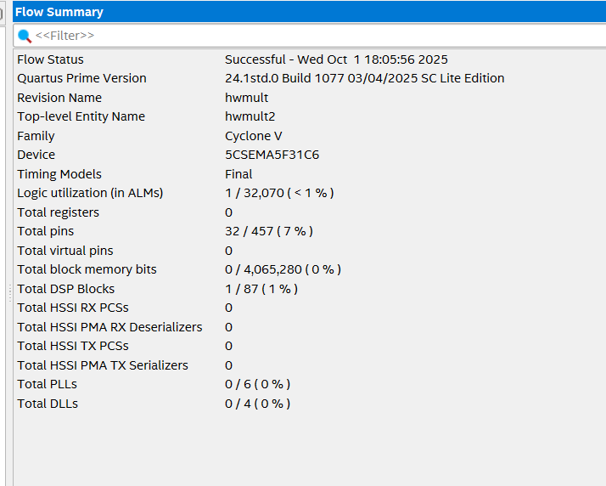
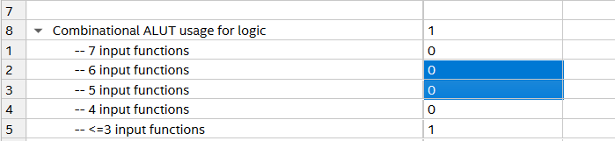
Fig6: 8x8 Mult Fitter Summary
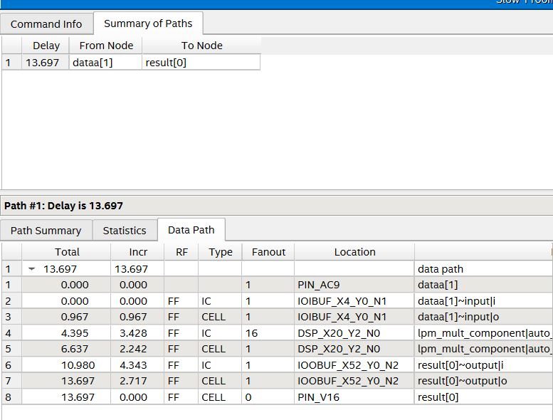
Fig7: 8x8 mult critical path delay
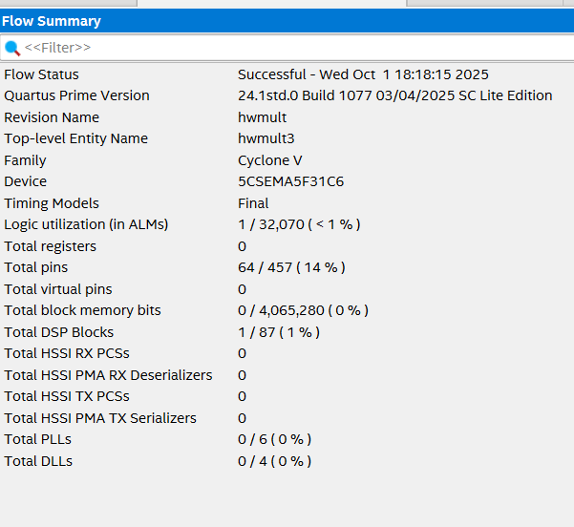
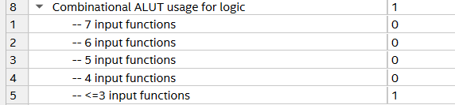
Fig8: 16x16 mult fitter summary
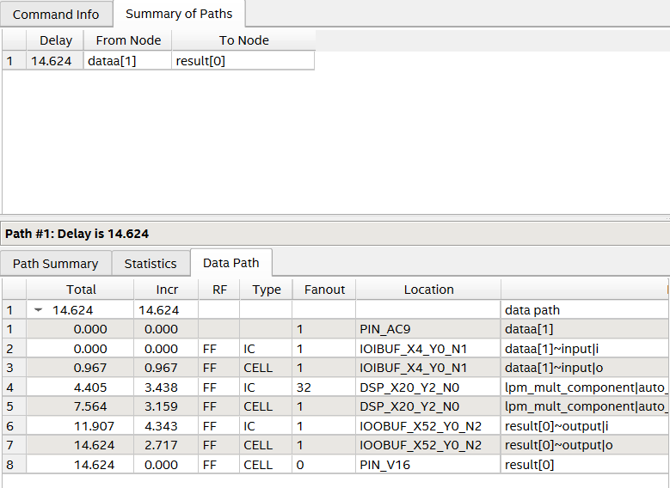
Fig9: 16x16 mult critical path delay
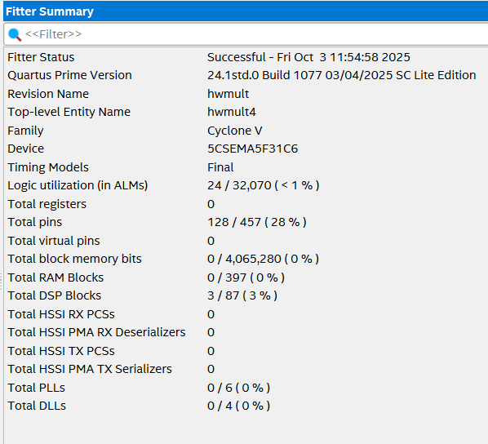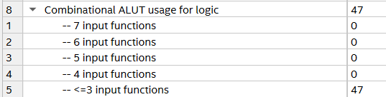
Fig10: 32x32 mult fitter summary
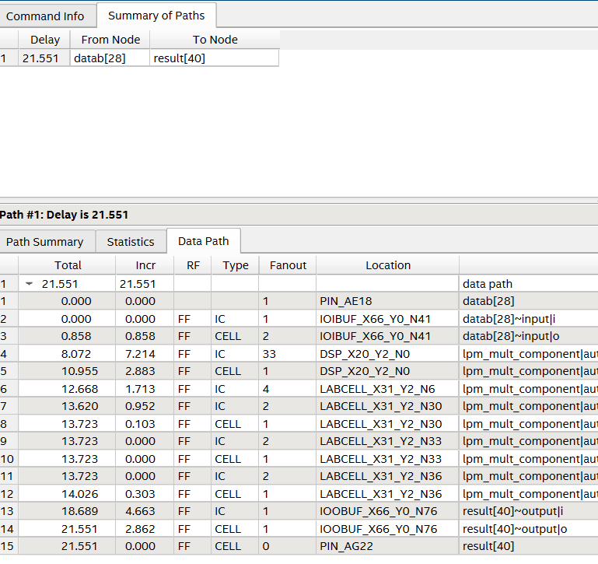
Fig11: 32x32 mult critical path delay (speed)
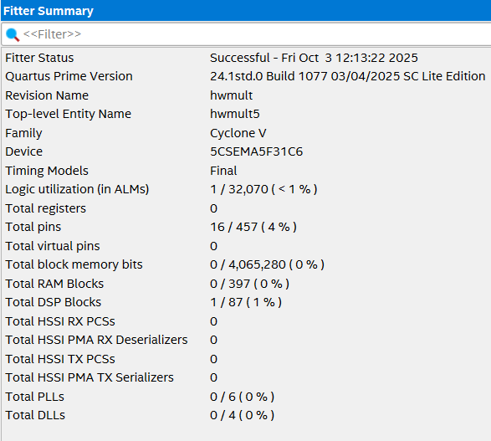
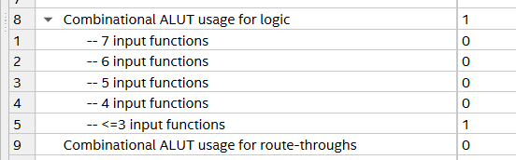
Fig12: 4x4 mult fitter summary (area)
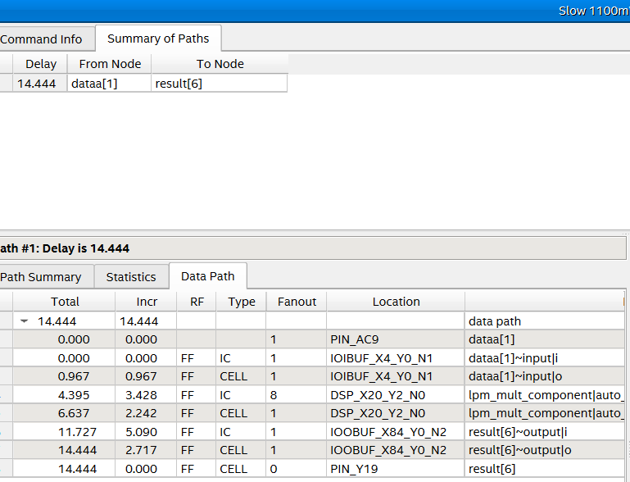
Fig13: 4x4 mult critical path delay (area)
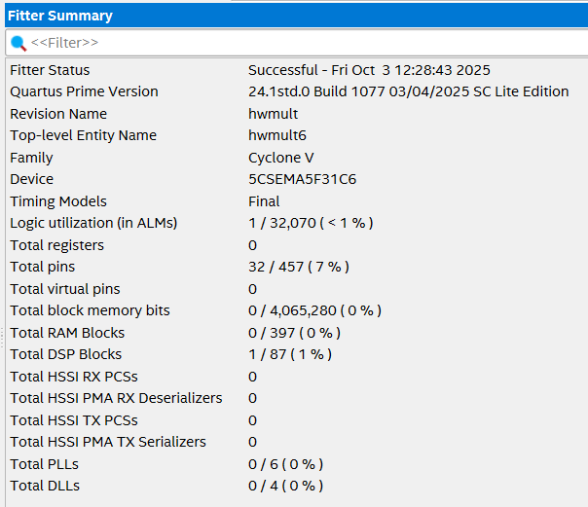
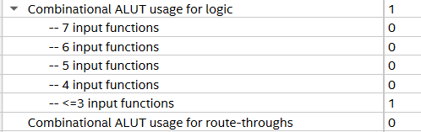
Fig14: 8x8 mult fitter summary (area)
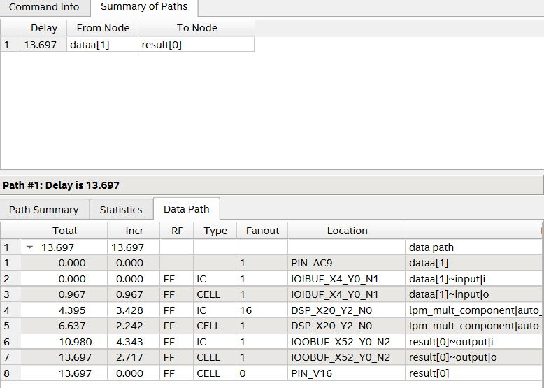
Fig15: 8x8 mult critical path delay (area)
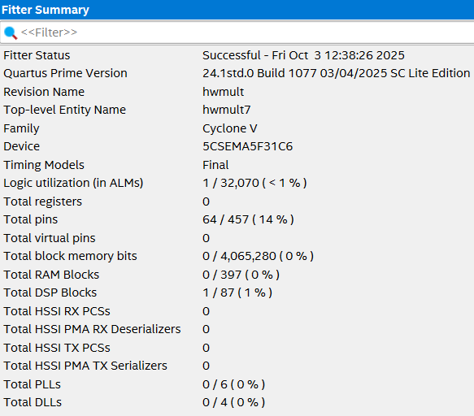
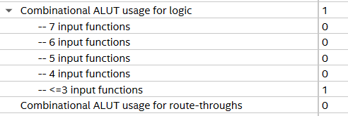
Fig16: 16x16 mult fitter summary (area)
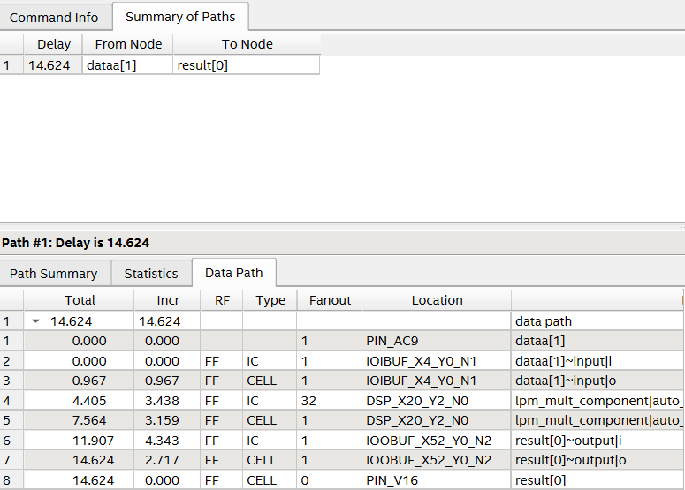
Fig17: 16x16 mult critical path delay (area)
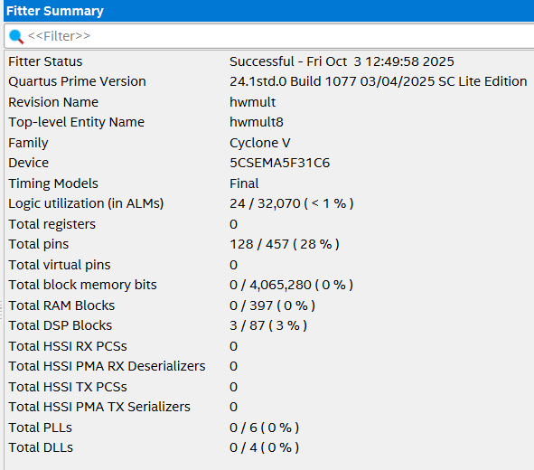
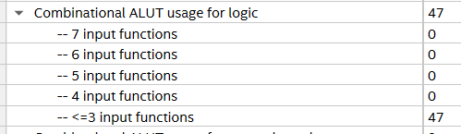
Fig18: 32x32 mult fitter summary (area)
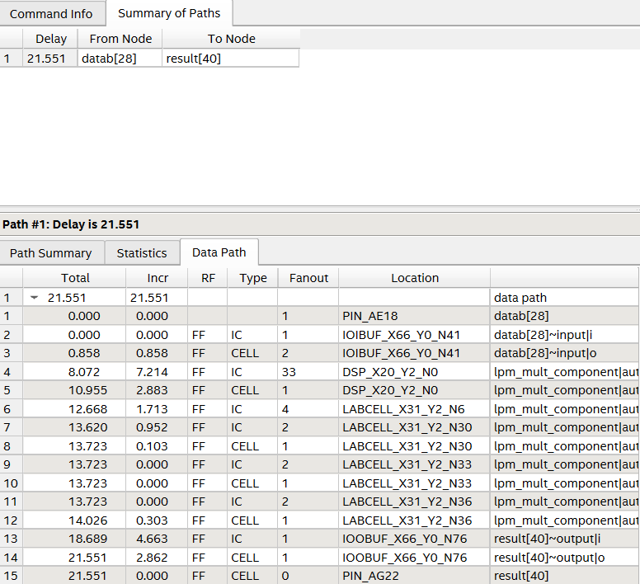
Fig19: 32x32 mult critical path delay (area)
Discussion:
The maximum frequency generally decreases as the multiplier bit width increases, except in the case of the 4x4 multiplier, which runs slightly slower than the 8x8 multiplier. The area/speed optimization option appears to only impact the 4x4 multiplier, with little to no effect on the performance or resource usage of larger multipliers. While using built-in DSP blocks helps reduce ALM/ALUT consumption, it results in slightly lower speed compared to implementing the 4x4 multiplier with ALMs/ALUTs. For the 32x32 multiplier, resource usage grows substantially, and the maximum frequency drops significantly.

Part II – Multiplier Output Modification (7-segment display)
- Modify the program such that the value of the multiplication is display on the 7-segment display instead of the LEDs. Because the result of two 4-bit unsigned number is an 8-bit value, the largest possible number to be generated is 225 (15x15=225). Hence, you need to use three 7-segment displays as shown below
Multiplication result

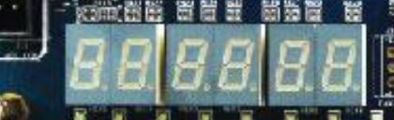

Include here your code and a short YouTube video showing that it works. Report also the number of resources used and the critical path
Marks
8

Video link: https://youtu.be/h4U3fRCLusk

 | ALM | ALUTs | BRAM | DSPs | Freq max
Design | 94 | 186 | 0 | 0 | 40.8MHz
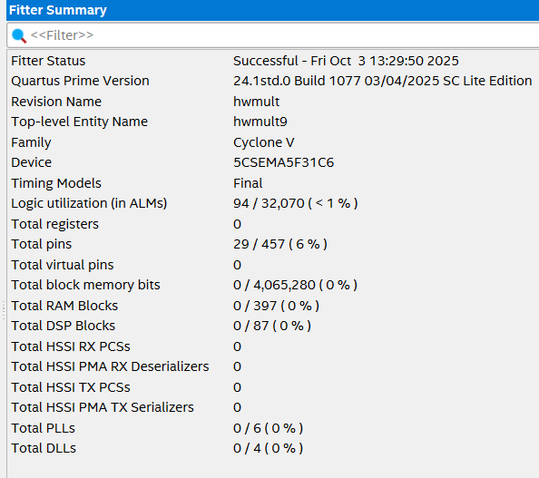
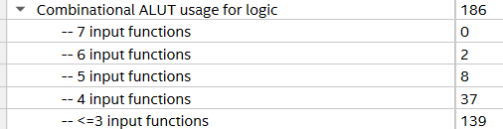
Fig20: 7 seg decoder fitter summary
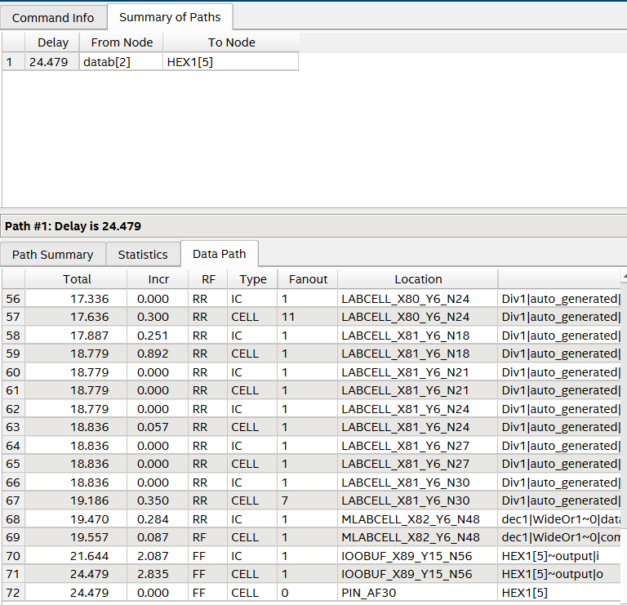
Fig21: 7 seg decoder critical path delay
// synopsys translate_off
`timescale 1 ps / 1 ps
// synopsys translate_on
module hwmult9 (
input [3:0] dataa,
input [3:0] datab,
output [6:0] HEX0, // ones
output [6:0] HEX1, // tens
output [6:0] HEX2 // hundreds
);

wire [7:0] result;
wire [3:0] ones, tens, hundreds;

// --- multiplier ---
lpm_mult lpm_mult_component (
.dataa (dataa),
.datab (datab),
.result(result),
.aclr (1'b0),
.clken (1'b1),
.clock (1'b0),
.sclr (1'b0),
.sum (1'b0)
);
defparam
lpm_mult_component.lpm_hint = "MAXIMIZE_SPEED=5",
lpm_mult_component.lpm_representation= "UNSIGNED",
lpm_mult_component.lpm_type = "LPM_MULT",
lpm_mult_component.lpm_widtha = 4,
lpm_mult_component.lpm_widthb = 4,
lpm_mult_component.lpm_widthp = 8;

// --- binary to BCD (simple division method) ---
assign hundreds = (result / 100);
assign tens = (result % 100) / 10;
assign ones = (result % 10);

// --- 7-seg decoders ---
seg7 dec0 (.bin(ones), .seg(HEX0));
seg7 dec1 (.bin(tens), .seg(HEX1));
seg7 dec2 (.bin(hundreds), .seg(HEX2));

endmodule

// ---- Binary to 7-segment decoder (active low for DE1-SoC) ----
module seg7(input [3:0] bin, output reg [6:0] seg);
always @(*) begin
case(bin)
4'd0: seg = 7'b1000000;
4'd1: seg = 7'b1111001;
4'd2: seg = 7'b0100100;
4'd3: seg = 7'b0110000;
4'd4: seg = 7'b0011001;
4'd5: seg = 7'b0010010;
4'd6: seg = 7'b0000010;
4'd7: seg = 7'b1111000;
4'd8: seg = 7'b0000000;
4'd9: seg = 7'b0010000;
default: seg = 7'b1111111; // blank
endcase
end
endmodule
