
EEDG/CE 6370
Due Date: Sunday October 12, 11:59pm– Submit this editable Word document NOT pdf
0
20
Design and Analysis of Reconfigurable Systems
Homework 4 – Physical design

Name: Yuyang Hsieh
Email: yxh230019@utdallas.edu

Part I – Design Implementation and timing analysis
a.) Follow the instructions in the lab sheet and synthesize the design without replacing any LUT in Chip Planner. Report the logic utilization (ALMs/ALUTs), total registers, pins, block memory, DSP blocks and DLLs used using the fitter report. Include a screenshot of the report too.
Marks
2

ALMs/ALUTs | FFs | IOs | DSPs | BRAM | DLLs
183/305 | 288 | 241 | 0 | 0 | 0/4

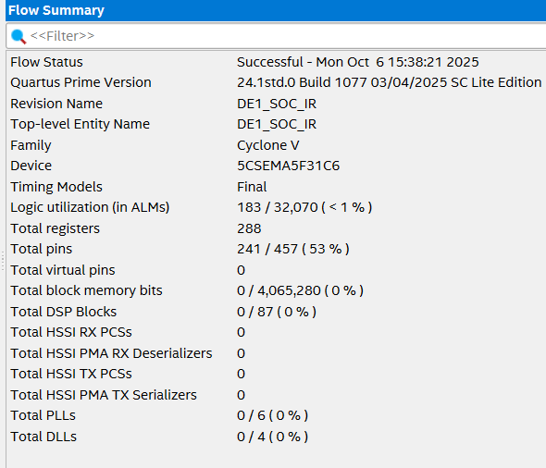
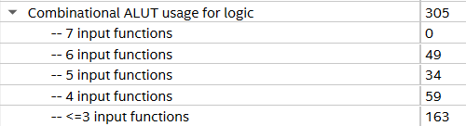
Fig1: Fitter Summary for DE1SoC_IR

b.) Open the Timing analyzer and report the maximum frequency. Include screenshot.
Marks
2
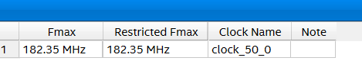
Fig2: Fmax Summary

c.) Annotate here the 5 longest critical paths from Timing analyzer and annotate here their delay and slack. Include screenshot.
Marks
2

Critical Path | Delay
1 | 5.229ns
2 | 5.231ns
3 | 5.229ns
4 | 5.231ns
5 | 5.231ns
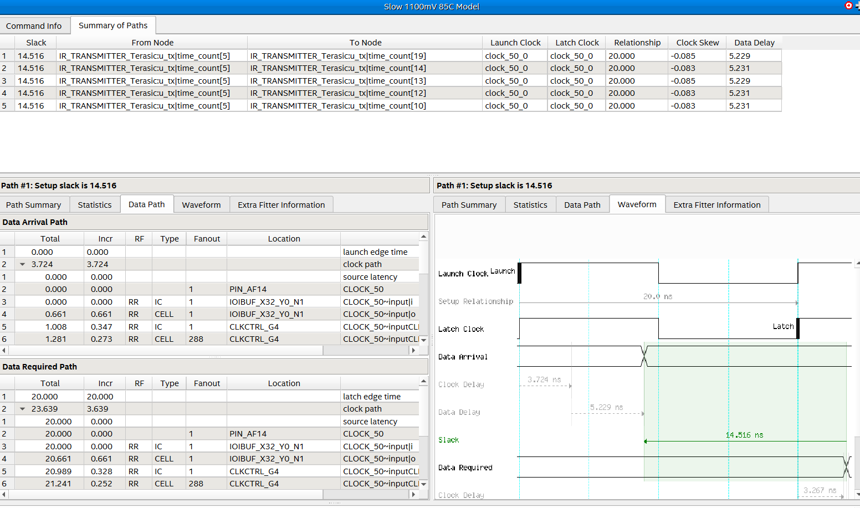
Fig3: slack and data delay for 20 ns
It is only using 5.229 ns out of 20 ns for data delay and slack is 14.516 ns
e.) Change the sdc constraint file setting the clock constraint to a period of 2ns (500Mhz) instead of 20ns (50Mhz). Reopen the Timing analyzer and report the 5 longest critical paths and their slack. Compare with the results in c). What did you notice? (include screenshot of the delays)
Marks
2

Critical Path | Delay
1 | 3.751 ns
2 | 3.749 ns
3 | 3.749 ns
4 | 3.749 ns
5 | 3.747 ns
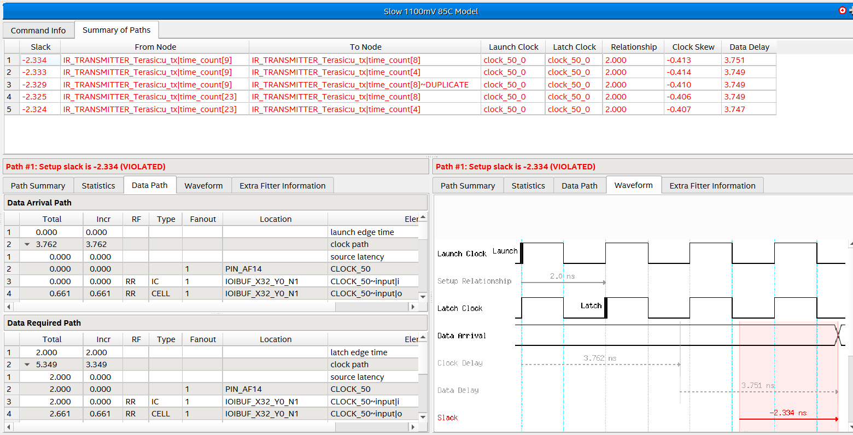
Fig4: slack and data delay for 2 ns
Discussion:
After tightening the clock constraint from 20 ns (50 MHz) to 2 ns (500 MHz), Quartus Prime re-analyzed and optimized the design: the critical-path from/to nodes changed and the data-path delay dropped, but the slowest path still measures ~3.75 ns—longer than the 2 ns period. With clock skew becoming more negative (further hurting setup), timing analysis reports negative slack (−2.334 ns), meaning the actual delay exceeds the requirement by 2.334 ns; the design would need that much additional time to meet setup at 500 MHz, so it cannot reliably operate at that speed.
Part II – Chip Planner
- Change back the sdc clock constraint to 20ns. Move the resources explained in the lab sheet (top and bottom left) using the Chip planner and re-compile the program.
Report the 5 longest critical paths from Timing Analyzer after the replacement. How did this affect the critical path? Compare the results with the original placement results. Explain why.
Marks
6

 | Critical Paths Original | Critical Paths New (moved)
1 | 5.229 ns | 10.508 ns
2 | 5.231 ns | 10.508 ns
3 | 5.229 ns | 10.508 ns
4 | 5.231 ns | 10.508 ns
5 | 5.231 ns | 10.508 ns
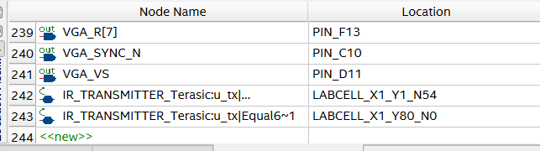
Fig5: move to bottom left X1_Y1_N54 and top left X1_Y80_N0
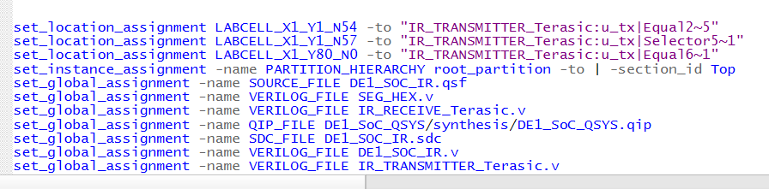
Fig6: .qsf has been update to the new location

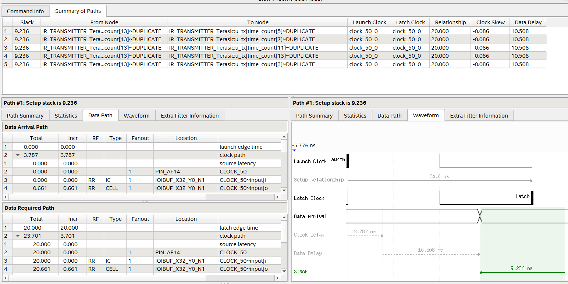
Fig7: slack and data delay after moving registers to top and bot corner
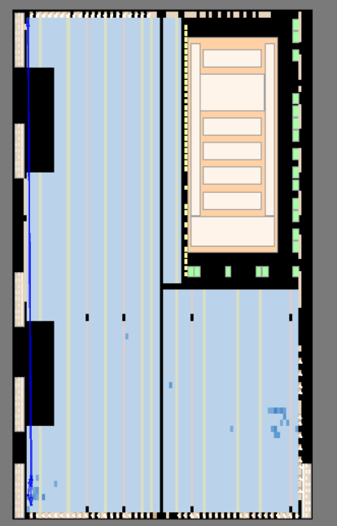
fig8: Longest path from top to bottom
Discussion:
After changing the SDC clock constraint back to 20 ns and manually moving the design resources to the bottom-left (X1_Y1_N54) and top-left (X1_Y80_N0) in the Chip Planner, the longest critical path increased from about 5.23 ns in the original placement to 10.508 ns. This indicates that relocating the logic elements created longer routing between key components, increasing overall propagation delay. As a result, the critical path became slower due to less optimal placement and longer interconnect distances within the FPGA fabric. The original automatic placement was more efficient, minimizing routing delay and achieving a shorter critical path, while the manual movement disrupted this optimized routing.
b.) Create a YouTube video showing the working designs and showing how you measured the information reported int this homework. Include in the video how you configure the FPGA through the automated batch file.
Marks
6

Video Link: https://youtu.be/zo81DKLAmHY

