
EEDG/CE 6370
Due Date: Sunday October 26, 11:59pm– Submit this editable Word document NOT pdf
0
32
Design and Analysis or Reconfigurable Systems
Homework 5
VGA-FPGA Interface and power estimation

Name:
Email:
Part I – VGA implementation with DCM IP to set clock
a.) Follow the instructions in the lab sheet and implement the design which draws two squares of different color to the screen using Altera’s IP catalogue to create a clock of different frequency (based on screen size and resolution). Create a short video demonstrating the working design.
Marks
4

Video Link: https://youtu.be/KZIafmwUPCA
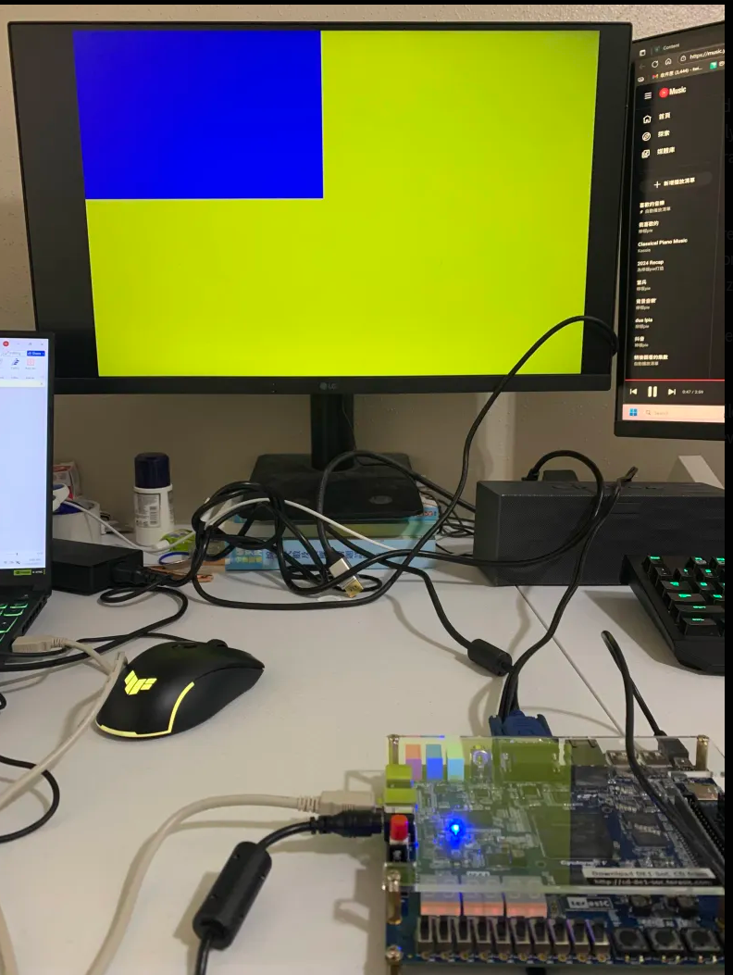
Fig1: blue square over a yellow background on the monitor
b.) Report the number of ALMs, ALUTs and critical path of the design from the synthesis report. Compute the maximum frequency. Include the screenshots generated by Quartus.
Marks
2

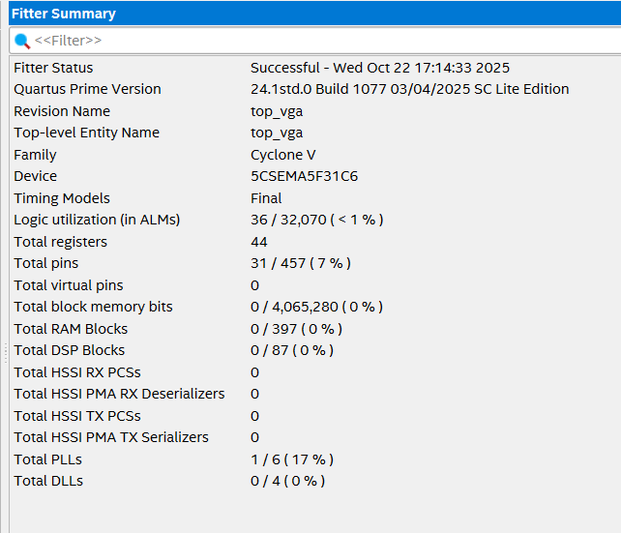
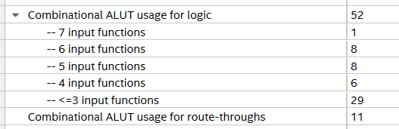
Fig2: Fitter Summary (ALMs, ALUTs)
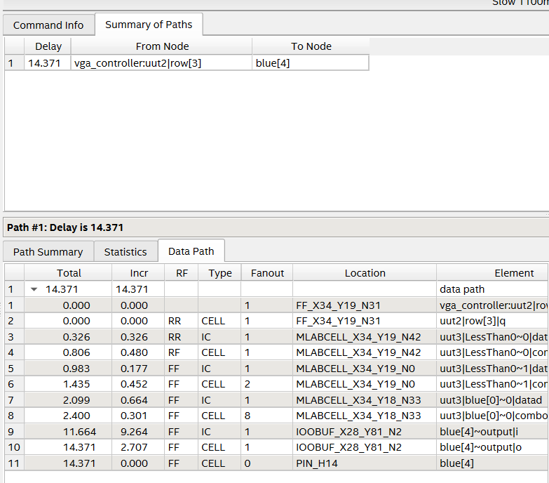
Fig3: critical path of the design (delay)
Ts = 14.371ns
Freq = 1/14.371 ns = 69.6 MHz

Part II – Timing analysis
c.) Open TimeQuest. 1) Netlist Create Timing netlist. 2.) Read .sdc file from VGA project (Constraints read sdc file). 3.) Update timing netlist (Netlist Update Timing netlist)
Report the slack of the circuit. Is it positive or negative? Explain what that means (Reports slack Report setup summary and Report hold summary.
Marks
2
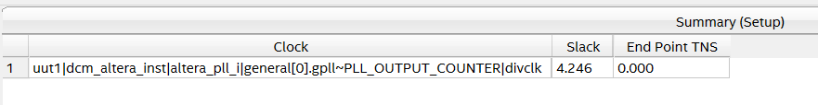
Fig4 : Report setup summary
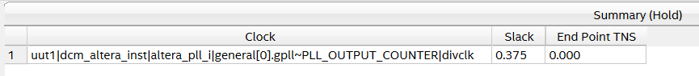
Fig5: Report hold summary
Discussion:
In TimeQuest, slack = required time − arrival time. Your report shows setup slack = +4.246 ns and hold slack = +0.375 ns (with TNS = 0), so both are positive—meaning every analyzed path meets its timing constraints. Positive setup slack says the slowest path still arrives 4.246 ns before the next clock edge (you have that much headroom); positive hold slack says the fastest path stays stable 0.375 ns after the clock edge (no data changing too early). In short, the design meets timing at the specified clock. If either slack were negative, that would indicate a timing violation by the magnitude of the negative value and you’d need to slow the clock, add pipelining, or otherwise optimize.

e.) Reporting the skew. Task pane Custom reports report skew. Edit “From clock” and “To clock” combo boxes. Which clock should you choose? Explain why.
Marks
2

I use
uut1|dcm_altera_inst|altera_pll_ilgeneral[0].gpll~PLL_OUTPUT_COUNTER|divclk
for both “From clock” and “To clock”
I want to measure intra-domain skew, i.e., how much the same clock arrives at different flip-flops within the VGA domain (your counters, image pipeline, etc.). Using the PLL’s output counter clock reflects the actual network that clocks those registers. Selecting sys_clk_in would analyze the board reference clock that doesn’t drive the VGA logic, and selecting the internal VCO node (…|vcoph[0]) would not match the routed clock seen by the registers. Setting the same pixel clock on both ends isolates pure clock-tree distribution effects. Both sys_clk_in and …|vcoph[0
will output “nothing to report”
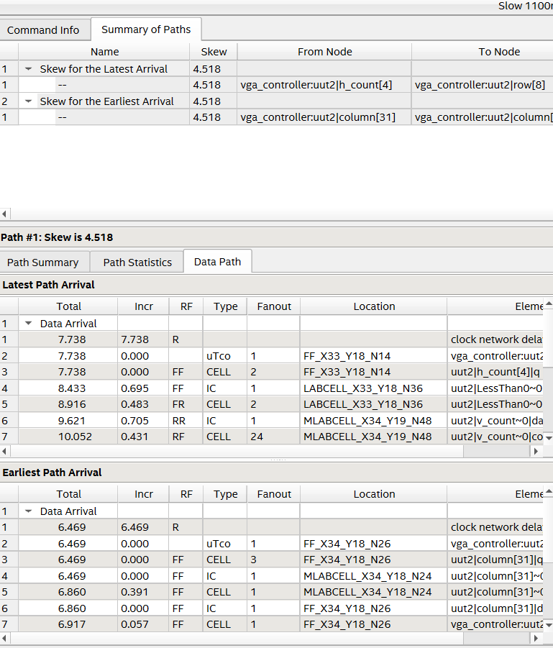
Fig6: Reporting the skew

f.) Is the slack positive or negative? What does the slack result obtained suggests?
Marks
2

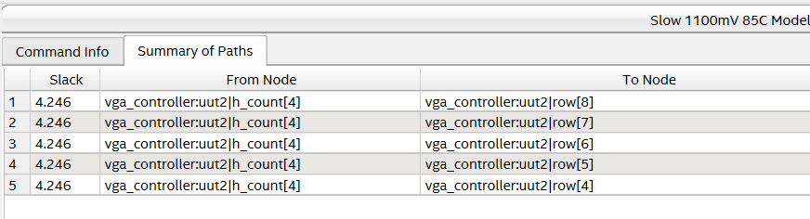
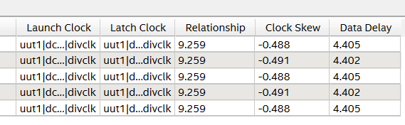
Fig7: slack
Discussion:
Positive. In TimeQuest, slack = required time − arrival time. Your report shows setup slack = +4.246 ns and hold slack = +0.375 ns (TNS = 0), so both are positive. That means every path meets timing at the specified clock: the slowest path arrives 4.246 ns before the next edge (headroom), and the fastest path remains stable 0.375 ns after the edge (no early change). In short, the design is timing-clean; negative slack would have indicated a violation.

Part III – Power Estimation
- Use the PowerPlay Excel sheet to estimate the total power of the design. Enter manually in the spreadsheet the resources used. Let the toggle rate at its default value. Annotate the estimated dynamic and static power, with the following values. Discuss the results.

Marks
6

Configs | Frequency  [MHz] | Temperature [ºC] | Toggle rate [%] | Static power (Quiescent) [W] | Dynamic Power [W] | Total Power [W]
Config 1 | 50 | 50 | 12.5 | 0.325 | 0.031 | 0.356
Config 2 | 60 | 50 | 12.5 | 0.325 | 0.034 | 0.359
Config 3 | 70 | 50 | 12.5 | 0.325 | 0.035 | 0.360
Config 4 | 50 | 55 | 12.5 | 0.334 | 0.031 | 0.365
Config 5 | 50 | 60 | 12.5 | 0.344 | 0.031 | 0.375
Config 6 | 50 | 65 | 12.5 | 0.355 | 0.031 | 0.386
Config 7 | 50 | 50 | 15 | 0.325 | 0.035 | 0.360
Config 8 | 50 | 50 | 20 | 0.325 | 0.039 | 0.364
Config 9 | 50 | 50 | 25 | 0.325 | 0.044 | 0.369
Power Analyzer Results:
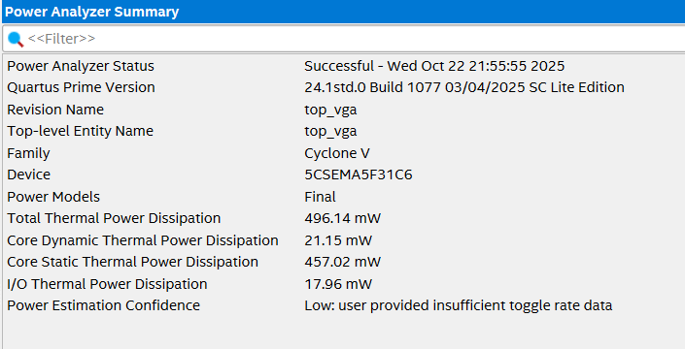
Fig8: freq= 50MHz, temp= 50 ºC, Toggle Rate = 12.5 %
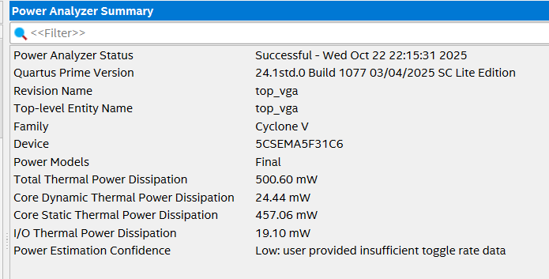
Fig9: freq= 60MHz, temp= 50 ºC, Toggle Rate = 12.5 %
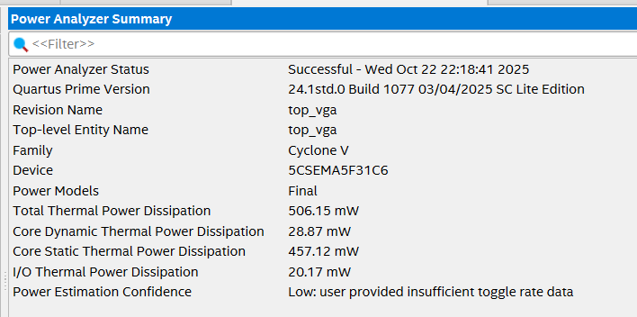
Fig10: freq= 70MHz, temp= 50 ºC, Toggle Rate = 12.5 %
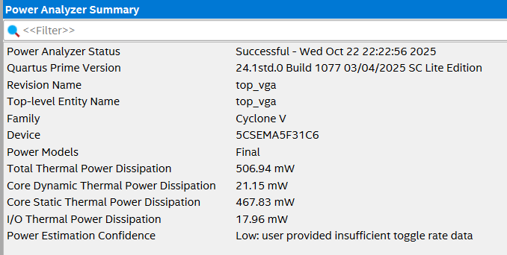
Fig11: freq= 50MHz, temp= 55 ºC, Toggle Rate = 12.5 %
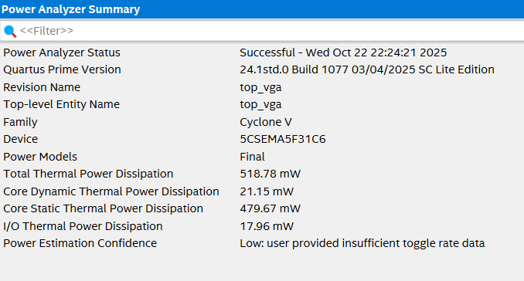
Fig12: freq= 50MHz, temp= 60 ºC, Toggle Rate = 12.5 %
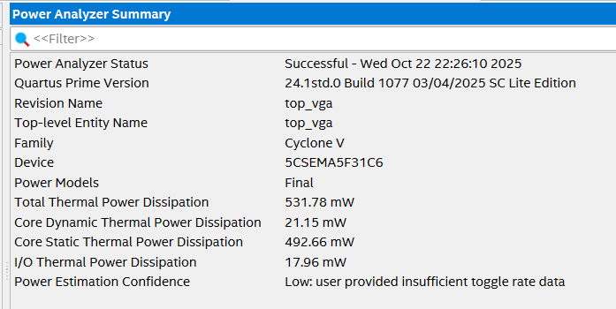
Fig13: freq= 50MHz, temp= 65 ºC, Toggle Rate = 12.5 %
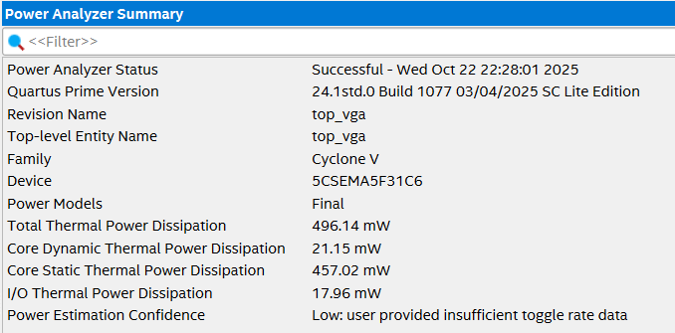
Fig14: freq= 50MHz, temp= 50 ºC, Toggle Rate = 15 %
freq= 50MHz, temp= 50 ºC, Toggle Rate = 20 %
freq= 50MHz, temp= 50 ºC, Toggle Rate = 25 % (All are the same)
Compare the results obtained from Power Play Early Power Estimator (Excel spreadsheet) with the results obtained from Power Play Power Analyzer (Quartus II power estimation tool). Do the results match? Explain why yes/no.
Marks
4
No—the results don’t match. Both tools agree that power increases with frequency, but EPE reports much lower totals (~356–360 mW) than the post-fit Power Analyzer (~496–506 mW). That gap is expected: EPE is a front-end, spreadsheet-style estimator that relies on a user-entered toggle rate (15% default), while Power Analyzer runs on the implemented design and incorporates actual placement/routing and real resource usage. As a result, the Power Analyzer numbers are the more accurate figures for the compiled design.

Part IV – Re-doing VGA Output
Re-do the design and display the following:

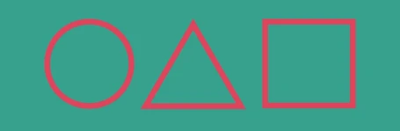

The symbols should be centered in the screen and ~2 inches big (width and height)

Include the RTL code that generates this image from the ‘hw_image_generator’ module. Only the code snippet. Adjust the monitor size parameters (porch values and horizontal and vertical pixels, etc..). Include the parameters settings here. Finally create a YouTube video showing that this works and narrate it.
Marks
10
Video Link: https://youtu.be/fwITyqzwbdc
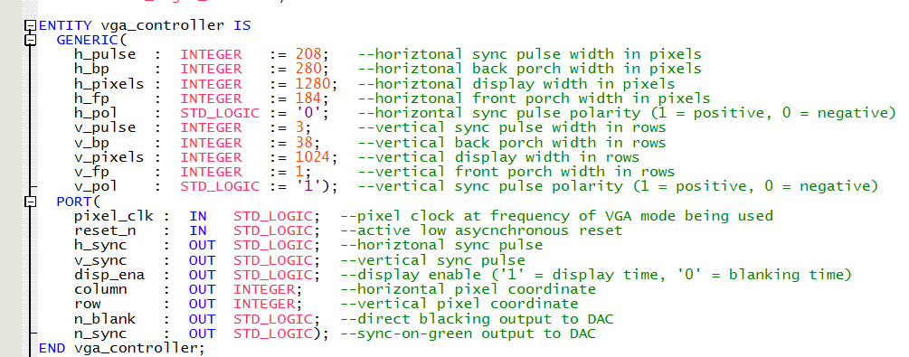
Fig15: Parameter setting
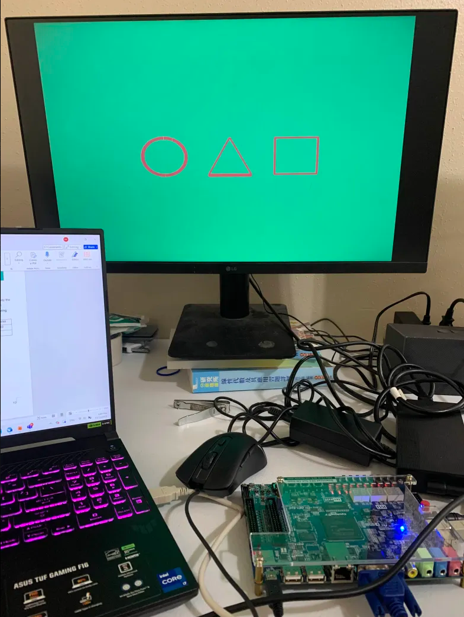
Fig 15: VGA symbol for squid game symbol
library ieee;
use ieee.std_logic_1164.all;
use ieee.numeric_std.all;

entity hw_image_generator is
generic (
-- screen size (set to your mode)
SCREEN_W : integer := 1920;
SCREEN_H : integer := 1080;

-- sizing (~2 inches ≈ 160 px on 1080p 27")
SHAPE_SIZE : integer := 160;
STROKE : integer := 12;
GAP : integer := 80;

--Negative = left, positive = right.
GROUP_SHIFT_X : integer := -300;

-- colors
BG_R : std_logic_vector(7 downto 0) := x"10";
BG_G : std_logic_vector(7 downto 0) := x"A0";
BG_B : std_logic_vector(7 downto 0) := x"90";
FG_R : std_logic_vector(7 downto 0) := x"E0";
FG_G : std_logic_vector(7 downto 0) := x"40";
FG_B : std_logic_vector(7 downto 0) := x"60"
);
port (
disp_ena : in std_logic;
row : in integer; -- y
column : in integer; -- x
red : out std_logic_vector(7 downto 0);
green : out std_logic_vector(7 downto 0);
blue : out std_logic_vector(7 downto 0)
);
end entity;

architecture rtl of hw_image_generator is
-- small integer abs
function iabs(a : integer) return integer is
begin
if a < 0 then return -a; else return a; end if;
end function;

-- geometry constants (from generics)
constant CX_MID : integer := SCREEN_W/2;
constant CY_MID : integer := SCREEN_H/2;

constant S : integer := SHAPE_SIZE;
constant R : integer := S/2;
constant T : integer := STROKE;
constant T2 : integer := STROKE/2;

-- centers: left=circle, middle=triangle, right=square
constant CX1 : integer := CX_MID - (S + GAP) + GROUP_SHIFT_X;
constant CX2 : integer := CX_MID + GROUP_SHIFT_X;
constant CX3 : integer := CX_MID + (S + GAP) + GROUP_SHIFT_X;
constant CY : integer := CY_MID;

-- triangle (isosceles up)
constant TRI_W : integer := S;
constant TRI_H : integer := S;
constant TRI_HALF_W : integer := TRI_W/2;
constant TRI_TOP_Y : integer := CY - TRI_H/2;
constant TRI_BASE_Y : integer := CY + TRI_H/2;
begin
process(disp_ena, row, column)
-- per-pixel vars declared BEFORE begin
variable x, y : integer;
variable dx, dy : integer;
variable r2, rin2, rout2 : integer;
variable leftx, rightx : integer;
variable topy, boty : integer;
variable vleft, vright : integer;
variable circle_on : boolean;
variable square_on : boolean;
variable tri_on : boolean;
begin
if disp_ena = '0' then
red <= (others => '0');
green <= (others => '0');
blue <= (others => '0');
else
x := column; y := row;

-- default background
red <= BG_R;
green <= BG_G;
blue <= BG_B;

-- -------- Circle outline (ring) --------
dx := x - CX1;
dy := y - CY;
r2 := dx*dx + dy*dy;
rin2 := (R - T2)*(R - T2);
rout2:= (R + T2)*(R + T2);
circle_on := (r2 >= rin2) and (r2 <= rout2);

-- -------- Square outline --------
leftx := CX3 - R; rightx := CX3 + R;
topy := CY - R; boty := CY + R;
square_on :=
(x >= leftx and x <= rightx and y >= topy and y <= boty) and
( iabs(x-leftx) <= T2 or iabs(x-rightx) <= T2 or
iabs(y-topy) <= T2 or iabs(y-boty) <= T2 );

-- -------- Triangle outline (three edges) --------
tri_on := false;

-- left edge: (y-TRI_TOP_Y)*TRI_HALF_W + TRI_H*(x-CX2) = 0
if (x >= CX2-TRI_HALF_W) and (x <= CX2) and
(y >= TRI_TOP_Y) and (y <= TRI_BASE_Y) then
vleft := iabs( (y-TRI_TOP_Y)*TRI_HALF_W + TRI_H*(x-CX2) );
if vleft <= T2*TRI_HALF_W then tri_on := true; end if;
end if;

-- right edge: (y-TRI_TOP_Y)*TRI_HALF_W - TRI_H*(x-CX2) = 0
if (not tri_on) and
(x >= CX2) and (x <= CX2+TRI_HALF_W) and
(y >= TRI_TOP_Y) and (y <= TRI_BASE_Y) then
vright := iabs( (y-TRI_TOP_Y)*TRI_HALF_W - TRI_H*(x-CX2) );
if vright <= T2*TRI_HALF_W then tri_on := true; end if;
end if;

-- base edge
if (not tri_on) and
(x >= CX2-TRI_HALF_W) and (x <= CX2+TRI_HALF_W) and
(iabs(y-TRI_BASE_Y) <= T2) then
tri_on := true;
end if;

-- draw outlines
if circle_on or square_on or tri_on then
red <= FG_R;
green <= FG_G;
blue <= FG_B;
end if;
end if;
end process;
end architecture;

