
EEDG/CE 6370
Due Date: Sunday November 9, 11:59pm– Submit this editable Word document NOT pdf
0

38
Design and Analysis of Reconfigurable Systems
Homework 6
High-Level Synthesis with CyberWorkBench

Name: Yuyang Hsieh
Email: yxh230019@utdallas.edu

PART 1 – ave8.c Synthesis
- Synthesize the ave8.c design. Annotate from the resource constraint file (FCNT) the number and type of Functional Units (FUs) used (include screenshots from the reports). Explain what type and why these FUs are needed. Report from the QoR file the size of the circuit in terms of number of LUTs and registers. Report also the latency of the synthesized circuit and the critical path and maximum frequency. Include screenshot.
Create a short YouTube video showing the process of creating the CWB project and synthesis. Narrate it.
Marks
6

YouTube link: https://youtu.be/LZKFaJ9_lp4
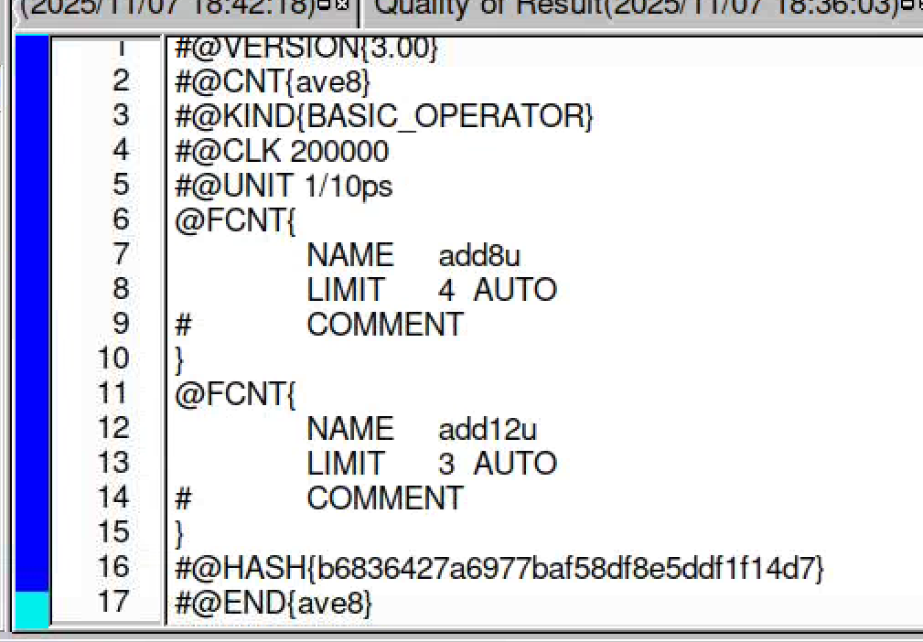
Fig1: resource constraint file (FCNT)

FU types
add8u → 8-bit unsigned adder functional unit
add12u → 12-bit unsigned adder functional unit
Number of FUs
LIMIT 4 → up to 4 instances of add8u
LIMIT 3 → up to 3 instances of add12u
The design ave8 performs several additions on 8-bit data and on wider (12-bit) partial sums. When you average 8 values (or otherwise accumulate several 8-bit numbers), the intermediate sum needs more bits than the inputs to avoid overflow, so the tool uses a wider adder (add12u) for those operations, and 8-bit adders (add8u) where only 8-bit results are required.
LIMIT 4 and LIMIT 3 tell the synthesis tool how many copies of each FU it is allowed to instantiate (max 4 × 8-bit adders and 3 × 12-bit adders), which controls resource sharing vs. parallelism during scheduling.
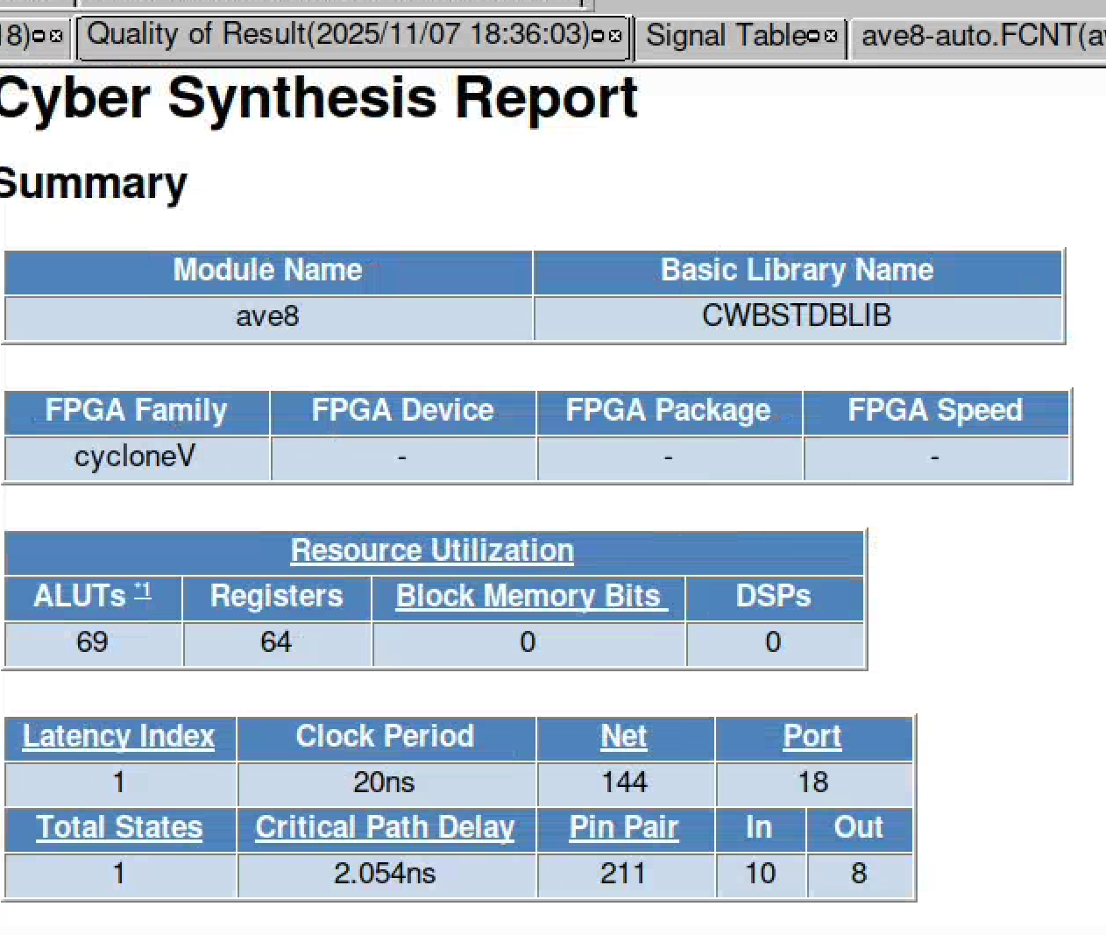
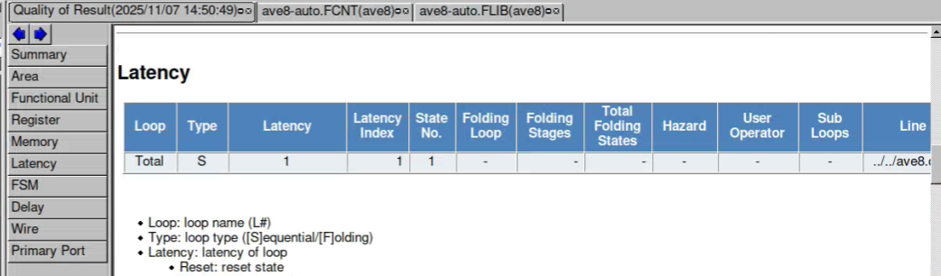
Fig2: QoR
Max frequency = 1 / 2.054ns = 487 MHz
- Perform Logic synthesis using Quartus Prime (after fitting) and compare the area results in terms of LUTs. You might call Quartus from within CWB as shown in the lab sheet or manually create a project in Quartus and include the RTL file generated by CWB, and an SDC file. Discuss if they match or not and why they do/don’t. Complete the table and shown Quartus results screenshots.
Marks
6

 | ALMs/ALUTs | FF/Registers | IOs | Delay [ns]
Reported by CWB | 69 | 64 | 18 | 2.054ns
Reported by Quartus | 25/43 | 71 | 18 | 6.177ns
Discussion:
The area numbers from CWB and Quartus do not match exactly, although they are of the same order. CWB reports 69 ALUTs, while Quartus (after fitting to the target FPGA) reports 25 ALMs / 43 ALUTs. This difference is expected because CWB uses a generic LUT-based technology library, whereas Quartus maps the RTL onto the specific Intel FPGA architecture, where each ALM can contain multiple LUTs plus dedicated carry-chain hardware. Quartus can therefore pack several logic equations into one ALM and use fast adder structures, reducing the effective LUT count compared to the abstract estimate from CWB.
The flip-flop count is also slightly different (64 vs 71) because Quartus may duplicate or add registers during optimization and fitting (e.g., to improve timing or register I/Os), which CWB does not model. The delay estimates differ as well: CWB reports about 2.054 ns (purely logical delay), while Quartus reports about 6.177 ns, which includes realistic routing and device-specific timing information. Overall, the tools are consistent qualitatively, but they do not give identical numbers because they use different technology models and optimization steps.

- Change the target HLS synthesis frequency to the following values and record the latency (clock cycles and critical path delay) reported by CWB. Include screenshots of reach QoR summary. Discuss the results.
Marks
4

HLS target synthesis frequency | Latency | Delay [ns]
50 MHz | 1 | 2.054ns
200 MHz | 1 | 2.054ns
400 MHz | 2 | 3.232ns
600 MHz | 2 | 1.8656ns

Discussion:
For the low target frequencies (50 MHz and 200 MHz) the latency remains 1 cycle and the critical-path delay is the same (≈2.054 ns). This delay corresponds to a maximum achievable frequency of about 1/2.054 ns ≈ 487 MHz, so both 50 MHz and 200 MHz constraints are very relaxed. CWB does not need to change the micro-architecture, so it keeps a single-cycle implementation and simply reports the intrinsic critical path of the design.
When the target frequency is increased to 400 MHz and 600 MHz, CWB tries to meet the tighter timing by modifying the schedule. It increases the latency to 2 cycles (effectively inserting a pipeline stage), which spreads the operations over more clock cycles. However, because of data-dependence and resource constraints, the tool cannot perfectly hit the requested period: the reported critical paths are 3.232 ns and 1.8656 ns, corresponding to maximum frequencies of about 309 MHz and 536 MHz, respectively. In other words, the “target” synthesis frequency is only a goal; CWB attempts to meet it by changing latency and resource usage, but the final achievable frequency is limited by the algorithm structure and available functional units, so the critical-path delay does not always match 1/target-frequency exactly.

Shows these results to ChatGPT and ask it to explain the results. Compare with your results discussions. Does ChatGPTs answer make sense?
Marks
4
After changing the target HLS synthesis frequency and recording latency and delay, I expected that a higher target frequency would simply make the design “run faster”. However, the results show that for 50 MHz and 200 MHz the latency stays at 1 cycle and the reported delay is about 2.054 ns, while for 400 MHz and 600 MHz the latency increases to 2 cycles and the actual delays are 3.232 ns and 1.8656 ns.
ChatGPT’s explanation is consistent with these observations. It points out that CWB has an intrinsic critical path of about 2.054 ns (≈ 487 MHz). As long as the target frequency is below this (50 MHz and 200 MHz), the constraint is easy to meet, so CWB keeps a 1-cycle implementation and the delay doesn’t change. When the target frequency is pushed close to or beyond this limit (400 MHz and 600 MHz), CWB responds by increasing the latency to 2 cycles, effectively inserting an extra pipeline stage to try to meet timing. Because of algorithmic dependencies and limited resources, the tool cannot hit the requested period exactly, so the achieved delays (3.232 ns and 1.8656 ns) correspond to maximum frequencies of ~309 MHz and ~536 MHz rather than exactly 400 MHz or 600 MHz.
Overall, ChatGPT’s answer makes sense and matches the measured data: low frequency targets leave the micro-architecture unchanged, while aggressive targets force extra pipelining and change both latency and achievable clock period.

PART 2 – ave8.c Verification
- Perform an RTL simulation using the untimed test vectors used for the software simulation and make sure that the simulation outputs match for the two versions with HLS frequency 50MHz and 600Mhz. Show the result (paste console window)
Marks
4

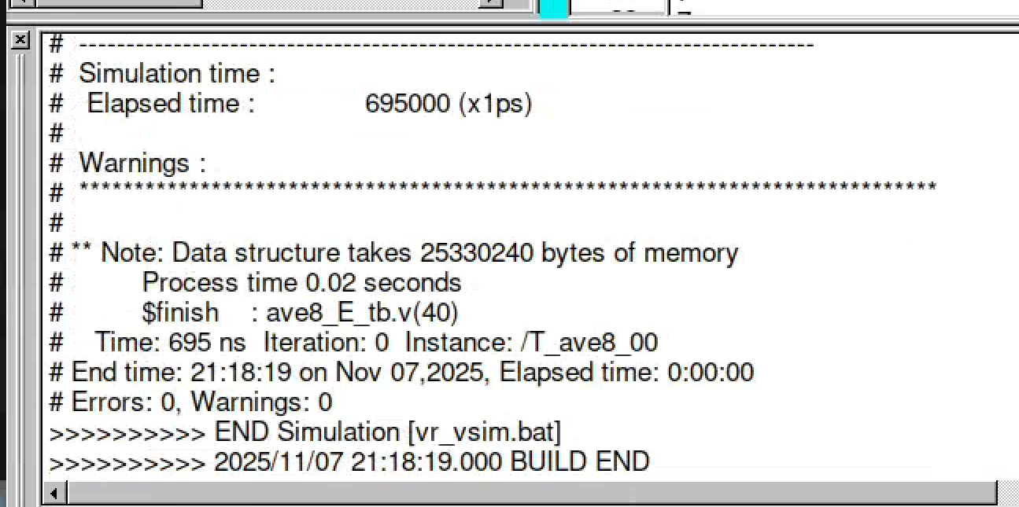
Fig3 : 50MHz

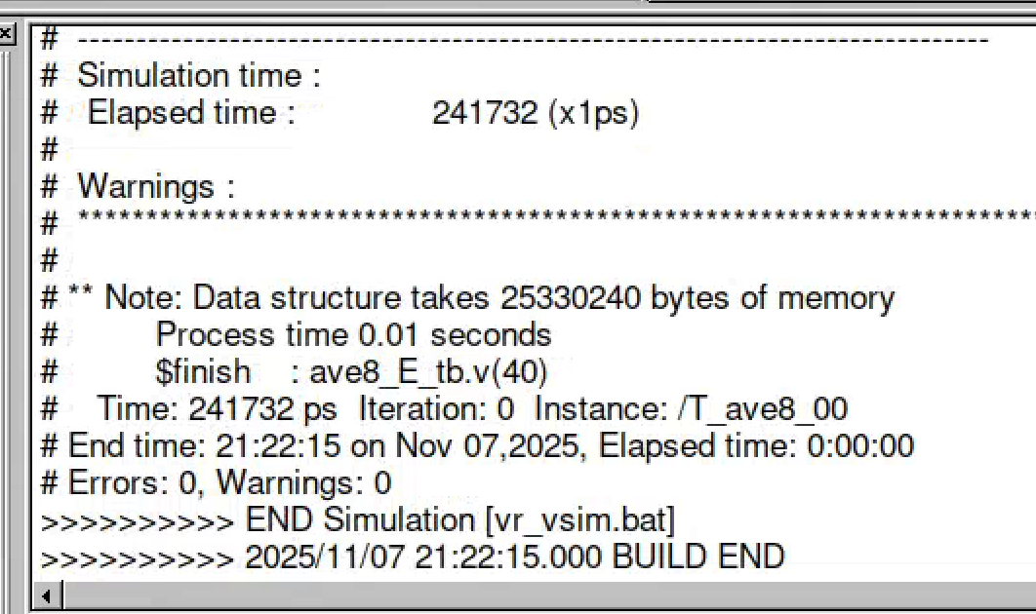
Fig4: 600MHz
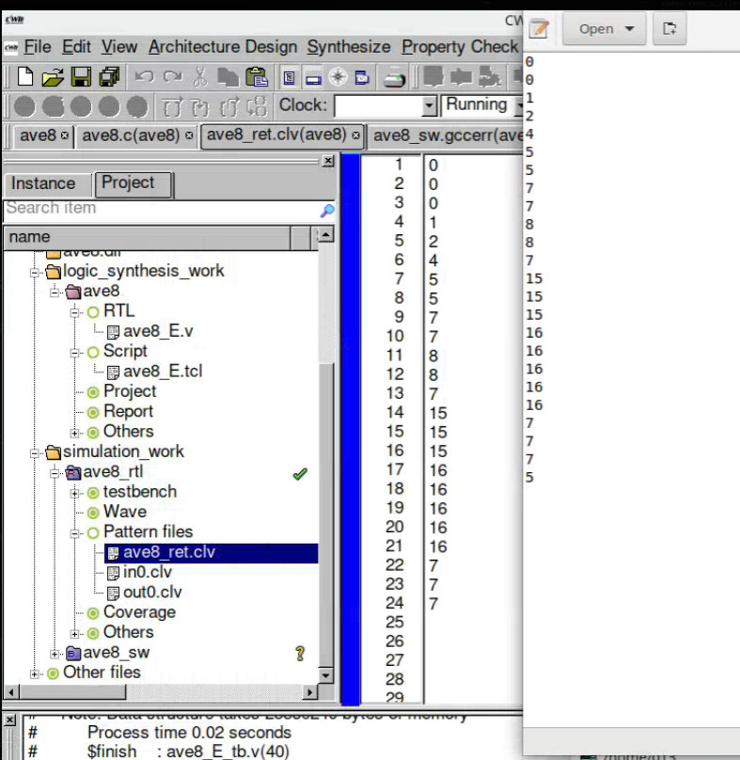
Fig5: simulation outputs match for 50MHz and 600mHz
This verification step shows that changing the HLS target frequency affects only the micro-architecture, not the functionality of the design. We generate two RTL implementations of ave8.c, one synthesized for 50 MHz and one for 600 MHz, but in both cases we drive the RTL with the same untimed test vectors (indata.txt → in0.clv) and compare the RTL outputs against the software golden results (out0.clv). The ModelSim console reports Errors: 0, Warnings: 0 for both runs, which means every RTL output sample matches the C reference. This demonstrates the role of RTL simulation as a functional equivalence check between the high-level C model and the hardware generated by HLS, and confirms that tighter timing constraints (higher target frequency) do not change the computed average values, only the internal timing/latency of the circuit.

PART 3 ave8.c Design Space Exploration
a.) Reduce the number of FUs in the Resource Constraint file (FCNT) from the maximum number obtained in the initial design (50Mhz) to half that number and to only 1 FU. Annotate the area in terms if LUTs and the latency of each of the 3 designs in a table. Plot the graph of area vs. latency of the 3 designs (y-axis area, x-axis latency). Discuss the results. Are they what you expected? (Yes/No)
Marks
6

Design | ALUTs | Latency [clk cycles] | Critical path [ns]
Max FUs | 69 | 1 | 2.054ns
Half FUs | 59 | 2 | 2.1ns
One single FU | 49 | 4 | 2.2ns

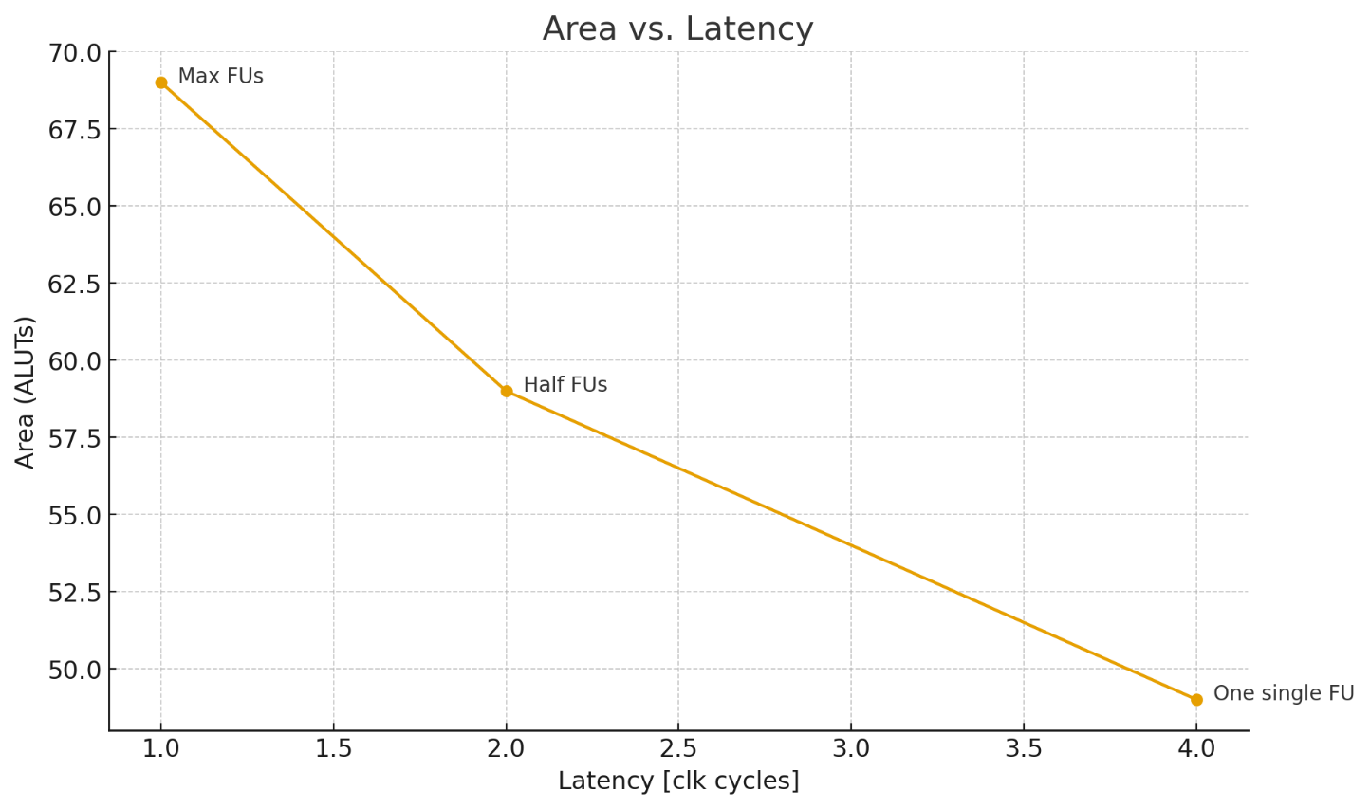

Yes, these results are what we would expect. When the number of functional units is reduced from “Max FUs” to “Half FUs” and then to “One single FU,” the available parallel hardware decreases, so operations must be scheduled over more clock cycles and the latency increases from 1 to 2 to 4 cycles. At the same time, fewer functional units mean less logic is required, so the area in ALUTs decreases from 69 to 59 to 49, showing a clear area–latency trade-off. The critical path changes only slightly (2.054–2.2 ns), which is reasonable because the kind of logic within each cycle is similar; we are mainly changing how many cycles it is spread over rather than adding a much longer combinational path.

PART 4 FPGA Prototyping
Prototype the design on the DE1-SoC board such that the switches act as a new unsigned 8-bit value to be read into the circuit each time that a button is pressed. The average of the last 8 values is displayed on the 7-segment displays as shown. Add, to this report the new synthesizable C code and create a YouTube video showing that the design works.

Note: You might want to re-write the given ANSI-C code to BDL

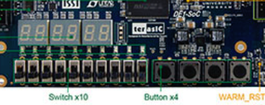
Display ave8 result on 7-segment display
Marks
8

Read the value when button is pressed
New unsigned 8-bit value

Include the modified ave8.c file that follows the specifications indicated and that displays the results on the 7-segment display and a video showing that the design is working.

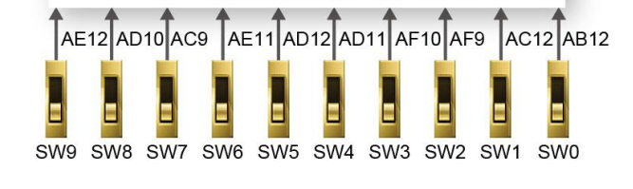

Youtube Link: https://youtu.be/DPjW3WAA40A
Verilog code: // ave8_fpga_top.v
// DE1-SoC: SW[7:0] are 8-bit input samples. Every press of KEY0 samples once,
// computes the average of the most recent 8 samples, and displays it on
// HEX1 (upper nibble) / HEX0 (lower nibble) in hexadecimal.

module ave8 (
input CLOCK_50, // 50 MHz board clock
input [3:0] KEY, // KEY[0] = sample button, KEY[1] = reset
input [9:0] SW, // SW[7:0] used as 8-bit input
output [6:0] HEX0,
output [6:0] HEX1,
output [6:0] HEX2,
output [6:0] HEX3
);

//--- Basic signals ----------------------------------------------------

wire rst = ~KEY[1]; // KEY1 pressed (0) → rst = 1 (active-high reset)
wire btn = ~KEY[0]; // KEY0 pressed (0) → btn = 1 (active-high button)
wire [7:0] sw_in = SW[7:0];// 8-bit input

//--- Button rising-edge detection ------------------------------------

reg btn_d; // Button state from previous clock

always @(posedge CLOCK_50 or posedge rst) begin
if (rst) begin
btn_d <= 1'b0;
end else begin
btn_d <= btn;
end
end

// Only the 0→1 transition counts as a single valid press
wire btn_rise = btn & ~btn_d;

//--- Buffer for the last 8 samples -----------------------------------

reg [7:0] buf0, buf1, buf2, buf3, buf4, buf5, buf6, buf7;

always @(posedge CLOCK_50 or posedge rst) begin
if (rst) begin
buf0 <= 8'd0;
buf1 <= 8'd0;
buf2 <= 8'd0;
buf3 <= 8'd0;
buf4 <= 8'd0;
buf5 <= 8'd0;
buf6 <= 8'd0;
buf7 <= 8'd0;
end else if (btn_rise) begin
// Shift: buf7 is oldest, buf0 is newest
buf7 <= buf6;
buf6 <= buf5;
buf5 <= buf4;
buf4 <= buf3;
buf3 <= buf2;
buf2 <= buf1;
buf1 <= buf0;
buf0 <= sw_in; // Load new 8-bit sample
end
end

//--- Compute average of the 8 samples --------------------------------

wire [10:0] sum; // Max 8*255 = 2040 → needs 11 bits
assign sum = buf0 + buf1 + buf2 + buf3 +
buf4 + buf5 + buf6 + buf7;

wire [7:0] avg;
assign avg = sum[10:3]; // Divide by 8 = shift right by 3 bits

//--- 7-segment decoding: show avg in hex ------------------------------

wire [3:0] low_nib = avg[3:0];
wire [3:0] high_nib = avg[7:4];

seven_seg_hex u0_hex0 (.n(low_nib), .seg(HEX0)); // Lower nibble
seven_seg_hex u1_hex1 (.n(high_nib), .seg(HEX1)); // Upper nibble

assign HEX2 = 7'b111_1111; // Turn off unused displays
assign HEX3 = 7'b111_1111;

endmodule

//======================================================================
// 4-bit hex digit → 7-segment (active-low) decoder
//======================================================================
module seven_seg_hex (
input [3:0] n,
output [6:0] seg
);
reg [6:0] r;

always @* begin
case (n)
4'h0: r = 7'b100_0000; // 0
4'h1: r = 7'b111_1001; // 1
4'h2: r = 7'b010_0100; // 2
4'h3: r = 7'b011_0000; // 3
4'h4: r = 7'b001_1001; // 4
4'h5: r = 7'b001_0010; // 5
4'h6: r = 7'b000_0010; // 6
4'h7: r = 7'b111_1000; // 7
4'h8: r = 7'b000_0000; // 8
4'h9: r = 7'b001_0000; // 9
4'hA: r = 7'b000_1000; // A
4'hB: r = 7'b000_0011; // b
4'hC: r = 7'b100_0110; // C
4'hD: r = 7'b010_0001; // d
4'hE: r = 7'b000_0110; // E
4'hF: r = 7'b000_1110; // F
default: r = 7'b111_1111; // All segments off
endcase
end

assign seg = r;
endmodule
