
EEDG/CE 6370
Due Date: Sunday November 16, 11:59pm– Submit this editable Word document NOT pdf
0

22
Design and Analysis of Reconfigurable Systems
Homework 7
High-Level Synthesis Optimizations

Name: Yuyang Hsieh
Email: yxh230019@utdallas.edu

PART 1 – bubblesort.c Synthesis and Verification
- Make the bubblesort.c design synthesizable for HLS (either ANSI-C synthesizable using cpars or to BDL using bdlpars). Include the entire code here. The code should still be compilable with gcc and also synthesizble with CWB. Use pre-compiler directives (#ifdefs) as needed. Add the code here.
Marks
4

#ifdef C
#include "stdio.h"
#include "stdlib.h"
#endif

#define DATANUM 8

#ifndef C
in var(7..0) in0;
out var(7..0) out0_v;
#endif
unsigned char buffer[8]={0,0,0,0,0,0,0,0};
unsigned char buffer2[8];
unsigned char buffer3[8];
int count = 0;
int count2 = 0;
// Cyber func=process
void main(){
int i, cnti ,cntj ,tmp ;

#ifdef C
FILE *fp1, *fp2 ;

if ((fp1 = fopen("indata.txt", "r")) == NULL) {
fprintf(stderr, "file indata.txt not open \n");
exit(1);
}

if ((fp2 = fopen("otdata.txt", "w")) == NULL) {
fprintf(stderr, "file otdata.txt not open \n");
exit(1);
}

for(cnti = 0 ; cnti < DATANUM ; cnti++){
if (fscanf(fp1, "%d", &buffer2[cnti]) == EOF) exit(0);
}

#else
input(in0);
output(out0_v);
#endif

#ifndef C
/* Cyber unroll_times=all */
for (i = 7; i > 0; i--) {
buffer[i] = buffer[i- 1];
}
buffer[0] = in0;
count ++;

if (count == DATANUM){
/* Cyber unroll_times=all */
for (i = 0; i <= 7; i++)
{buffer2[i] = buffer[i];}
#endif
/* Cyber unroll_times=all */
for (cnti = 0 ; cnti < DATANUM ; cnti++){
/* Cyber unroll_times=all */
for(cntj = DATANUM-1 ; cntj > cnti ; cntj--){
if(buffer2[cntj] < buffer2[cntj-1]){
tmp = buffer2[cntj] ;
buffer2[cntj] = buffer2[cntj-1] ;
buffer2[cntj-1] = tmp ;
}
}
}
#ifndef C

/* Cyber unroll_times=all */
for (i = 0; i <= 7; i++)
{buffer3[i] = buffer2[7-i];}
}

out0_v = buffer3[7];
/* Cyber unroll_times=all */
for (i = 7; i > 0; i--) {
buffer3[i] = buffer3[i- 1];
}
#endif

#ifdef C
for(cnti = 0 ;cnti < DATANUM ;cnti++){
fprintf(fp2, "%d\n", buffer2[cnti]) ;
}
fclose(fp1) ;
fclose(fp2) ;
#endif
}
I did not return 0 because I want to check if success or not more clearly!

- Synthesize the bubblesort.c design. Report from the QoR file the size of the circuit in terms of number of LUTs and registers. Report also the latency of the synthesized circuit and the critical path and maximum frequency from CWB. Include screenshots from CWB here.
Marks
4
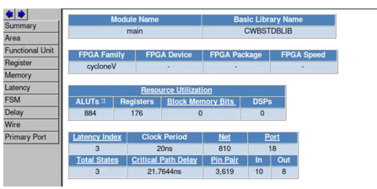
Fig1: QoR and latency
maximum frequency= 45.9MHz

- Perform Logic synthesis using Quartus Prime and compare the area results in terms of ALMS/ALUTs. You might call Quartus from within CWB as shown in the lab sheet or manually create a project in Quartus and include the RTL file generated by CWB, and an SDC file. Discuss if they match or not and why they do/don’t. Add screenshot from Quartus here. Fill out the table given below.
Marks
4

 | CWB | Quartus
ALMS/ALUTs | 886 | 652/982
Registers | 176 | 196
IOS | 18 | 18
DSP Macros | 0 | 0
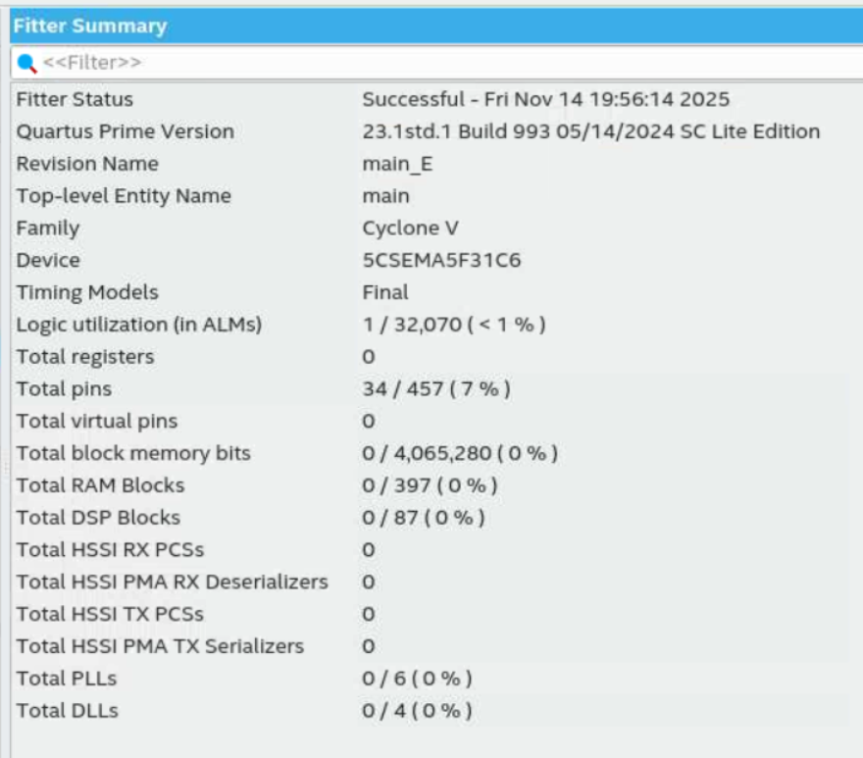
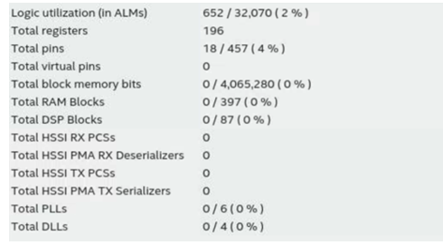
Fig2: Fitter Summary
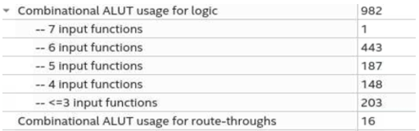
Fig3: critical Path Delay
Discuss differences:
The gap between the CWB QoR report and the Quartus Fitter report is much smaller than in Homework 6, but there are still noticeable differences in the ALM/ALUT and register counts. Quartus uses roughly 15% more ALMs/ALUTs and registers. This is reasonable because Quartus performs additional backend steps such as detailed physical design, placement and routing, and floorplanning using device-specific libraries. On top of that, the synthesis options and optimization strategies used by CWB and Quartus are not identical, so they naturally produce slightly different LUT and register utilizations.
Bubblesort.c Verification
Perform a pure SW simulation, and an RTL simulation using the untimed test vectors used for the software simulation and make sure that the simulation outputs match for the two versions with HLS. Show the result (paste console window). Paste the SW and RTL simulation results here from CWB’s console window (or Linux terminal).
Marks
4

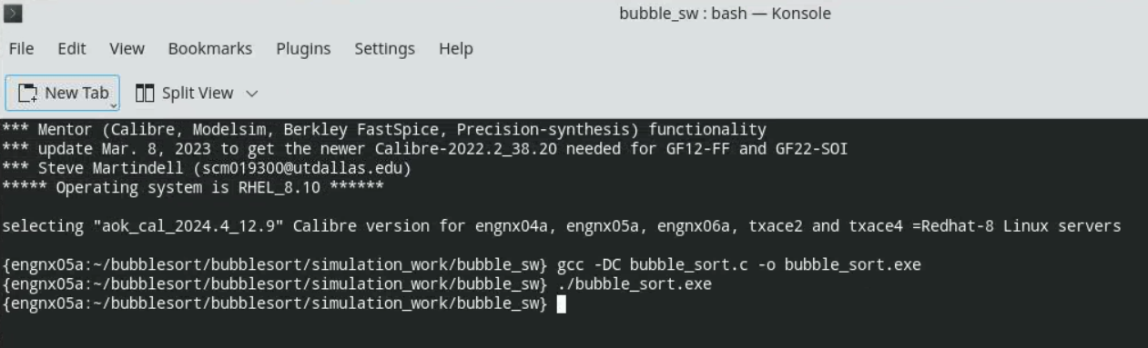
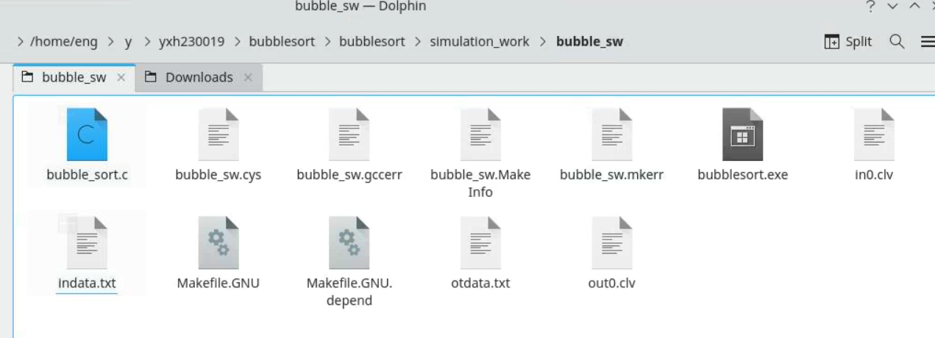
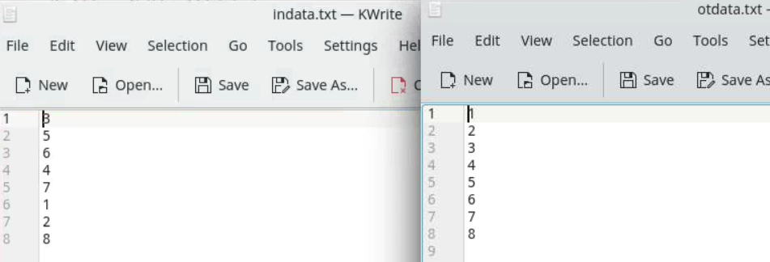
fig4: SW output (gcc)
RTL Simulation
I first synthesized the source code from Part 1 using the BDL parser and then ran RTL simulation. Because the circuit latency is 3 cycles, we modified the input data vector by inserting two zeros between each sample. This guarantees that new valid data arrives every 3 clock cycles. The updated input pattern is shown below:
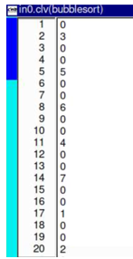
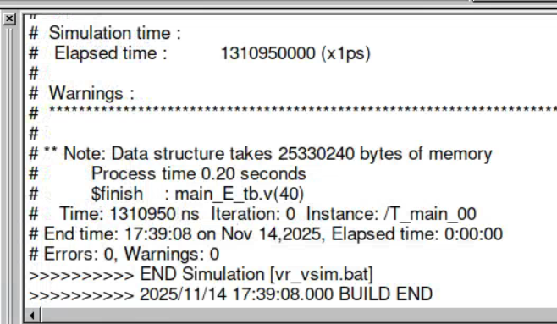
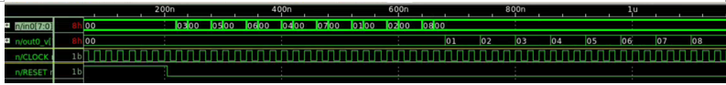
Fig5: RTL simulation (return sorted 12345678)

PART 2 bubblesort.c Design Space Exploration
Follow the instructions in the homework sheet and set different pragma combinations, resynthesize (HLS) the design and observe the effect of the pragmas on the resultant circuit. Include a screenshot of the synthesis window with the original design with no pragmas and the the following pragma combinations:
 | Pragmas 1 | Pragma 2 | Pragma 3
Design 1 | Array=RAM | Unroll_times=all | Unroll_times=all
Design 2 | Array=REG | Unroll_times=all | Unroll_times=0
Design 3 | Array=REG | Unroll_times=all | Unroll_times=all

Discuss the results and suggest other pragma combinations that you could insert to generate other types of hardware implementations. Create a YouTube video showing how the different pragmas are set and explaining the results obtained in CWB’s synthesis window. Narrate the video.

Marks
6
Youtube Link: https://youtu.be/m2xn87KTsyY
No Pragma
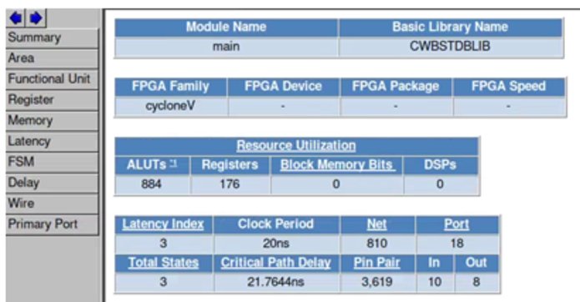
Fig6: QoR and latency (no Pragma)
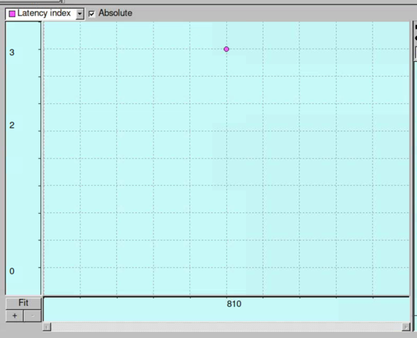
Fig7: synthesis window
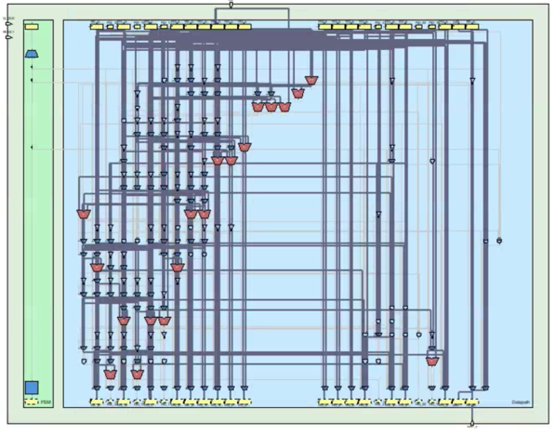
Fig8: Data Path (no Pragma)
Design 1
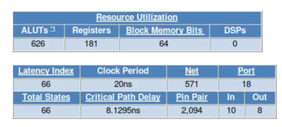
Fig10: QoR and latency (Design 1)
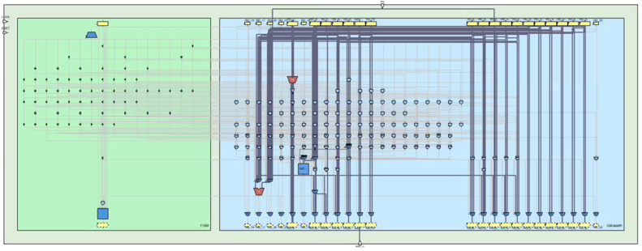
Fig11: Data Path (Design 1)
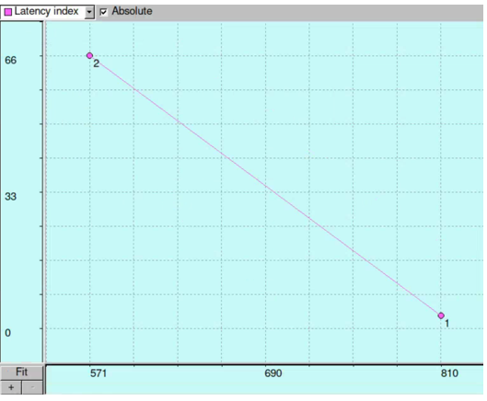
Fig12: Synthesis Window (Design 1)
Design2
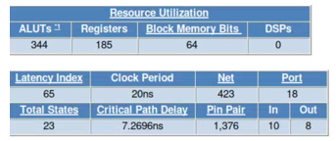
Fig13: QoR and latency (Design 2)
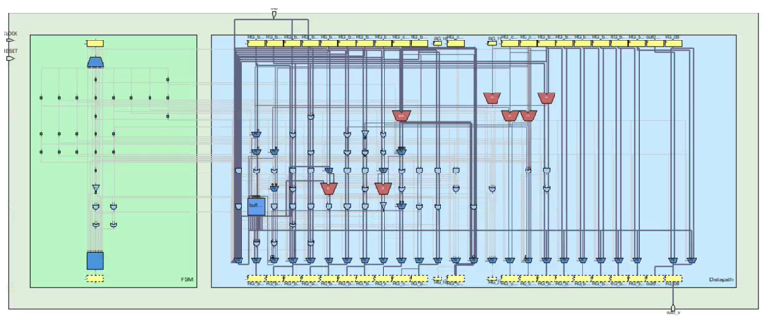
Fig14: Data Path (Design 2)
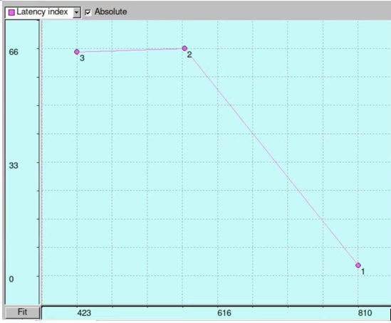
Fig15: Synthesis Table (Design 2)
Design3
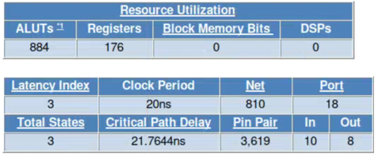
Fig16: QoR and latency (Design 3)
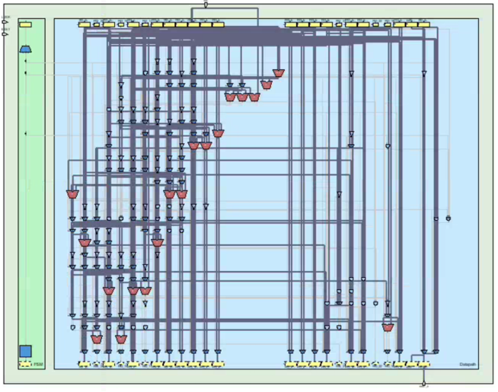
Fig17: Data Path (Design 3)
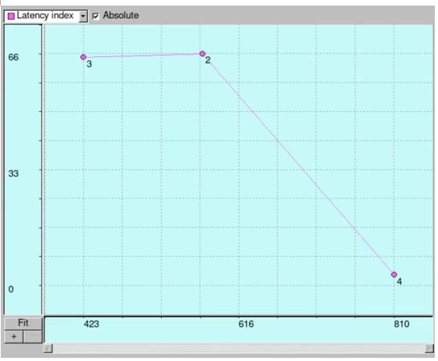
Fig17: Synthesis (Design 3)
Discussion:
Without any pragmas, CWB builds a very simple single-cycle implementation: the array is kept in registers, there is no block memory, latency is 1, and the FSM has only one state.
In Design 1 (Array=RAM, both loops unroll_times=all), the array is pushed into a single-port RAM, so every compare–swap must go through that memory. Even though we asked to fully unroll the loops, the memory port becomes a bottleneck and the scheduler is forced to serialize the operations over 8 cycles. That shows up as higher latency, more registers and ALUTs, and some block-memory bits being used.
In Design 2 the pragma combination further increases the number of states and loop bodies and the tool instantiates more compare/swap hardware, so ALUT and register counts increase again; this design trades much more control complexity and area for a deeply sequential schedule with RAM-based storage.
Design 3, with the array back in registers and both loops unrolled, collapses back to a 1-cycle implementation very similar to the no-pragma case: the tool can keep all data in registers and implement all compare–swap operations as a single large combinational network, so latency returns to 1 and resource usage matches the baseline.
Other pragma combinations could explore intermediate trade-offs. For example, array=RAM with unroll_times=0 on the outer loop and unroll_times=2 or 4 on the inner loop would keep a RAM-based array but allow limited parallelism on a few compare–swaps per cycle, giving medium latency and moderate area. Conversely, array=REG with partial unrolling of only the inner loop would keep the data in registers but avoid a fully flattened combinational network, shortening the critical path at the cost of a few extra cycles. You could also try leaving the inner loop sequential (unroll_times=0) and only unrolling the outer loop, or mixing RAM/REG mappings for different arrays if the design had more memories; each combination would give a different point in the area-vs-latency design space.

