
EEDG/CE 6370
Due Date: December 4, 11:59pm– Submit this editable Word document NOT pdf
0
18
Design and Analysis or Reconfigurable Systems
Homework 9 – HPS+FPGA
LAST HOMEWORK

Name: Yuyang Hsieh
Email: yxh230019@utdallas,edu

NOTE: For the latest Quartus version to be able to compile all of the Platform Designer IPs you need to install in your Windows machine WSL (Windows Subsystem for Linux.) This feature allows users to run a GNU/Linux environment directly on Windows 10 and 11. Once you install it update the installed packages and install the make utility as follows:

%sudo apt update
%sudo apt upgrade
%sudo apt install make

Upen the Quartus project included in the homework after you have done these steps.

Part I –Simple HPS+FPGA System
a.) Follow the instructions in the My_First_HPW_FPGA.pdf document provided by Terasic and show that the system is working. In this example the SW running on the HPS does:
- The LED on DE1-SoC will be expected to perform 60 times of LED light shift operation, and then the program is terminated.
Deliverables:
- Report the number of FPGA resources used, and the maximum frequency achieved.
- Report the size of the compiled SW program
- A YouTube video showing that the system works.
Marks
6
0

YouTube Link: https://youtu.be/FP_HN1PUW34
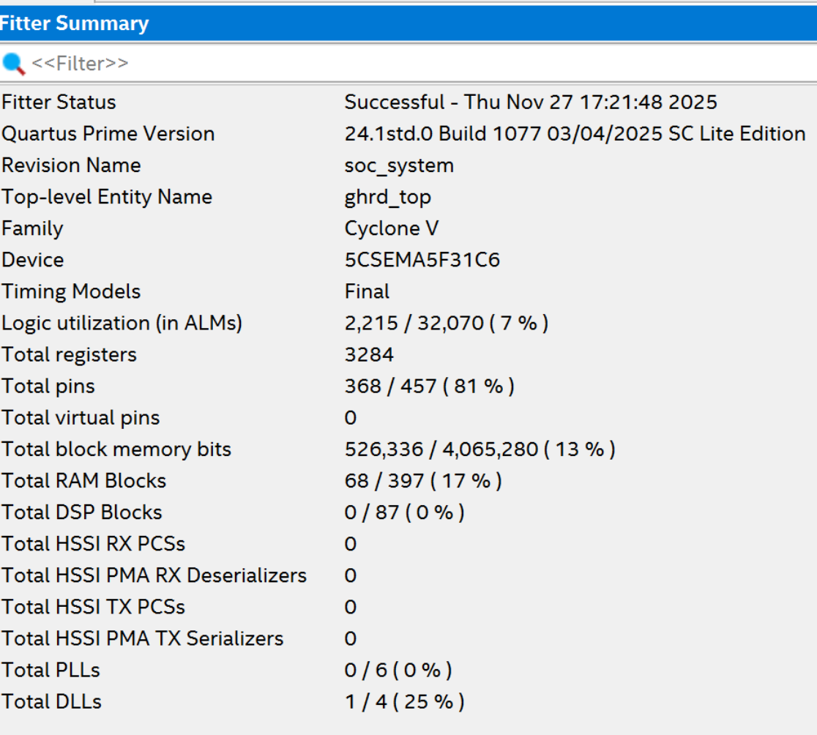
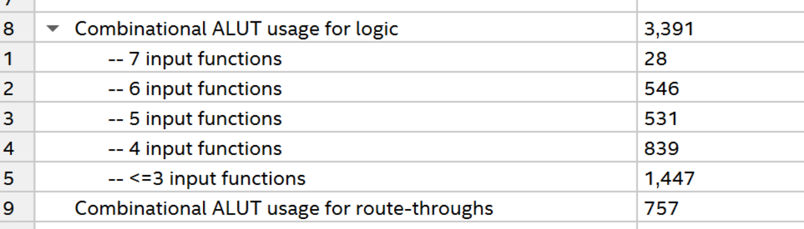
Fig1: Fitter Summary
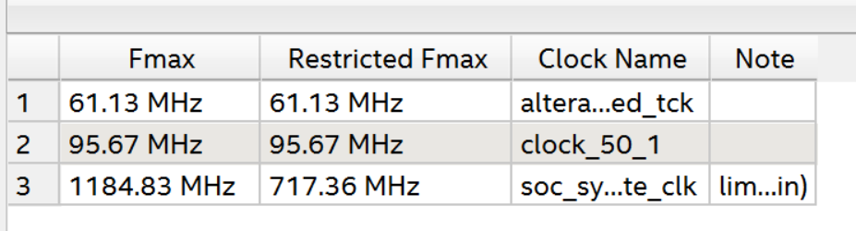
Fig2: Fmax ≈ 95.67 MHz (clock_50_1)
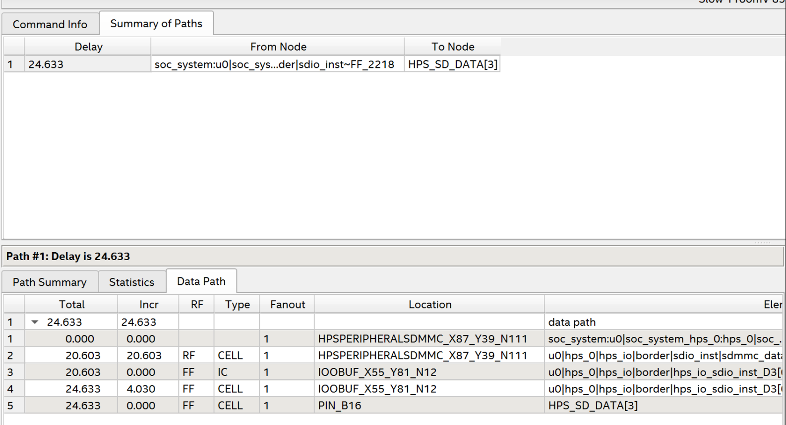
Fig3: Critical Path Delay
Fig4: File size (my first hps fpga)
Part II – Modifying the HPS+FPGA System
- Modify the system so that the 7-segment displays on the board will display a running counter generated by the HPS which counts, seconds, minutes and hours. Every 1 second until 60 seconds and then wraps around incrementing the minutes, which in turn wrap around when 60 minutes is reached by incrementing the hours by one, which in turn wrap around when 24 is reached.
Marks
12
0

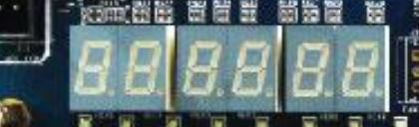
hours minutes seconds

Deliverables:
- Show that your system works by creating a small video (You do not need to wait for the hour to change).
- Report the FPGA resources used, max frequency, etc.
- Attach all of the project files in zipped file.
YouTube Link: https://youtu.be/NaTpTuLHPak
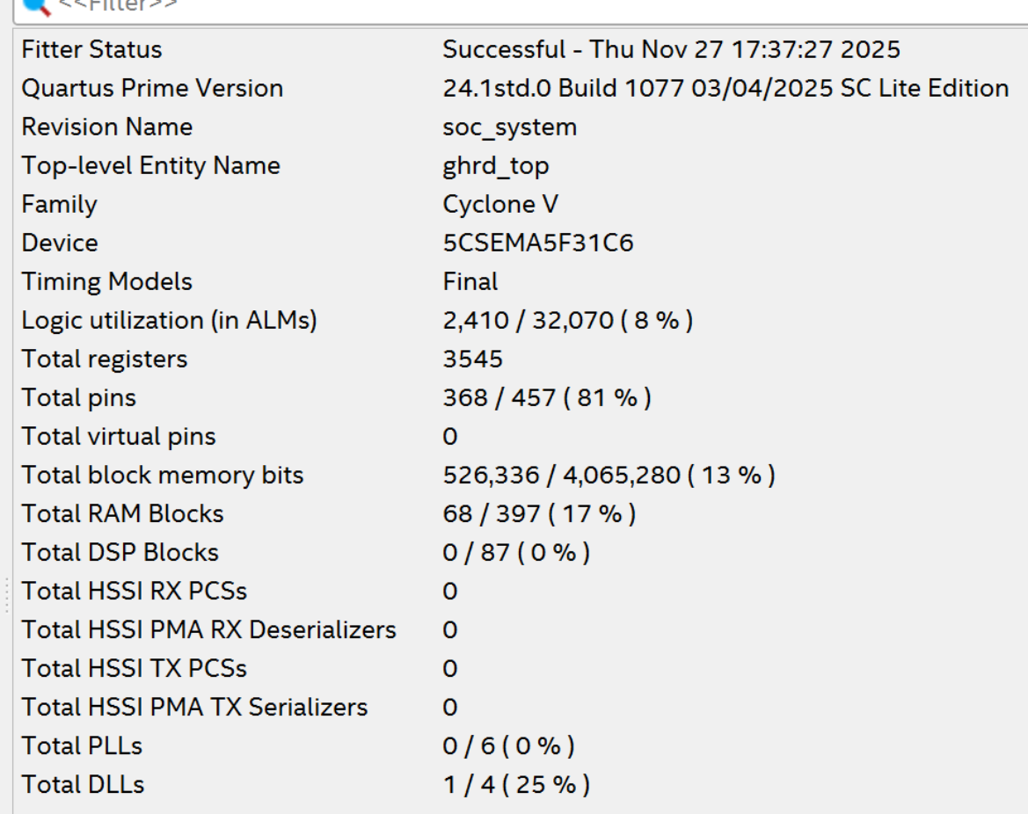
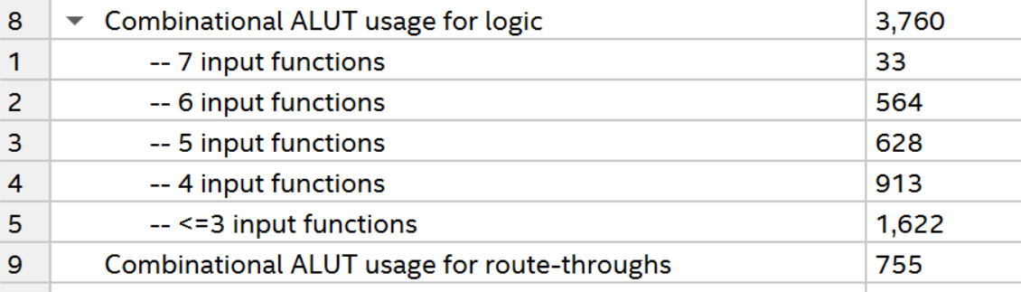
Fig5: Fitter Summary
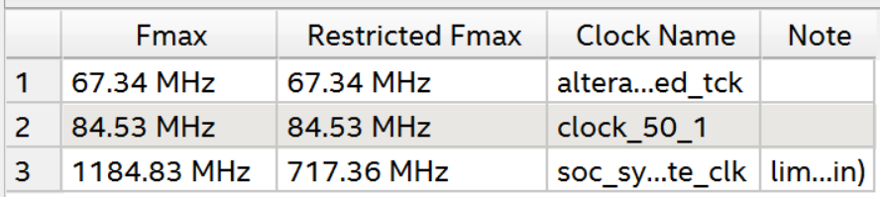
Fig6: Fmax ≈ 84.53 MHz (clock_50_1)
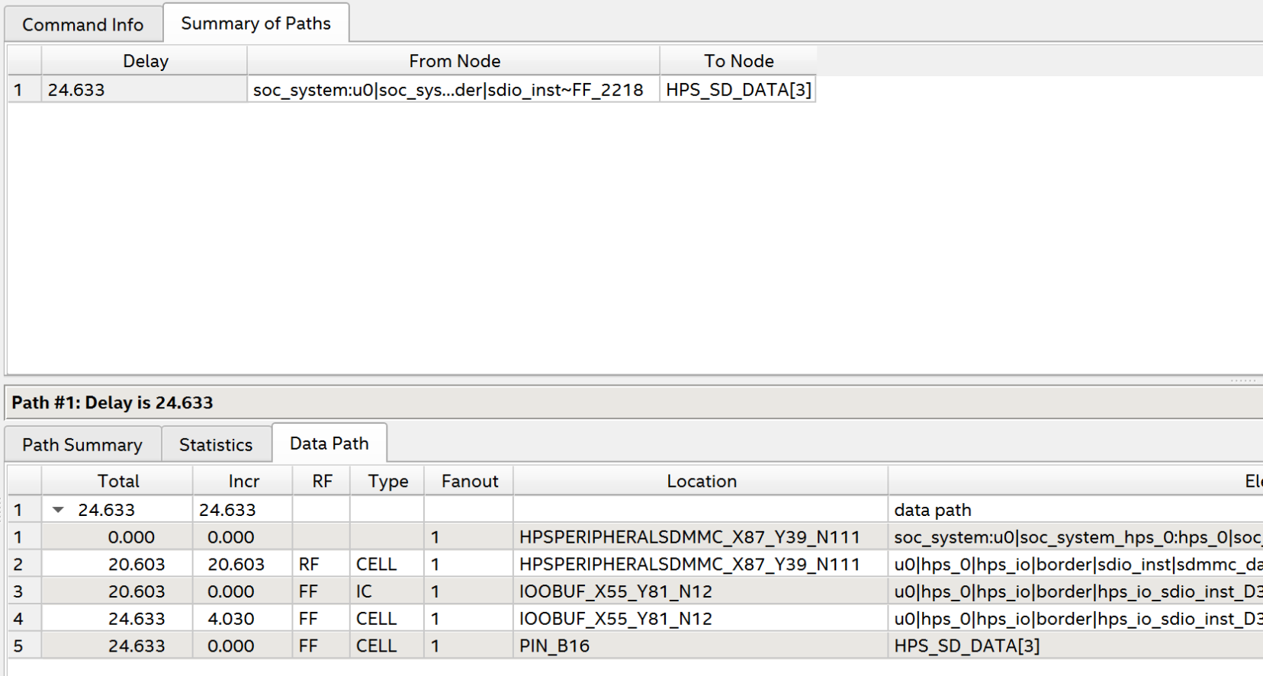
Fig7: Critical Path Delay
Fig8: File Size (counter)

