Monash friend Finder

UI Design Report

Yuyao Ni

Student ID:29408083

Xin Zhang

Student ID: 29790336

**Table of Content**

1. Paper-based Prototype 2

2. Digital prototype 4

**2.1** **The login screen** 4

2.1.1 Form design guidelines: Error prevention 4

2.1.2 Mobile form guidelines: Provide hint text using the appropriate design pattern 4

2.1.3 Mobile accessibility: Robust 5

2.1.4 Sign-up form improvement 5

**2.2** **User profile** 6

2.2.1 Mobile accessibility considerations related primarily to Principle 3: Understandable 6

2.2.2 Mobile Form design guideline: efficient 7

2.2.3 Hick’s law: keep it short and simple 7

**2.3** **Home/ main screen** 9

2.3.1 Bottom Navigation Bars 9

2.3.2 IOS navigation guidelines: Design an information structure that makes it fast and easy to get to the content 9

2.3.3 IOS navigation guidelines: Use a navigation bar to traverse a hierarchy of data 9

**2.4** **Multi-Criteria Search for friends** 10

2.4.1 Shneiderman 8 Golden Rules: reduce short term memory 10

2.4.2 Gestalt Principles: Closure 11

2.4.3 Mobile accessibility guideline: Grouping operable elements that perform the same action 11

2.4.4 Searching friend page improvement 12

**2.5** **Reports** 12

2.5.1 Guidelines for menu design 12

2.5.2 Visual design principles: Repetition 13

2.5.3 Discoverability: Constraints 13

**2.6** **Maps** 13

2.6.1 Design guideline for colours 13

2.6.2 Grouping and Gestalt Laws 14

2.6.3 Search form design: auto-complete 14

3. Reference 16

4. Appendix 17

# **Paper-based Prototype**

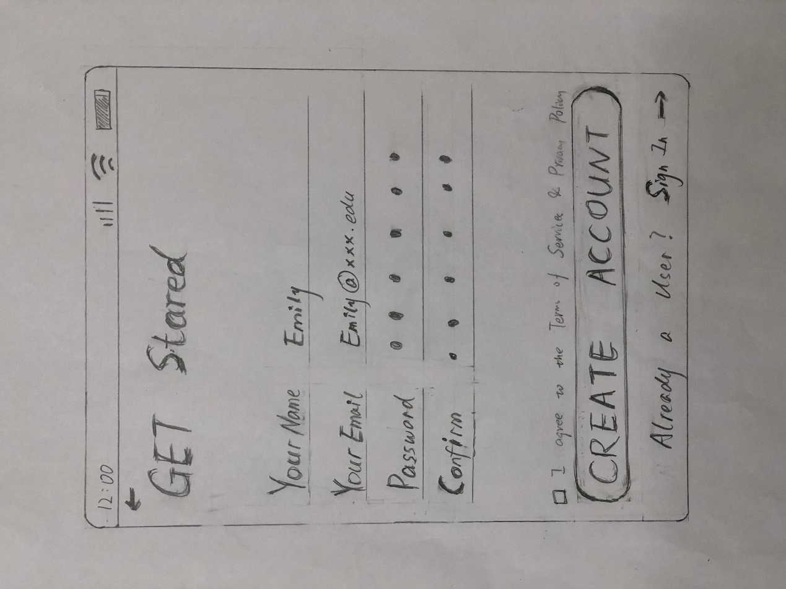

**Figure 1** Sign-up form

Figure 1 is the paper-based Sign-up form where the user can use their name, email, and password to create a new account. If the user already has an account, he/she can tab sign-in switch to the login screen.

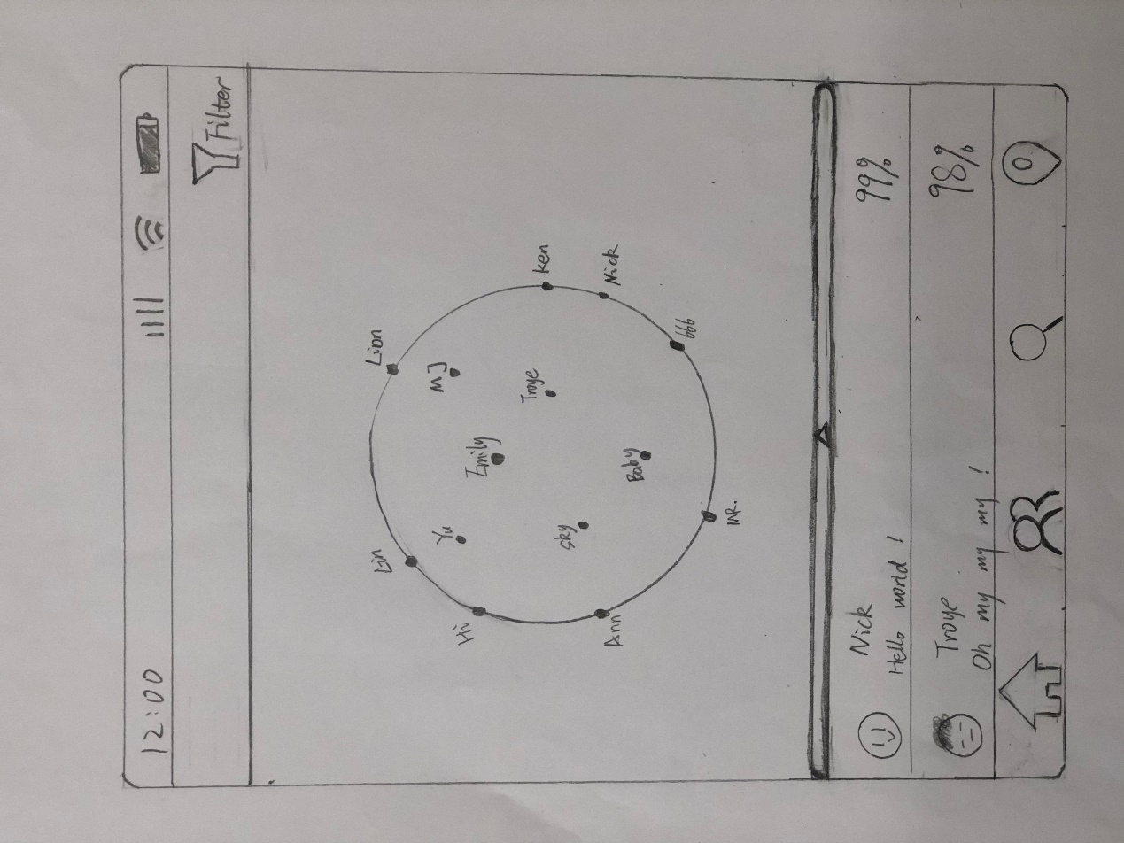

**Figure 2** Searching friends

Figure 2 shows the page of searching for friends. The filter icon on the top right allows users to select multiple attributes to find friends. The circle in the middle is a dynamic sphere which shows the searching results. The points stand for matched friends and users can tab the point to see more information about the friend. The triangle symbol under the sphere means users can upglide to see the list of the finding results. The list will display friends' account images, names, and matching degree. There is a bottom navigation bar that includes four options: "home screen", "Friend reports", "Search friends" and "map" at the bottom of the screen.

# **Digital prototype**

## **The login screen**

### Form design guidelines: Error prevention

As Figure 3 shows, the “create account” button is disabled to prevent an error if the user hasn’t completed the required information in the sign-up screen. Because users tend to prone to mistakes when entering data and the limited size of the mobile phone also raise the error possibility.

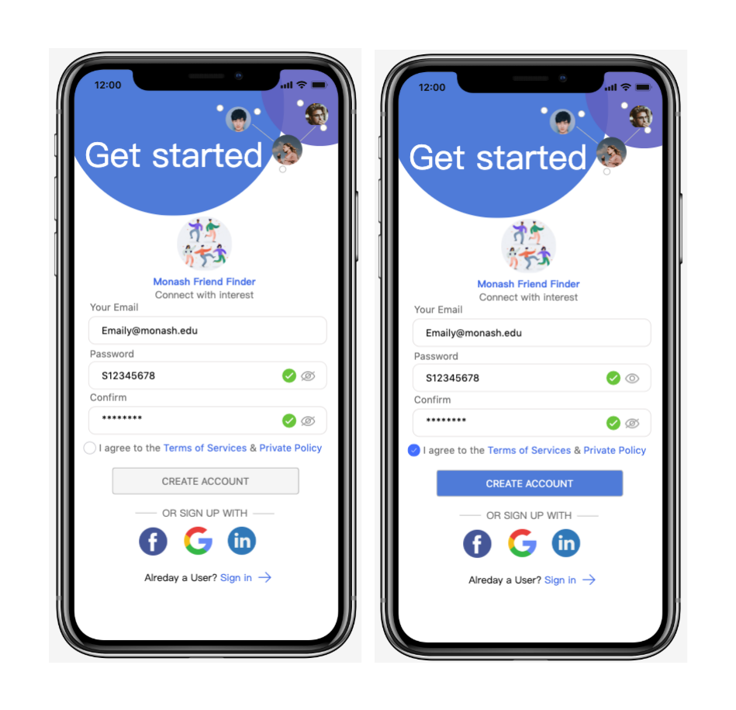

**Figure 3** Sign-up error prevention

### Mobile form guidelines: Provide hint text using the appropriate design pattern

As Figure 4 shows, we provide some hint text inside the text box to inform the user of the form we required. A study demonstrated that inform format restrictions in advance would significantly fewer errors and trials, thus enhancing the user experience of the form interaction (Bargas-Avila et al., 2010). For example, in the password input box, we tell the user the password must 6-12 characters and have at least one letter.

**Figure 4** Sign-up provide hint text

### Mobile accessibility: Robust

One of the guidelines of Mobile accessibility of robust is providing easy methods for data entry. As Figure 4 shows, in the sign-up screen, we offer social sign-in buttons to let users easily connect and create an account. Additional buttons for text input and special function keys contribute to optimizing a significant reduction in the number of clicks and the amount of battery power consumed for a mobile device (Subramanya & Yi, 2006).

### Sign-up form improvement

Improvement 1: Eliminate redundant and less important entries

By comparing the paper-based sign-up form, we eliminate the name input box since this information is not necessary when creating a new account. Instead, we put the name entry requirement to the user profile form, which is more logical and common in a social type application.

Improvement 2: Replace horizontal labelling by vertical labelling

Another improvement in the digital sign-up form is replacing the horizontal labelling by vertical labelling, as Neil (2014) recommended in the mobile form design guidelines. Horizontal labelling isn't as good as vertical, considering horizontal labelling might truncate or cut into the space needed to enter the value, particularly in a mobile application that has limited space.

## **User profile**

### Mobile accessibility considerations related primarily to Principle 3: Understandable

According to Patch, Spellman, and Wahlbin (2015), the system should be designed to provide instructions for users to explain what gestures can be used to control the interface. In this mobile application, users need to complete their profiles after they create a new account. When they first use this function, the system will display a explain page to tell them what gestures they can use and what are the results of these actions. As Figure 5 shows, there are instructions for the three buttons “back”, “skip”, “next”. For example, users can tab the "back" button to go to the home screen. These instructions can help users to understand the operations on the page. Alonso, Fuertes, González, and Martínez (2010) state that the understandable principle is the system should enable users to understand the information and the operation of the user interface.

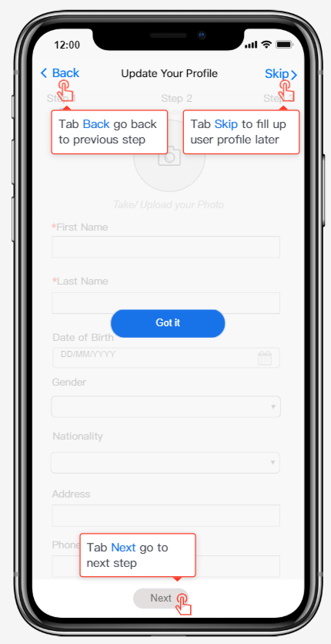

**Figure 5** Instructions

### Mobile Form design guideline: efficient

As Figure 6 shows, users need to fill forms to complete their profiles on this screen. Shneiderman et al. (2016) reports the field labels of the form should be meaningful, familiar and standard for users. The design of these forms improves users to use efficiently. First, they can understand what information they should enter, like "first name", "last name", "date of birth", "gender" and so on. Besides, the icons on the screen are easy for users to understand, like the camera icon, dropdown icon, calendar. Jarrett and Gaffney (2009) suggest systems should be easy for users to enter the answer on the form. For example, on the date of the birth file, users can select a date from the given calendar. Gender and nationality sections will provide users with lists to select from which is easy for users to find answers.

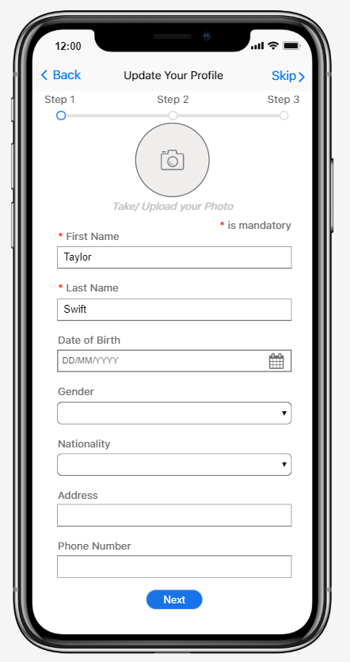

**Figure 6** User profile

### Hick’s law: keep it short and simple

According to Hick (1952), the system should provide fewer choices in the menus to help users to save the decision-making time. In the interesting selecting page (Figure 7), the system will provide some popular options for users. If they want to find more options, they can choose “more” or add new labels by themselves.

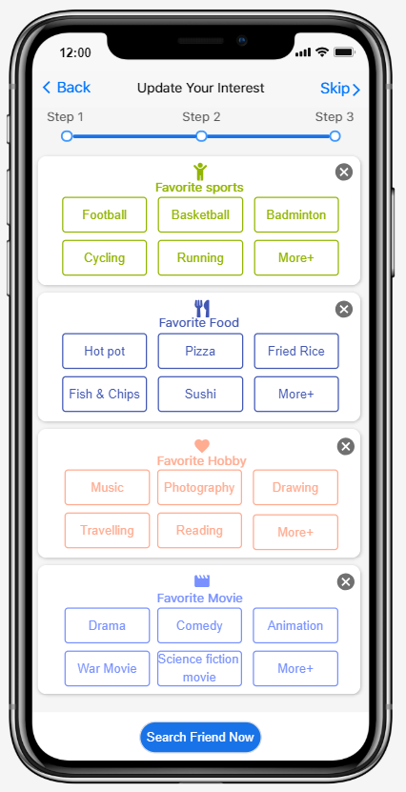

**Figure 7** Interesting

## **Home/ main screen**

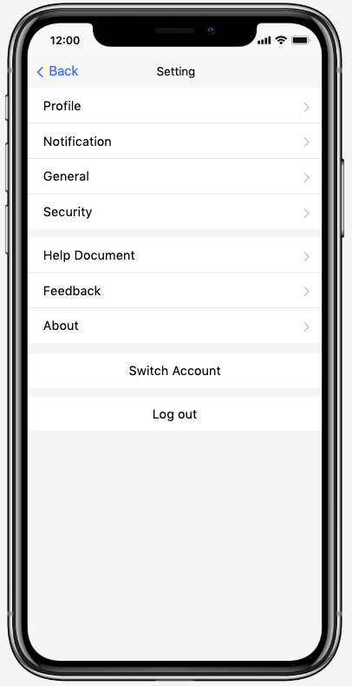

**Figure 8** Home/main screen(left) and Setting screen(right)

### Bottom Navigation Bars

As Figure 8 home/main screen shows, we adopt the bottom tab bar as our primary navigation as the guidelines suggested. Because the bottom tab bar navigation is suitable for 3-5 options of which has the same level of importance. Especially in iOS, tab bars are used to switch between different sections of an app quickly.

### IOS navigation guidelines: Design an information structure that makes it fast and easy to get to the content

In the home screen, we design it as a "personal space" where you can manage your profile, notification, and setting. As the IOS guideline (2019) suggested, we try to use this structure to minimize the number of actions before the user gets what they want. For example, we embedded the matching rate in the new friend request for the user reference and put the accept and decline button along with the request to achieve efficiency.

### IOS navigation guidelines: Use a navigation bar to traverse a hierarchy of data

The user can tap the setting icon in the home screen and jump to the setting screen, as Figure 8 setting screen shows. We use the navigation bar on the top to inform the current position in the hierarchy, and the back button makes it easy to return to the previous location (home screen). As a result, users can easily know where they are and get back to the previous screen.

## **Multi-Criteria Search for friends**

### Shneiderman 8 Golden Rules: reduce short term memory

Shneiderman et al. (2016) report the system should be designed to reduce users’ short-term memory during the operations. For example, on the page of searching for friends, users can touch "filter" to select multiple matching attributes. The selected labels will be highlighted (Figure 10) and display on the page (Figure 9). Users do not need to remember what they have selected when using the system, which improves the usability of the system.

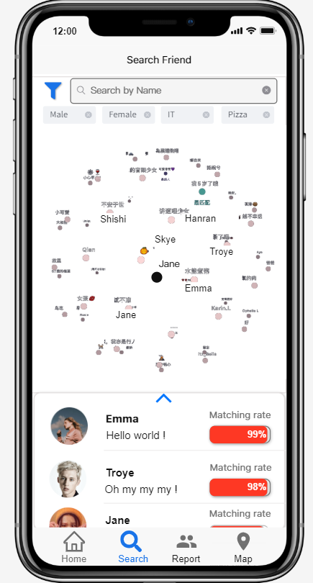

**Figure 9** Searching friends

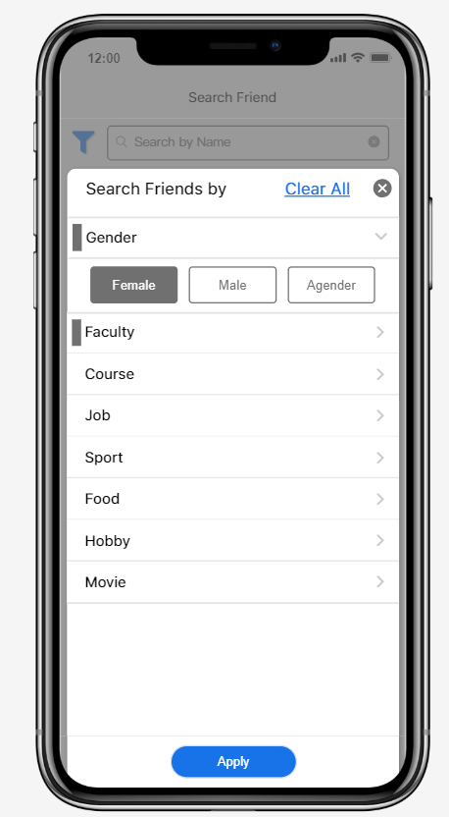

**Figure 10** Accordion menus

### Gestalt Principles: Closure

According to Gestalt Principles, people tend to complete objects that are not complete. We can see from Figure 9, there is a sphere in the middle of the screen. The size of points in the middle is larger while the points near the edge are smaller. Each point stands for a matching friend with the friends' names and all the points form a sphere. Users can rotate the sphere to see the finding result. They can click the name to see the homepage of this friend. This is a creative way to display the findings result. Besides, this way can make the design more engaging and reducing complexity (Jon, 2016, para. 9).

### Mobile accessibility guideline: Grouping operable elements that perform the same action

We design an accordion menu to group the same class together. As Figure 10 shows, there are many different classes, like gender, faculty, course, food, hobby and so on. Users can select matching attributes from different classes. According to Patch, Spellman, and Wahlbin (2015), this design can reduce redundant focus targets making the interface clearer for users to read and control.

### Searching friend page improvement

Based on the paper-based prototype (Figure 2), we made some improvements in the digital prototype (Figure 9):

Improvement 1: Searching bar

The search bar is added to the top which enables users to search for special friends by their names. This function can help users to find their friends faster.

Improvement 2: Matching degree

The matching degree part will be shown in different colours and percentage bars which is easier for users to see the matching degree of the found friends. What is more, these colours are applied in the “map” screen to guarantee consistency.

Improvement 3: Bottom Navigation bar

We change the order of the icons in the bottom navigation bar: the "search" is changed to the second place and friends report is moved to the third. This order will be more logical. Because the "searching friends" function is more important than the report. After users completing their profile, they can use this function to search for friends and add friends. And then, they can see the friends report. Besides, the text of each icon is added under the icon which makes the navigation bar more understandable for users.

## **Reports**

**Figure 11** Report

### Guidelines for menu design

Provide a number of different navigation options for items is one of the menu design guidelines. As Figure 11 shows, we provide search, list menu, and alphabetic sidebar for users to navigate and find a friend. Moreover, we avoid long and complex menu using the pop-up menu to display the detailed matching report. In this way, we empower the user to efficiently choose the navigation method to match their needs and maintain the interface to stay concise and aesthetic.

### Visual design principles: Repetition

Repetition in the visual design refers to use the same colours, fonts, shapes or images to provide consistency. As Figure 11 shows, we use the same structure, fonts, shapes and size for each friend in the friends' list to indicate that they are similar content and at the same level. In this way, we keep the interface consistent and avoid irritating the user by disorganized items.

### Discoverability: Constraints

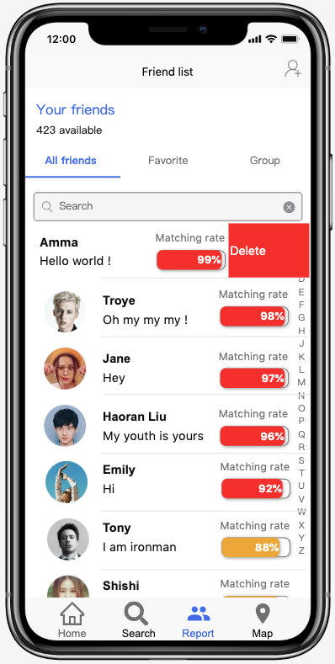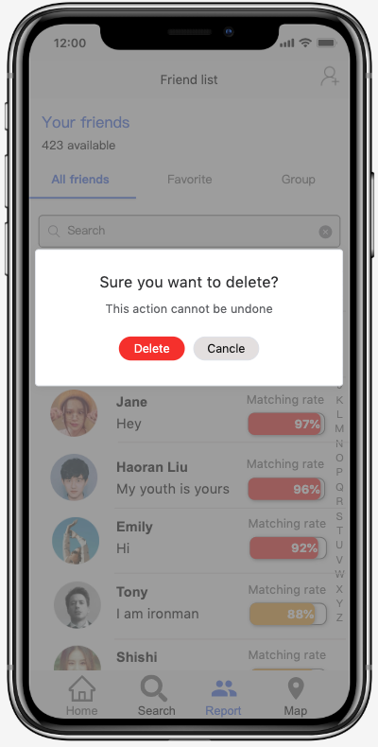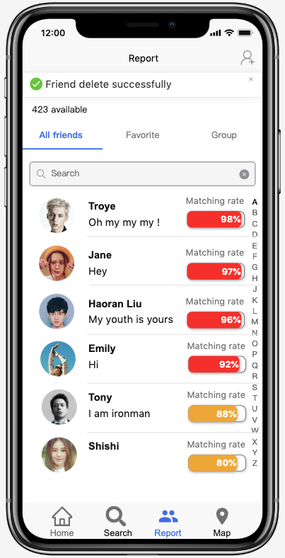

**Figure 12** Delete a friend

As Figure 12 shows, we constrain the delete step to prevent error and provide feedback when the delete option is successful. Gong and Tarasewich (2004) demonstrated that good design should avoid triggering potential harm by too simple options. By requiring the user to confirm delete option, we manage to ensure the user would not delete friends by accident and inform the user what happened by providing feedback.

## **Maps**

### Design guideline for colours

According to the design guideline for colour, the different colours can represent different meanings. In the Figure 13, the location icons in different colours present the different matching degrees of these friends: red is the high matching degree, yellow is medium and green is low. Besides, these colours are the same as the matching degree in the searching friend's lists.

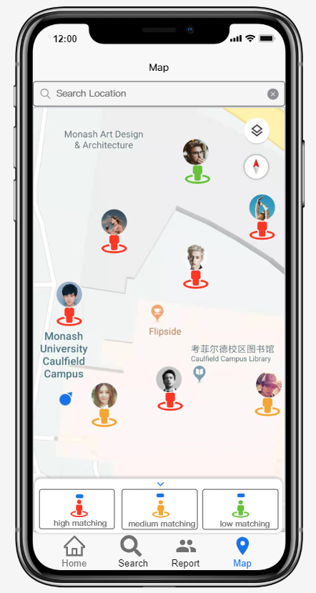

**Figure 13** Different matching degree

### Grouping and Gestalt Laws

Based on the Gestalt laws of grouping, we group colours sections in a hidden menu. Users can click the upward arrow to display the menu and select what kind of matching degree colours to be displayed on the map. As Figure 13 shows, the three legends selections have similar visual properties: select buttons, location icons, and text explanations. This design optimizes the information process approach for users. Because Peterson and Berryhill (2013) report Gestalt principles of grouping can facilitate users' visual working memory performance that is essential for human cognitive processes.

### Search form design: auto-complete

The system can offer auto-complete function in the search form. As Figure 14 shows, the system will provide a set of possible results when users enter text in the search bar. Neil (2014) mentions this function can make the system easier for users to search for relevant results.

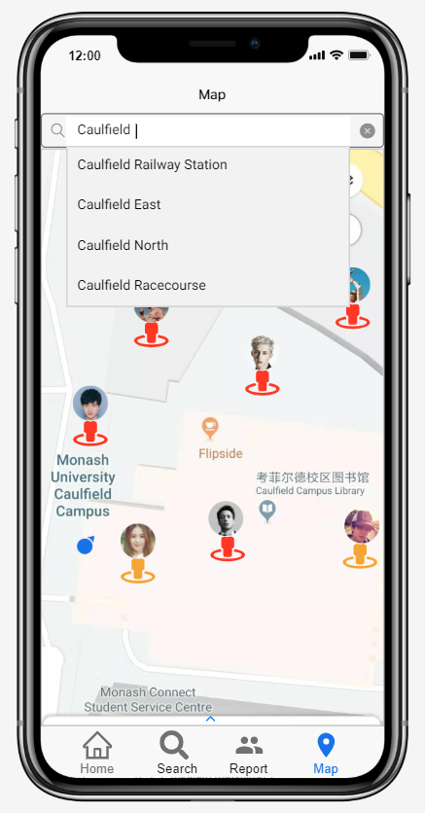

**Figure 14** Searching location

(Word count:2076)

# Reference

Alonso, F., Fuertes, J. L., González, Á. L., & Martínez, L. (2010, April). On the testability of WCAG 2.0 for beginners. In Proceedings of the 2010 International Cross Disciplinary Conference on Web Accessibility (W4A) (p. 9). ACM.

Apple. (2019). IOS Design Themes. Retrieve from: <https://developer.apple.com/design/human-interface-guidelines/ios/overview/themes/>

Bargas-Avila, J. A., Orsini, S., Piosczyk, H., Urwyler, D., & Opwis, K. (2010). Enhancing online forms: Use format specifications for fields with format restrictions to help respondents. *Interacting with Computers*, *23*(1), 33-39.

Gong, J., & Tarasewich, P. (2004, November). Guidelines for handheld mobile device interface design. In *Proceedings of DSI 2004 Annual Meeting* (pp. 3751-3756).

Hick, W. E. (1952). On the Rate of Gain of Information.Quarterly Journal of Experimental Psychology, (4):11-26

Jarrett, C., & Gaffney, G. (2009). Forms that work: Designing Web forms for usability. Morgan Kaufmann.

Jon, H. (2016). Improve Your Designs with The Principles of Closure and Figure-Ground (Part 2). Retrieved from <https://www.smashingmagazine.com/2016/05/improve-your-designs-with-the-principles-of-closure-and-figure-ground-part-2/>

Neil, T. (2014). *Mobile design pattern gallery: UI patterns for smartphone apps*. " O'Reilly Media, Inc.".

Patch, K., Spellman, J., & Wahlbin, K. (2015). Mobile accessibility: how wcag 2.0 and other w3c/wai guidelines apply to mobile. *W3C First Public Working Draft*, *26*.

Peterson, D. J., & Berryhill, M. E. (2013). The Gestalt principle of similarity benefits visual working memory. Psychonomic bulletin & review, 20(6), 1282-1289.

Shneiderman, B., Plaisant, C., Cohen, M., Jacobs, S., Elmqvist, N., & Diakopoulos, N. (2016). Designing the user interface: strategies for effective human-computer interaction. Pearson.

Subramanya, S. R., & Yi, B. K. (2006). User interfaces for mobile content. *Computer*, *39*(4), 85-87.

# Appendix

**Figure 15** Navigation Hierarchy Diagram