翻译内容：4.7.6

# 4.7.6 Intelligence Collection and Analysis Center (Intel CAC)

4.7.6情报收集与分析中心（Intel CAC）

## 4.7.6.1 Intel CAC Overview

4.7.6.1英特尔CAC概述

The Intel CAC is a multi-purpose data correlation, fusion, and processing node. The Intel CAC receives surveillance reports from external sources.

Intel CAC是一个多用途的数据关联、融合和处理节点。Intel CAC接收来自外部来源的监视报告。

As a function of the type of target being tracked and the selected messagegeneration options for the Intel CAC, intelligence reports are generated to perform a variety of functions on the battlefield. These reports can be used as a source of targeting information for attack operations by both surface-to-surface tactical missiles and attack aircraft loaded with air-to-surface weapons. This targeting information supports both initial detection of potential targets as well as Battle Damage Assessment (BDA) of attacked targets. Reports on the potential target locations are either a result of surveillance of the specific ground target or a launch point prediction based on detection of a ballistic missile. These reports can also be used to provide sensor cueing and intelligence-based target prioritization based on detection of both missiles and aircraft.

根据被跟踪目标的类型和英特尔CAC选定的消息生成选项，生成情报报告，以便在战场上执行各种功能。这些报告可作为地对地战术导弹和空对地武器攻击机攻击行动的目标信息来源。这种目标定位信息既支持潜在目标的初始检测，也支持被攻击目标的战斗损伤评估（BDA）。关于潜在目标位置的报告要么是对特定地面目标的监视结果，要么是基于弹道导弹探测的发射点预测结果。这些报告还可用于提供传感器提示和基于导弹和飞机探测的基于情报的目标优先排序。

The Early Warning Data Processing Center (EWDPC) is modeled as an extension to the Intel CAC ruleset capability. The EWDPC was developed to emulate the remote, generally ground-based data-processing capabilities of assets used to perform the data processing of missile detection data gathered by earlywarning sensors. The functions emulated include track handling, multi-sensor correlation, and message handling. The EWDPC works as a ground or airborne system with either ground or airborne sensors. It operates most naturally as a ground system with airborne or satellite-based sensors. Early-warning messages include a launch-point detection message and a burnout message. Additional capability to provide ongoing track error messages through midcourse is also available. These messages can be optionally turned on or off through the Intel CAC ruleset window

预警数据处理中心（EWDPC）被建模为“英特尔CAC规则集”功能的扩展。EWDPC的开发是为了模拟远程的、通常是基于地面的数据处理能力，这些数据处理能力用于对早期预警传感器收集的导弹探测数据进行数据处理。仿真功能包括航迹处理、多传感器关联和消息处理。EWDPC作为地面或机载系统，带有地面或机载传感器。它作为一个带有机载或卫星传感器的地面系统运行最为自然。预警消息包括启动点检测消息和烧毁消息。此外，还提供了通过中段提供持续跟踪错误消息的附加功能。可以通过“英特尔CAC规则集”窗口选择打开或关闭这些消息

Early-warning sensors should be deployed and networked together with the EWDPC. When an early-warning sensor detects a missile launch, the data are sent to the EWDPC for processing. This processing includes determining if this is a new report, in which case a new track is established, or if the report belongs to a track that has already been established. Reports generated by multiple sensors are correlated and merged with the tracks for which they belong. Early-warning messages will be sent based on what has been selected through the ruleset window. Detailed explanation of all the messages follow.

预警传感器应与EWDPC一起部署和联网。当预警传感器检测到导弹发射时，数据被发送到EWDPC进行处理。该处理包括确定这是一个新报告，在这种情况下建立了一个新的跟踪，或者该报告是否属于已经建立的跟踪。由多个传感器生成的报告与它们所属的轨迹相关联并合并。将根据通过规则集窗口选择的内容发送早期警告消息。所有信息的详细解释如下。

## 4.7.6.2 Intel CAC Received Message Processing

4.7.6.2 Intel CAC接收消息处理

The Intel CAC processes received track information on all types of targets. When an Intel CAC receives a surveillance report, it first determines if the target is a system, missile or class of interest. The Intel CAC can ptionally base this decision on either truth or perceived target class as described in section 4.6.10. Targets of interest are selected by the user on the Classes of Interest listbox on the Intel CAC ruleset window. Next the Intel CAC determines if the data is older than the time window specified in the ruleset definition. If so, the data is not used. Targets that are determined to be of interest to the Intel CAC and pass the time window checks are placed in the Intel CAC track file and are subjected to further track processing. Intel CAC tracks are processed using the track processing methodology described in section 4.6.

“英特尔CAC”进程接收所有类型目标的跟踪信息。当英特尔CAC收到监视报告时，它首先确定目标是系统、导弹还是感兴趣的类别。“英特尔CAC”可以根据第4.6.10节所述的事实或感知的目标类来选择此决定。用户在“英特尔CAC规则集”窗口的“感兴趣的类”列表框中选择感兴趣的目标。接下来，“英特尔CAC”确定数据是否早于规则集定义中指定的时间窗口。如果是，则不使用数据。确定为“英特尔CAC”感兴趣并通过时间窗口检查的目标被放置在“英特尔CAC”轨迹文件中，并接受进一步的轨迹处理。英特尔CAC磁道使用第4.6节中描述的磁道处理方法进行处理。

### 4.7.6.2.1 Intel CAC Image Processing

4.7.6.2.1英特尔CAC图像处理

The Intel CAC can receive image data from an AGAttacker with imaging capability. The data can be received as processed or non-processed. If already processed, the information is received as standard track data and will be processed as standard track data. If the image has not yet been processed, then the track information that can be derived from the image will be processed individually after the delay time specified for the processing time for image data on the communications options for the ruleset.

Intel CAC可以从具有成像功能的AGAttacker接收图像数据。数据可以作为已处理或未处理的数据接收。如果已经处理，则信息作为标准轨道数据接收，并将作为标准轨道数据处理。如果图像尚未被处理，则在为规则集的通信选项上的图像数据的处理时间指定的延迟时间之后，可以从图像导出的轨迹信息将被单独处理。

If the received image data is from an AGAttacker that is imaging an installation and the Intel CAC is set to send the Installation Message, the image is stored as a collection of images for each installation and imaging platform pair. When an image is received that is marked as the last image for an installation, a delay timer then starts which models the effect of processing the images to form an initial interpretation of the images. When the timer expires, the collection of images is sent out in an Installation Message on Intel capable networks.

如果接收到的映像数据来自正在对安装进行映像的AGAttacker，并且Intel CAC被设置为发送安装消息，则映像将存储为每个安装和映像平台对的映像集合。当接收到标记为用于安装的最后一个图像的图像时，延迟定时器随后启动，其对处理图像的效果进行建模以形成对图像的初始解释。计时器过期时，映像集合将在支持Intel的网络上以安装消息的形式发出。

### 4.7.6.2.2 Surveillance Report Forwarding

4.7.6.2.2监督报告转发

If selected, the Intel CAC will forward data as a surveillance report if an intelligence report is not generated from the information. This option is controlled by the Forward Surveillance Tracks option on the Intel CAC ruleset definition.

如果选中此选项，如果情报报告不是由情报报告生成的，则Intel CAC会将数据作为监视报告转发。此选项由“英特尔CAC”规则集定义上的“前向监视轨迹”选项控制。

### 4.7.6.2.3 Intelligence Report Generation

4.7.6.2.3情报报告生成

Each time non-intel track data is received on a target, the Intel CAC determines if the number of sources, number of updates, and time-interval criteria have been met. If so, a random draw from a uniform distribution will be compared with the Intel CAC's probability of correlation. If the draw is above the correlation probability, no action is taken. The criteria are checked again when more data are received. If the draw is below the probability of correlation, then the Intel CAC is marked as having achieved target identification on this target. With randomness eliminated, target identification will always be achieved.

每次在目标上接收到非英特尔跟踪数据时，“英特尔CAC”都会确定是否满足源数、更新数和时间间隔标准。如果是这样，则从均匀分布中随机抽取的数据将与Intel CAC的相关概率进行比较。如果抽签高于相关概率，则不采取任何行动。当接收到更多数据时，将再次检查标准。如果提取低于相关概率，则Intel CAC被标记为已在此目标上实现目标识别。在消除随机性的情况下，目标识别总是能够实现的。

When an Intel CAC receives a track message that is marked as an intel message, then the message is immediately processed and an intelligence report is generated with no checks on the number of sources, updates, time-interval criteria, or correlation probability. The message is delayed by the amount of time specified on the Track Data Message Processing Time field on the Communication Options window of the Intelligence Center ruleset window.

“英特尔CAC”收到标记为“英特尔消息”的跟踪消息时，将立即处理该消息，并生成情报报告，而不检查源数、更新、时间间隔标准或相关概率。消息延迟的时间量在情报中心规则集窗口的“通信选项”窗口的“跟踪数据消息处理时间”字段中指定。

The Intel CAC generates a report based on whether the received track is the first track on a target or is an update to a track already in the Intelligence Center track file. If the track is the first report received on a target, then the track message is delayed by the amount of time specified on the Track Data Message Processing Time field on the Communication Options window of the Intelligence Center ruleset window and then sent out. Subsequent intelligence reports on a track are sent out at the Track Message delay time past the running of the trackreporting phase if new track information has been received. The track-reporting phase for each Intelligence Center starts at 12 seconds simulation time and repeats at the time specified in the Update Interval field of the Intelligence Message Window off the Intel window for the Intelligence Center ruleset.

“英特尔CAC”会根据接收到的磁道是目标上的第一个磁道还是对情报中心磁道文件中已有磁道的更新生成报告。如果跟踪是在目标上接收到的第一个报告，则跟踪消息将延迟情报中心规则集窗口的“通信选项”窗口的“跟踪数据消息处理时间”字段中指定的时间量，然后发送出去。如果接收到新的轨道信息，则轨道上的后续情报报告将在超过轨道报告阶段运行的轨道消息延迟时间发出。每个情报中心的跟踪报告阶段从12秒模拟时间开始，并在情报中心规则集的“英特尔”窗口的“情报消息”窗口的“更新间隔”字段中指定的时间重复。

A Level of Intelligence Data (LID) is assigned to each intelligence report. This LID is a single value from 0 to 9 representing the type of information reported from this center. If the LID is set to 0, the track information is considered to be a standard surveillance message and is not flagged as intelligence data. For values from 1 to 9, the track information is flagged as intelligence data. The LID is used in the SAM systems for the intelligence-based target prioritization, as described in Appendix B4.

为每个情报报告分配一级情报数据（LID）。此LID是0到9之间的单个值，表示从该中心报告的信息类型。如果LID设置为0，则跟踪信息将被视为标准监视消息，不会标记为情报数据。对于从1到9的值，轨迹信息被标记为情报数据。LID在SAM系统中用于基于情报的目标优先级排序，如附录B4所述。

Each message is also assigned a DFD rating, which is a measure of the quality of the information. The number of sources contributing data to the track will be used to determine the DFD rating applied to the target track. This is accomplished through a user-defined table of DFD ratings as a function of number of sources contributing to the track. This enables the user to emulate, through the improved DFD, the track improvement yielded by multiple sensor coverage of a target. These DFD ratings are subsequently used either for sensor cuing or for decisions within the ground-attack operations.

每个消息还被分配一个DFD等级，这是对信息质量的度量。向航迹提供数据的源数将用于确定应用于目标航迹的DFD等级。这是通过一个用户定义的DFD等级表来实现的，该表是对轨道有贡献的震源数量的函数。这使得用户能够通过改进的DFD模拟目标的多传感器覆盖所产生的跟踪改进。这些DFD等级随后用于传感器线索或地面攻击行动中的决策。

The Intel CAC can also be used to produce TSIU_RECON and TSIU_TACREP messages in DIS Signal PDU’s when an Intelligence report is generated. If the received track message is a grouped track, then each platform within the group is treated independently in counting the units and echelons. See section MM 11.2.7 for more information.

Intel CAC还可用于在生成情报报告时，在DIS信号PDU中生成TSIUèU RECON和TSIUèU TACREP消息。如果接收到的轨道消息是分组轨道，则在计算单元和梯队时，组内的每个平台都被独立地处理。更多信息见第11.2.7节。

The Intel CAC can also be used to produce Tactical.Recon and Tactical.TACREP HLA interactions when an Intelligence report is generated. If the received track message is a grouped track, then each platform within the group is treated independently in counting the units and echelons. See section MM 11.10.4.4 for more information.

Intel CAC也可用于生产战术侦察以及战术.TACREP生成情报报告时的HLA交互。如果接收到的轨道消息是分组轨道，则在计算单元和梯队时，组内的每个平台都被独立地处理。详见MM 11.10.4.4节。

#### 4.7.6.2.3.1Track State Processing

4.7.6.2.3.1跟踪状态处理

The Intelligence Center has several ways of determining the final position, velocity, and related information that is generated in the intelligence report. The reported information can be based on the most recent track data or the most accurate errored track information, or the reported information can be determined by fusing the errored information from several sources. Errored data are required in the latter two cases. If no errored information is available, the default methodology is to base all state information on time (i.e., most recent). If the state information is based on accuracy (i.e., least errored) the track position with the least amount of positional error is reported in the intelligence message. The velocity is taken from the most recent measured target velocity. The NCTR identification and confidence rating is taken from the source with the best confidence rating. If the state information is developed through fusion of track data, the reported position is computed using an error ellipse intersection algorithm. The velocity is taken from the most recent measured target velocity. The NCTR identification and confidence rating is taken from the source with the best confidence rating. When the state data are determined by the fusion process, only the two best tracks are considered, since including further tracks does not substantially improve the reported state information.

情报中心有几种方法来确定情报报告中生成的最终位置、速度和相关信息。报告的信息可以基于最新的航迹数据或最准确的错误航迹信息，也可以通过融合多个来源的错误信息来确定报告的信息。后两种情况需要错误的数据。如果没有错误信息可用，则默认方法是基于所有状态信息（即最近的）。如果状态信息基于精度（即最小误差），则在情报消息中报告位置误差最小的航迹位置。速度取自最近测量的目标速度。NCTR识别和置信度评级取自具有最佳置信度评级的来源。如果状态信息是通过航迹数据融合得到的，则采用误差椭圆求交算法来计算报告的位置。速度取自最近测量的目标速度。NCTR识别和置信度评级取自具有最佳置信度评级的来源。当通过融合过程确定状态数据时，仅考虑两个最佳轨迹，因为包括进一步的轨迹不会实质性地改进所报告的状态信息。

#### 4.7.6.2.3.2Track Fusion

4.7.6.2.3.2轨道融合

Track fusion is the process by which two individual tracks are combined to yield a track with improved accuracy and confidence. Classically, this is performed by taking the covariance information for both tracks and fusing the covariances together to get the intersection of the error volumes. Since covariance information is not computed in EADSIM, the track fusion is based on the error ellipses generating the track and is described below.

航迹融合是将两条单独的航迹合并，得到一条精度和置信度都有所提高的航迹的过程。经典地，这是通过获取两个轨迹的协方差信息并将协方差融合在一起以获得误差体积的交集来执行的。由于在EADSIM中不计算协方差信息，因此轨迹融合基于生成轨迹的误差椭圆，如下所述。

Figure 4.7.6-1 illustrates a typical tracking geometry. The ellipses shown are projections of the tracking error covariance into the ground plane. The illustration is typical of a sensor with poor range data and very good angular error, where the majority of the error is directed along the sensor-to-target line of sight or downrange. The projection of the error ellipse into the ground plane and its associated reduction as a function of the number of track updates is what is captured with this capability.

图4.7.6-1说明了典型的跟踪几何结构。显示的椭圆是跟踪误差协方差到地平面的投影。该图是典型的传感器，具有较差的距离数据和非常好的角度误差，其中大部分误差沿传感器指向目标视线或下射程。误差椭圆在地平面上的投影及其与轨道更新次数相关的减少量就是利用这种能力捕获的。

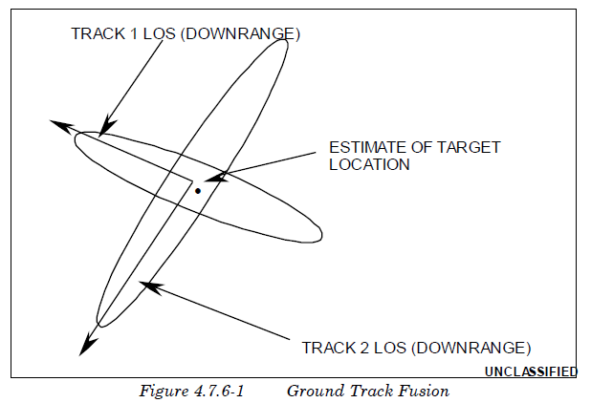  
 If more than two sources are reporting track data on a target, the fusion process determines the two most accurate tracks for fusing. The associated downrange and crossrange errors of each respective track along with the orientation of the ellipse are then used to determine the intersection of the ellipses. The resultant error in downrange and crossrange of the intersection is defined as the fused error and is used as a one-sigma standard deviation value in determining the amount of error applied to the track. In performing track fusion, zero mean (bias) error is assumed.

如果有两个以上的源报告目标上的轨迹数据，则融合过程将确定两个最精确的轨迹进行融合。然后利用每个轨道的相关下程和交叉程误差以及椭圆的方向来确定椭圆的交点。交叉口下向和横向的合成误差被定义为融合误差，并用作确定应用于轨道的误差量的一西格玛标准偏差值。在进行航迹融合时，假设平均（偏差）误差为零。

#### 4.7.6.2.3.3Track Triangulation

4.7.6.2.3.3轨道三角测量

If the Intel CAC has been configured to generate intelligence messages, an indication of triangulation of jamming strobes associated with a particular track can be included as part of the intelligence message. The Intel CAC is capable of triangulating jamming strobes received from various reporting sources. When the number of sources reporting on a track is greater than the required number of sources and other considerations described in Subsection 4.7.6.2.3 are met, the Intel CAC creates an intelligence report on the track. The positional and DFD information are taken from the sources and included in the message. Similarly, sources that include jamming strobes for the target are used in determining whether the track can be triangulated. The positional information from the sources is compared two by two until all sources have been compared or the angular resolution required between reporting sources has been met by one pair of sources. Once the track is determined to be triangulated, this information is included in the intelligence report. The algorithm used in determining triangulation is described in Subsection 4.6.2.3.

如果已将Intel CAC配置为生成情报消息，则与特定磁道相关联的干扰频闪的三角测量指示可作为情报消息的一部分。Intel CAC能够对从各种报告源接收到的干扰频闪进行三角测量。当一条磁道上报告的震源数大于所需的震源数且满足第4.7.6.2.3小节中所述的其他注意事项时，“英特尔CAC”将在该磁道上创建一份情报报告。位置和DFD信息从源中获取并包含在消息中。类似地，包括对目标的干扰频闪的源用于确定轨迹是否可以三角化。两个源的位置信息进行比较，直到所有源都进行了比较，或者一对源满足了报告源之间所需的角度分辨率。一旦确定轨道是三角的，情报报告中就会包含这些信息。第4.6.2.3小节描述了用于确定三角测量的算法。

### 4.7.6.2.4 Launch-Point Message Generation

4.7.6.2.4发射点消息生成

After track has been established on a missile target, a launch-point message can optionally be scheduled for the track. Mean and sigma time values can be defined through the user interface that enable the user to randomly vary the time at which the message will be scheduled. The time used to vary the launch-point message is relative to the report time of the initial data being received. The mean of the variation for the launch-point message time should be sufficient to account for the reception of the required number of updates for establishing target track. The sigma value models randomness in the processing delays at the EWDPC. If randomness is eliminated, the launch point message will be scheduled at the specified mean time.

在导弹目标上建立跟踪后，可以选择为跟踪安排发射点消息。可以通过用户界面定义平均值和sigma时间值，使用户可以随机改变消息的调度时间。用于改变启动点消息的时间与接收到的初始数据的报告时间有关。发射点信息时间变化的平均值应足以说明为建立目标轨迹所需更新次数的接收情况。sigma值对EWDPC处理延迟的随机性进行建模。如果消除了随机性，则将在指定的平均时间安排发送点消息。

At the time the message is to be sent, the track file is reevaluated to determine the number of updates the track has received since initial detection, as well as the number of independent sources contributing data on the target. The number of sources contributing data to the track are used to determine a measure of quality for the track and subsequent launch-point position. This is accomplished by means of a user-defined table of DFD ratings as a function of the number of sources contributing to the track. This enables the user to emulate, through the improved DFD, the track improvement yielded by multiple sensor coverage of a target. Alternatively, if track error is selected, EADSIM attempts to match the current track with a user-specified list of missile target types. The entry for each missile type contains the one-sigma down-range and cross-range position errors at the time of missile launch. This implicitly represents the error generated by a viewing sensor in the direction of the target trajectory.

在要发送消息时，重新评估跟踪文件以确定自初始检测以来跟踪已接收的更新的数目，以及在目标上贡献数据的独立源的数目。向轨道提供数据的源的数量用于确定轨道和后续发射点位置的质量度量。这是通过一个用户定义的DFD等级表来实现的，该表是对轨道有贡献的震源数量的函数。这使得用户能够通过改进的DFD模拟目标的多传感器覆盖所产生的跟踪改进。或者，如果选择了跟踪错误，EADSIM将尝试将当前跟踪与用户指定的导弹目标类型列表相匹配。每种导弹类型的条目包含导弹发射时的一西格玛下射程和交叉射程位置误差。这隐式地表示由观察传感器在目标轨迹方向上产生的误差。

This improved track data and launch-point prediction is used by ground attack operations in scheduling aircraft for search and engagement of hostile missile launch sites. The message contains typical intelligence message data with the addition of the launch ID, launch position, and improved DFD rating.

这种改进的航迹数据和发射点预测可用于地面攻击行动，用于安排飞机搜索和攻击敌方导弹发射场。消息包含典型的情报消息数据，添加了发射ID、发射位置和改进的DFD等级。

The launch-point prediction uses the down-range and cross-range values to apply an errored position to ground tracks. Figure 4.7.6-2 displays the errored position computed by the algorithm described below.

发射点预测使用向下距离和横向距离值将错误位置应用于地面轨迹。图4.7.6-2显示了由下述算法计算的错误位置。

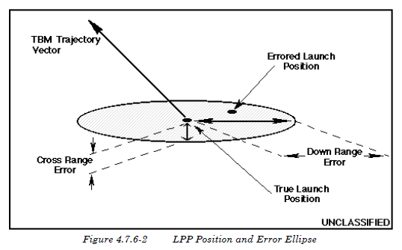

First, a unit vector in the direction of the cross-range of the TBM trajectory is established at the launch position.

首先，在发射位置建立TBM弹道横距方向的单位矢量。

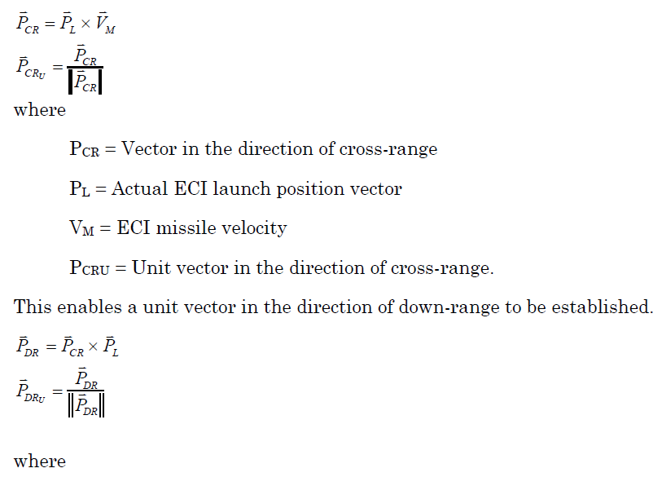

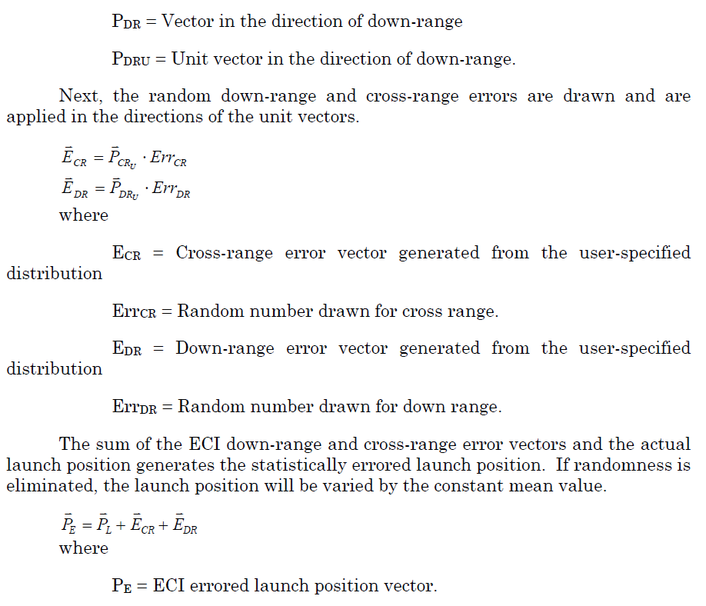

### 4.7.6.2.5 Burnout Message Generation

4.7.6.2.5烧毁信息生成

The burnout message is handled in a very similar manner to the launch point message. As soon as a track is created on a target, the process by which a message will be sent is scheduled at the final-stage burnout time. When this time is reached in the simulation, the message is generated and processing delays are added to the time. These processing delays are computed using a random draw from a userdefined distribution. If randomness is eliminated, the value entered for the mean is used as the processing delay. The delay is meant to model the time needed for recognition of burnout.

burnout消息的处理方式与launch point消息非常相似。一旦在目标上创建了跟踪，发送消息的过程就被安排在最后阶段的耗尽时间。当在模拟中达到该时间时，将生成消息并将处理延迟添加到时间中。这些处理延迟是使用用户定义分布的随机抽取来计算的。如果消除了随机性，则输入的平均值用作处理延迟。延迟是为了模拟识别倦怠所需的时间。

#### 4.7.6.2.5.1Burnout Track Data

4.7.6.2.5.1烧毁轨道数据

Two options are available for specifying the quality associated with the target track at missile burnout: DFD and a user-defined error sigma in each coordinate axis. If the DFD option is selected, the number of sources contributing to the track is determined at the time the message is to be sent and the DFD is determined in the same fashion as the launch-point message. If track error is selected, EADSIM attempts to match the current track with a user-specified list of missile target types. The entry for each missile type contains the one-sigma error variance data for both position and velocity at the final burnout of the missile. The one-sigma errors of position and velocity components are entered in a coordinate system defined with respect to the velocity of the missile being tracked and then transformed to Earth Centered Inertial (ECI) coordinates for reporting.

有两个选项可用于指定导弹烧毁时与目标轨迹相关的质量：DFD和每个坐标轴上用户定义的误差sigma。如果选择了DFD选项，则在发送消息时确定参与跟踪的源的数量，并且以与发射点消息相同的方式确定DFD。如果选择跟踪错误，EADSIM将尝试将当前跟踪与用户指定的导弹目标类型列表相匹配。每种导弹类型的条目都包含导弹最终烧毁时位置和速度的一西格玛误差方差数据。位置和速度分量的一西格玛误差输入到一个坐标系中，该坐标系与被跟踪导弹的速度有关，然后转换为地心惯性（ECI）坐标进行报告。

The burnout message contains typical intelligence message data as well as the DFD and/or missile track covariance in ECI coordinates. The improvement in the track data yielded by receipt of a burnout message will aid in sensor cueing at greater ranges due to reduced search volumes obtained from the improved target positional data. In addition, the burnout announcement is accompanied by an impact-point prediction as described in the section on Intel CAC Impact-Point Predictions.

烧毁信息包含典型的情报信息数据，以及在ECI坐标中的DFD和/或导弹轨迹协方差。由于从改进的目标位置数据获得的搜索量减少，接收到烧毁信息产生的轨迹数据的改进将有助于在更大范围内的传感器提示。此外，burnout公告还附带了“英特尔CAC撞击点预测”一节中所述的撞击点预测。

#### 4.7.6.2.5.2Intel Center Impact-Point Prediction

4.7.6.2.5.2整体中心落点预测

The Intelligence Center creates impact-point predictions based upon burnout and midcourse track message generation. The impact point is predicted using the selected trajectory prediction algorithm as described in Appendix B5. An uncertainty error ellipse is generated for the position as described in section Appendix B5.7 and sent in the IPP message.

情报中心根据倦怠和中途轨迹信息生成创建撞击点预测。使用附录B5中所述的选定轨迹预测算法预测撞击点。如附录B5.7所述，为位置生成不确定误差椭圆，并在IPP消息中发送。

### 4.7.6.2.6 Midcourse Track Message Generation

4.7.6.2.6中间轨道信息生成

The midcourse track messaging option generates track position and velocity updates for ballistic missiles at specified update intervals. These messages include errors based on either DFD ratings and/or track error data. The track error for the respective track may be either DFD, track error, or both, depending on the userselected options and the data that have been defined. In addition, the midcourse track message is accompanied by an impact-point prediction as described in Subsection 4.7.6.2.5.2.

中段航迹消息选项按指定的更新间隔为弹道导弹生成航迹位置和速度更新。这些消息包括基于DFD等级和/或跟踪错误数据的错误。各个磁道的磁道误差可以是DFD、磁道误差或两者，这取决于用户选择的选项和已定义的数据。此外，如第4.7.6.2.5.2小节所述，中段航迹信息附有撞击点预测。

The DFD methodology is performed in the same fashion as that in the launch-point and burnout messages. The number of sources contributing to the track is computed at the time the message is to be sent, and the DFD is selected from the user-defined table based on the number of contributing sources. A default update interval is also included to specify at what rate the data messages are to be sent.

DFD方法的执行方式与启动点和燃尽消息中的方式相同。在要发送消息时，计算参与跟踪的源的数目，并且基于参与源的数目从用户定义的表中选择DFD。还包括一个默认的更新间隔，以指定数据消息的发送速率。

The track error methodology compares the current track with a user-specified list of missile target types. Each target type contains an associated table of track load, data messaging rate (update interval), and error data parameters. The message update interval and associated track error for the target type being evaluated will be selected based on the number of tracks currently being processed by the Intel CAC. This allows the user to model a decreased rate at which messages can be generated due to an increased number of tracks being processed by the Intel CAC.

跟踪误差方法将当前跟踪与用户指定的导弹目标类型列表进行比较。每种目标类型都包含一个与跟踪负载、数据消息传递速率（更新间隔）和错误数据参数相关联的表。将根据“英特尔CAC”当前正在处理的磁道数选择要评估的目标类型的消息更新间隔和相关磁道错误。这允许用户对由于“英特尔CAC”处理的磁道数增加而导致的消息生成速率降低进行建模。

Track error data may be specified in two formats: tabular or curve fit. Tabular error data represent one-sigma error variances as a function of time since missile burnout. The variances are specified for both position and velocity in missile body-centered coordinates. The time the message is to be generated is computed and the data in each coordinated axis are interpolated from the tables for that time. The interpolated error variances are then used to define the track covariance.

轨迹误差数据可以用两种格式指定：表格格式或曲线拟合。表格误差数据表示一西格玛误差方差作为导弹烧毁后时间的函数。在以弹体为中心的坐标系中，对位置和速度的方差进行了规定。将计算生成消息的时间，并从该时间的表中插入每个坐标轴中的数据。然后使用插值误差方差来定义轨迹协方差。

The curve fit format represents the coefficients of an exponential function that define the missile position and velocity errors for a specified period of time. The curve-fit-error coefficients are used to compute the missile track variance as a function of time since missile burnout based on the formula:

曲线拟合格式表示指数函数的系数，指数函数定义了指定时间段内导弹的位置和速度误差。曲线拟合误差系数用于计算导弹航迹方差，作为导弹烧毁后时间的函数，公式如下：

  
 The curve-fit segment is chosen whose data start/end-time interval bounds the elapsed time from missile final burnout. The track covariance is then transformed into ECI coordinates for reporting.

选择曲线拟合段，其数据开始/结束时间间隔限定了导弹最终烧毁所经过的时间。然后将轨迹协方差转换为ECI坐标进行报告。

The midcourse track messages will begin at the user-defined message start time, which is defined relative to missile burnout, provided the track error data have been specified for the proper targets or the DFD versus number of reporting sources have been defined. The messages will continue to be sent at the defined update interval for the duration of the target’s track as long as the missile is still alive. When the time since missile burnout exceeds the time entries in the userdefined data tables or the end time of the final curve fit segment, the track is assumed to have achieved steady state and the last table entry or last curve fit segment is used for defining the covariance for the remainder of the track messages.

中段航迹信息将从用户定义的信息开始时间开始，该时间是相对于导弹烧毁而定义的，前提是已为适当的目标指定了航迹误差数据，或已定义了DFD与报告源数量的关系。只要导弹还活着，在目标跟踪期间，这些信息将继续以规定的更新间隔发送。当导弹燃尽后的时间超过用户定义的数据表中的时间项或最终曲线拟合段的结束时间时，假设航迹已达到稳定状态，最后一个表项或最后一个曲线拟合段用于定义剩余航迹信息的协方差。

The improvement in the track covariance as a function of time since missile burnout and/or DFD yielded by multi-sensor coverage will aid in sensor cueing at greater ranges due to reduced search volumes obtained from the improved target positional uncertainty.

由于改进的目标位置不确定性减少了搜索量，多传感器覆盖产生的导弹烧毁和/或DFD后，随着时间的推移，航迹协方差的改善将有助于在更大范围内提供传感器提示。

### 4.7.6.2.7 Battle Damage Assessment

4.7.6.2.7战斗损伤评估

Battle Damage Assessment (BDA) is an automatic capability driven by a target being attacked. BDA is the determination of a target as being dead or alive. Accuracy of assessment is modeled as a probability draw to determine if a dead target is assessed as dead or an alive target as alive based on the target type and the confidence level of the data. If the Intel CAC has track on a target that is attacked, it will attempt to perform BDA, provided that the current time is between the maximum and minimum times for BDA, as input by the user. If the Intel CAC has updated the track within this window, and the track has a confidence level greater than the specified minimum, then BDA is performed. If the data are of insufficient confidence level, the track was not updated within this window, or the current time is not within this window, the Intel CAC requests that a Ground Attacker Commander or a ground-capable Flexible Commander send an AGAttacker to survey the target.

战斗损伤评估（BDA）是一种由被攻击目标驱动的自动能力。BDA是确定目标是死的还是活的。评估的准确性被建模为概率图，以根据目标类型和数据的置信水平来确定是将死目标评估为死目标还是将活目标评估为活目标。如果Intel CAC跟踪到被攻击的目标，它将尝试执行BDA，前提是用户输入的当前时间介于BDA的最大和最小时间之间。如果“英特尔CAC”在此窗口内更新了磁道，并且磁道的置信度大于指定的最小值，则执行BDA。如果数据的置信度不足，轨迹未在此窗口内更新，或者当前时间不在此窗口内，则“英特尔CAC”会请求地面攻击者指挥官或地面灵活指挥官发送攻击机来调查目标。

### 4.7.6.2.8 Flash Message Generation

4.7.6.2.8 Flash消息生成

After a flash track has been received from a sensor, the Intel CAC ruleset has the capability to add a time delay to the flash message. This delay is calculated from the user specified mean and sigma time using a user-specified distribution. Both the mean and sigma are in seconds. If randomness is eliminated, the mean value is used as the delay

从传感器接收到闪光轨迹后，“英特尔CAC”规则集可以向闪光消息添加时间延迟。使用用户指定的分布，从用户指定的平均值和西格玛时间计算延迟。平均值和西格玛都是以秒为单位的。如果消除了随机性，则使用平均值作为延迟

The Intel CAC also has the ability to add track location error to the flash message based upon the target type. It is two sided; one error is true Northing, while the other is true Easting. This error is calculated with a random number draw from a user-defined distribution. If randomness is eliminated, values entered for mean are used for the Northing and Easting track location errors.

Intel CAC还能够根据目标类型向flash消息中添加跟踪位置错误。它是双面的；一个错误是真北距，而另一个是真东距。这个误差是通过从用户定义的分布中抽取一个随机数来计算的。如果消除了随机性，输入的平均值将用于北距和东距轨道位置误差。

The Intel CAC will only add error to the flash location if Track Error is selected on the Flash Message window and the flash track matches one of the userspecified target types. The potentially errored flash message is then transmitted on any of the intel center’s networks based on when the flash message was received by the intel center plus any delay specified by the user.

“英特尔CAC”只会在“闪存消息”窗口中选择“跟踪错误”且“闪存跟踪”与用户指定的目标类型之一匹配时，将错误添加到闪存位置。然后，根据intel center接收到闪存消息的时间加上用户指定的任何延迟，在intel center的任何网络上传输可能出错的闪存消息。

### 4.7.6.2.9 Intel CAC Commanded Track Update

4.7.6.2.9英特尔CAC指令磁道更新

The Intel CAC requests a commanded track update from a Ground Attacker Commander when a BDA request is received for a track number unknown to the Intel CAC. The commanded track update message contains the track data for the requested track number as well as the data contained in the previous command on the track. When the Intel CAC receives the update message, it first processes the track information into its track file. The track data processing is detailed in Section 4.6. Once the track data has been processed, the platform then processes the original command message for which this track was requested.

当接收到针对“英特尔CAC”未知的航迹号的BDA请求时，“英特尔CAC”请求地面攻击者指挥官进行命令航迹更新。指令航迹更新信息包含请求航迹号的航迹数据以及航迹上的上一个指令中包含的数据。“英特尔CAC”收到更新消息后，首先将磁道信息处理到其磁道文件中。轨道数据处理详见4.6节。处理完轨迹数据后，平台将处理请求此轨迹的原始命令消息。

### 4.7.6.2.10 Intel CAC Installation Message Generation

4.7.6.2.10生成Intel CAC安装消息

Installations are pre-built in EADSIM with a location, a defined area, and a list of expected equipment, both type and count. A platform with the AGAttacker ruleset is scripted to view the installations with a specified time on target. As the aircraft moves through a pre-planned route, i.e. user-specified waypoints, the aircraft takes pictures of the installations using an IMINT sensor that is capable of imaging. The number of images taken at a particular installation is determined by the sensor image size; thus, the installation is treated as a grid where the size of each grid element (sector) is the size of the sensor image. The installations are imaged based on ground range distance at the time of selection and installation priority. An installation may be only partially covered if there is insufficient time to image the installation. The images are transmitted to an Intel CAC platform either as the images are being taken or after the aircraft hits a report waypoint. The last image taken for a particular installation is marked as being the last for that installation. When the Intel CAC platform receives and has processed the last image for an installation, the Installation Message is sent out on Intel capable networks.

安装是在EADSIM中预先建立的，有一个位置、一个定义的区域和一个预期设备的列表，包括类型和数量。带有AGAttacker规则集的平台被编写脚本以查看目标上指定时间的安装。当飞机通过预先计划的路线，即用户指定的航路点时，飞机使用能够成像的IMINT传感器对装置进行拍照。在特定装置上拍摄的图像数量由传感器图像大小决定；因此，该装置被视为网格，其中每个网格元素（扇区）的大小是传感器图像的大小。根据选择和安装优先级时的地面距离对安装进行成像。如果没有足够的时间对安装进行映像，则只能部分覆盖安装。图像在拍摄过程中或飞机到达报告航路点后传输到Intel CAC平台。为特定安装拍摄的最后一张图像被标记为该安装的最后一张图像。当Intel CAC平台接收并处理了安装的最后一个映像时，安装消息将在支持Intel的网络上发出。

There are two delays that are important in the Installation Message generation process: delaying each image as it is received by the Intel CAC, and delaying the set of images for a particular installation. Each image received by the Intel CAC is delayed by the amount of time specified for the Image Data field of the Message Receipt section in the Communication Options window. After the delay time for each image message has passed, the targets detected from the image are placed in the track file. Once the Intel center receives the end of installation message from the sensor platform for a particular installation, all of the tracks from the images of the installation are packaged together to be sent out on track capable networks. These messages are sent after the installation message delay time specified for the Intel CAC. The Message Delay time is specified on the intelligence center under the installation message button. It represents the amount of time required to process all of the images as a set to create the installation message. Once the Installation Message has been generated, a DIS signal PDU (TSIU_IPIR) can be generated based on the Installation Message being generated.

在安装消息生成过程中，有两个重要的延迟：延迟Intel CAC接收到的每个映像，以及延迟特定安装的映像集。“英特尔CAC”接收到的每个图像都会延迟一段时间，该时间是为“通信选项”窗口中“消息接收”部分的“图像数据”字段指定的。在每个图像消息的延迟时间过去之后，从图像中检测到的目标被放置在跟踪文件中。一旦英特尔中心从传感器平台接收到特定安装的安装结束消息，安装映像中的所有磁道将打包在一起，在支持磁道的网络上发送出去。这些消息在为“英特尔CAC”指定的安装消息延迟时间之后发送。消息延迟时间在智能中心的安装消息按钮下指定。它表示作为一个集合处理所有映像以创建安装消息所需的时间量。一旦生成了安装消息，就可以基于正在生成的安装消息生成DIS信号PDU（TSIU_IPIR）。

### 4.7.6.2.11 Intel CAC NBC Message Generation

4.7.6.2.11 Intel CAC NBC消息生成

The Intel CAC ruleset has the ability to process and disseminate NBC information as described in section 4.6.14. For NBC messages, the Classes of Interest list is not used. Only the parameters as specified on the NBC Track Options window are relevant for NBC Message handling and dissemination.

“英特尔CAC”规则集具有处理和传播NBC信息的能力，如第4.6.14节所述。对于NBC消息，不使用感兴趣的类列表。只有NBC Track Options窗口中指定的参数与NBC消息处理和传播相关。

## 4.7.6.3 Intel CAC System Configuration

4.7.6.3 Intel CAC系统配置

The Intel CAC ruleset is designed to be used on ground systems. A communications device is required. Sensors and weapons are not used. The Intel CAC cannot be a commander, flight leader, or wingman. Intel CAC cannot have a commander. Targets and assets are not used.

“英特尔CAC”规则集设计用于地面系统。需要通信设备。不使用传感器和武器。“英特尔CAC”不能是指挥官、飞行领导人或僚机。英特尔CAC不能有指挥官。不使用目标和资产。

## 4.7.6.4 Intel CAC Network Recommendations

4.7.6.4英特尔CAC网络建议

The Intel CAC should have incoming links of any network type with message class track from any track source that will be supplying data on the desired target type. For example, to act as the EWDPC, track information on ballistic missiles will need to be sent to the platform operating with this ruleset. The Intel CAC can also have incoming links with message classes intel and track from another Intel CAC. Another type of link can be an incoming link with message class intel from a Flexible Commander. Recommended outgoing links are simplex and broadcast networks with message classes track and intel going to such players as another Intel CAC, an SSM Commander, a Flexible Commander, a Flexible SAM, or a Ground Attacker Commander.

“英特尔CAC”应具有任何网络类型的传入链接，该链接具有来自任何跟踪源的消息类跟踪，该跟踪源将提供所需目标类型的数据。例如，要充当EWDPC，需要将弹道导弹的跟踪信息发送到使用此规则集操作的平台。“英特尔CAC”还可以与消息类“英特尔”建立传入链接，并从另一个“英特尔CAC”进行跟踪。另一种类型的链接可以是来自灵活指挥官的消息类intel的传入链接。建议的传出链接是单工和广播网络，带有消息类track和intel到其他intel CAC、SSM Commander、Flexible Commander、Flexible SAM或地面攻击者Commander。

For BDA to be performed correctly, all platforms involved must be netted together. It is recommended that duplex track links be set up between the Intel CAC and the AGAttackers that are providing the BDA surveillance information. A duplex network with message classes track and command should link the Intel CAC and the Ground Attacker Commanders or ground-capable Flexible Commanders it will use for BDA requests.

为了正确执行BDA，所有涉及的平台必须联网在一起。建议在Intel CAC和提供BDA监视信息的Agattacker之间设置双工磁道链路。带有消息类track and command的双工网络应将Intel CAC与地面攻击者指挥官或具有地面能力的灵活指挥官链接起来，以便用于BDA请求。