翻译内容：4.7.6

# 4.7.6 Intelligence Collection and Analysis Center (Intel CAC)

4.7.6 情报收集和分析中心(Intel CAC)

## 4.7.6.1 Intel CAC Overview

4.7.6.1 Intel CAC概述

The Intel CAC is a multi-purpose data correlation, fusion, and processing node. The Intel CAC receives surveillance reports from external sources.

情报收集和分析中心是一个多用途的数据关联、融合和处理节点。情报收集和分析中心接收来自外部的监控报告。

As a function of the type of target being tracked and the selected messagegeneration options for the Intel CAC, intelligence reports are generated to perform a variety of functions on the battlefield. These reports can be used as a source of targeting information for attack operations by both surface-to-surface tactical missiles and attack aircraft loaded with air-to-surface weapons. This targeting information supports both initial detection of potential targets as well as Battle Damage Assessment (BDA) of attacked targets. Reports on the potential target locations are either a result of surveillance of the specific ground target or a launch point prediction based on detection of a ballistic missile. These reports can also be used to provide sensor cueing and intelligence-based target prioritization based on detection of both missiles and aircraft.

根据被跟踪的目标类型和情报中心选定的信息生成选项，生成的情报报告可在战场上发挥各种功能。这些报告可作为地对地战术导弹和装载空对地武器的攻击机攻击行动的目标信息来源。这种目标信息既支持对潜在目标的初步探测，也支持对被攻击目标的战损评估（BDA）。关于潜在目标位置的报告，要么是对具体地面目标进行监视的结果，要么是根据对弹道导弹的探测而预测的发射点。这些报告还可用于根据对导弹和飞机的探测，提供传感器提示和基于情报的目标优先次序。

The Early Warning Data Processing Center (EWDPC) is modeled as an extension to the Intel CAC ruleset capability. The EWDPC was developed to emulate the remote, generally ground-based data-processing capabilities of assets used to perform the data processing of missile detection data gathered by earlywarning sensors. The functions emulated include track handling, multi-sensor correlation, and message handling. The EWDPC works as a ground or airborne system with either ground or airborne sensors. It operates most naturally as a ground system with airborne or satellite-based sensors. Early-warning messages include a launch-point detection message and a burnout message. Additional capability to provide ongoing track error messages through midcourse is also available. These messages can be optionally turned on or off through the Intel CAC ruleset window

预警数据处理中心（EWDPC）是作为情报收集和分析中心规则集能力的扩展而设计的。开发预警数据处理中心，是为了模拟（用于对预警传感器收集的导弹探测数据进行数据处理的）平台的远程数据处理能力——该平台一般是基于地面的。模拟的功能包括轨道处理、多传感器相关和信息处理。EWDPC可作为地面或机载系统，使用地面或机载传感器工作。它作为地面系统与机载或卫星传感器一起工作是最自然的。预警信息包括发射点检测信息和目标损毁信息。此外，还可以提供贯穿中途的持续跟踪错误信息。这些信息可以通过情报收集和分析中心规则集窗口选择开启或关闭。

Early-warning sensors should be deployed and networked together with the EWDPC. When an early-warning sensor detects a missile launch, the data are sent to the EWDPC for processing. This processing includes determining if this is a new report, in which case a new track is established, or if the report belongs to a track that has already been established. Reports generated by multiple sensors are correlated and merged with the tracks for which they belong. Early-warning messages will be sent based on what has been selected through the ruleset window. Detailed explanation of all the messages follow.

预警传感器应与EWDPC一起部署和联网。当早期预警传感器探测到导弹发射时，数据将被发送到预警和发展中心进行处理。这种处理包括确定这是否是一个新的报告，在这种情况下，建立一个新的跟踪轨道，或者确定该报告是否属于一个已经建立的跟踪报告中。多个传感器生成的报告会与其所属的跟踪对象进行关联和合并。将根据通过规则集窗口选择的内容发送预警消息。所有消息的详细解释如下。

## 4.7.6.2 Intel CAC Received Message Processing

4.7.6.2 Intel CAC接收到的信息处理

The Intel CAC processes received track information on all types of targets. When an Intel CAC receives a surveillance report, it first determines if the target is a system, missile or class of interest. The Intel CAC can ptionally base this decision on either truth or perceived target class as described in section 4.6.10. Targets of interest are selected by the user on the Classes of Interest listbox on the Intel CAC ruleset window. Next the Intel CAC determines if the data is older than the time window specified in the ruleset definition. If so, the data is not used. Targets that are determined to be of interest to the Intel CAC and pass the time window checks are placed in the Intel CAC track file and are subjected to further track processing. Intel CAC tracks are processed using the track processing methodology described in section 4.6.

情报收集和分析中心处理收到的所有类型目标的跟踪信息。当情报收集和分析中心收到监视报告时，它首先确定目标是系统、导弹还是目标类别。情报收集和分析中心可以根据4.6.10节中描述的真相或感知到的目标类别来做出这一决定。感兴趣的目标由用户在Intel CAC规则集窗口的兴趣类列表框中选择。接下来，Intel CAC会确定数据是否比规则集定义中指定的时间窗口更早。如果是，则不使用该数据。被确定为Intel CAC感兴趣并通过时间窗口检查的目标将被放入Intel CAC跟踪文件中，并进行进一步的跟踪处理。情报收集和分析中心轨迹的处理采用4.6节所述的跟踪处理方法。

### 4.7.6.2.1 Intel CAC Image Processing

4.7.6.2.1 情报收集和分析中心图像处理系统

The Intel CAC can receive image data from an AGAttacker with imaging capability. The data can be received as processed or non-processed. If already processed, the information is received as standard track data and will be processed as standard track data. If the image has not yet been processed, then the track information that can be derived from the image will be processed individually after the delay time specified for the processing time for image data on the communications options for the ruleset.

情报收集和分析中心可以从具有成像能力的AGAttacker接收图像数据。该数据可以作为已处理或未处理的数据接收。如果已经处理过，则作为标准跟踪数据接收信息，并将作为标准跟踪数据进行处理。如果图像尚未处理，则将在规则集的通信选项上为图像数据的处理时间指定的延迟时间后，单独处理从图像中可以得到的跟踪信息。

If the received image data is from an AGAttacker that is imaging an installation and the Intel CAC is set to send the Installation Message, the image is stored as a collection of images for each installation and imaging platform pair. When an image is received that is marked as the last image for an installation, a delay timer then starts which models the effect of processing the images to form an initial interpretation of the images. When the timer expires, the collection of images is sent out in an Installation Message on Intel capable networks.

如果接收到的图像数据来自正在对一个装置进行成像的AGAttacker，并且情报收集和分析中心被设置为发送装置消息，则图像被存储为每个装置和成像平台对的图像集合。当接收到一个被标记为装置的最后一个图像时，一个延迟计时器随即启动，该计时器模拟处理图像的效果，以形成对图像的初步解释。当定时器过期时，图像集合会以装置消息的形式在支持Intel的网络上发送出去。

### 4.7.6.2.2 Surveillance Report Forwarding

4.7.6.2.2 监督报告的转发

If selected, the Intel CAC will forward data as a surveillance report if an intelligence report is not generated from the information. This option is controlled by the Forward Surveillance Tracks option on the Intel CAC ruleset definition.

如果选择该选项，那么在没有从信息中生成情报报告的情况下，情报收集和分析中心将把数据作为监视报告转发。该选项由情报收集和分析中心规则集定义中的 "转发监视跟踪 "（Forward Surveillance Tracks）选项控制。

### 4.7.6.2.3 Intelligence Report Generation

4.7.6.2.3 情报报告的生成

Each time non-intel track data is received on a target, the Intel CAC determines if the number of sources, number of updates, and time-interval criteria have been met. If so, a random draw from a uniform distribution will be compared with the Intel CAC's probability of correlation. If the draw is above the correlation probability, no action is taken. The criteria are checked again when more data are received. If the draw is below the probability of correlation, then the Intel CAC is marked as having achieved target identification on this target. With randomness eliminated, target identification will always be achieved.

每次接收到目标上的非Intel跟踪数据时，情报收集和分析中心都会确定其是否满足来源数量、更新数量和时间间隔标准。如果是，将从均匀分布中随机抽出一个概率，与情报收集和分析中心的相关概率进行比较。如果随机结果高于相关概率，则不采取任何行动。当收到更多数据时，会再次检查标准。如果随机结果低于相关概率，则标记为Intel CAC在该目标上实现了目标识别。在消除随机性的情况下，总会实现目标识别。

When an Intel CAC receives a track message that is marked as an intel message, then the message is immediately processed and an intelligence report is generated with no checks on the number of sources, updates, time-interval criteria, or correlation probability. The message is delayed by the amount of time specified on the Track Data Message Processing Time field on the Communication Options window of the Intelligence Center ruleset window.

当情报收集和分析中心收到标记为Intel报文的跟踪数据报文时，则立即处理该报文，并生成情报报告，不对报文来源数量、更新情况、时间间隔标准或相关概率进行检查。该报文会按照情报中心规则集窗口中通信选项窗口的跟踪数据报文处理时间属性所指定的时间量进行延迟。

The Intel CAC generates a report based on whether the received track is the first track on a target or is an update to a track already in the Intelligence Center track file. If the track is the first report received on a target, then the track message is delayed by the amount of time specified on the Track Data Message Processing Time field on the Communication Options window of the Intelligence Center ruleset window and then sent out. Subsequent intelligence reports on a track are sent out at the Track Message delay time past the running of the trackreporting phase if new track information has been received. The track-reporting phase for each Intelligence Center starts at 12 seconds simulation time and repeats at the time specified in the Update Interval field of the Intelligence Message Window off the Intel window for the Intelligence Center ruleset.

情报收集和分析中心根据生成报告有两种方式，因为跟踪信息的性质而不同，一种是收到的跟踪信息是属于目标上的第一条跟踪信息，另一种是该跟踪信息是对情报中心跟踪文件中已有的跟踪信息进行更新来的。

如果跟踪是针对该目标上收到的第一份报告，那么跟踪报文会按照情报中心规则集窗口的通信选项窗口的 "跟踪数据报文处理时间 "属性所指定的时间量进行延迟，然后发送出去。

如果收到了新的跟踪信息，则后续的跟踪情报报告会在跟踪信息延迟时间超过跟踪报告阶段的运行时间后发送出去。每个情报中心的跟踪报告阶段从模拟时间下的12秒开始，按照情报中心规则集的情报窗口外的情报信息窗口的更新间隔属性中指定的时间重复。

A Level of Intelligence Data (LID) is assigned to each intelligence report. This LID is a single value from 0 to 9 representing the type of information reported from this center. If the LID is set to 0, the track information is considered to be a standard surveillance message and is not flagged as intelligence data. For values from 1 to 9, the track information is flagged as intelligence data. The LID is used in the SAM systems for the intelligence-based target prioritization, as described in Appendix B4.

每份情报报告都有一个情报数据级别（LID）。这个LID是一个从0到9的单一数值，代表该中心报告的信息类型。如果LID设置为0，则跟踪信息被视为标准监视信息，不标记为情报数据。对于1～9的值，则将跟踪信息标记为情报数据。LID在SAM系统中用于基于情报的目标优先排序，如附录B4所述。

Each message is also assigned a DFD rating, which is a measure of the quality of the information. The number of sources contributing data to the track will be used to determine the DFD rating applied to the target track. This is accomplished through a user-defined table of DFD ratings as a function of number of sources contributing to the track. This enables the user to emulate, through the improved DFD, the track improvement yielded by multiple sensor coverage of a target. These DFD ratings are subsequently used either for sensor cuing or for decisions within the ground-attack operations.

同时系统还为每条信息分配了一个DFD评级，这是衡量信息质量的标准。向轨道提供数据的来源数量将用于确定适用于目标轨道的DFD评级。这是通过用户定义的 DFD 评级表来实现的，该表是向跟踪提供数据的来源数量的函数。这使用户能够通过改进的DFD来模拟目标的多个传感器覆盖所带来的跟踪信息改进。这些DFD评级随后被用于传感器提示或地面攻击行动中的决策。

The Intel CAC can also be used to produce TSIU_RECON and TSIU_TACREP messages in DIS Signal PDU’s when an Intelligence report is generated. If the received track message is a grouped track, then each platform within the group is treated independently in counting the units and echelons. See section MM 11.2.7 for more information.

Intel CAC也可以在生成情报报告时，在DIS信号PDU中产生TSIU_RECON和TSIU_TACREP消息。如果接收到的跟踪报文是分组跟踪，那么在计算单元和梯队时，分组内的每个平台都是独立处理的。详见MM 11.2.7节。

The Intel CAC can also be used to produce Tactical.Recon and Tactical.TACREP HLA interactions when an Intelligence report is generated. If the received track message is a grouped track, then each platform within the group is treated independently in counting the units and echelons. See section MM 11.10.4.4 for more information.

当生成情报报告时，也可以使用Intel CAC来生成Tactical.Recon和Tactical.TACREP HLA交互。如果接收到的跟踪信息是分组跟踪信息，那么在计算单位和梯队时，组内的每个平台都会被独立对待。详见MM 11.10.4.4节。

#### 4.7.6.2.3.1Track State Processing

4.7.6.2.3.1 跟踪状态处理

#### 4.7.6.2.3.2Track Fusion

4.7.6.2.3.2轨道融合

Track fusion is the process by which two individual tracks are combined to yield a track with improved accuracy and confidence. Classically, this is performed by taking the covariance information for both tracks and fusing the covariances together to get the intersection of the error volumes. Since covariance information is not computed in EADSIM, the track fusion is based on the error ellipses generating the track and is described below.

轨道融合是指将两条单独的轨道合并起来，以产生一条准确度和可信度更高的轨道的过程。通常情况下，这是通过获取两条航迹的协方差信息，并将协方差融合在一起，以获得误差量的交点。由于EADSIM中没有计算协方差信息，轨道融合是基于生成轨道的误差椭圆，下文将对其进行说明。

Figure 4.7.6-1 illustrates a typical tracking geometry. The ellipses shown are projections of the tracking error covariance into the ground plane. The illustration is typical of a sensor with poor range data and very good angular error, where the majority of the error is directed along the sensor-to-target line of sight or downrange. The projection of the error ellipse into the ground plane and its associated reduction as a function of the number of track updates is what is captured with this capability.

图4.7.6-1为典型的跟踪几何图形。图中的椭圆是跟踪误差协方差在地面上的投影。该图示是典型的传感器，具有较差的距离数据和非常好的角度误差，其中大部分误差是沿着传感器到目标的视线或向下的距离。误差椭圆投射到地面平面上，以及作为轨道更新次数函数的减少，就是这种能力所能捕捉到的。

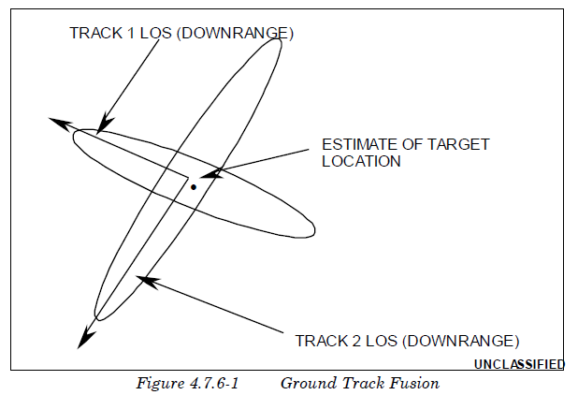  
 If more than two sources are reporting track data on a target, the fusion process determines the two most accurate tracks for fusing. The associated downrange and crossrange errors of each respective track along with the orientation of the ellipse are then used to determine the intersection of the ellipses. The resultant error in downrange and crossrange of the intersection is defined as the fused error and is used as a one-sigma standard deviation value in determining the amount of error applied to the track. In performing track fusion, zero mean (bias) error is assumed.

如果一个目标有两个以上的轨道数据来源，融合过程将确定两个最准确的轨道进行融合。然后，利用每个轨道的相关下距和横距误差以及椭圆的方向来确定融合椭圆的交点。交点的下距和横距的结果误差被定义为融合误差，并在确定应用于轨道的误差量时作为一西格玛标准偏差值。在进行跟踪融合时，假设平均（偏置）误差为零。

#### 4.7.6.2.3.3Track Triangulation

4.7.6.2.3.3 轨迹三角测量法

### 4.7.6.2.4 Launch-Point Message Generation

4.7.6.2.4 发射点信息的生成

After track has been established on a missile target, a launch-point message can optionally be scheduled for the track. Mean and sigma time values can be defined through the user interface that enable the user to randomly vary the time at which the message will be scheduled. The time used to vary the launch-point message is relative to the report time of the initial data being received. The mean of the variation for the launch-point message time should be sufficient to account for the reception of the required number of updates for establishing target track. The sigma value models randomness in the processing delays at the EWDPC. If randomness is eliminated, the launch point message will be scheduled at the specified mean time.

在导弹目标上建立轨道后，可选择为该轨道安排发射点信息。可以通过用户界面定义平均和西格玛时间值，使用户能够随机改变安排信息的时间。用于改变发射点信息的时间是相对于收到初始数据的报告时间而言的。发射点报文时间变化的平均值应足以说明接收建立目标轨道所需的更新次数。sigma值模拟了EWDPC处理延迟的随机性。如果随机性被消除，发射点信息将被安排在指定的平均时间。

At the time the message is to be sent, the track file is reevaluated to determine the number of updates the track has received since initial detection, as well as the number of independent sources contributing data on the target. The number of sources contributing data to the track are used to determine a measure of quality for the track and subsequent launch-point position. This is accomplished by means of a user-defined table of DFD ratings as a function of the number of sources contributing to the track. This enables the user to emulate, through the improved DFD, the track improvement yielded by multiple sensor coverage of a target. Alternatively, if track error is selected, EADSIM attempts to match the current track with a user-specified list of missile target types. The entry for each missile type contains the one-sigma down-range and cross-range position errors at the time of missile launch. This implicitly represents the error generated by a viewing sensor in the direction of the target trajectory.

在将要发送信息时，对轨道文件进行重新评估，以确定轨道自最初探测到以来收到的更新次数，以及为目标提供数据的独立来源的数量。向轨道提供数据的来源数量用于确定轨道和后续发射点位置的报告质量的衡量标准。这是通过用户定义的DFD评级表来实现的，该表是对轨道提供数据源数量的函数。这使得用户能够通过改进的DFD来模拟多传感器覆盖目标所产生的轨道修订。另外，如果选择轨道误差模式，EADSIM将尝试将当前的轨道与用户指定的导弹目标类型列表进行匹配。每种导弹类型的条目包含导弹发射时的一西格玛下程和跨程位置误差。这隐含了观察传感器在目标跟踪方向上产生的误差。

This improved track data and launch-point prediction is used by ground attack operations in scheduling aircraft for search and engagement of hostile missile launch sites. The message contains typical intelligence message data with the addition of the launch ID, launch position, and improved DFD rating.

这种改进的轨道数据和发射点预测被地面攻击行动用来安排飞机搜索和打击敌方导弹发射场。该电文包含典型的情报电文数据，增加了发射ID、发射位置和改进的DFD等级。

The launch-point prediction uses the down-range and cross-range values to apply an errored position to ground tracks. Figure 4.7.6-2 displays the errored position computed by the algorithm described below.

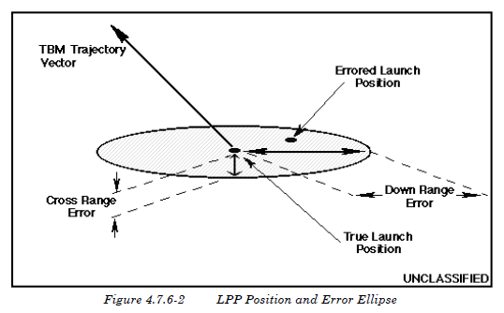发射点预测利用下程和跨程值对地面轨道进行误差位置的计算，图4.7.6-2显示了由下述算法计算出的误差位置。图4.7.6-2显示了用下述算法计算出的错误位置。

First, a unit vector in the direction of the cross-range of the TBM trajectory is established at the launch position.

首先，在发射位置建立TBM弹道横距方向的单位矢量。

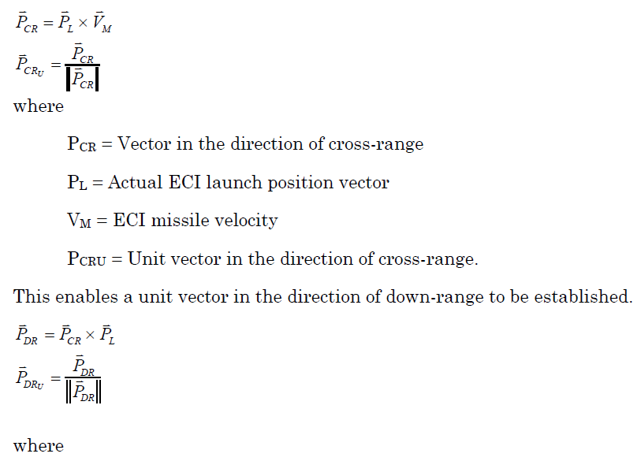

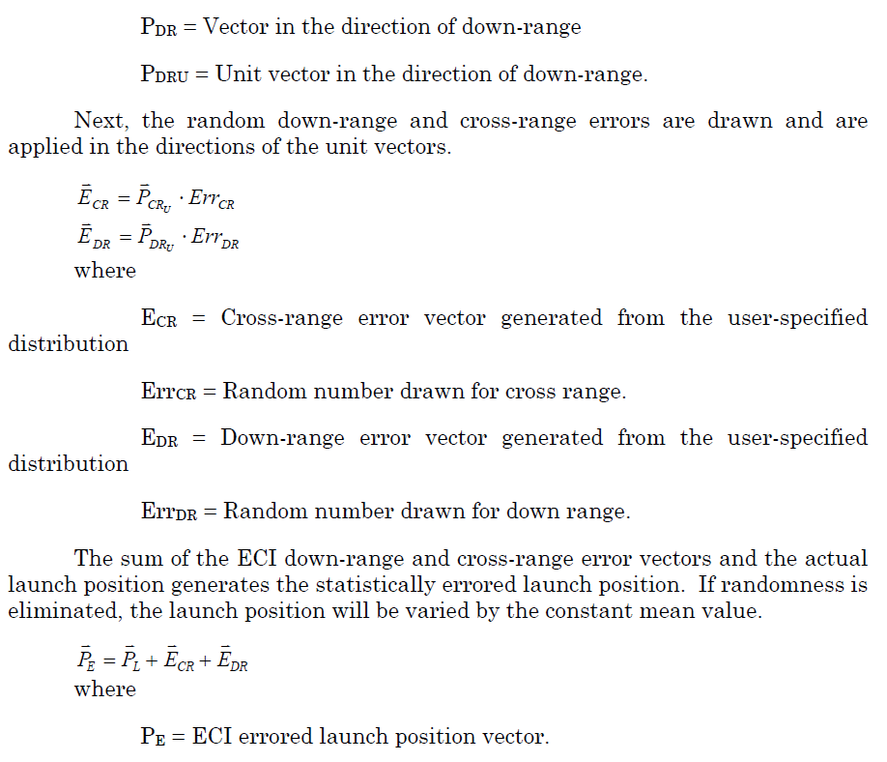

### 4.7.6.2.5 Burnout Message Generation

4.7.6.2.5 销毁信息的生成

The burnout message is handled in a very similar manner to the launch point message. As soon as a track is created on a target, the process by which a message will be sent is scheduled at the final-stage burnout time. When this time is reached in the simulation, the message is generated and processing delays are added to the time. These processing delays are computed using a random draw from a userdefined distribution. If randomness is eliminated, the value entered for the mean is used as the processing delay. The delay is meant to model the time needed for recognition of burnout.

销毁消息的处理方式与发射点消息非常相似。一旦在目标上创建了一条轨道，发送消息的触发点就被安排在最后阶段的销毁时间。当在模拟中达到这个时间时，消息就会被生成，并在时间上加上处理延迟。这些处理延迟使用从用户定义的分布中随机抽取计算。如果随机性被消除，则输入的平均值的值被用作处理延迟。延迟是为了模拟识别目标销毁所需的时间。

#### 4.7.6.2.5.1Burnout Track Data

4.7.6.2.5.1 已燃尽导弹的轨道数据

Two options are available for specifying the quality associated with the target track at missile burnout: DFD and a user-defined error sigma in each coordinate axis. If the DFD option is selected, the number of sources contributing to the track is determined at the time the message is to be sent and the DFD is determined in the same fashion as the launch-point message. If track error is selected, EADSIM attempts to match the current track with a user-specified list of missile target types. The entry for each missile type contains the one-sigma error variance data for both position and velocity at the final burnout of the missile. The one-sigma errors of position and velocity components are entered in a coordinate system defined with respect to the velocity of the missile being tracked and then transformed to Earth Centered Inertial (ECI) coordinates for reporting.

有两个选项可用于指定与导弹燃尽时目标跟踪相关的质量。DFD和用户在每个坐标轴上定义的误差Σ。

如果选择DFD选项，则在发送消息时确定对轨道有贡献的源数量，DFD的确定方式与发射点消息相同。

如果选择轨道误差，EADSIM将尝试将当前轨道与用户指定的导弹目标类型列表进行匹配。每种导弹类型的条目包含导弹最终燃尽时位置和速度的一西格玛误差差异数据。位置和速度分量的一西格玛误差被输入相对于被跟踪的导弹速度而定义的坐标系中，然后转换为地球中心惯性坐标进行报告。

The burnout message contains typical intelligence message data as well as the DFD and/or missile track covariance in ECI coordinates. The improvement in the track data yielded by receipt of a burnout message will aid in sensor cueing at greater ranges due to reduced search volumes obtained from the improved target positional data. In addition, the burnout announcement is accompanied by an impact-point prediction as described in the section on Intel CAC Impact-Point Predictions.

燃尽信息包含典型的情报电文数据以及ECI坐标中的DFD和导弹轨道协方差。由于从改进的目标位置数据中获得的搜索量减少，收到燃尽信息所产生的轨道数据的改进将有助于传感器在更远的距离上进行提示。此外，如情报收集和分析中心影响点预测一节所述，燃尽信息的宣布还附有影响点预测。

#### 4.7.6.2.5.2Intel Center Impact-Point Prediction

4.7.6.2.5.2 Intel中心影响点预测

The Intelligence Center creates impact-point predictions based upon burnout and midcourse track message generation. The impact point is predicted using the selected trajectory prediction algorithm as described in Appendix B5. An uncertainty error ellipse is generated for the position as described in section Appendix B5.7 and sent in the IPP message.

情报中心根据燃尽和跟踪信息建立撞击点预测。使用附录B5中描述的选定跟踪预测算法预测撞击点。如附录B5.7节所述，为该位置生成不确定性误差椭圆，并在IPP报文中发送。

### 4.7.6.2.6 Midcourse Track Message Generation

4.7.6.2.6 中段航迹信息生成

The midcourse track messaging option generates track position and velocity updates for ballistic missiles at specified update intervals. These messages include errors based on either DFD ratings and/or track error data. The track error for the respective track may be either DFD, track error, or both, depending on the userselected options and the data that have been defined. In addition, the midcourse track message is accompanied by an impact-point prediction as described in Subsection 4.7.6.2.5.2.

中段航迹信息传递选项以指定的更新间隔为弹道导弹生成轨道位置和速度更新。这些信息包括基于DFD评级和轨道误差数据的误差。根据用户选择的选项和已定义的数据，各轨道的轨道误差可以是DFD，也可以是轨道误差，或者两者都有。此外，中段航迹信息还附有4.7.6.2.5.2小节所述的撞击点预测。

The DFD methodology is performed in the same fashion as that in the launch-point and burnout messages. The number of sources contributing to the track is computed at the time the message is to be sent, and the DFD is selected from the user-defined table based on the number of contributing sources. A default update interval is also included to specify at what rate the data messages are to be sent.

DFD方法的执行方式与发射点和燃尽信息的传递执行方式相同。在发送消息时，计算对跟踪有贡献的源的数量，并根据贡献源的数量从用户定义的表格中选择DFD。还包括一个默认的更新间隔，以指定数据消息的发送速率。

The track error methodology compares the current track with a user-specified list of missile target types. Each target type contains an associated table of track load, data messaging rate (update interval), and error data parameters. The message update interval and associated track error for the target type being evaluated will be selected based on the number of tracks currently being processed by the Intel CAC. This allows the user to model a decreased rate at which messages can be generated due to an increased number of tracks being processed by the Intel CAC.

轨道误差方法将当前轨道与用户指定的导弹目标类型清单进行比较。每种目标类型都包含一个相关的轨道载荷表、数据报文速率（更新间隔）和误差数据参数。被评估的目标类型的报文更新间隔和相关的轨道误差将根据情报收集和分析中心当前处理的轨道数量来选择。这样，用户就可以模拟由于 Intel CAC 处理的轨道数量增加而导致的消息生成率下降。

Track error data may be specified in two formats: tabular or curve fit. Tabular error data represent one-sigma error variances as a function of time since missile burnout. The variances are specified for both position and velocity in missile body-centered coordinates. The time the message is to be generated is computed and the data in each coordinated axis are interpolated from the tables for that time. The interpolated error variances are then used to define the track covariance.

轨道误差数据可以用两种格式指定：表格或曲线拟合。表格式的误差数据表示导弹燃尽后作为时间函数的一西格玛误差方差。差异是以导弹弹体为中心的坐标，同时指定位置和速度。计算信息产生的时间，并从表中内插该时间的每个坐标轴的数据。然后用插值后的误差方差来定义轨道协方差。

The curve fit format represents the coefficients of an exponential function that define the missile position and velocity errors for a specified period of time. The curve-fit-error coefficients are used to compute the missile track variance as a function of time since missile burnout based on the formula:

曲线拟合格式表示指数函数的系数，指数函数定义了指定时间段内导弹的位置和速度误差。曲线拟合误差系数用于计算导弹航迹方差，作为导弹烧毁后时间的函数，公式如下：

  
 The curve-fit segment is chosen whose data start/end-time interval bounds the elapsed time from missile final burnout. The track covariance is then transformed into ECI coordinates for reporting.

选择曲线拟合段，其数据开始时间间隔限定了导弹最终燃尽的时间。然后将轨道协方差转化为ECI坐标，以便报告。

The midcourse track messages will begin at the user-defined message start time, which is defined relative to missile burnout, provided the track error data have been specified for the proper targets or the DFD versus number of reporting sources have been defined. The messages will continue to be sent at the defined update interval for the duration of the target’s track as long as the missile is still alive. When the time since missile burnout exceeds the time entries in the userdefined data tables or the end time of the final curve fit segment, the track is assumed to have achieved steady state and the last table entry or last curve fit segment is used for defining the covariance for the remainder of the track messages.

中段航迹信息将在用户定义的信息开始时间开始，该时间是相对于导弹燃尽而定义的，条件是为适当的目标指定了跟踪误差数据，或定义了DFD与报告源的数量。只要导弹仍存活，在目标的跟踪时间内，消息将以定义的更新间隔继续发送。当导弹燃尽后的时间超过用户定义的数据表中的时间条目或最后一个曲线拟合段的结束时间时，则假定该轨道已达到稳定状态，并使用最后一个表条目或最后一个曲线拟合段来定义其余轨道信息的协方差。

The improvement in the track covariance as a function of time since missile burnout and/or DFD yielded by multi-sensor coverage will aid in sensor cueing at greater ranges due to reduced search volumes obtained from the improved target positional uncertainty.

多传感器覆盖所产生的协方差（导弹燃尽后时间函数的轨道协方差）和/或DFD的改进，将有助于传感器在更远的距离上进行报告，因为精确目标位置的不确定性可减少搜索量。

### 4.7.6.2.7 Battle Damage Assessment

4.7.6.2.7 战损评估

Battle Damage Assessment (BDA) is an automatic capability driven by a target being attacked. BDA is the determination of a target as being dead or alive. Accuracy of assessment is modeled as a probability draw to determine if a dead target is assessed as dead or an alive target as alive based on the target type and the confidence level of the data. If the Intel CAC has track on a target that is attacked, it will attempt to perform BDA, provided that the current time is between the maximum and minimum times for BDA, as input by the user. If the Intel CAC has updated the track within this window, and the track has a confidence level greater than the specified minimum, then BDA is performed. If the data are of insufficient confidence level, the track was not updated within this window, or the current time is not within this window, the Intel CAC requests that a Ground Attacker Commander or a ground-capable Flexible Commander send an AGAttacker to survey the target.

战损评估(BDA)是一种由被攻击目标驱动的自动能力。BDA可以确定一个目标是否存活。评估的精确性是以概率随机的方式进行建模的，其根据目标类型和数据的置信度来确定是将目标评估为销毁，还是存活。如果情报收集和分析中心对被攻击的目标有跟踪，则会尝试执行BDA，但前提是当前时间在用户输入的BDA的最大和最小时间之间。如果情报收集和分析中心在这个窗口内更新了跟踪，且跟踪的置信度大于指定的最小值，则执行BDA。如果数据的置信度不够，跟踪没有在这个窗口内更新，或者当前时间不在这个窗口内，则情报收集和分析中心会要求地面攻击指挥官或具有地面能力的灵活指挥官派出AGA攻击者对目标进行勘察。

### 4.7.6.2.8 Flash Message Generation

4.7.6.2.8 闪光灯信号的生成

After a flash track has been received from a sensor, the Intel CAC ruleset has the capability to add a time delay to the flash message. This delay is calculated from the user specified mean and sigma time using a user-specified distribution. Both the mean and sigma are in seconds. If randomness is eliminated, the mean value is used as the delay

从传感器接收到闪光灯信号后，情报收集和分析中心规则集能够为闪光灯消息添加一个时间延迟。该延迟是使用用户指定的分布从用户指定的平均值和西格玛时间计算出来的。平均值和西格玛的单位都是秒。如果消除了随机性，则使用平均值作为延时。

The Intel CAC also has the ability to add track location error to the flash message based upon the target type. It is two sided; one error is true Northing, while the other is true Easting. This error is calculated with a random number draw from a user-defined distribution. If randomness is eliminated, values entered for mean are used for the Northing and Easting track location errors.

情报收集和分析中心还可以根据目标类型在闪光灯信号中添加跟踪位置错误。它是双面的；一个错误是真正的北纬，而另一个是真正的东经。这个误差是用从用户定义的分布中随机抽取的数字计算的。如果消除了随机性，则北纬和东经跟踪位置误差将使用输入的平均值。

The Intel CAC will only add error to the flash location if Track Error is selected on the Flash Message window and the flash track matches one of the userspecified target types. The potentially errored flash message is then transmitted on any of the intel center’s networks based on when the flash message was received by the intel center plus any delay specified by the user.

只有在Flash消息窗口上选择Track Error，并且Flash跟踪与用户指定的目标类型之一相匹配时，情报收集和分析中心才会将错误添加到Flash位置。然后，根据英特尔中心收到闪电信息的时间加上用户指定的任何延迟，潜在出错的闪光灯信号就会在英特尔中心的任何网络上传输。

### 4.7.6.2.9 Intel CAC Commanded Track Update

4.7.6.2.9 情报收集和分析中心指令轨道更新

The Intel CAC requests a commanded track update from a Ground Attacker Commander when a BDA request is received for a track number unknown to the Intel CAC. The commanded track update message contains the track data for the requested track number as well as the data contained in the previous command on the track. When the Intel CAC receives the update message, it first processes the track information into its track file. The track data processing is detailed in Section 4.6. Once the track data has been processed, the platform then processes the original command message for which this track was requested.

当收到对未知追踪轨道号的BDA请求时，情报收集和分析中心向地面攻击者指挥官请求指令式跟踪轨道信息更新。指令轨道更新消息中，包含了请求轨道号的跟踪轨道数据，以及之前对该轨道的指令中包含的数据。情报收集和分析中心收到更新消息后，首先将轨道信息处理到其轨道文件中。轨道数据的处理详见4.6节。轨道数据处理完毕后，平台再对请求该轨道的原始命令报文进行处理。

### 4.7.6.2.10 Intel CAC Installation Message Generation

4.7.6.2.10 情报收集和分析中心装置消息的生成

Installations are pre-built in EADSIM with a location, a defined area, and a list of expected equipment, both type and count. A platform with the AGAttacker ruleset is scripted to view the installations with a specified time on target. As the aircraft moves through a pre-planned route, i.e. user-specified waypoints, the aircraft takes pictures of the installations using an IMINT sensor that is capable of imaging. The number of images taken at a particular installation is determined by the sensor image size; thus, the installation is treated as a grid where the size of each grid element (sector) is the size of the sensor image. The installations are imaged based on ground range distance at the time of selection and installation priority. An installation may be only partially covered if there is insufficient time to image the installation. The images are transmitted to an Intel CAC platform either as the images are being taken or after the aircraft hits a report waypoint. The last image taken for a particular installation is marked as being the last for that installation. When the Intel CAC platform receives and has processed the last image for an installation, the Installation Message is sent out on Intel capable networks.

在EADSIM中预先建立装置，包括一个地点、一个确定的区域和一个预期设备清单，包括类型和数量。带有AGAttacker 规则集的平台被编写成脚本，以便在指定时间内查看目标上的装置。当飞机通过预先规划的路线，即用户指定的航点时，飞机使用能够成像的IMINT传感器对设施进行拍照。在某一设施上拍摄的图像数量由传感器图像大小决定；因此，将该设施视为一个网格，其中每个网格元素(扇形)的大小就是传感器图像的大小。根据选择时的地面范围距离和装置优先级对装置进行成像。如果没有足够的时间对装置进行成像，则可能只覆盖部分装置。图像在拍摄时或在飞机到达报告航点后传送到Intel CAC平台。为某一特定装置拍摄的最后一幅图像被标记为该装置的最后一幅图像。当英特尔CAC平台收到并处理完某一装置的最后一幅图像后，装置信息就会在Inter功能网络上发送出去。

There are two delays that are important in the Installation Message generation process: delaying each image as it is received by the Intel CAC, and delaying the set of images for a particular installation. Each image received by the Intel CAC is delayed by the amount of time specified for the Image Data field of the Message Receipt section in the Communication Options window. After the delay time for each image message has passed, the targets detected from the image are placed in the track file. Once the Intel center receives the end of installation message from the sensor platform for a particular installation, all of the tracks from the images of the installation are packaged together to be sent out on track capable networks. These messages are sent after the installation message delay time specified for the Intel CAC. The Message Delay time is specified on the intelligence center under the installation message button. It represents the amount of time required to process all of the images as a set to create the installation message. Once the Installation Message has been generated, a DIS signal PDU (TSIU_IPIR) can be generated based on the Installation Message being generated.

在装置信息生成过程中，有两个延迟是很重要的：在 Intel CAC 收到每个图像时延迟，以及延迟特定装置的图像集。Intel CAC 接收到的每个图像都会按照通信选项窗口中消息接收部分的图像数据属性指定的时间量进行延迟。在每个图像消息的延迟时间过后，从图像中检测到的目标将被放入跟踪文件中。一旦Inter CAC从传感器平台接收到特定装置的安装结束消息，所有来自装置图像的信息都会被打包在一起，以便在具有跟踪功能的网络上发送出去。这些消息是在为英特尔CAC指定的装置消息延迟时间之后发送的。消息延迟时间是在情报中心的装置消息（Installation Message）按钮下指定的。它表示将所有图像作为一组处理以创建装置消息所需的时间。装置信息生成后，可以根据生成的装置信息生成DIS信号PDU（TSIU_IPIR）。

### 4.7.6.2.11 Intel CAC NBC Message Generation

4.7.6.2.11 情报收集和分析中心 NBC信息生成

The Intel CAC ruleset has the ability to process and disseminate NBC information as described in section 4.6.14. For NBC messages, the Classes of Interest list is not used. Only the parameters as specified on the NBC Track Options window are relevant for NBC Message handling and dissemination.

Intel CAC规则集具有处理和传播NBC信息的能力，如4.6.14节所述。对于NBC信息，不使用兴趣类列表。只有NBC跟踪选项窗口中指定的参数才与NBC信息处理和传播有关。

## 4.7.6.3 Intel CAC System Configuration

4.7.6.3 Intel CAC系统配置

The Intel CAC ruleset is designed to be used on ground systems. A communications device is required. Sensors and weapons are not used. The Intel CAC cannot be a commander, flight leader, or wingman. Intel CAC cannot have a commander. Targets and assets are not used.

情报收集和分析中心规则集设计用于地面系统时需要一个通信设备，但是不需要使用传感器和武器。Intel CAC不能是指挥官、飞行队长或僚机。情报收集和分析中心不能有指挥官，也不使用目标和资产作为Inter。

## 4.7.6.4 Intel CAC Network Recommendations

4.7.6.4 情报收集和分析中心网络建议

The Intel CAC should have incoming links of any network type with message class track from any track source that will be supplying data on the desired target type. For example, to act as the EWDPC, track information on ballistic missiles will need to be sent to the platform operating with this ruleset. The Intel CAC can also have incoming links with message classes intel and track from another Intel CAC. Another type of link can be an incoming link with message class intel from a Flexible Commander. Recommended outgoing links are simplex and broadcast networks with message classes track and intel going to such players as another Intel CAC, an SSM Commander, a Flexible Commander, a Flexible SAM, or a Ground Attacker Commander.

情报收集和分析中心应该有任何网络类型的传入链路，其消息链路来自任何将提供所需目标类型数据的跟踪源。例如，为了充当EWDPC，需要将弹道导弹的轨道信息发送到使用该规则集运行的平台。情报收集和分析中心也可以有来自另一个情报收集和分析中心的消息类的Inter和轨道的传入链路。另一种类型的链路可以是来自灵活指挥官的带有消息类的intel的传入链路。推荐的输出链是能够传输track和情报类消息的简单或广播网络，消息发往其他Intel CAC、SSM Commander, Flexible Commander, Flexible SAM, 或 Ground Attacker Commander规则集的平台

For BDA to be performed correctly, all platforms involved must be netted together. It is recommended that duplex track links be set up between the Intel CAC and the AGAttackers that are providing the BDA surveillance information. A duplex network with message classes track and command should link the Intel CAC and the Ground Attacker Commanders or ground-capable Flexible Commanders it will use for BDA requests.

为了正确执行BDA，所有涉及的平台都必须网罗在一起。建议在情报收集和分析中心和提供BDA监视信息的AGA攻击者之间建立双向轨道链路。具有信息类跟踪和命令能力的双向网络应将情报收集和分析中心和将向它发起BDA请求的地面攻击者指挥官或具有地面能力的灵活指挥官联系起来。