Васильев ИП-19-3
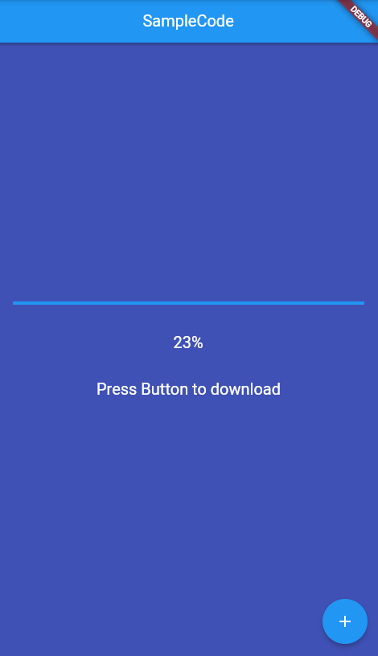
void main() {
runApp(
MyApp(),
);
}

class MyApp extends StatelessWidget {
const MyApp({Key? key}) : super(key: key);

@override
Widget build(BuildContext context) {
return MaterialApp(
home: Scaffold(
backgroundColor: Colors.indigo,
appBar: AppBar(
title: Text('SampleCode'),
centerTitle: true,
),
body: Center(
child: Container(
padding: EdgeInsets.all(20),
child: Column(
mainAxisAlignment: MainAxisAlignment.center,
children: [
LinearProgressIndicator(
value: 23,
),
SizedBox(height: 35),
Text(
'23%',
style: TextStyle(
color: Colors.white,
fontSize: 20,
),
),
SizedBox(height: 35),
Text(
'Press Button to download',
style: TextStyle(
color: Colors.white,
fontSize: 20,
),
),
],
),
),
),
floatingActionButton: FloatingActionButton(
child: Icon(Icons.add),
onPressed: () {},
),
),
);
}
}
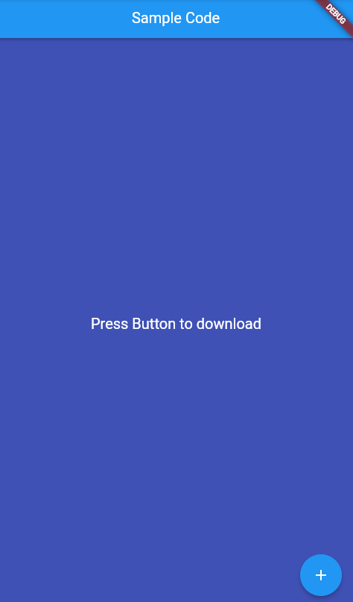
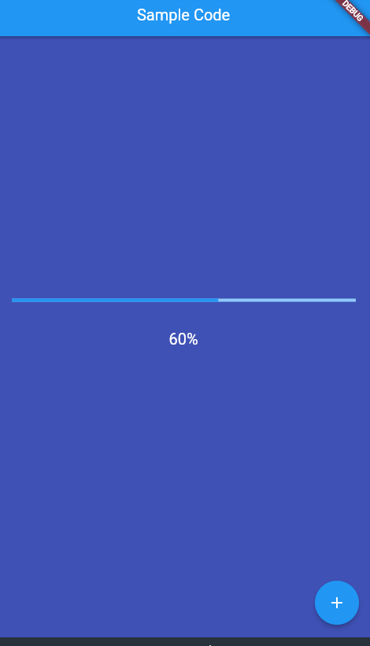
import 'package:flutter/material.dart';
import 'dart:async';
void main() {
runApp(
MyApp(),
);
}

class MyApp extends StatefulWidget {
const MyApp({Key? key}) : super(key: key);

@override
State<StatefulWidget> createState() {
return _MyAppState();
}
}

class _MyAppState extends State<MyApp> {
late bool _loading;
late double _progressValue;

@override
void initState() {
_loading = false;
_progressValue = 0.0;
super.initState();
}

@override
Widget build(BuildContext context) {
return MaterialApp(
home: Scaffold(
backgroundColor: Colors.indigo,
appBar: AppBar(
title: Text('Sample Code'),
centerTitle: true,
),
body: Center(
child: Container(
padding: EdgeInsets.all(20),
child: _loading
? Column(
mainAxisAlignment: MainAxisAlignment.center,
children: [
LinearProgressIndicator(
value: _progressValue,
),
SizedBox(height: 35),
Text(
'${(_progressValue * 100).round()}%',
style: TextStyle(
color: Colors.white,
fontSize: 20,
),
),
SizedBox(height: 35),
],
)
: Text(
'Press Button to download',
style: TextStyle(
color: Colors.white,
fontSize: 20,
),
),
),
),
floatingActionButton: FloatingActionButton(
child: Icon(Icons.add),
onPressed: () {
setState(() {
_loading = !_loading;
_updateProgress();
});
},
),
),
);
}

void _updateProgress() {
const oneSec = Duration(seconds: 1);
Timer.periodic(
oneSec,
(Timer t) {
setState(
() {
_progressValue += 0.2;
if (_progressValue.toStringAsFixed(1) == '1.0') {
_loading = false;
t.cancel();
_progressValue = 0.0;
return;
}
},
);
},
);
}
}

