

DATA2001: Data Science, Big Data and Data Variety

(Lab 06, Group 5)
yuli4070 | 530184409
nyip2588 | 530577139
ysio0983 | 530261009

Dataset Description
The “SA2Boundaries.zip” dataset comprises statistical area level 2 digital boundaries which are communities with a population of 3000 - 25,000. This shapefile is sourced from the Australian Bureau of Statistics and aims to integrate with various datasets to provide insights into how busy different regions within the Greater Sydney area are. The data is imported and cleaned by converting the columns’ names to lowercase, and the “loci_uri21” column is dropped as it consists of URL links instead of data. The records in the “sa2_code21” column are also converted to integers for further analysis. As a result, a data frame is generated, producing a comprehensible structure for the data to be joined with other datasets to provide insightful information.

The “Businesses.csv” dataset is sourced from the Australian Bureau of Statistics which includes information on the number of businesses categorized by type of industry and Statistical Area Level 2 (SA2) Regions. The data is recorded based on turnover size ranges and sums up the total number of businesses in a specific area and industry in the last column. After the dataset is imported, rows where the value in column “sa2_name” is “Currently Unknown” are removed and filters rows where the value in the column “sa2_code” is in “sa2” data frame under column “sa2_code21”.

The “Stops.txt '' dataset is sourced from Transport for NSW which provides comprehensive information about various public transport stops, including their location types, accessibility features etc. The dataset is imported and pre-processed by listing the column name in order to transfer it into the data frame. Next, the original columns containing longitude and latitude are dropped after creating a geometry column using the information in longitude and latitude.

The “PollingPlaces2019.csv” dataset contains locations of different polling places in the 2019 Federal Election. This dataset is sourced from the Australian Electoral Commission and aims to indicate how busy different areas within the Greater Sydney area are. The data is imported and preprocessed by removing rows with null values. The “latitude” and “longitude” columns are also combined to create a “geom” column. By doing this, a data frame is produced, providing a clear structure for the data to be further analysed.

The “Catchments.zip” dataset is sourced from the NSW government website and includes information about the specific areas that students must reside in in order to attend primary, secondary and future Government schools. This file contains three distinct datasets that must each be processed independently in a comparable manner. To further build the table, column names are converted to lowercase. It appears preferable to leave the values in the "priority" column of the "primary" and "secondary" datasets after verifying the presence of values. For additional table merging, a column called "priority" is made in the "future" dataset.

The “Population.csv” dataset is sourced from Canvas and represents the population demographics categorized by age groups within SA2 (Statistical Area Level 2) regions. Each record in this dataset corresponds to a specific SA2 region and contains population counts for various age brackets and the total number per SA2 region. After the dataset was imported, the dataset appeared to be quite clean, hence no pre-proceeded process was needed.

The Canvas provides the "Income.csv” file that offers the overall earnings figures by SA2 regions. Rows with null values are eliminated during the import and preprocessing of the data. This creates a data frame, which offers a straightforward framework for the correlation analysis that follows.

The "TfNSW_PopUp_Cycleway.shp" dataset, which contains statistics on the number of cycleways in various SA2 regions, was obtained from the NSW government website. Column names are converted to lowercase before the file’s schema is created in order to generate a table.

The “Off-Street-Parking.csv” dataset was obtained from the transport category of TfNSW Open Data Hub which contains information for parking spaces that are available for service and delivery drivers in Sydney’s CBD. After the dataset is imported, the data is cleaned by converting the columns’ names to lowercase. Some columns containing data that are not useful for analysis were also dropped and a geometry column was created using longitude and latitude.

The “EmergencyManagementFacility.json” dataset consists of the distribution of different emergency facilities across New South Wales. This JSON file is sourced from the Commonwealth of Australia and aims to give insight into different emergency facilities offered in various regions within the Greater Sydney area. The JSON file is converted into a data frame, and filtered by the “facility_state” column to be “New South Wales”. “latitude” and “longitude” columns are also removed after being combined to form a “geometry” column. Through this, the data frame produced reveals different types of emergency facilities in the corresponding SA2 regions.

Database Description
From the database schema diagram as shown in Figure 1, it is evident that all datasets contain primary keys as indicated by the underlined attributes. This is vitally important as these are the unique attributes that identify each row in the dataset, increasing efficiency. Some datasets contain two primary keys as no attribute can be uniquely identified in the table. Foreign keys are indicated by the arrows between two tables in the database schema diagram. Having foreign keys is crucial in the database as they help to reference other tables, suggesting that relationships exist between datasets. This allows different datasets to be integrated. Thus, having both primary keys and foreign keys ensures data integrity and consistency throughout the database.

Two GIST indexes named “stops_geom_index” and “sa2_geom_index” are created for datasets provided in Canvas to improve the performance of queries by allowing the database to quickly locate rows based on the indexed columns. “stops_geom_index” is created on the “geom” column of the “stops” table while “sa2_geom_index” is created on the “geom” column of the “sa2” table. Additionally, one index named “facilities_geom_idx” is created for the new dataset we found on the “geometry” column of the “facilities_df” table. GIST(Generalized Search Tree) indexes are often used for indexing spatial data types.

Results Analysis
In order to observe how “bustling” SA2 regions are within Greater Sydney, detailed analysis is performed using the sigmoid function, Score = S(Z_{business} + Z_{stops} + Z_{polls} + Z_{schools}). This formula is a great reflection of how busy an area is as it takes into account several aspects of a community, and together shapes the overall interactions and activities within the Greater Sydney area.

Rationale for the formula computation
In the score computation, various datasets including “Businesses.csv”, “Stops.txt”, “PollingPlaces2019.csv” and “Catchments.zip” are considered as they represent the general daily activities which indicate how busy a region is. Z score is an appropriate choice for this calculation as the data is normalised to allow easy comparison between different values in the dataset. Outliers are also easily detected, as values with 3 standard deviations away from the mean are considered outliers, increasing the accuracy of the scoring function.

The Z_{business} focuses on the business activities in the corresponding SA2 regions. The retail trade industry is chosen to be the focal point of this computation as it is a clear indicator of urban development and economic growth. This is due to the fact that consumer activities have a direct relationship to the number of businesses, with a high number of businesses showing a busy region. The Z_{stops} is a strong representation as it depicts the distribution of public transport stops in the SA2 regions within the Greater Sydney area. This is a clear measurement as the number of stops indicates the frequency of movements within a district, with a high number of stops representing a high level of pedestrian activity and great accessibility in the area. The Z_{polls} depicts the number of polling places during the 2019 Federal Election in each SA2 region. This is vitally important as the number of polling places is determined to meet the demand of the area, with a high number of polling places suggesting a greater number of residents in the district. The Z_{schools} represents the number of schools with young people aged 19 or below. The number of schools indicates the number of students living inside the local catchment of the school. Thus, a high number of schools indicates the presence of more families and students within the corresponding SA2 regions.

Therefore, it is evident that these four datasets are a reasonable choice for the computation. By summing up the four Z scores computed using the sigmoid function, an overall score is computed as shown in Figure 2. This score takes into account different aspects of human activities and interactions within an area. Thus, the formula computation provides a comprehensive reflection on how “bustling” each SA2 region is within Greater Sydney.

Implications of extending the base formula with additional datasets
The base formula is extended with additional datasets on top of the four Z scores computed as shown in Figure 3. This includes Z_{parking}, Z_{cycleway} and Z_{facility} using the “Off-Street-Parking.csv”, “TfNSW_PopUp_Cycleway.shp'' and “EmergencyManagementFacility.json” respectively. By extending the score with extra datasets, the accuracy of the overall score is improved. Having more datasets relating to diverse aspects of SA2 regions encompass the social interactions and community dynamics. Thus, this enhances the accuracy of the formula as more information is included to portray the “bustling” level in the districts within the Greater Sydney area.

Besides, extending the scoring function with additional datasets also increases the reliability of the formula. As the number of datasets increases, outliers can be easily detected and eliminated. To avoid bias and outliers, datasets are chosen in different formats and are sourced from different websites. By having more datasets, the formula has become more generic and can be applied to different situations. This means that the extended base formula can apply to diverse regions, not limited to the Greater Sydney area, to compute the overall score of how “bustling” an area is in different locations.

However, a disadvantage of extending the base formula is that data quality might be reduced if the z score of a misleading dataset is inserted in the formula. More specifically, datasets that do not include aspects indicating how busy a SA2 region will lead to the computation of an incorrect overall score, thus, generating misleading results and misrepresentation of the real situation. Therefore, the additional datasets are chosen with care, and include the number of cycleways, parking and emergency facilities which all portray human activities in SA2 regions. Thus, data quality is ensured when extending the scoring function.

Summary of overall distribution
After the total score for each SA2 region within the Greater Sydney area is computed using the sigmoid function, a table is created to represent the summary of the overall distribution. The sigmoid function ranges between 0 and 1, representing the overall score as a probability. Given the Z score inputs are large, the overall score would approach 1 if the inputs are positive, and the overall score would approach 0 if the inputs are negative.

As evident in Figure 4, various measurements of the central tendency of the overall score are clearly revealed. The total score ranges from 0.038799 to 0.941803, with a median of 0.132386. It is noticeable that a majority of total scores are below the upper quartile, 0.177775. This clearly indicates that the overall score approaches 0, meaning that the probability of having a SA2 region to be busy is low, as indicated in Figure 5.

Trends, regions and scores of interest
Through detailed analysis of each dataset with its corresponding Z scores, and the overall score, individuals can gain a deeper insight into how “bustling” a SA2 region within the Greater Sydney area is. A significant conclusion is visible through the “PollingPlaces2019.csv” dataset which produces the number of federal election polling locations during the 2019 Federal Election. It is evident that urban areas such as Haymarket and Chatswood have the highest number, with 15 and 5 polling places respectively, while rural areas such as Nowra and South Dubbo have the lowest number, with 1 and 2 polling places respectively. Meanwhile, it is also clear that most areas have a Z score of around 0, indicating that the number of polling places in the area is close to the mean. However, Haymarket has a Z score of greater than 2, indicating that the number of polling places in Haymarket is more than 2 standard deviations away from the mean. Therefore, the high number of polling places depicts that metropolitan areas are the busiest regions within the Greater Sydney area. Thus, trends are clearly revealed in the “PollingPlaces2019.csv” dataset.

In contrast, the “EmergencyManagementFacility.json” dataset gives insight into different emergency facilities offered in different SA2 regions. It is noticeable that the number of facilities varies and is independent of the SA2 regions, indicating that locations do not have a direct impact on the number of facilities. Furthermore, it is also evident that most Z scores are between the range of -2 to 2, with a majority being close to 0. This shows that the number of facilities in each region is close to the mean, and the Z scores do not follow a trend. Therefore, there is no direct relationship between the location and the number of facilities. Thus, trends are not clearly noticeable in the “EmergencyManagementFacility.json” dataset.

These opposing conclusions give rise to the limitations of the scoring function. This is because of the fact that two datasets relating to the same topic have contradictory results. The limitation that arises from this is due to the diverse nature of a SA2 region. More specifically, each SA2 region is composed of unique demographics and societal components, incorporated with personal factors, together determining how actively occupied the area is. The datasets do not give a full representation of how a region looks like as other factors such as local wildlife, cultural factors and other census statistics are not considered in the scoring functions. This leads to a misleading interpretation of how “bustling” a SA2 region can be within the Greater Sydney area.

In conclusion, each dataset uniquely indicates how busy an area is. As supported by the Z scores computed, some datasets depict a clear relationship, while some do not show a clear trend towards the “bustling” level of a region. To overcome the limitations arised, more datasets with information that contributes to the topic should be incorporated. This results in improvements of the accuracy of the scoring function, and represents the “bustling” level of each SA2 region of Greater Sydney to a fuller extent. Thus, it is crucial to note the hybrid nature of SA2 regions, as well as the elements and factors that together shape the unique “bustling” metric of each SA2 region within Greater Sydney.

Correlation Analysis
The computed score is further extended to compare with the median income of each SA2 region in the Greater Sydney area. To determine the correlations, the total score computed is aligned with the corresponding median income within the same SA2 region to create a table, enabling individuals to understand and compare the data. After this, a linear regression model is produced, with the total score being the independent variable and the median income being the dependent variable. As shown in Figure 6, the points in the scatterplot concentrate in regions with a total score less than 0.5, introducing difficulties in identifying the correlation between the variables.

A trendline is then added to the plot, showing a graphical relationship between the two variables. The correlation coefficient is also calculated using the trendline. However, a value of -0.01 is computed, indicating an extremely weak negative correlation between the overall score and the median income that is almost negligible. This correlation is predictable, and further investigation is performed to understand the reason behind the weak correlation between the total score and the median income.

The main reason for this result is due to the several factors that affect the level of income. An individual’s salary is mainly based on one’s level of education and experience, market demand of the particular industry, health and gender status, which have not been taken into consideration in this linear regression model. An individual’s qualification has a direct relationship with the income earned, with higher educational levels often associated with higher incomes. One’s income level is also affected by the market demand of the occupation as certain professions such as medicine have a higher demand, resulting in higher salaries. Health status also affects an individual’s salary due to the gender pay gap. People with long-term sickness impact their productivity, resulting in different levels of income. Therefore, it can be concluded that an individual’s income level is due to various personal and societal factors and does not solely depend on geographic locations and the number of public services provided in each SA2 region within the Greater Sydney area.

Another reason is that the dependent variable of this correlation is the median income which does not represent all income levels to a full extent. The median income only indicates the midpoint of the income recorded in each SA2 region and does not represent all individuals’ salaries. Thus, there is a possibility that some useful data might be excluded, leading to misleading computation of the correlation analysis.

Data Visualisations
After a detailed data analysis of each dataset and the computation of the total score, it is evident that trends and correlations relating to the “bustling” level of a SA2 region are clearly revealed. However, it is highly crucial to communicate these findings and insights to the general public in an understandable manner. Data visualisation is important as it allows individuals with little to no knowledge about the topic to gain insight into the relationships between various variables. Thus, several graphs and tables are generated to deliver the key results in an engaging approach.

Several graphs and tables have been produced to deliver the results and analysis in a detailed manner. This is shown by the table, Figure 3, and the boxplot, Figure 5. An extra visualisation is generated to further engage the audiences. A map-overlay visualisation, as evident in Figure 7, is produced to represent the total score of each SA2 region, with the x-axis being the longitude and the y-axis being the latitude. The colour intensity on the right indicates the values of total scores, with a darker colour representing a higher total score. Individuals with little to no knowledge about SA2 regions are aware of how busy different regions are within Greater Sydney. Therefore, this graph is beneficial in delivering major results and key insights in both an engaging and understandable manner.

This map shows that regions with the highest total score are the Sydney central business district (CBD) and regional areas located north of Sydney. A limitation is that some aspects are not taken into consideration such as the ratio between the number of public services and the size of regions. Contradictory to the general beliefs that regional areas are isolated and spacious, this graph shows the complete opposite. Upon further investigation, the reason for the contradiction might be due to the size of each SA2 region. As shown in the map, the regional areas located north of Sydney are relatively larger in size compared to the CBD. Thus, it is obvious that these areas have a higher total number of public services, leading to a higher value of Z score. However, if the same size of land is considered in both areas, then the CBD will have a higher number of public services as more people are concentrated in the CBD and require more access to these facilities. Therefore, the ratio between the number of public services and the size of regions should be considered to yield the most accurate results.

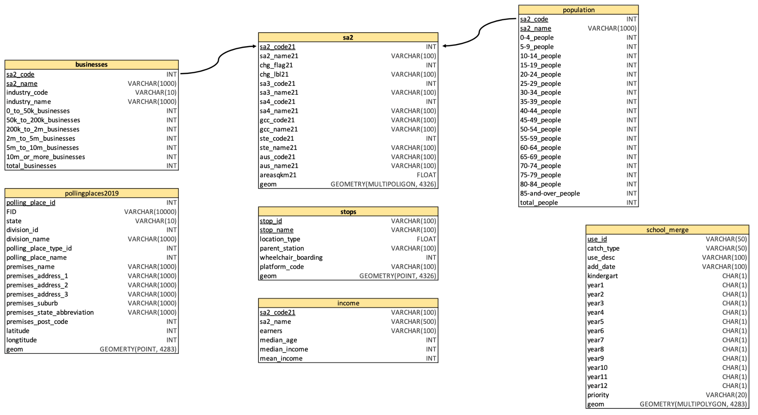
Appendix

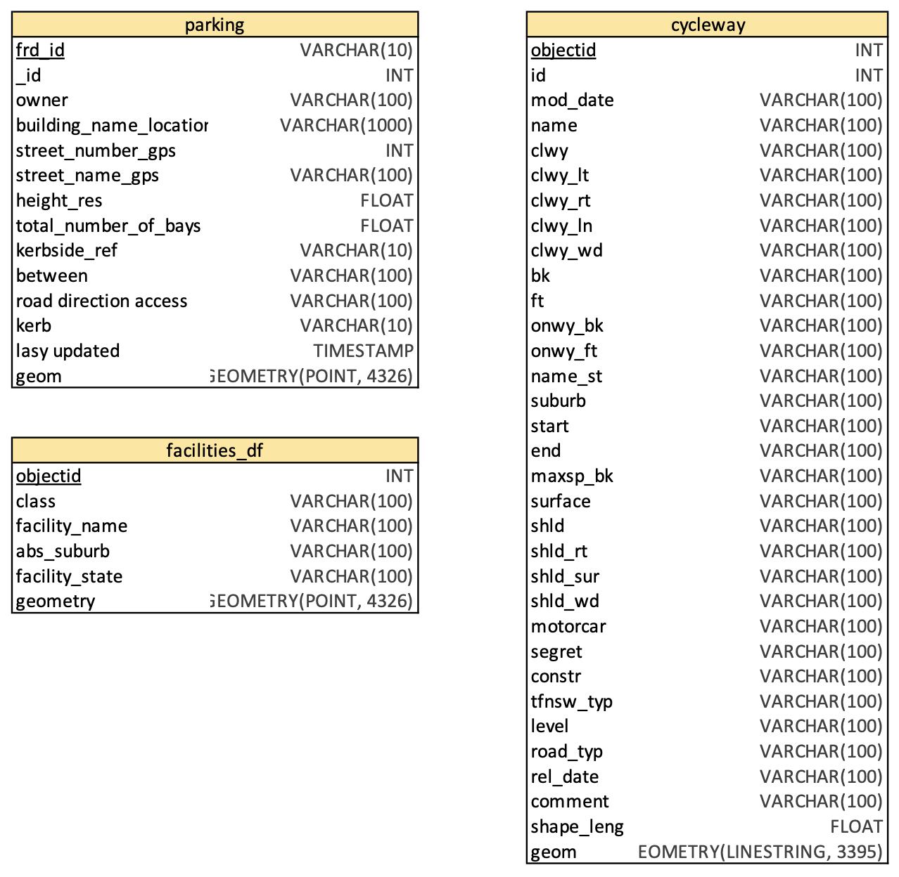

Figure 1: Database schema diagram

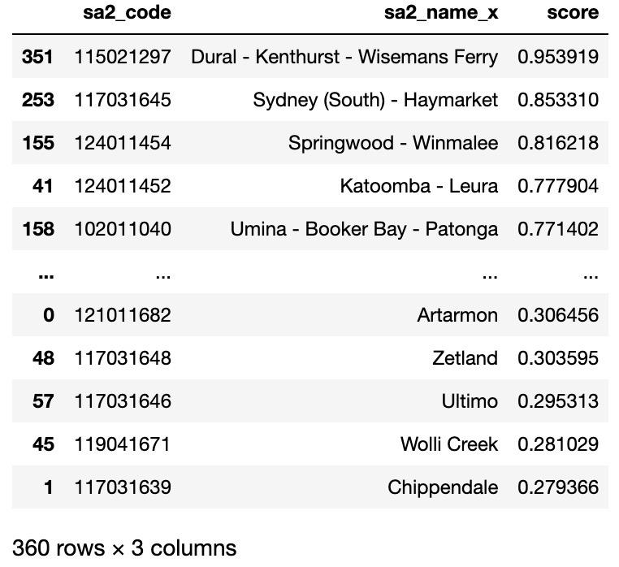

Figure 2: Overall score with four datasets (from task 2)

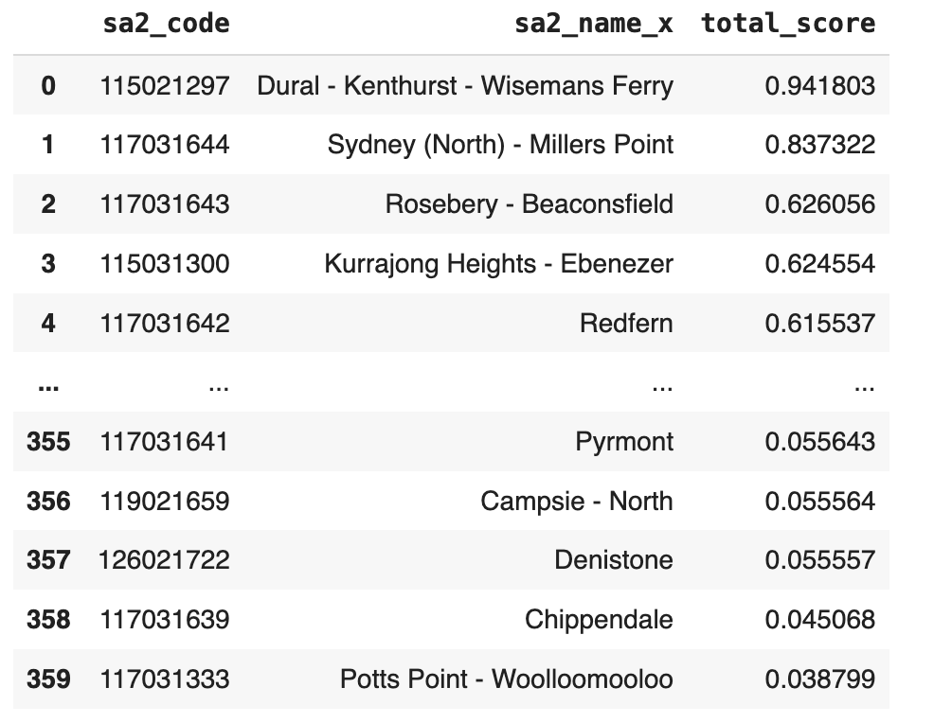

Figure 3: Overall score with additional dataset (from task 3)

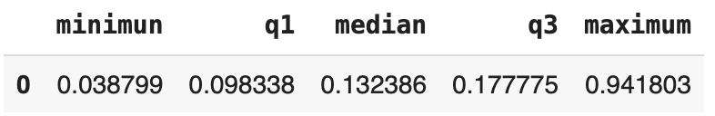
Figure 4: Summary of overall score

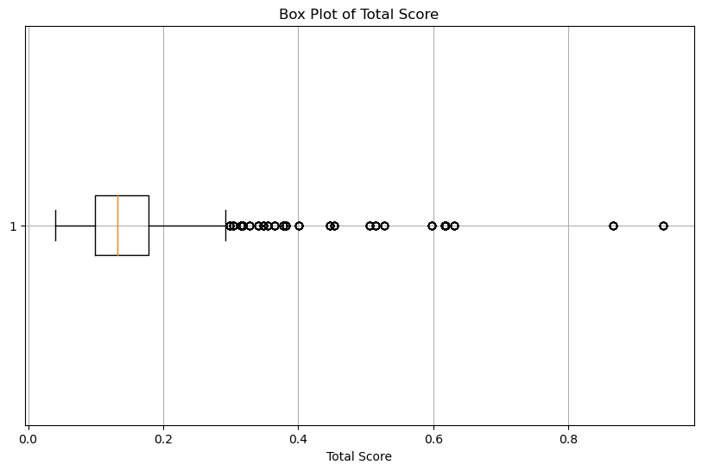

Figure 5: Boxplot representing the summary of overall distribution

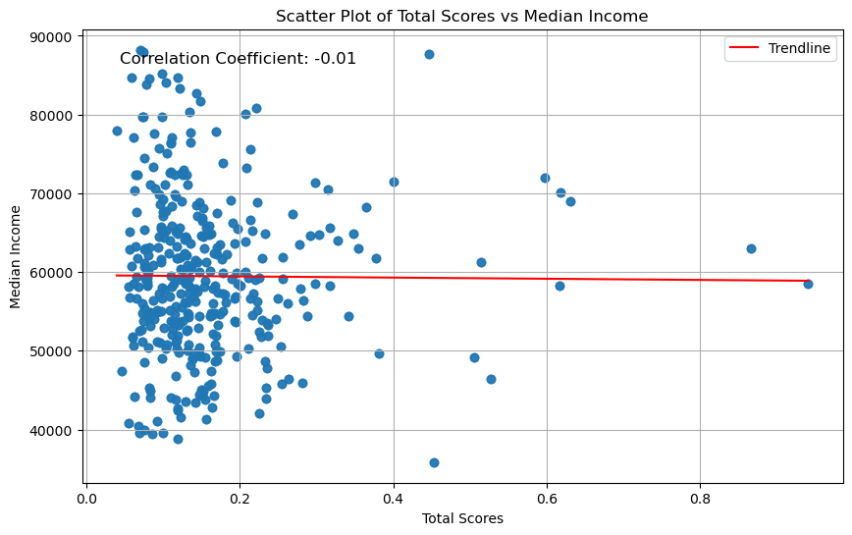

Figure 6: Correlation using linear regression model

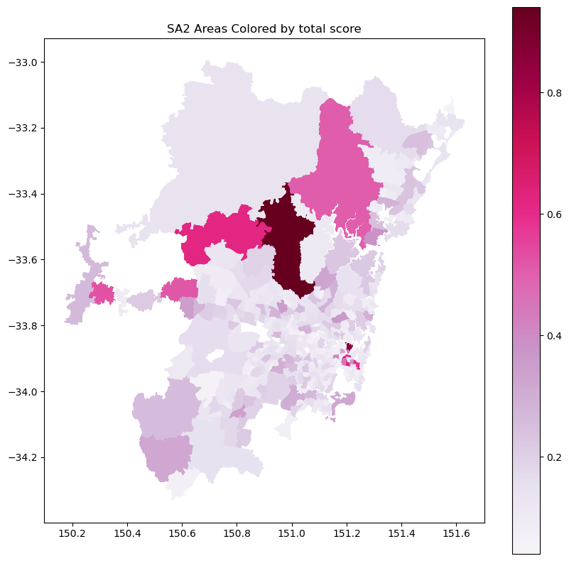

Figure 7: map representing the total score for SA2 regions

Referencing:
- Choosing colormaps in matplotlib#. Choosing Colormaps in Matplotlib - Matplotlib 3.8.4 documentation. (n.d.). https://matplotlib.org/stable/users/explain/colors/colormaps.html
- SQL foreign key keyword. SQL FOREIGN KEY. (n.d.). https://www.w3schools.com/sql/sql_ref_foreign_key.asp
- 15. spatial indexing - introduction to postgis. (n.d.). http://postgis.net/workshops/postgis-intro/indexing.html
- Sigmoid Function | Dremio. (2023). Dremio.com. https://www.dremio.com/wiki/sigmoid-function/
- Fuary-Wagner, I. (2016, July 30). What makes a suburb liveable? The 16 factors that make or break a neighbourhood. Domain; Domain. https://www.domain.com.au/news/what-makes-a-suburb-liveable-the-16-factors-that-make-or-break-a-neighbourhood-20160730-gqhdkw-281398/

