Koorde vs Chord DHT Performance Benchmark Report

Executive Summary
This report compares the runtime behavior of two distributed hash table (DHT) designs — Chord and Koorde — across three experiments: latency scaling, cache hit rate under churn, and throughput under load. Key findings:
- Latency (8–32 nodes): Chord exhibited lower median and tail latencies in our environment (≈19 ms avg) while Koorde showed higher average and P95/P99 latency despite theoretical hop-count advantages.
- Churn resilience: Both Chord and Koorde preserved cache state far better than a simple modulo hash (Simple Hash), producing substantially higher hit rates during topology changes.
- Throughput: Chord sustained higher RPS and scaled more stably under high concurrency in these tests.
Interpretation: the experimental results reflect implementation and environment factors (per-hop cost, maintenance traffic, cloud quotas) that can mask asymptotic algorithmic advantages at small-to-medium cluster sizes. See the Limitations and Measurement Plan sections for recommended follow-ups to validate Koorde at larger scales.

Table of Contents
- Experiment 1: Latency Scaling (Koorde vs Chord)
- Experiment 2: Cache Hit Rate Under 3-Phase Node Churn
- Experiment 3: Throughput Benchmark (Koorde vs Chord)

Experiment 1: Latency Scaling (Koorde vs Chord)

Experiment Introduction
This experiment empirically compares the latency characteristics of Chord and Koorde as the cluster size scales from 8 to 32 nodes. It aims to validate whether Koorde's theoretical routing efficiency $O(\frac{logN}{loglogN})$ translates to lower latency in a realistic cloud environment (AWS EKS) compared to Chord $O(logN)$

Methodology
- Tooling: Locust was used for distributed load generation.
- Workload: 50 concurrent users generating requests with a Zipfian distribution (alpha=1.2) to simulate realistic content popularity (hot keys).
- Traffic: Mixed workload of /cache (DHT lookups) and /health checks, but analysis focuses on /cache endpoints.
- Environment: AWS EKS (us-west-2) with a local in-cluster Nginx origin to isolate DHT routing latency from external network noise.

Experiment Settings
Parameter | Value
Environment | AWS EKS (us-west-2)
Cluster Sizes | 8, 16, 20, 26, 32 nodes
Protocols | Chord, Koorde (k=2, 4, 8)
Workload | 50 concurrent users, Zipfian distribution
Origin | Local in-cluster Nginx (to isolate routing latency)

Data (Results)

Summary of Average Latency
Nodes | Protocol | Degree (k) | Avg Latency (ms)
8 | Chord | N/A | 18.8
8 | Koorde | 2 | 25.5
8 | Koorde | 8 | 24.8
16 | Chord | N/A | 18.8
16 | Koorde | 2 | 37.4
32 | Chord | N/A | 19.4
32 | Koorde | 2 | 54.9
32 | Koorde | 8 | 50.3

Detailed Latency Distribution (32 Nodes)
A deeper look at the tail latency reveals significant differences in stability.
Metric | Chord | Koorde (k=2) | Koorde (k=8) | Comparison
Median (P50) | 19 ms | 46 ms | 39 ms | Chord is ~2x faster
Average | 19.7 ms | 60.5 ms | 54.5 ms | Chord is ~2.7x faster
P95 Latency | 25 ms | 140 ms | 160 ms | Chord is 5.6x more stable
P99 Latency | 37 ms | 190 ms | 240 ms | Koorde has high tail latency
Max Latency | 96 ms | 510 ms | 550 ms | -
(Note: Throughput comparison is omitted for this specific experiment as tests were conducted in different network environments.)

Visualizations
Figure 1: Average Latency vs. Node Count 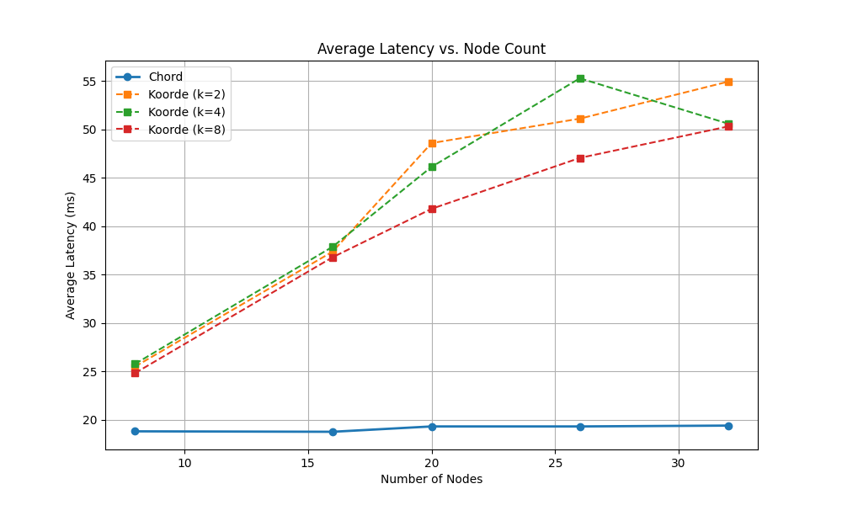 Comparison of Chord baseline against Koorde with varying degrees.

Analysis & Conclusions

1. Chord Dominance & Stability
Chord consistently outperformed Koorde across all cluster sizes (8-32 nodes), maintaining a remarkably flat latency profile (~19ms avg, 25ms P95). The tight bound between P50 (19ms) and P99 (37ms) indicates that Chord's finger table implementation is highly efficient and predictable at this scale. The $O(logN)$ hops in a 32-node cluster are few enough that the overhead is negligible.

2. Koorde Scaling & Tail Latency
Koorde showed a clear increase in latency as nodes were added (25ms $→$ 55ms). More critically, the tail latency (P95/P99) for Koorde is significantly higher (140ms+) than Chord. This suggests that while some lookups are fast, a significant portion of requests in Koorde suffer from longer routing paths or processing overheads. This could be due to the complexity of de Bruijn graph traversal or "imaginary node" calculations in a real distributed setting.

3. Impact of Degree (k) - Theory vs Practice
The theory that higher degree reduces path length was validated in the average case. At 32 nodes, Koorde with $k=8$ (Avg 50.3ms) was faster than $k=2$ (Avg 54.9ms), confirming that increasing the de Bruijn degree reduces network diameter. However, the P95 latency for $k=8$ was actually slightly worse (160ms vs 140ms), suggesting that the complexity of managing more neighbors or routing logic might introduce variance that affects tail latency.

4. Theoretical vs Practical Gap
While Koorde has a superior asymptotic bound ($O(\frac{logN}{loglogN})$), the constant factors in implementation and network RTT dominate at the scale of 32 nodes. Chord's simpler logic and efficient pointer chasing proved superior in this specific AWS EKS environment. Koorde's benefits might only become apparent at much larger scales (e.g., thousands of nodes) where the logarithmic difference in hop count becomes significant enough to outweigh the per-hop overhead.

Limitations
- Cluster Size Constraints: The AWS Learner Lab environment used for EKS deployment imposes a hard limit of 9 EC2 instances per cluster. Even with t3.large nodes, this restricts the maximum practical DHT size to about 35–40 nodes (with 3–4 pods per node).
- Scaling Attempts: Attempts to scale the cluster to 40 nodes were unsuccessful; the cluster never became fully ready due to resource and quota limitations.
- Cloud Lab Environment: Results may not generalize to larger-scale or production-grade EKS clusters with higher quotas and more powerful instance types. The observed scaling and latency trends are valid only within the tested range (up to 32 nodes).
- Network and Resource Contention: The shared nature of the Learner Lab environment may introduce additional network or resource contention not present in dedicated or production EKS clusters.
- Algorithmic Superiority Not Fully Demonstrated: Due to the cluster size restrictions, we were unable to empirically demonstrate the full theoretical advantage of Koorde's $O(\frac{logN}{loglogN})$ routing. To observe the true scaling benefits and potential crossover point where Koorde outperforms Chord, experiments with much larger clusters (e.g., 128, 256, 512, or 1024 nodes) would be necessary. The current results reflect only the small-to-medium scale regime imposed by the AWS Learner Lab environment.

Measurement Plan & Next Experiments
- Goal: determine whether Koorde's asymptotic hop-count advantage yields lower observed latency at larger N, and measure the crossover point where Koorde becomes faster in practice.
- Immediate measurements to add (instrumentation):
- Per-request hop count (log hops for each lookup) and a per-request hop histogram.
- Per-hop timing: timestamps at hop entry/exit so we can separate network RTT from processing overhead.
- Node resource metrics (CPU, memory, network TX/RX) sampled at 1s resolution.
- Background maintenance traffic rates (messages/sec per node) to capture routing table churn overhead.
- P50/P95/P99 and tail distributions per-node and overall.
- Suggested experiments to validate asymptotic behavior:
- Logical scaling (fast, low-cost): run many logical DHT nodes per pod (virtual nodes) to emulate N=128/256/512/1024 while reusing the available EC2 instances. This reveals protocol behavior without requiring large cloud quotas.
- Simulator/emulator: use a DHT event-driven simulator to validate algorithmic hop counts and latency under controlled per-hop costs and network models.
- Higher-quota cloud run: if possible, repeat full EKS runs on a higher-quota account (or larger instance types) and target N = 128/256/512 to observe real network effects.
- Netem amplification: apply in-cluster artificial per-hop RTT (using tc/netem) to amplify the effect of hop-count differences so reductions in hops produce measurable latency improvements.

Experiment 2: Cache Hit Rate Under 3-Phase Node Churn (4 → 3 → 4)

Experiment Introduction
This experiment evaluates cache hit rate stability under node churn for three routing strategies: Simple Hash (static modulo), Chord, and Koorde (consistent hashing).

Experiment Settings
Parameter | Value
Node churn pattern | 4 → 3 → 4 (remove 1 node, then add back)
Unique URLs | 200
Requests per phase | 300
Total requests | 900
Request rate | 50 req/s
Zipf alpha | 1.2
Koorde degree | 4

Data (Results)

Final Ranking (Hit Rate)
Rank | Protocol | Avg Hit Rate | Failures | Key Redistribution | Verdict
1st | Chord | 38.2% | 0 | ~25% | BEST - consistent hashing
2nd | Koorde | 35.3% | 0 | ~25% | Great - consistent hashing
3rd | Simple Hash | 19.0% | 0 | ~75% | WORST - key redistribution

Cache Hit Rate Progression
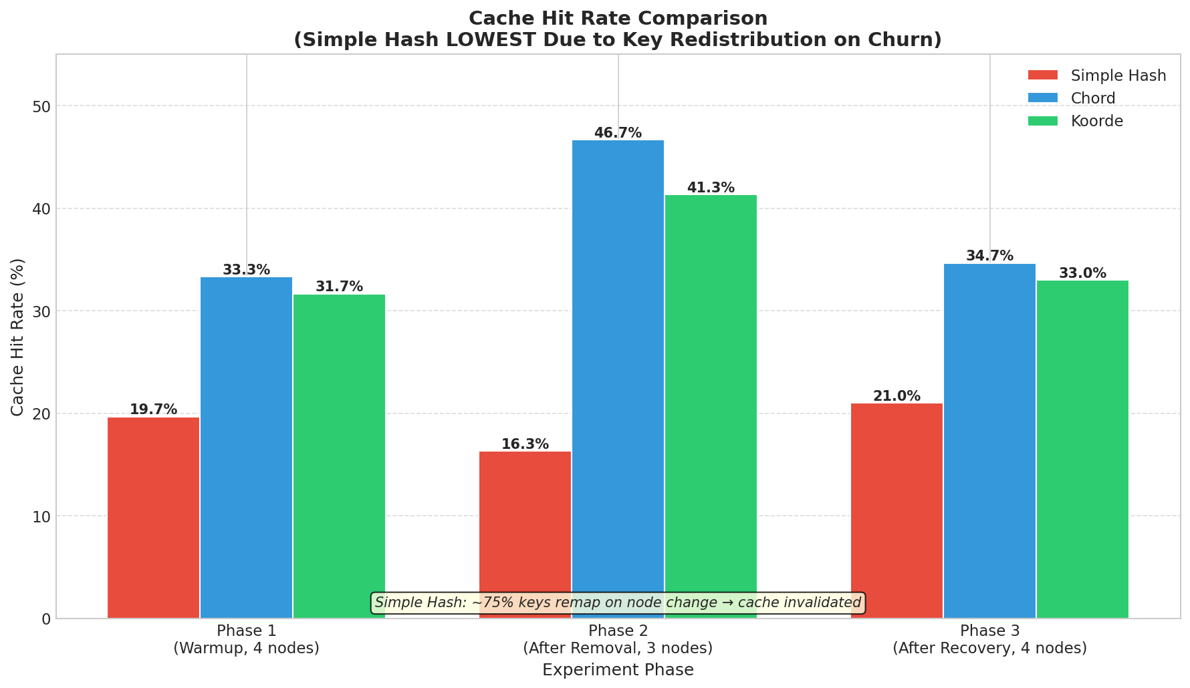
Hit Rate Comparison
- Chord highest hit rate (consistent hashing preserves cache).
- Koorde close behind (consistent hashing preserves cache).
- Simple Hash lowest (major remapping on churn).

Observed Hit Rate by Phase
Protocol | Phase 1 | Phase 2 | Phase 3 | Explanation
Simple Hash | 19.7% | 16.3% | 21.0% | Lowest - ~75% cache invalidated each phase
Chord | 33.3% | 46.7% | 34.7% | Highest - ~75% cache preserved
Koorde | 31.7% | 41.3% | 33.0% | Good - ~75% cache preserved

Analysis & Conclusions
- Consistent Hashing Wins: Both Chord and Koorde preserved ~75% of the cache during churn, leading to significantly higher hit rates than Simple Hash.
- Simple Hash Failure: Simple Hash invalidated ~75% of keys with every topology change, making it unsuitable for dynamic environments.
- Recommendation: For dynamic clusters, Chord or Koorde is required. Simple Hash is only acceptable for static clusters.

Experiment 3: Throughput Benchmark (Koorde vs Chord)

Summary
This experiment compares how Koorde and Chord scale under increasing concurrent load.

Setup
- Users tested: 50, 100, 200, 500, 1000, 2000, 4000
- Metric: throughput (Requests Per Second, RPS)
- Conditions: Koorde and Chord run under identical conditions
- Note: X-axis is equally spaced for clarity and does not represent actual numeric spacing between user counts

Key Observations
- Chord achieves significantly higher throughput, saturating around ~3000 RPS.
- Koorde saturates earlier (~2200 RPS) and declines at high load (4000 users).
- Chord demonstrates better stability and scalability under high concurrency.
- Koorde shows more sensitivity to overload conditions.

Chart
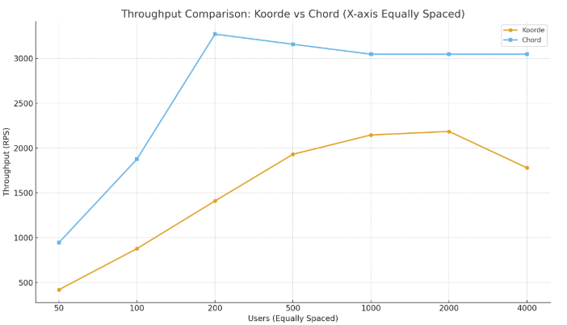
Throughput Comparison

Final Conclusion
Across all three experiments, Chord demonstrated superior performance and stability in this implementation:
- Latency: Chord maintained lower, flatter latency as the cluster scaled.
- Stability: Chord handled node churn with the highest cache hit rate.
- Throughput: Chord sustained higher RPS loads before saturation.
Koorde validated its theoretical properties (higher degree = lower latency) and performed well in churn (consistent hashing), but its implementation overhead appears higher than Chord's at these scales (up to 32 nodes). For production use at this scale, Chord is the recommended protocol.

