**Method**:

To deal with data sparsity and preserve dependency structure within the birth rates distribution, we propose a hierarchical model to estimate the birth rate of each county and distributions in each states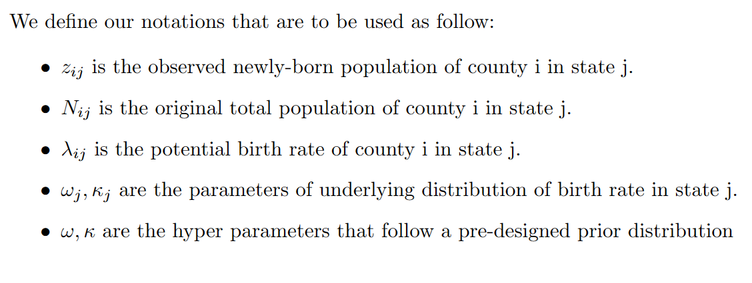 We define our notations as follow, where zij and nij are observation, lambda ij, omega j are the quantities of interest with omega, kappa being the hyper parameters.

The basic model structure is shown in this picture The model is quite similar to what we have done in homework 9. The only difference is that instead of Bernoulli likelihood we select Poisson likelihood for better interpretation.

**Future Work:**

1. We want to take advantages of the inductive property of Bayesian models, so that we can obtain a better estimation of parameters by setting the prior distribution to be the marginal posterior distribution in last year’s model.