Enhanced GARCH Model for SP500 Volatility

ECON/FIN250A Final Project

Yuzhou Liu, Qinghan Shen, Yukun Xia, Zihao Song, Jiaren Ma

12/8/2018

Our motivation to develop an enhanced model for SP500 volatility arises from the VIX spike during the market crush in early February, during which two large short volatility EFTs lost over 90% of their net worth. We generate a more accurate AR model including leverage effects to forecast volatility of SP500 by adding the dummy variables to the most recent return of index. We compare the forecast accuracy of our model to other models including traditional GARCH model, the simple AR model; and VIX itself; and we find out that our model is significantly more accurate than the other models. We believe our model could be applicated in the financial world to develop index option trading strategies, and control the overall risk exposure of portfolio.

# Topic Introduction

Nowadays, volatility is widely used as a prime perimeter for financial risk management. Risk parity funds tend to hedge their exposure using derivatives when the market volatility exceeds some certain levels. The traditional GARCH model for volatility forecasting implies that Volatility will risk after a large movement in markets regardless of the direction of the movement. However, market experiences show that VIX index, which is calculated using the IV of index option, tend to rise when market crushes, and decrease when market rises. This phenomenon could be explained by the leverage effect, and our goal is to add the leverage effect to the traditional model and test whether our model is more accurate in forecasting the real volatility of the market for the period than the traditional GARCH model and the VIX index.

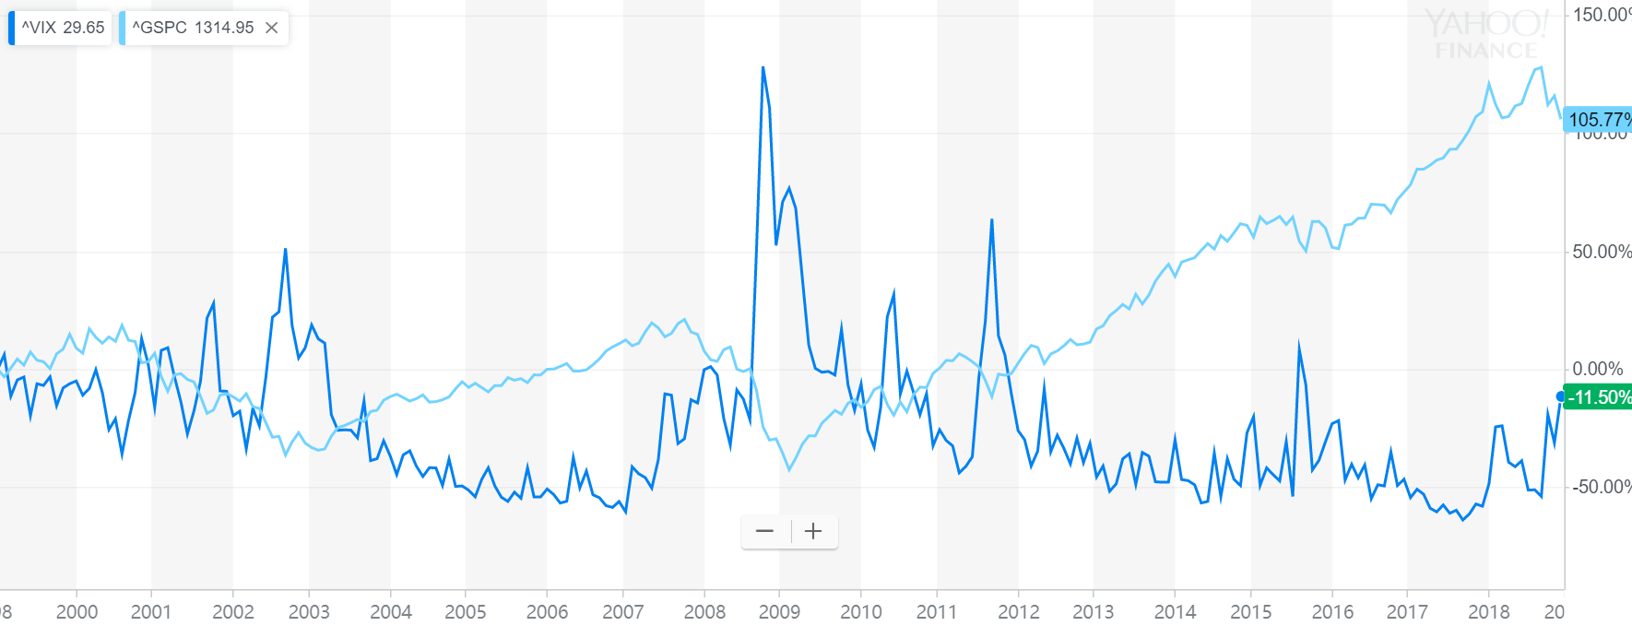

Source: Yahoo Finance

# Data Source

First, we use the daily open and close quote for S&P500 ETF from yahoo finance to generate the SP500 return time series. Second, we use the daily realized volatility SP500 data from Oxford-Man institute of quantitative Finance library to get the realized volatility of SP500 from 2000.Finally, we use the daily open and close data of VIX index from yahoo finance to get the market implied volatility of the SP500 index.

# Relized Volatility Forecasting

### Basic check for Realized Vol series

After getting the time series of realized volatility, SP500 returns and VIX, we want to investigate the properties of the data for our model selection. First, we plot the SP500 Daily Realized Volatility from 2000 to 2018 to get a full view. In the plot, we can find there are several peaks but the intervals between peaks are not constant. And the highest peak in 2008 could be demonstrated by Financial Crisis casuing market-wide panic. On the whole, we can conculde that the volatility has no seasonal pattern, and excluding the several extreme values, the volatility appears to be stationary. And the conclusion makes sense in real world because volatility is influenced by the market factors which have no seasonal pattern and market return also has long-run mean reversion which pulls the volatility to a certain level.

Since we assume the realized volatility is stationary, we use the type “one” unit root test, and we select the best model with lowest BIC. The t-test value is -7.9543, which is less than critical value for 1 percent significance level. Thus, we can conclude that on 99% confidence level, the realized volatility is stationary.

Then we use Acf and Pacf to find the autocorelation and partial autocorelation of the realized volatility. From Acf plot, we find the autocorelation decreases as the lag becomes larger, but even at lag 30, the atuocorelation is still larger than 0. From Pacf plot, only the first two pacf values are large and significant. And it seems that realized volatility can fit an AR(2) model. And we will dig into that later.

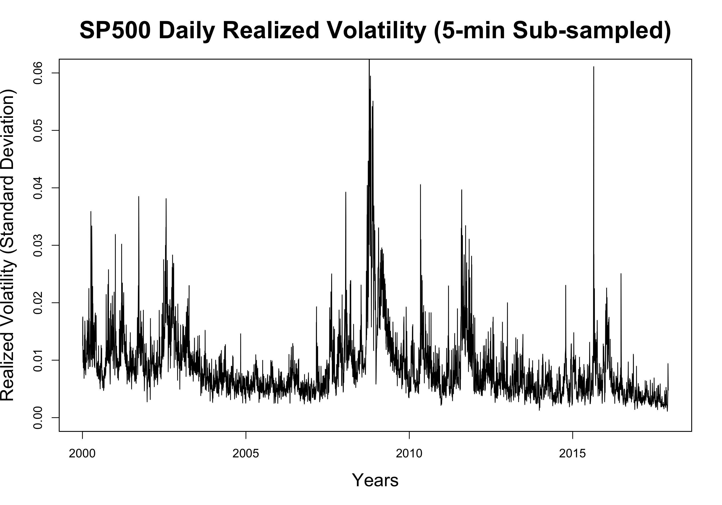

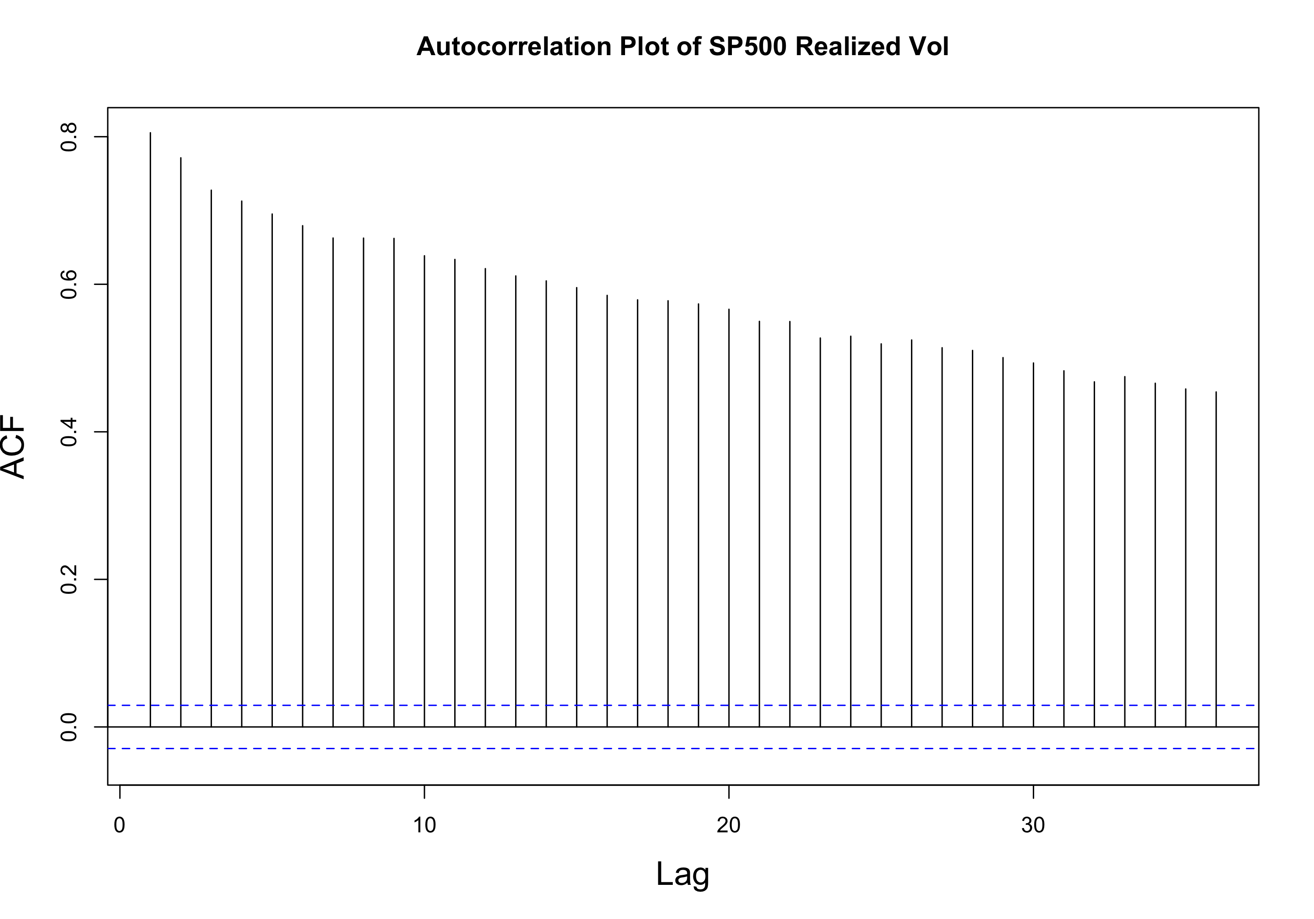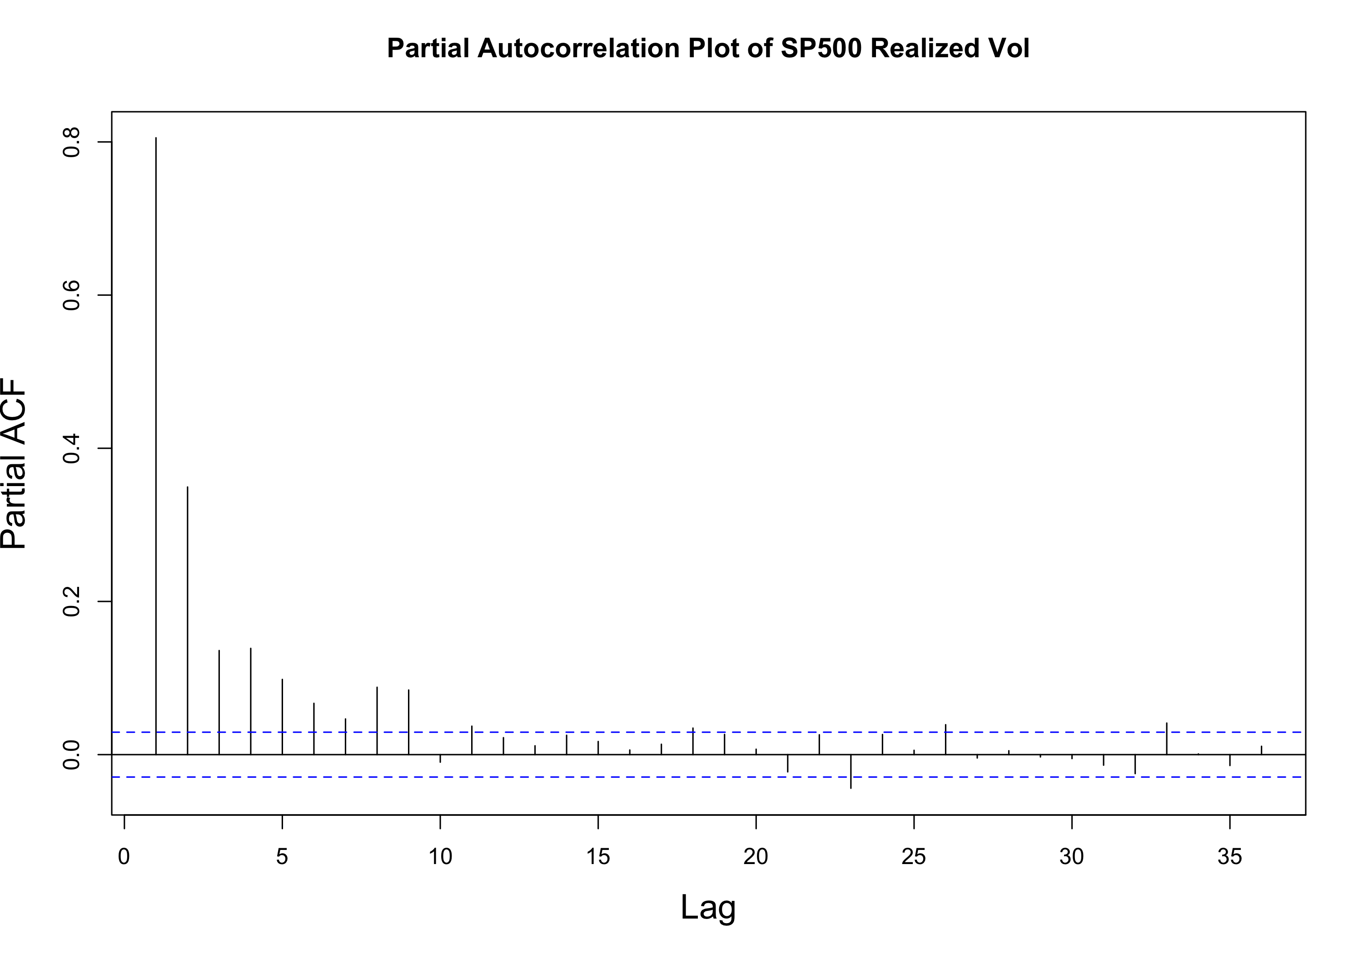

### Data Preprocessing

&&&5 some descripe of the process and train and validation ?

### GRACH Model as Benchmark

The chart below shows that GARCH model is not an accurate method to forecast SP500 volatility. During some periods when market goes up rapidly, the GARCH model???s forecast is even opposite to the real change in Volatility.

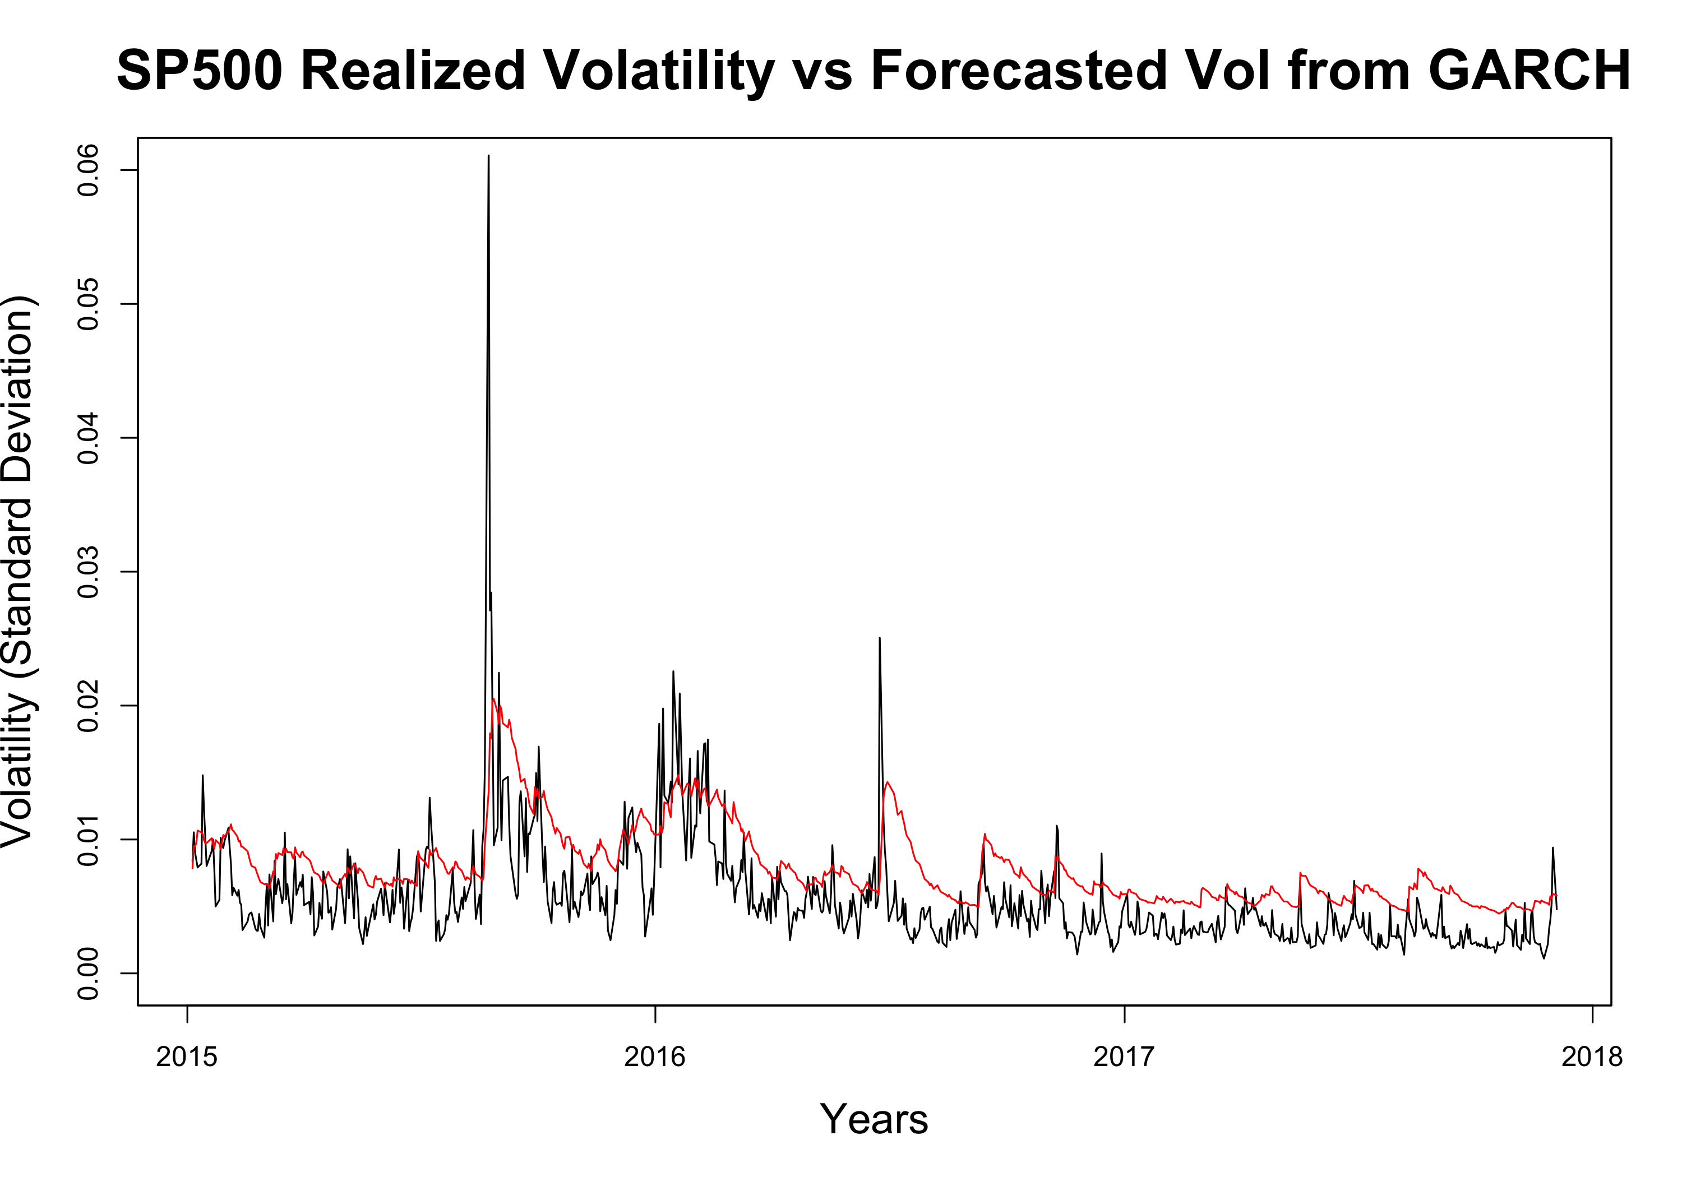

### Benchmark Model For Relized Volatility

&&&8 Explain how the two benchmark works and a little explaination of realized vol ?

### Leverage Effect as Dummy

For our first model, we add a dummy variable to the traditional model to factor in the leverage effect. This method assumes that leverage effect from return is a constant effect and do not scales with return itself.

The forecasting results give a significant lower error in the validation set, and the volatility forecasting improvements are statistically significant proved by Diebold/Mariano test (Pvalue=9.169e-05) against benchmark model without leaverage effect. The detailed outputs are shown in appendix. The improvement proved the the existence of leverage effect and feasibility to help volatility forecasting in S&P500 series.

### Leverage Effect as Return

For our second model, we simply add the return factor to the traditional GARCH model to mimic the leverage effect and test the accuracy of volatility forecasts in validation set. The forecasting results give a significant lower error in the validation set, and the volatility forecasting improvements are statistically significant proved by Diebold/Mariano test (Pvalue = 0.01411) against dummy leverage effect model. The detailed outputs are shown in appendix.

The better performance of this model shows that the leaverage is not a constant effect but can scale with the level of the return, meaning that higher positive returns or lower negative returns all have a bigger leverage effect on future volatility.

### Best Forecasting Model: Leverage effect as Return and Cross-product term with sign dummy

For our third model on the basis of second return model, we add the sign dummy multiply by the most recent return to reveal the asymmetric phenomenon in leverage effects, which is that Vol is more sensitive to leverage effect brought by negative returns and less to the effect brought by positive returns. And this model turns out to perform best in forecasting of S&P500 realized volatility based on the validation set error Table below.

**The forecasting error (MSE) from each Model**

|  |  |
| --- | --- |
|  | RMSE |
| **GARCH Model** | 0.003909 |
| **AR2 Benchmark** | 0.002883 |
| **MIDAS Benchmark** | 0.002862 |
| **Leverage Effect as Dummy Model** | 0.002812 |
| **Leverage Effect as Return Model** | 0.002754 |
| **Leverage Effect with Return and Dummy Model** | 0.002511 |

From the table, it is obvious that the forecasts improve as our models accouting for additional aspects and porperties of the leverage effect. Comparing to the orignial GARCH benchmark, our final best model offers great overall improvement at least in S&P500 series.

The best model is a MIDAS model with leverage effect (return and Cross-product term with sign dummy):

is the realized volatility in time t (daily), **Sign** is the indicator for return positive or negative (1 for positive and 0 for negative).

According to the formular, the leverage effect on negative return is **-0.1834Return**, and the leverage effect on positive return is **0.110819Return**. Therefore, it proved the asymmetric phenomenon that a leverage effect (negative relationship between Vol and return) is more prominent in negative returns than in positive ones.

# Final Conclusion

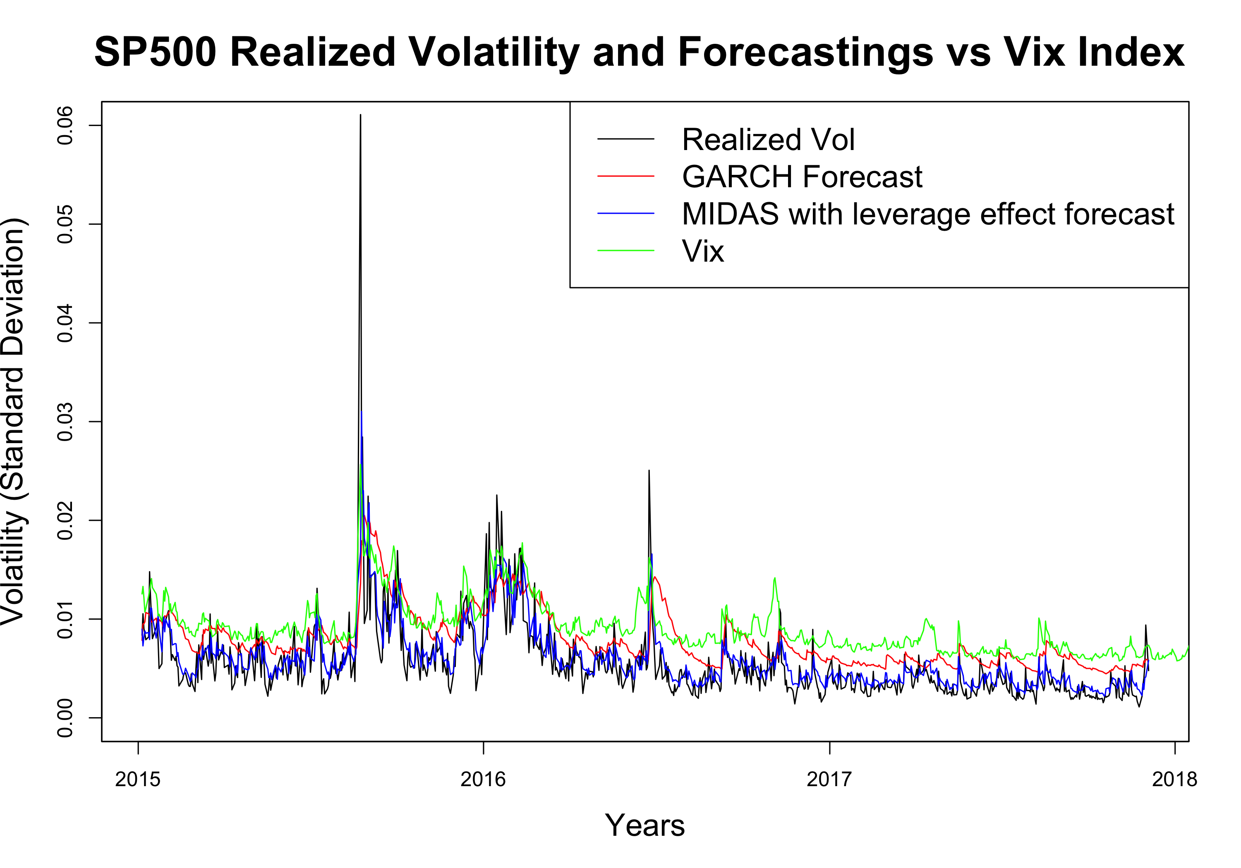

As the chart shown above, we can see that VIX is not an accurate estimation of the real volatility of the S&P500 index, because the annualized VIX is generally 3-5% higher than the historical real realized volatility of S&P500 on the long run, indicating that investors are overpaying for index options.

Moreover, the traditional GARCH model is a bad estimator for real volatility of the S&P500 index, because GARCH model ignores the leverage effects and in some strong bull market environments GARCH model???s estimation on future volatility is totally contradict to the real change in S&P500 volatility.

Finally, our MIDAS Model with leverage effect best fits the historical realized volatility of S&P500. Our model shows that volatility tend to rise after market crushes and volatility tend to drop in bull markets. We also find that future volatility is more sensitive to downward movements of the market and less sensitive to the upward movements in the market. We have two presumed explanations for these phenomena. Firstly, most large insurance companies using portfolio insurance strategy tend to sell some stock position or buying puts to deleverage their total exposure when the stock market falls, and their hedging actions would strengthen the market momentums and lead to higher volatility after market crushes. Secondly, behavior finance studies showed that most human beings tend to take profits after having some gain in portfolio. This risk aversion nature of investors makes the volatility of stock market drops when market goes up and less sensitive to the size of the upward movement.

# Potential Financial Applications

### Option Volatility Trading Strategy Monitor

Our MIDAS Model with leverage effect could be used to build option trading strategy when our model???s forecast Vol has a large dispersion with the VIX index. In rapidly crushing markets, the VIX index which is calculated using the implied volatility of 30 forward SP500 ETF options, is often temporarily over priced because some put sellers might be forced to unwind their position for margin call issues. If our model shows that the VIX is over-reacted we could enter the market to sell straddles to take advantage from the extraordinarily high implied volatility of options.

### Control Volatility

We use the model to forecast the sp500 volatility; and if the portfolio volatility rises above the maximize level we set, we sell some of the equity positions to deleverage our position and if the portfolio volatility drops below the certain given level, we leverage up our portfolio by buying more equity and investing less risk free assets.

We simulate the strategy sharp ratio by setting the target portfolio annually Volatility of 15%; and the testing results shows that the sharp ratio of using volatility control strategy is significantly higher than that of direct investment

|  |  |  |  |  |
| --- | --- | --- | --- | --- |
|  | SharpRatio | MeanReturn | SDReturn | SDofSD |
| **Vol Control Method** | 1.114 | 0.08722 | 0.05138 | 0.01461 |
| **Direct Investment** | 0.4424 | 0.08516 | 0.1247 | 0.06479 |

