Enhanced GARCH Model for SP500 Volatility

ECON/FIN250A Final Project

Yuzhou Liu, Qinghan Shen, Yukun Xia, Zihao Song, Jiaren Ma

12/8/2018

# Topic Introduction

Nowadays, volatility is widely used as a prime perimeter for financial risk management. Risk parity funds tend to hedge their exposure using derivatives when the market volatility exceeds some certain levels. The traditional GARCH model for volatility forecasting implies that Volatility will risk after a large movement in markets regardless of the direction of the movement. However, market experiences show that VIX index, which is calculated using the IV of index option, tend to rise when market crushes, and decrease when market rises. This phenomenon could be explained by the leverage effect, and our goal is to add the leverage effect to the traditional model and test whether our model is more accurate in forecasting the real volatility of the market for the period than the traditional GARCH model and the VIX index.

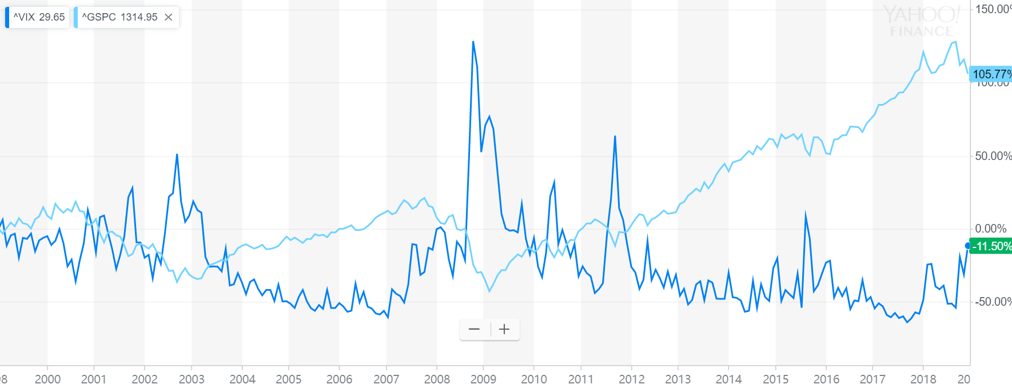

Source: Yahoo Finance

# Data Description

First, we use the daily open and close quote for S&P500 ETF from yahoo finance to generate the SP500 return time series. The plot of data is as follows. From the graph, we can see there is no obvious trend or seasonality.

Second, we use the daily realized volatility SP500 data from Oxford-Man institute of quantitative Finance library to get the realized volatility of SP500 from 2000.

Finally, we use the daily open and close data of VIX index from yahoo finance to get the market implied volatility of the SP500 index.

# Data Preprocessing

asdkjfhakjsdhf adsfouasoidfuioasudoifasd adskfjhasdjkfads

# Relized Volatility Forecasting

### Basic check for Relized Vol series

&&&1 The seasonal and trend or stationary from its plot? 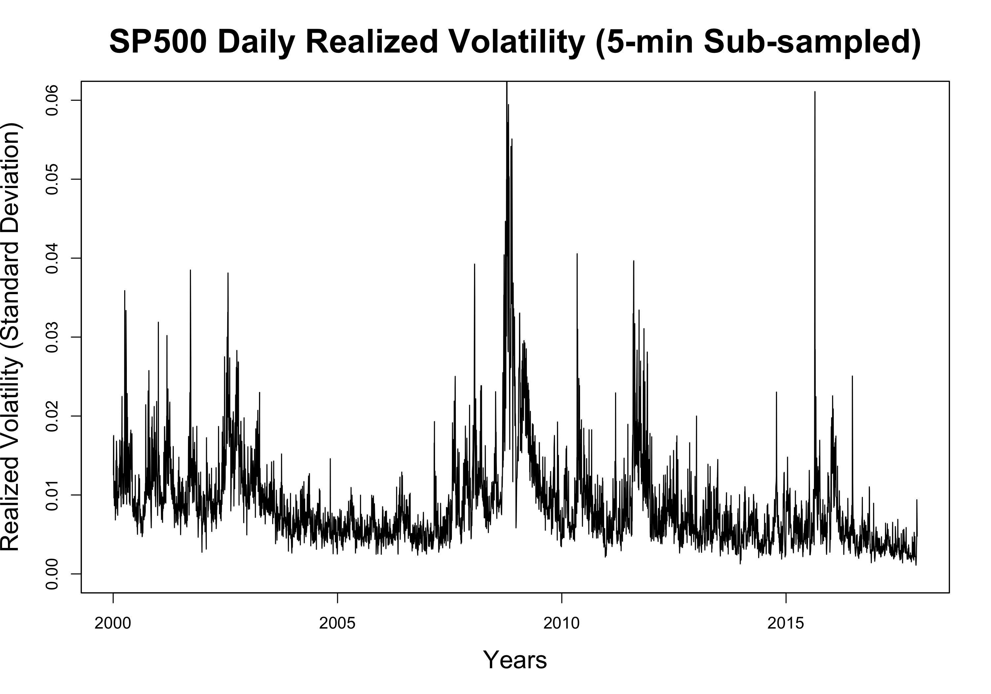

&&&2 Unit Root Test check stationary?

##   
## ###############################################################   
## # Augmented Dickey-Fuller Test Unit Root / Cointegration Test #   
## ###############################################################   
##   
## The value of the test statistic is: -7.9543

## [1] "Critical Value Table"

## 1pct 5pct 10pct  
## tau1 -2.58 -1.95 -1.62

&&&3 ACF and PACF ? &&&4 ACF and PACF ? 