Enhanced GARCH Model for SP500 Volatility

ECON/FIN250A Final Project

Abstract#1

Yuzhou Liu, Qinghan Shen, Yukun Xia, Zihao Song, Jiaren Ma

12/8/2018

# Topic Introduction

Nowadays, volatility is widely used as a prime perimeter for financial risk management. Risk parity funds tend to hedge their exposure using derivatives when the market volatility exceeds some certain levels. The traditional GARCH model for volatility forecasting implies that Volatility will risk after a large movement in markets regardless of the direction of the movement. However, market experiences show that VIX index, which is calculated using the IV of index option, tend to rise when market crushes, and decrease when market rises. This phenomenon could be explained by the leverage effect, and our goal is to add the leverage effect to the traditional model and test whether our model is more accurate in forecasting the real volatility of the market for the period than the traditional GARCH model and the VIX index.

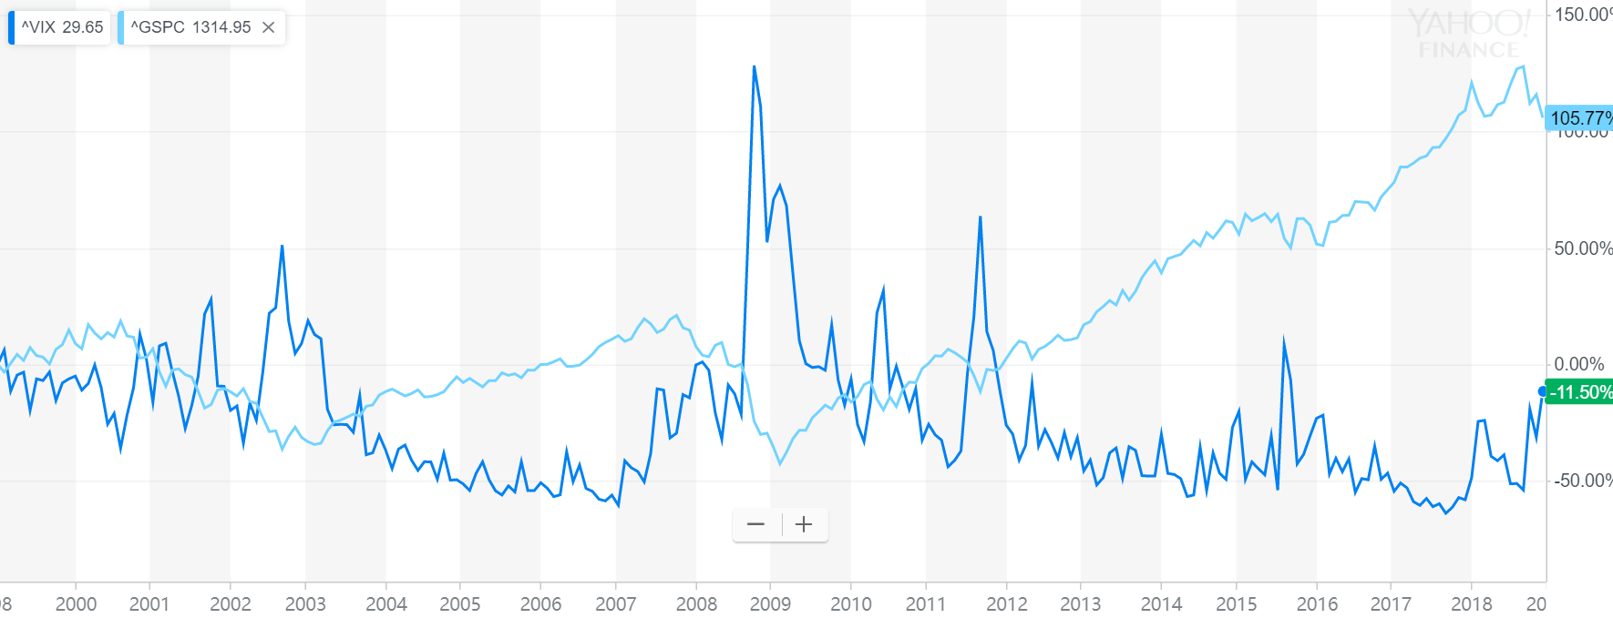

Source: Yahoo Finance

# Data Source

First, we use the daily open and close quote for S&P500 ETF from yahoo finance to generate the SP500 return time series. Second, we use the daily realized volatility SP500 data from Oxford-Man institute of quantitative Finance library to get the realized volatility of SP500 from 2000.Finally, we use the daily open and close data of VIX index from yahoo finance to get the market implied volatility of the SP500 index.

# Relized Volatility Forecasting

### Basic check for Realized Vol series

#2 The seasonal and trend or stationary from its plot? 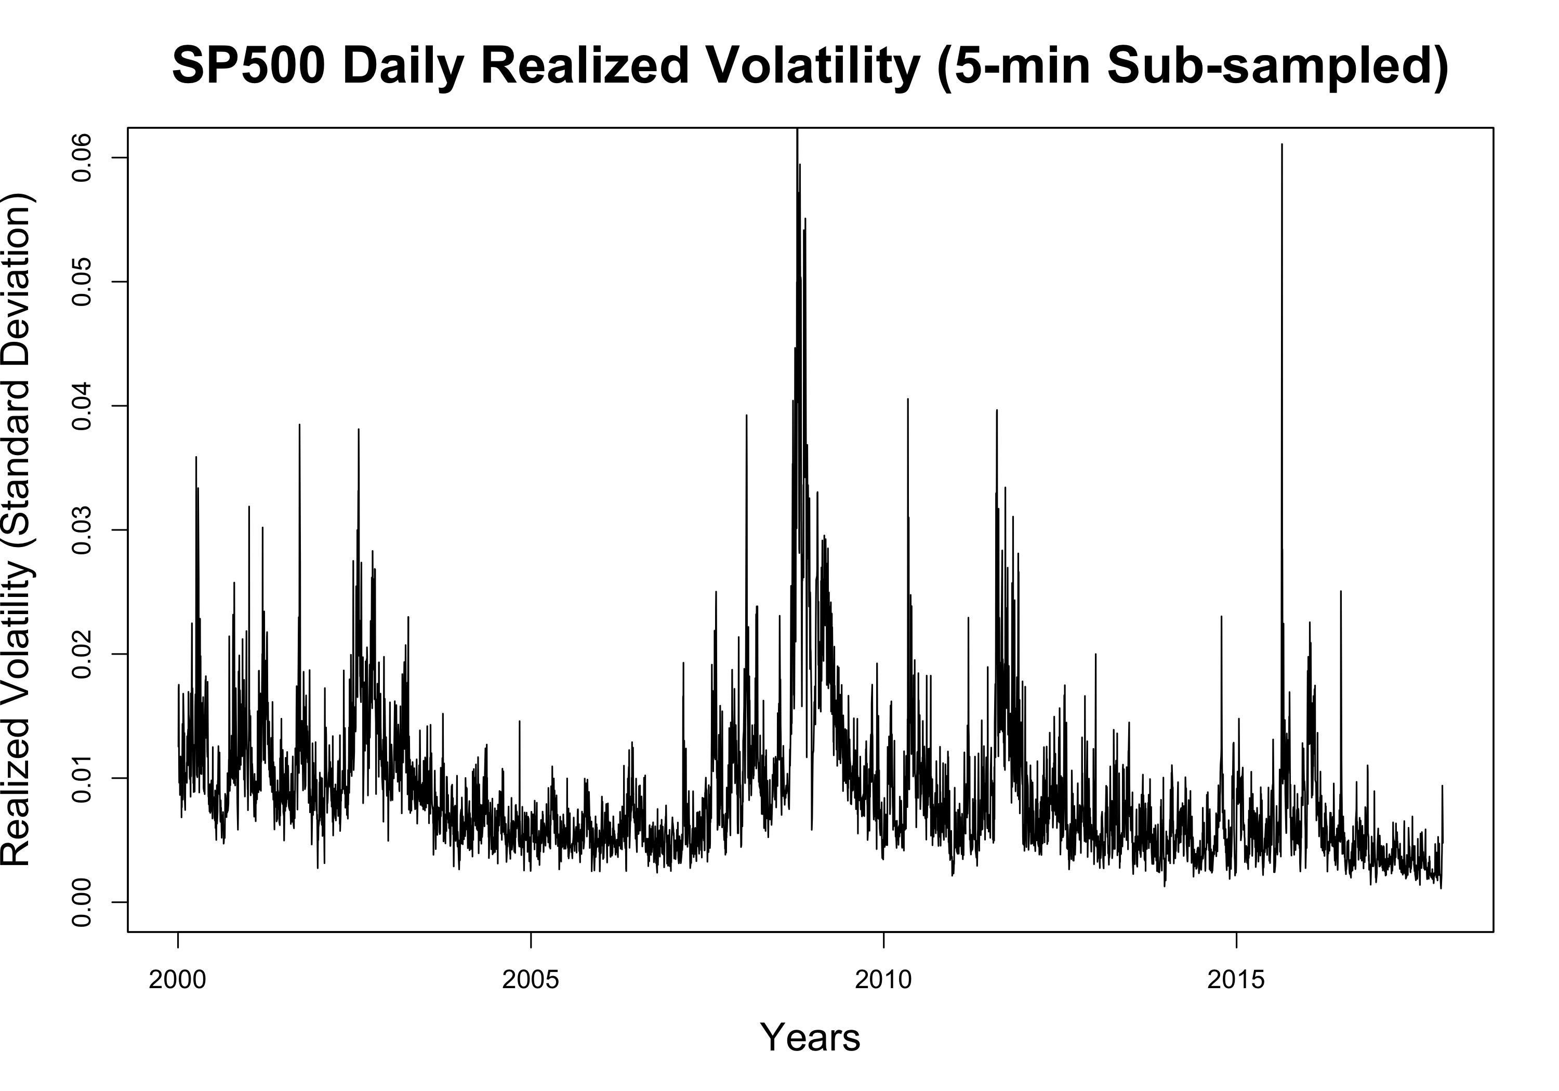

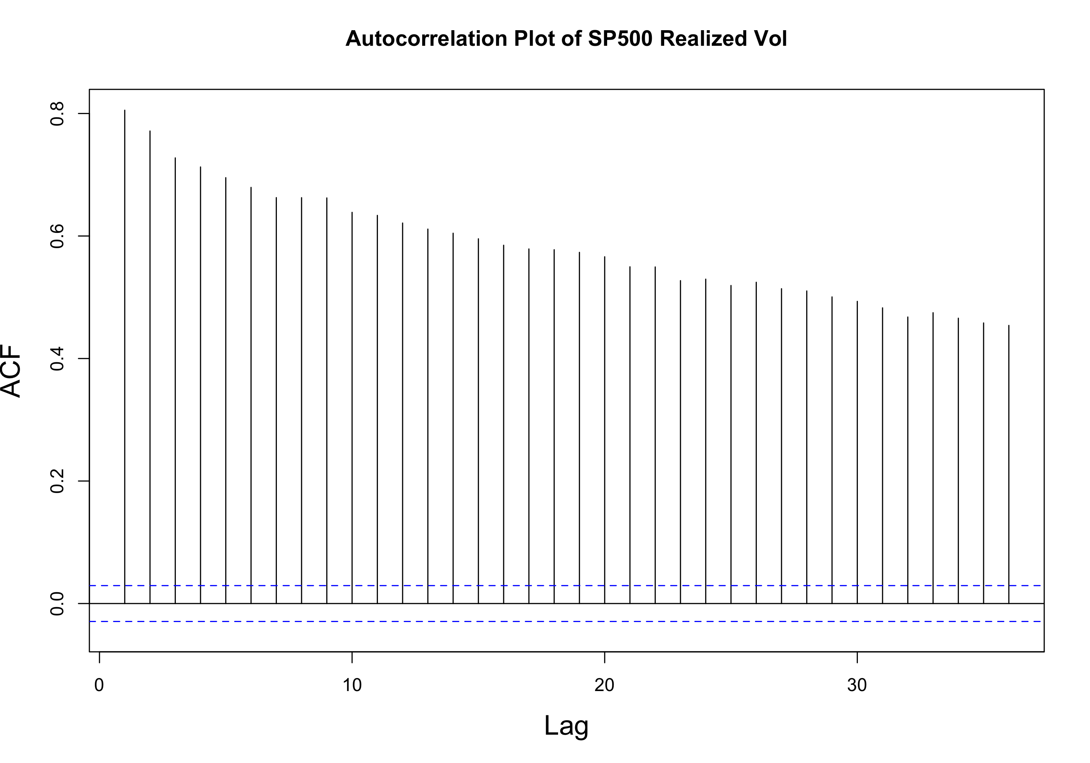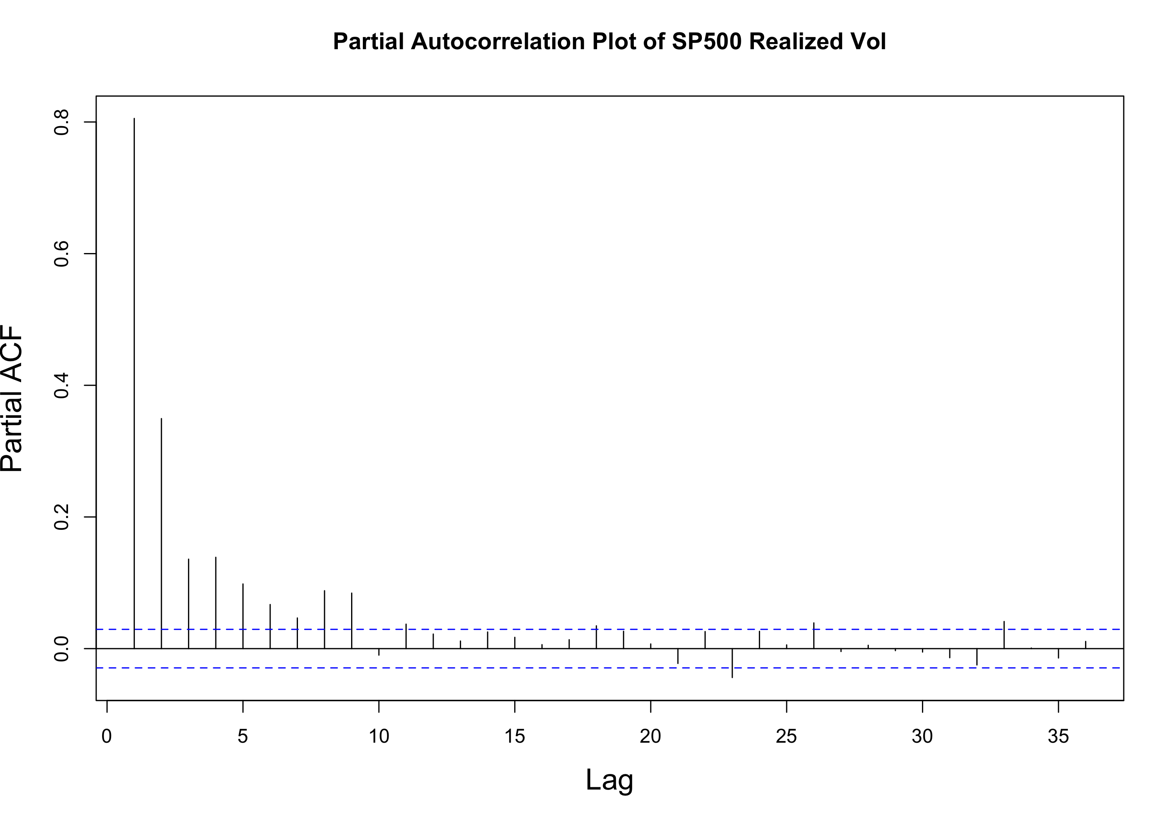

### Data Preprocessing

#3 怎么处理的data，最后进入model的data啥样

### GRACH Model as Benchmark

#4GARCH model的描述一下，然后在下面的图，说一下GARCH MODEL 表现不好，从图上看出来（具体到GRACH Model的估计lag的decrease of Real Vol）

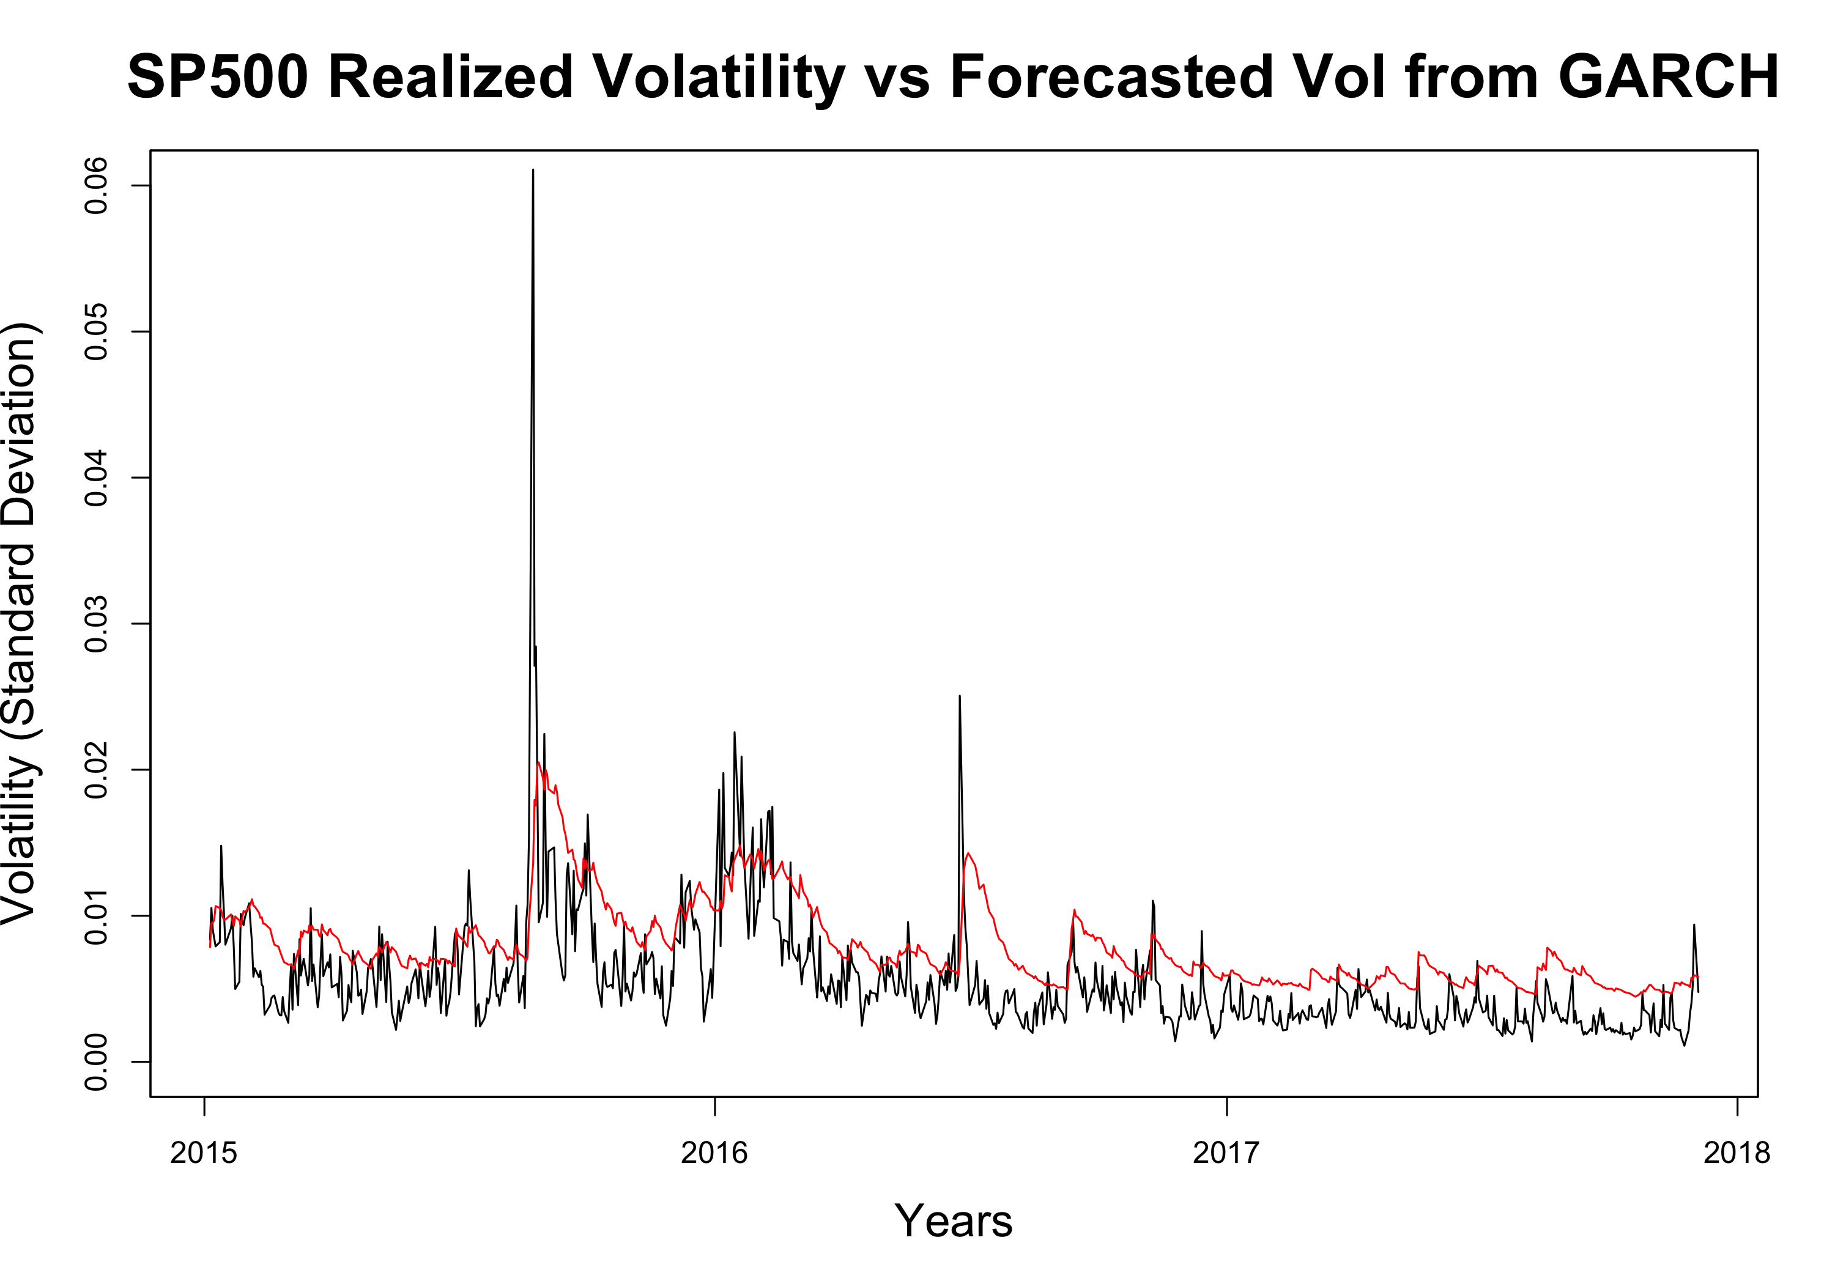

### Benchmark Model For Relized Volatility

#5 Benchmark Model For Relized Volatility 解释AR2 和 MIDAS model，以及他们最后的结果。

### Leverage Effect as Dummy

For our first model, we add a dummy variable to the traditional model to factor in the leverage effect. This method assumes that leverage effect from return is a constant effect and do not scales with return itself.

The forecasting results give a significant lower error in the validation set, and the volatility forecasting improvements are statistically significant proved by Diebold/Mariano test against benchmark model without leaverage effect. The detailed outputs are shown in appendix. The improvement proved the the existence of leverage effect and feasibility to help volatility forecasting in S&P500 series.

### Leverage Effect as Return

For our second model, we simply add the return factor to the traditional GARCH model to mimic the leverage effect and test the accuracy of volatility forecasts in validation set. The forecasting results give a significant lower error in the validation set, and the volatility forecasting improvements are statistically significant proved by Diebold/Mariano test (Pvalue = ) against dummy leverage effect model. The detailed outputs are shown in appendix.

The better performance of this model shows that the leaverage is not a constant effect but can scale with the level of the return, higher

### Return and Dummy

&&&10 Explain the result?

### Model Selection/Evaluation

&&&13 Explain which model is best, and look deep into the model, and some things to notice

**The forecasting error (MSE) from each Model**

|  |  |
| --- | --- |
|  | RMSE |
| **GARCH Model** | 0.003909 |
| **AR2 Benchmark** | 0.002883 |
| **MIDAS Benchmark** | 0.002862 |
| **Leverage Effect as Dummy Model** | 0.002812 |
| **Leverage Effect as Return Model** | 0.002754 |
| **Leverage Effect with Return and Dummy Model** | 0.002511 |

# Final Conclusion

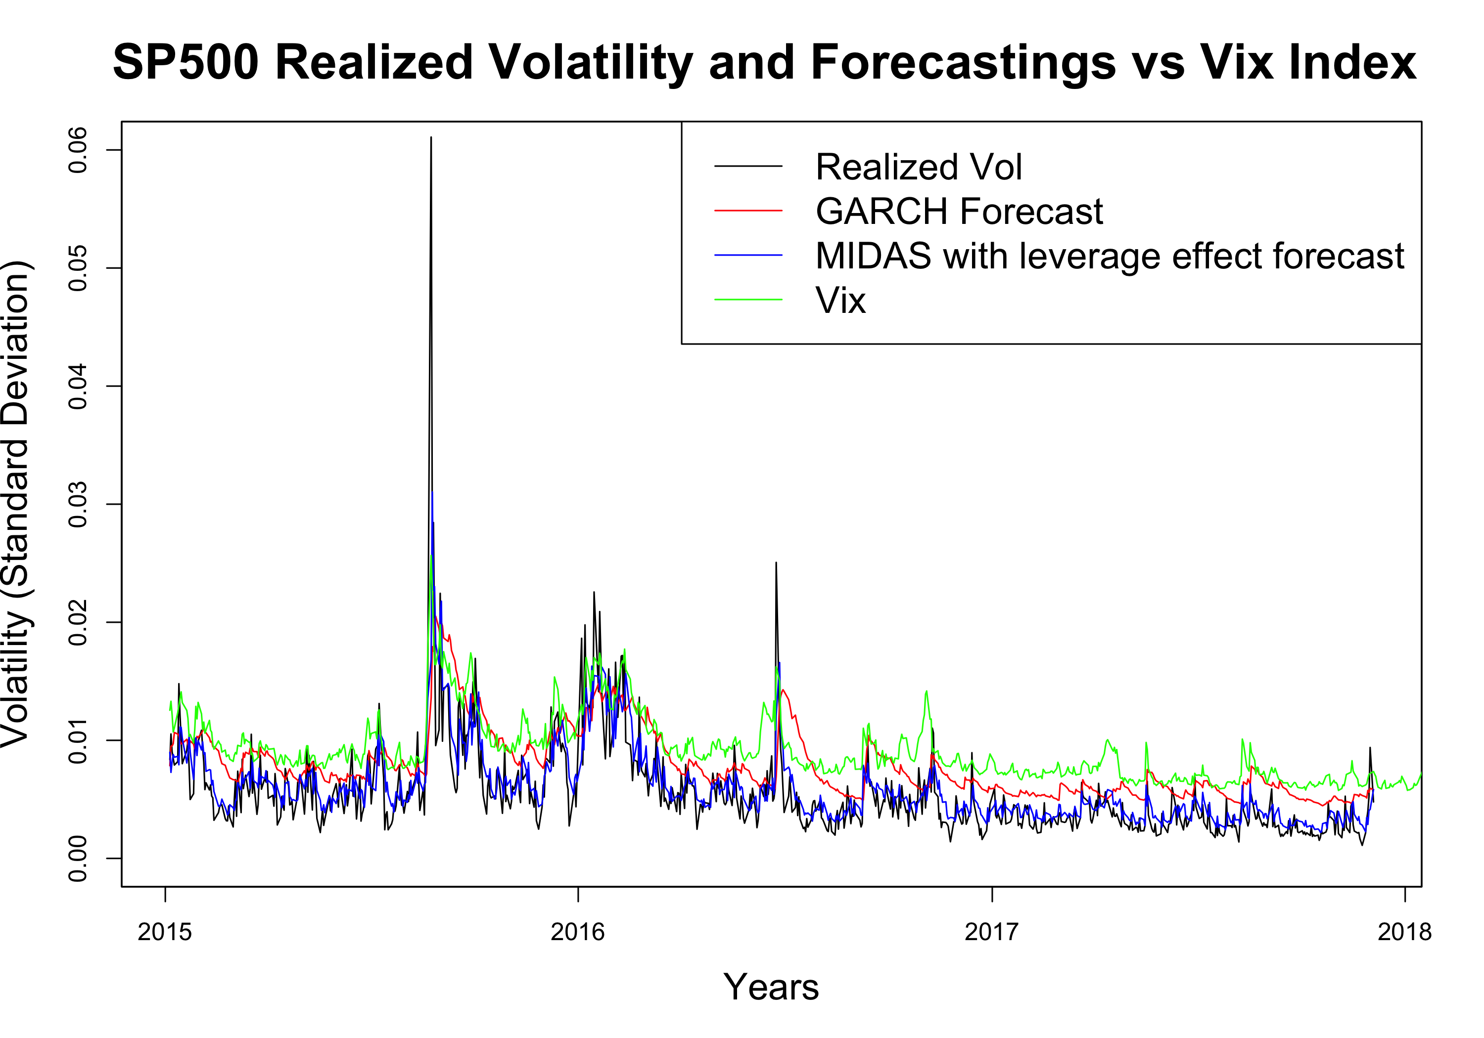

As the chart shown above, we can see that VIX is not an accurate estimation of the real volatility of the S&P500 index, because the annualized VIX is generally 3-5% higher than the historical real realized volatility of S&P500 on the long run, indicating that investors are overpaying for index options.

Moreover, the traditional GARCH model is a bad estimator for real volatility of the S&P500 index, because GARCH model ignores the leverage effects and in some strong bull market environments GARCH model’s estimation on future volatility is totally contradict to the real change in S&P500 volatility.

Finally, our MIDAS Model with leverage effect best fits the historical realized volatility of S&P500. Our model shows that volatility tend to rise after market crushes and volatility tend to drop in bull markets. We also find that future volatility is more sensitive to downward movements of the market and less sensitive to the upward movements in the market. We have two presumed explanations for these phenomena. Firstly, most large insurance companies using portfolio insurance strategy tend to sell some stock position or buying puts to deleverage their total exposure when the stock market falls, and their hedging actions would strengthen the market momentums and lead to higher volatility after market crushes. Secondly, behavior finance studies showed that most human beings tend to take profits after having some gain in portfolio. This risk aversion nature of investors makes the volatility of stock market drops when market goes up and less sensitive to the size of the upward movement.

# Potential Financial Applications

### Option Volatility Trading Strategy Monitor

Our MIDAS Model with leverage effect could be used to build option trading strategy when our model’s forecast Vol has a large dispersion with the VIX index. In rapidly crushing markets, the VIX index which is calculated using the implied volatility of 30 forward SP500 ETF options, is often temporarily over priced because some put sellers might be forced to unwind their position for margin call issues. If our model shows that the VIX is over-reacted we could enter the market to sell straddles to take advantage from the extraordinarily high implied volatility of options.

### Control Volatility

#6Control Volatility 下面，这个strategy的逻辑，以及最后验证的结果显著提高了sharp ratio。

|  |  |  |  |  |
| --- | --- | --- | --- | --- |
|  | SharpRatio | MeanReturn | SDReturn | SDofSD |
| **Vol Control Method** | 0.07015 | 0.08722 | 0.8156 | 0.01461 |
| **Direct Investment** | 0.02787 | 0.08516 | 1.98 | 0.06479 |

