DISTINCTION CODING · DevOps/SRE Track
Week 1 Lab
Linux Basics & GitOps
90 minutes

Before the timer starts
Complete Section 1 (EC2 setup) first. Once you see *** READY *** in your terminal, the 90-minute clock starts.

SECTION 1 EC2 Setup

1.1 Launch an EC2 instance

Log in to https://console.aws.amazon.com

Step 1 — Set your region
- Click the region dropdown (top-right corner)
- Select ap-southeast-2 (Sydney)

Step 2 — Launch EC2
- Search for "EC2" in the top search bar and click Launch instance

Step 3 — Configure the instance
Field | Value
Name | linux-lab-yourname
AMI | Ubuntu Server 22.04 LTS (HVM), SSD Volume Type
Architecture | 64-bit (x86)
Instance type | t2.micro (Free Tier eligible)
Key pair | Create new → see Step 4
Storage | 8 GiB gp3 (default)

Step 4 — Create a Key Pair
- Click Create new key pair
- Name: lab-key Type: RSA Format: .pem
- Click Create key pair — browser downloads lab-key.pem
- Save it somewhere you can find it

You only get this file once
AWS never shows you this private key again. Lose it and you must terminate the instance and start over.

Step 5 — Network settings
Click Edit inside Network settings:

Setting | Value
VPC | Default VPC
Subnet | Any — pick the first in the list
Auto-assign Public IP | ENABLE ← critical, without this you cannot SSH in
Firewall | Create security group → name it lab-sg

Step 6 — Security Group rules
Rule | Type | Port | Source
Rule 1 | SSH | 22 | My IP (auto-filled)
Rule 2 | HTTP | 80 | Anywhere 0.0.0.0/0

Step 7 — Launch and get your Public IP
- Click Launch instance
- Wait until Instance State = "running" and Status check = "2/2 checks passed"
- Copy your Public IPv4 address

1.2 SSH into your instance

Mac / Linux
chmod 400 ~/Downloads/lab-key.pem
ssh -i ~/Downloads/lab-key.pem ubuntu@<YOUR-PUBLIC-IP>

Windows — Git Bash
chmod 400 /c/Users/YourName/Downloads/lab-key.pem
ssh -i /c/Users/YourName/Downloads/lab-key.pem ubuntu@<YOUR-PUBLIC-IP>

Type yes at the fingerprint prompt. You are in when you see: ubuntu@ip-xxx:~$

Common SSH errors
Error | Fix
Permission denied (publickey) | Wrong .pem path, or forgot chmod 400
Connection timed out | Security Group port 22 not open, or wrong IP
UNPROTECTED PRIVATE KEY FILE | Run chmod 400 on the .pem file

1.3 Plant the lab environment

Copy the entire block below, paste into your terminal, and press Enter. Takes 1–3 minutes.

Do not start your timer until you see *** READY ***
The script installs packages and breaks things for you to fix.

sudo bash << 'LABSETUP'
set -e
TARGET_PCT=85
echo '--- Installing packages ---'
apt-get update -q
apt-get install -y nginx
mkdir -p /etc/nginx/sites-available /var/www/html
cat > /etc/nginx/sites-available/myapp.conf << 'NGINXEOF'
server {
listen 80;
server_name _;
root /var/www/html
index index.html;
}
NGINXEOF
ln -sf /etc/nginx/sites-available/myapp.conf /etc/nginx/sites-enabled/myapp.conf
rm -f /etc/nginx/sites-enabled/default
echo '<h1>Hello from '$(hostname)'</h1>' > /var/www/html/index.html
systemctl stop nginx
systemctl disable nginx
echo '--- Filling disk ---'
mkdir -p /var/log/myapp
TOTAL_KB=$(df / | awk 'NR==2{print $2}')
USED_KB=$(df / | awk 'NR==2{print $3}')
NEED_KB=$(( TOTAL_KB * TARGET_PCT / 100 - USED_KB ))
if [ $NEED_KB -gt 102400 ]; then
MAIN=$(( NEED_KB * 70 / 100 / 1024 ))
REST=$(( NEED_KB * 30 / 100 / 1024 ))
dd if=/dev/urandom bs=1M count=${MAIN} 2>/dev/null | base64 > /var/log/myapp/app.log
dd if=/dev/zero bs=1M count=${REST} of=/var/log/myapp/debug.log 2>/dev/null
fi
df -h /
chown root:root /var/log/myapp
chmod 700 /var/log/myapp
echo ''
echo '*** READY ***'
LABSETUP

PART A Troubleshooting

A1
Web service is not responding

curl http://localhost returns nothing. The server should be serving a webpage on port 80. Find every reason it is broken and fix them all.

There is more than one bug
Do not stop after the first fix. Keep going until curl http://localhost returns a 200 with HTML.

Deliver
- Every diagnostic command you ran, in order, with a one-line comment explaining what you were looking for
1. curl http://localhost
结果：curl: (7) Failed to connect to localhost port 80 after 1 ms: Couldn't connect to server

发现80端口连接不上

2. ping google.com
成功
证明server网络正常

3. ping localhost
成功

4. nslookup localhost
解析到了127.0.0.1

说明：
localhost 解析没问题，但是 80 端口没有 web server 在监听
- nc -zv localhost 80
说明：
localhost 解析成功了，网络也到了本机，但是 本机 80 端口没有任何程序在监听。
不是 DNS 问题
不是 localhost 问题
不是 curl 问题
不是 security group 问题
- 怀疑webserver，排查nginx
- which nginx
ubuntu@ip-172-31-27-110:~$ which nginx
/usr/sbin/nginx
说明nginx 已经安装
- systemctl status nginx
检查nginx 状态 Active: inactive (dead)
- sudo systemctl start nginx
尝试启动nginx 失败
- systemctl status nginx.service

- ubuntu@ip-172-31-27-110:~$ sudo nginx -t
2026/06/05 13:45:47 [emerg] 2065#2065: invalid number of arguments in "root" directive in /etc/nginx/sites-enabled/myapp.conf:5

- nano /etc/nginx/sites-enabled/myapp.conf

- root路径不正确 加了一个；
- sudo nginx -t
成功
- sudo systemctl restart nginx
- curl http://localhost 成功
- sudo systemctl enable nginx
设置开机自启动nginx

- Each root cause you found — list them separately
  - 本机 80 端口没有任何程序在监听
  - nginx 状态 Active: inactive (dead)
  - 尝试启动nginx 失败,nginx 配置文件错误
  - nginx 没有设置开机自启动
- The exact fix commands for each root cause
  - nc -zv localhost 80
  - systemctl status nginx
  - sudo systemctl start nginx，sudo nginx -t nano /etc/nginx/sites-enabled/myapp.conf
  - sudo systemctl enable nginx
- Final proof: output of curl -v http://localhost showing HTTP 200
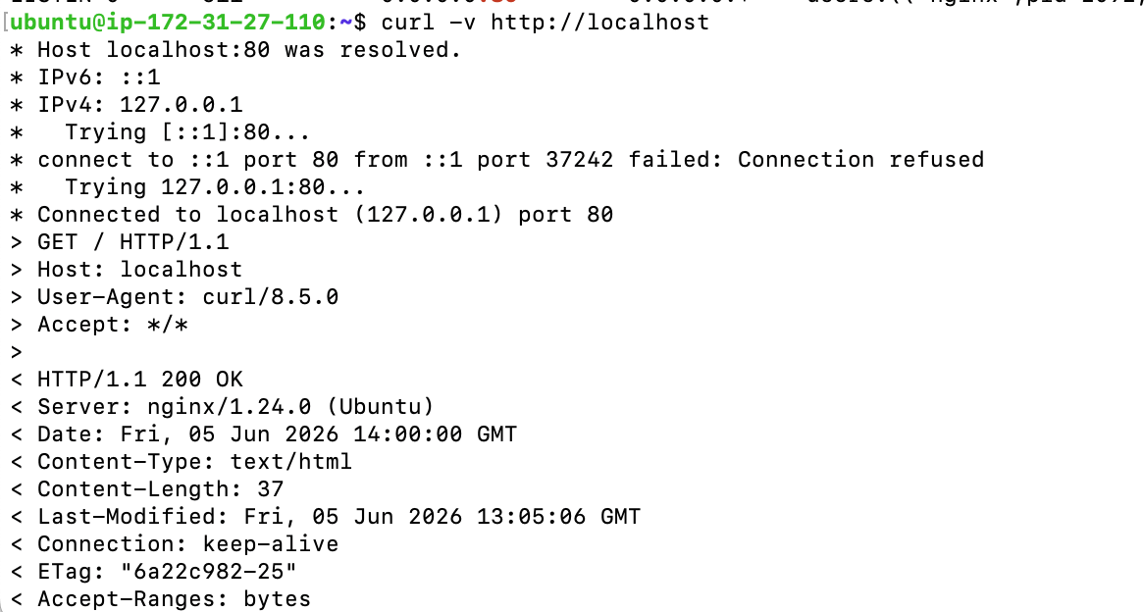

A2
Disk space alert

df -h shows the root partition / is nearly full. The application has been writing uncontrolled log files. Find what is consuming space, clean it up safely, and prevent it happening again.

A2-1 — Find the space consumers
Write the commands to show overall disk usage and identify the top 5 largest files or directories under /var. Show the actual output.
- df -h
- sudo du -hd1 /var | sort -h
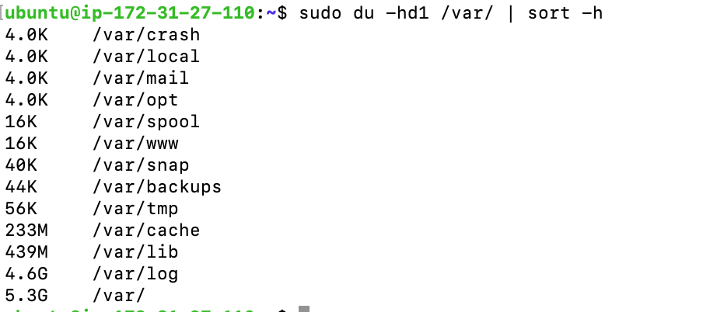

A2-2 — Safe cleanup
- Before deleting any log file, check whether a running process has it open. Write the command. Explain what happens on Linux if you rm a file a process has open. Explain what you do instead and why.

- sudo du -h /var/log
发现myapp占4.6g
- sudo lsof /var/log/myapp/
发现没有进程占用
- sudo du -hd1 /var/log/myapp/
发现只有两个文件，app.log和debug.log一起占4.6g内存

- sudo lsof /var/log/myapp/app.log ， sudo lsof /var/log/myapp/app.log
发现都没有进程占用
- sudo truncate -s 0 /var/log/myapp/app.log, sudo truncate -s 0 /var/log/myapp/debug.log
把文件清理而不是删除
- 清理apt缓存， sudo apt clean

if rm a file that has process running on it, the file is not offically removed, the file name will disappear but the process will keep writing into this file.
- Clean up enough to bring / usage below 70%. Show df -h output before and after.
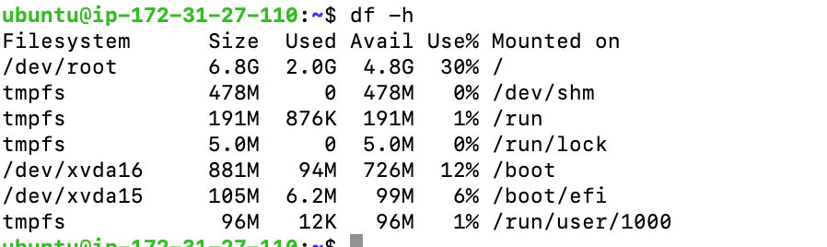

A2-3 — Configure logrotate
Create /etc/logrotate.d/myapp so this cannot happen again. Requirements:
- Target /var/log/myapp/*.log
- Rotate daily, keep 7 days, compress old files
- Do not error if the log file does not exist
- Handle the case where the application keeps the log file open while it is being rotated
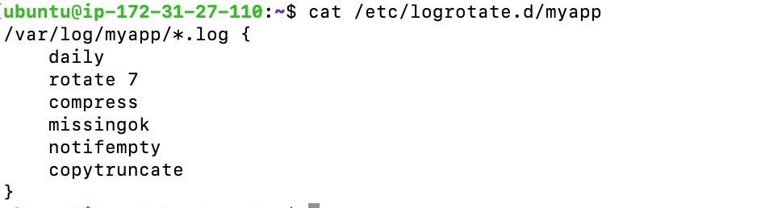
Verify your config with a dry run and include the output in your answer.
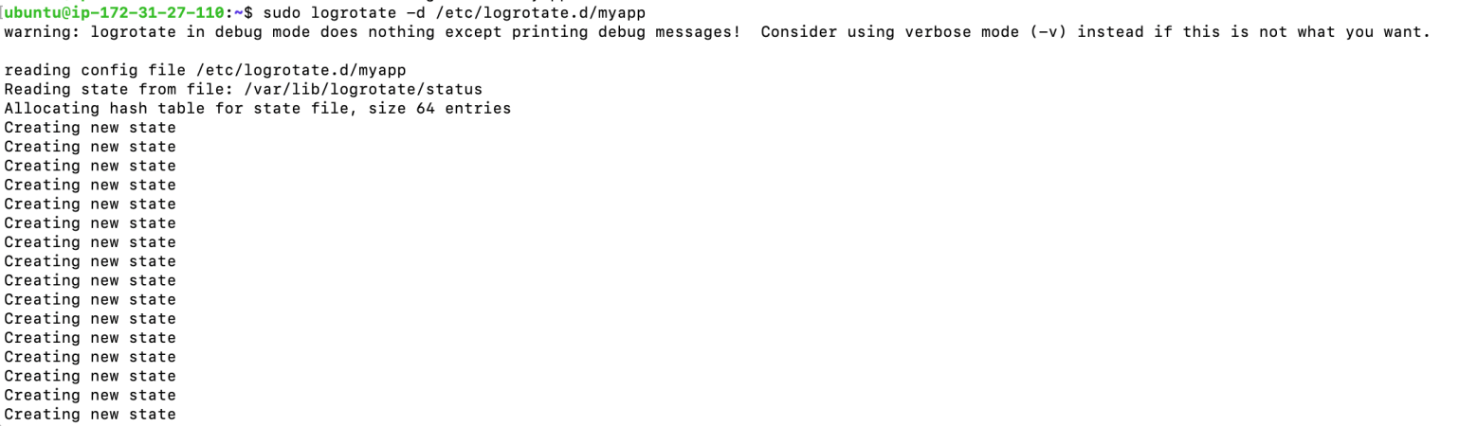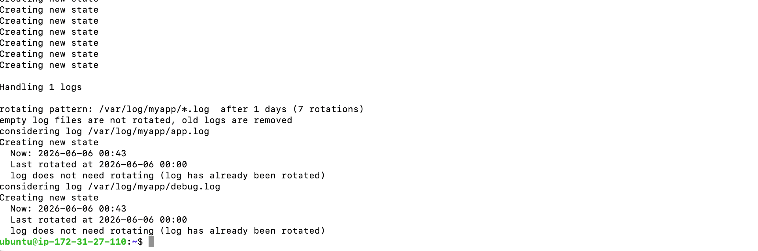

PART B Shell Scripting

B1
Health check script

Create /usr/local/bin/healthcheck.sh from scratch. No skeleton — write the whole thing yourself.

Requirements
- Check if nginx is running using its systemd exit code. If down, restart it and log the result. If restart fails, log the error and exit with code 1.
- Check disk usage on /. Log a WARNING if above 80%.
- Check memory usage. Log a WARNING if above 85%.
- All thresholds and the log path must be variables at the top of the script.
- Every log line must include a timestamp in this exact format: [YYYY-MM-DD HH:MM:SS]
- Write all output to /var/log/healthcheck.log

Required log format
[2025-06-01 14:32:01] OK nginx is running
[2025-06-01 14:32:01] WARNING disk usage is 87% on /
[2025-06-01 14:32:01] WARNING memory usage is 89%
[2025-06-01 14:32:02] ACTION nginx was down -- restarting
[2025-06-01 14:32:03] OK nginx restarted successfully
[2025-06-01 14:32:03] ERROR nginx failed to restart

Make it executable and test it. Show the log output as proof it works.
sh file in week1-lab branch : Git repo: https://github.com/YuzhuoMa816/DistinctionCode.git

- sudo nano /usr/local/bin/healthcheck.sh
- sudo chmod +x /usr/local/bin/healthcheck.sh
- ls -l /usr/local/bin/healthcheck.sh
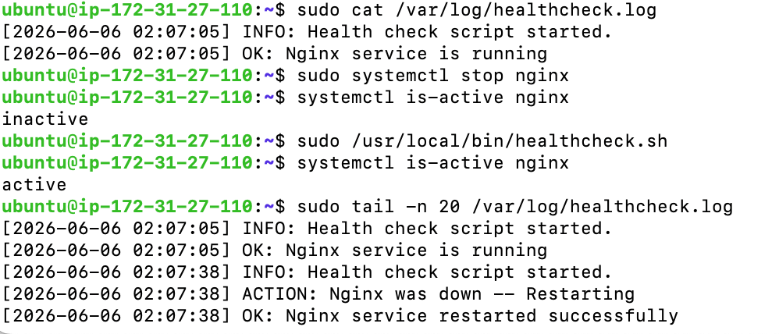

B2
Schedule and permissions

- Schedule healthcheck.sh to run every 5 minutes as root using cron. Write the full crontab entry. Explain each of the five time fields and explain why cron requires an absolute path.

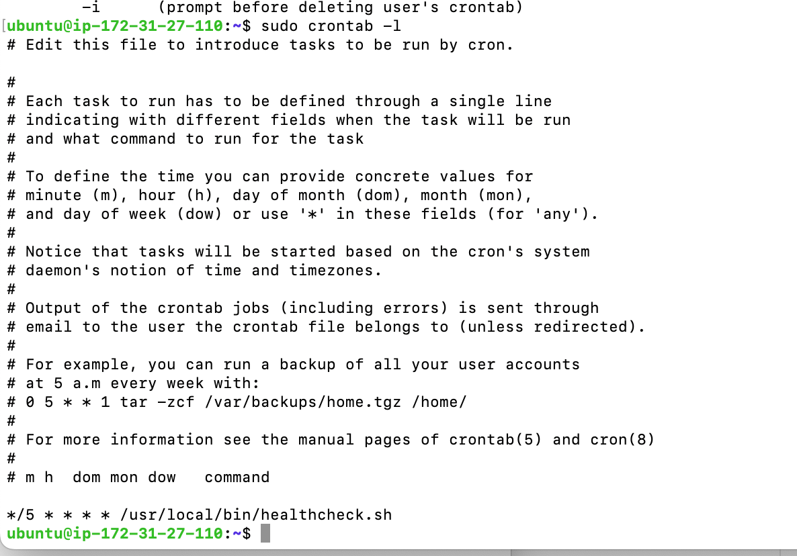
Explain each of the five time fields: minute hour day-of-month month day-of-week command
explain why cron requires an absolute path: we do not sure if cron execute on the path we put our script in, absolute path can make sure we execute correct shell script
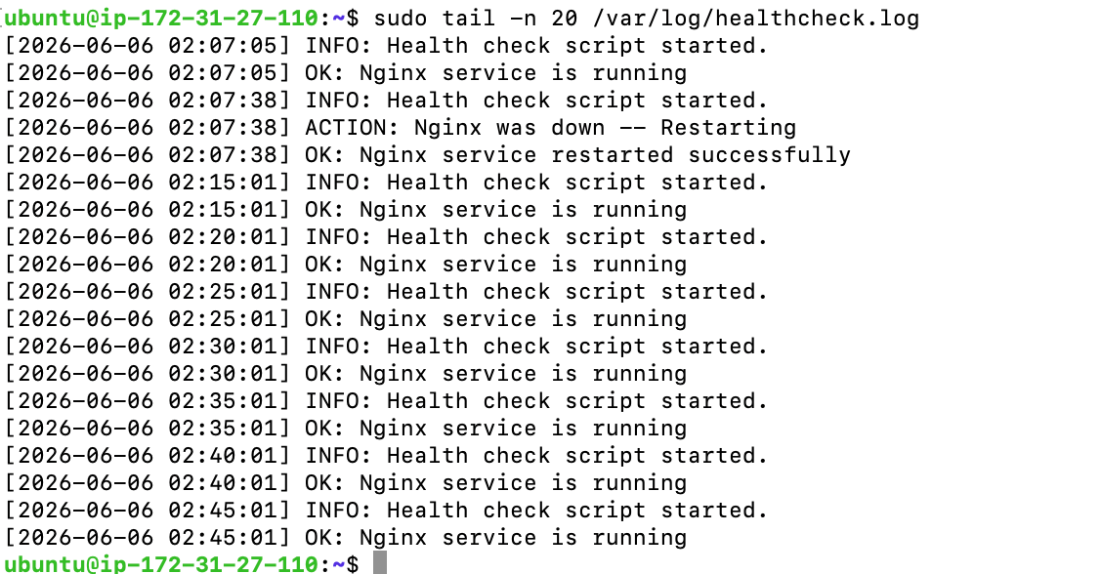
Create a system user appuser with no home directory and no login shell. Show the command and verify it with grep /etc/passwd.
sudo useradd --system --no-create-home --shell /usr/sbin/nologin appuser

- Transfer ownership of /var/log/myapp/ to appuser. Set permissions so only appuser can read or write it. Show ls -la output as proof. Explain what the three permission digits mean.
  - sudo mkdir -p /var/log/myapp/
  - sudo chown appuser:appuser /var/log/myapp/
  - sudo chmod 700 /var/log/myapp/
change owner to appuser
assign only owner can rwx, group 其他用户 can not
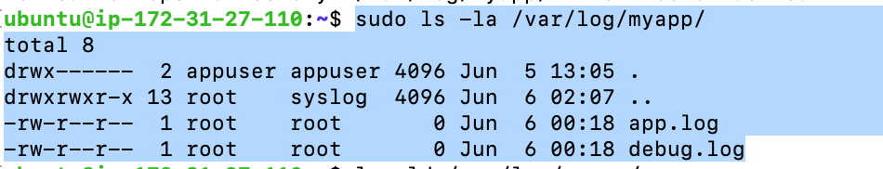
- Set healthcheck.sh so all users can execute it but only root can modify it. Show ls -la output. Explain why your chosen permission value achieves this.
sudo chown root:root /usr/local/bin/healthcheck.sh
sudo chmod 755 /usr/local/bin/healthcheck.sh
ls -la /usr/local/bin/healthcheck.sh

PART C Real-World Script

C1
Deployment log archiver

Background: A fintech company's deployment pipeline runs on a fleet of Linux servers. After each deployment, the pipeline writes a log file to /var/log/deployments/ named with a timestamp:

/var/log/deployments/deploy_20250601_143201.log
/var/log/deployments/deploy_20250601_161045.log
/var/log/deployments/deploy_20250602_090312.log

Logs older than 7 days must be compressed and moved to /var/log/deployments/archive/. Logs older than 30 days must be deleted entirely. The pipeline team wants to know the outcome of each run.

Write /usr/local/bin/archive_deploys.sh from scratch
Your script must:
- Create /var/log/deployments/archive/ if it does not exist
- Find all .log files in /var/log/deployments/ that are older than 7 days and compress and move each one to the archive directory
- Find all .gz files in the archive directory that are older than 30 days and delete them
- Print a summary at the end showing: how many files were compressed, how many were deleted, and the current disk usage of /var/log/deployments/
- Write a one-line entry to /var/log/archive_deploys.log each time the script runs, recording the timestamp and summary counts

Constraints
Do not use logrotate for this task — write the logic yourself using find, gzip, and mv. The script must handle the case where there are no files to process without erroring out.

Test it
Create some dummy log files with fabricated timestamps to verify your script works:
# Create a dummy log file with a modified timestamp 10 days ago
sudo touch -d '10 days ago' /var/log/deployments/deploy_test_old.log

# Run your script
sudo /usr/local/bin/archive_deploys.sh

# Verify the file was compressed and moved
ls -la /var/log/deployments/archive/

Show your complete script and the output of the test run in your answer.

shell code & test file in https://github.com/YuzhuoMa816/DistinctionCode.git Week1-lab branch

test result:
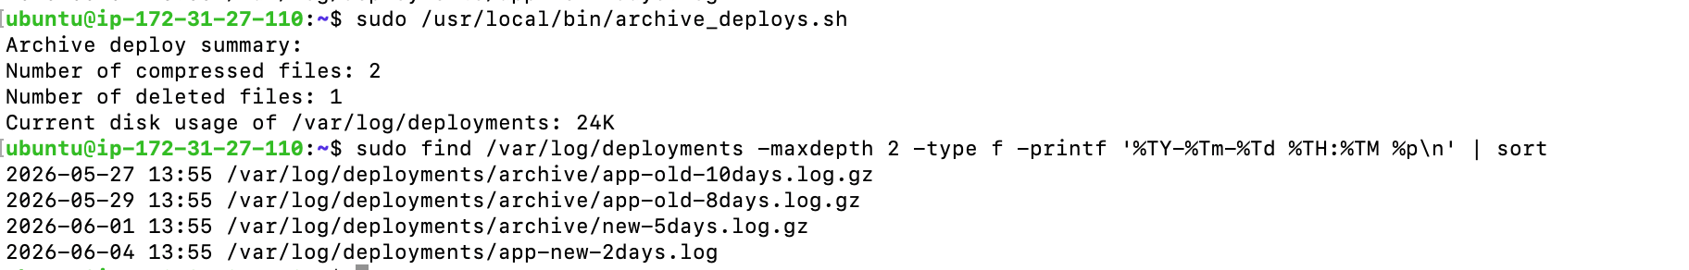

PART D Questions

D1
Answer in plain English

Question 1
After the EC2 instance reboots, does your cron job automatically resume? Does nginx automatically start? Are the answers the same or different — and why?
Both cron and nginx will restart automatically in my setup after reboot because of the setting of the services.
Nginx depends on the nginx service, cron depnds on the cron daemon services
we can check the setup by
sudo systemctl status nginx / cron

Question 2
healthcheck.log will grow without limit over time. You set up logrotate for the app log but not for healthcheck.log itself. Describe two different approaches to solve this. Give one real trade-off for each.
2 possible approach
- create a logrotate for maintaince related log as well, but this require one more file to maintain(extra cost), also this service depends on logrotate services and timer on the host.
- maintain the maintaince related log file in itself, create a rule to monitor it’s own size. But this introduce more complicate shell script and possibly repeat code if we have more than one maintaince related script

Question 3
Your manager wants to replace the shell script health check with an AWS-native solution that pages the on-call engineer when nginx goes down. No third-party tools. Name the AWS services you would use, explain the role of each, and describe how they connect together.
We can use the CloudWatch Agent on the EC2 instance to monitor the nginx process. The CloudWatch Agent would run on the EC2 instance and monitor the nginx process. The on-call engineer will subscribe the cloudwatch then get the notification (email/sms) 对这块了解的不太多

LAB
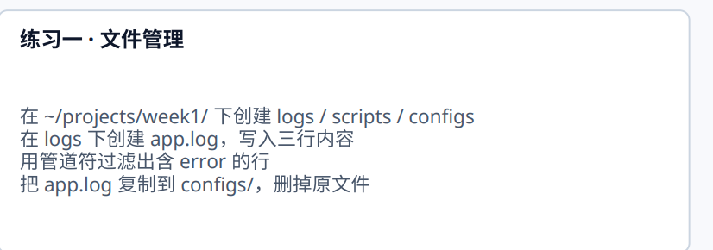
cd class_lab
mkdir -p logs
mkdir -p scripts
mkdir -p configs
touch logs/app.log
echo "INFO: this is prac info" >> logs/app.log
echo "ERROR: this is prac error" >> logs/app.log
echo "ERROR: this is the second prac error" >> logs/app.log
cat logs/app.log|grep "ERROR"
cp logs/app.log configs
rm -r logs/app.log

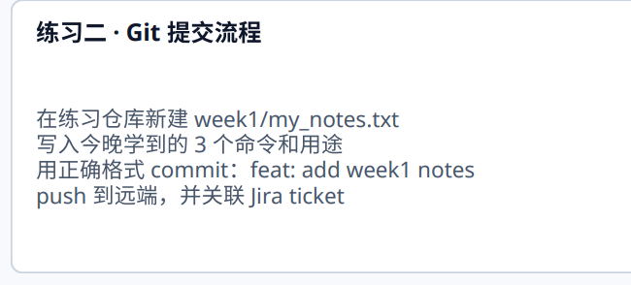

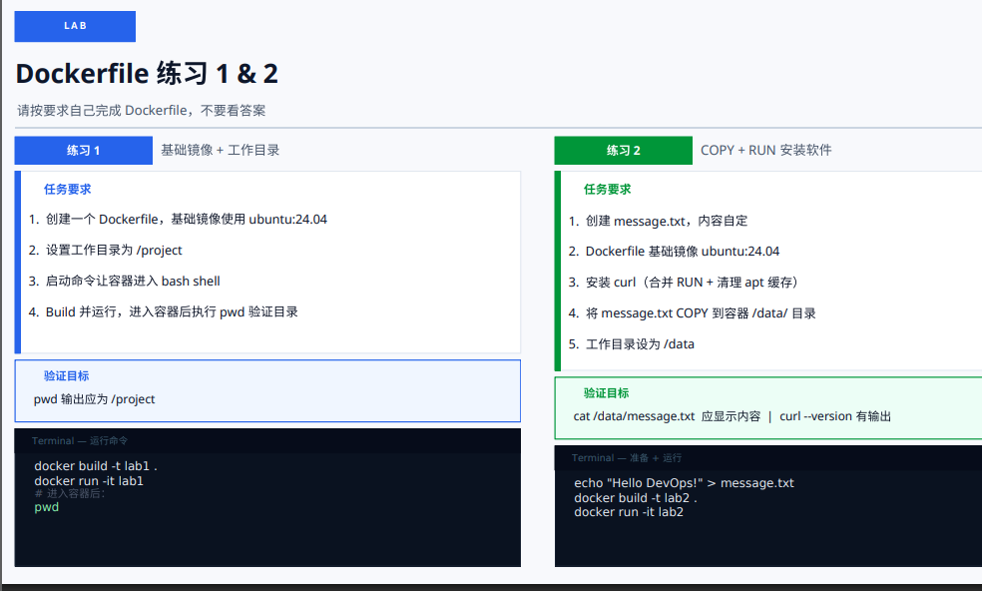

# prac 1

FROM ubuntu:24.04

WORKDIR /project

CMD ["/bin/bash"]

# docker build -t prac1-ubuntu:24.04 .

# docker run -it prac1-ubuntu:24.04

# prac 2
FROM ubuntu:24.04

RUN apt-get update && \
apt-get install -y curl && \
rm -rf /var/lib/apt/lists/*

WORKDIR /data

COPY message.txt /data/

CMD ["/bin/bash/data"]

Distinction Coding · Week 1 · Good luck

