Pathfinder Hexadecimal Translation

**Yvan Gihoza 010785599**

*Secret code: GROUND*

*Overview*—for the first assignment using the adaptation of “The Martian” a pathfinder from which we could publish (angles) on a servomotor and display on an LCD.

# INTRODUCTION

F

or the communication we were to use a servomotor at pin 9, so we could exactly point at the 16 hex characters using 180 degrees equally (0 - F). We had to use an MQTT client to communicate with the server (**thor.csce.uark.edu**). The angles were to be published on “uark/csce5013/username/angles” and the messages to the LCD “uark/csce5013/username/lcd”.

# Application Design

I started, by studying the professor’s MQTT to understand how the communication is supposed to occur. And then I used the Arduino sketch to build on my program.

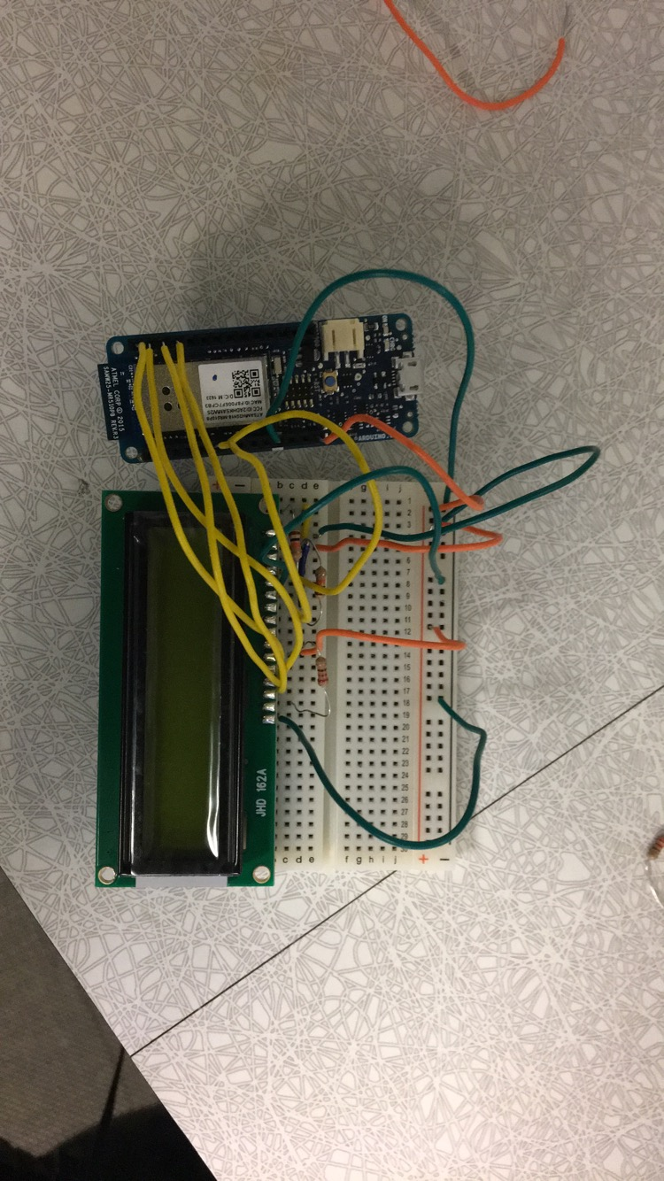

# Results

The results were not quite promoting, due to lack of time I was not able to implement the whole functionality of the program as I was stuck with the servomotor drawing the angles. But I was able to print out the secret message

# conclusion

Next time I will try to get started early on a project so I can have enough time to ask questions.