**Programming Project Report VI**

Yvan Gihoza

010785599

**Problem Statement:**

For the last assignment, we were to work with ray tracing. Ray tracing in graphics help to give more realistic images with reflection, refraction and shadows.

**Design:**

The professor provided us a head start. We were to use some of his code (ray_classes.h, ray_trace.cpp and ray_classes.cpp) to do the project. We were supposed to extend it and add more functionality being the display of N spheres, adding shadows and (bonus) simulating reflection or refraction.

**Implementation:**

My first approach was to draw a bunch of spheres which was the first task, after drawing random spheres I went to draw them at random places and random colors. My first task then was to implement shadows

**Testing:**

I tested function by function and task by task. To make sure every functionality was working, and I did not miss something.

**Conclusions:**

The project was successful as I was able to meet all the requirements required. Due to my color random calling function, the shadows pictures were quite different to the pictures provided but you can clearly see them.

**Testing:**

**Drawing spheres at random places with random colors**

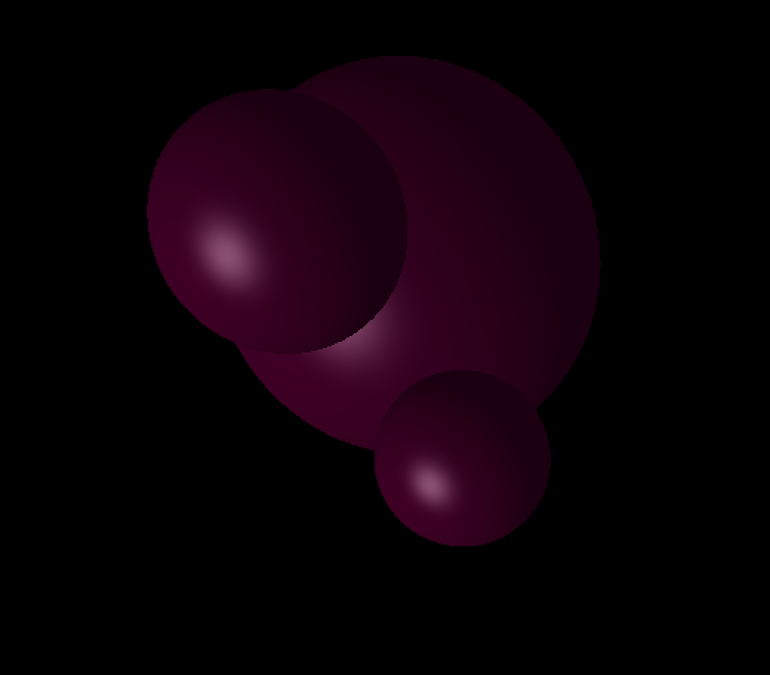

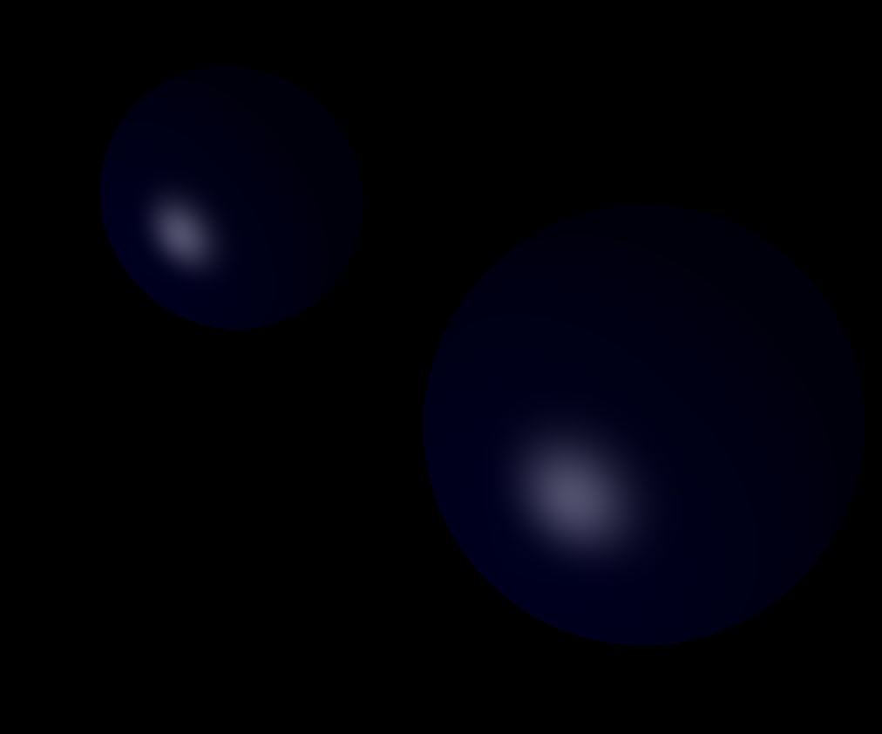

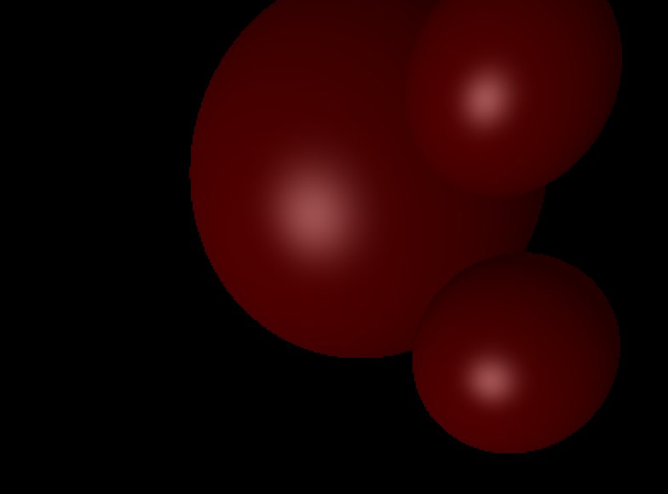

**TESTING SHADOWS:  
