**Create a configuration or montage in Profusion**

Creating an EEG configuration and montage in Profusion is necessary if your research protocol requires a specific set of electrodes instead of the classical clinical polysomnography montage.

* Configuration: for acquisition, defines which channels you will use
* Montage: for both acquisition and review, defines visualization of channels

Montages can also be useful if you regularly want to export your data with different parameters than those used for recording (set of electrodes, sampling frequency, reference, scale, filtering), or to use predefined parameters for visualization and sleep scoring in Profusion.

We advise you to first read the whole tutorial before using it step-by-steps, to identify important steps (to avoid making mistakes) and prepare yourself.

Steps to create an EEG configuration or montage:

1. Access a computer in the acquisition room
2. Search for the software `PSG config` and launch it

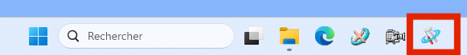

1. Click on the folder icon 📁​ (‘Ouvrir le fichier de configuration’)

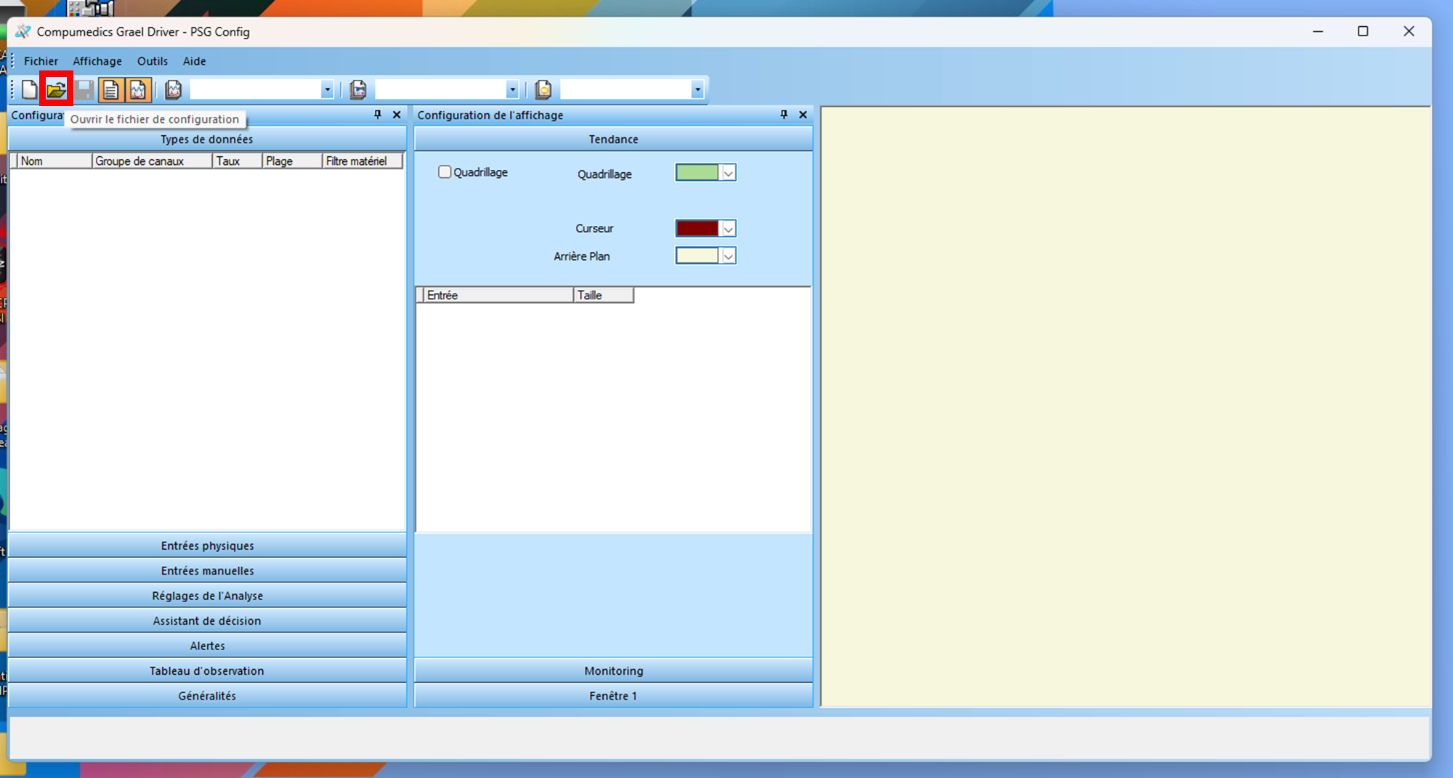

1. Select the `Compumedics Grael Driver` (corresponding to the amplifier)

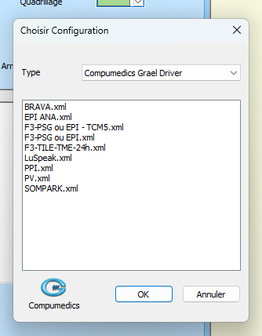

1. Select an existing configuration that you will modify according to your study (creating a configuration from scratch will be more time-consuming).

⚠ Make sure (in accordance with your PI and the team) that the selected configuration is close to your need and that you have the approval of the owner to use it. ⚠

If you already have a study configuration and you want to create a new montage (e.g., for sleep scoring), choose your existing configuration.

1. The following screen will be shown:

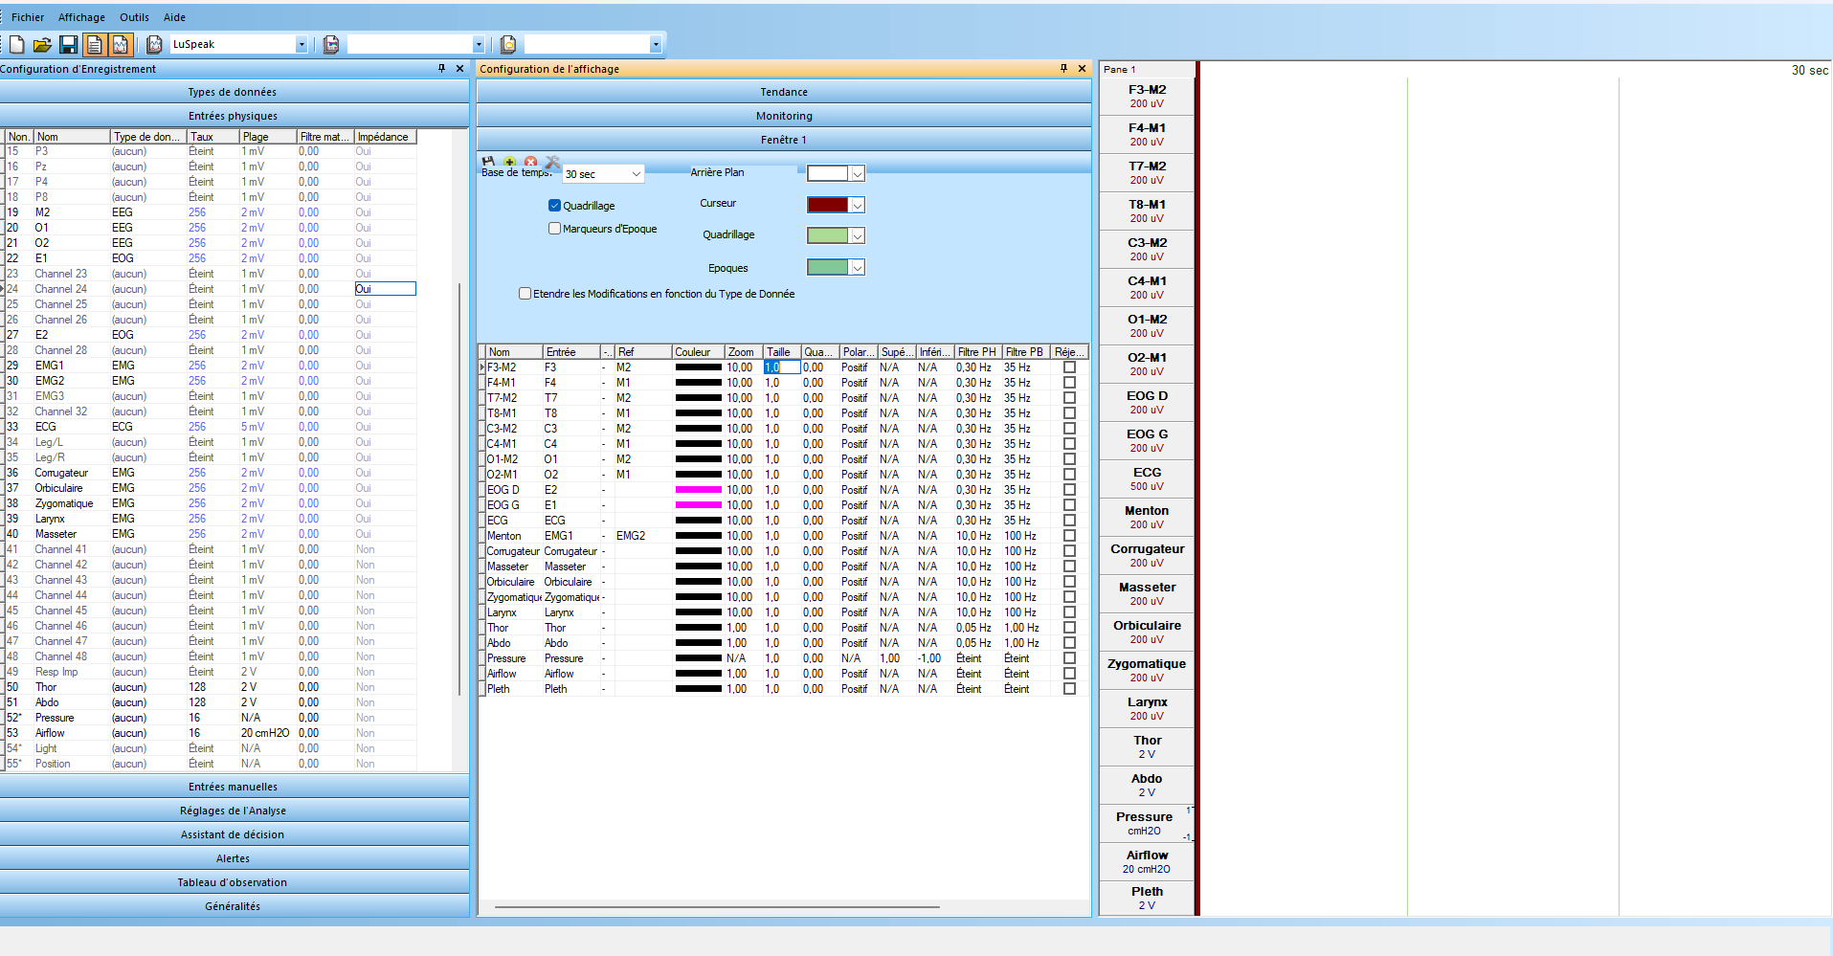

1. The left window will be used to create the configuration. In “Type de données” you can define generic types of data (EEG, EOG, EMG...) with specific default parameters (that will apply to your channel when you set the type)
2. Still in the left window, with “entrées physiques" you will define the channels of your configuration and their parameters. Here, you can define:

* Which channels will be active or inactive
* Channel labels
* Type of data (EEG, EOG, EMG... defined in step 7.)
* Default parameters (that will apply to your channel when you set the type).
* Those parameters will be applied for the acquisition, so you need to be extra careful. It is recommended to keep the default parameters for each channel unless you have strong reason to change them.

The number of each channel (“Non.”) corresponds to the numbers on the amplifier. So, when checking, trust the number and not the written label.

1. The middle window (“Fenêtre 1”) is important for creating a montage. Here, you can change the way you visualize the data:

* ***Channels***: right-click to add a channel
* ***Ref***: it corresponds to the reference of the channel
* ***Zoom***: it corresponds to the scale of the data for visualization, but it will also define the dynamic range (upper and lower boundaries in µV) of the data when exported. Zoom and the scale are negatively correlated: when Zoom increases, the scale decreases e.g.:
  + Zoom = 2 ó scale = 1 mV (dynamic range ±500 µV) ;
  + Zoom = 0.2 ó scale = 10 mV (dynamic range ±5000 µV)
* ***Taille***: it corresponds to the size of the box in the display (not really important, use default parameter)
* ***Polarité***: allows to change the sign of the signal (setting it to negative will multiply the signal by –1)
* ***Filtre PH*** (Passe-Haut): high-pass filter to remove low frequencies (let pass frequencies only higher than the threshold)
* ***Filtre PB*** (Passe-Bas): low-pass filter to remove high frequencies (let pass frequencies only lower than the threshold)
* ***Réjecteur***: Notch filter to remove power line noise
* Recommended parameters in the team:
  + Ref: None
  + Zoom: 2 (scale = 1 mV ; dynamic range = ±500 µV)
  + Polarity: positive
  + Filtre PH: 0.01 Hz (to remove slow drift in long recordings such as whole night recordings)
  + Filtre PB: None
  + Réjecteur: None

You can add or remove a channel by right-clicking here with your mouse.

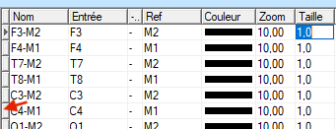

1. To save your modifications, go to `Fichier` -> `Enregistrer sous…`

⚠️ Very important! Don’t click on the icon `save` 💾​ or don’t go to `Fichier` -> `Enregistrer…` as it will save and overwrite the configuration and montage you selected at step 5. ⚠️

In case of doubt of overwriting an existing configuration, stop the process here, as the synchronization with the server will erase your modification (every ~15 min, see step 12. To save your modification permanently)

1. Depending on whether you want to create a configuration, a montage, or both, check the corresponding box, define a name, and click on `sauvegarder`

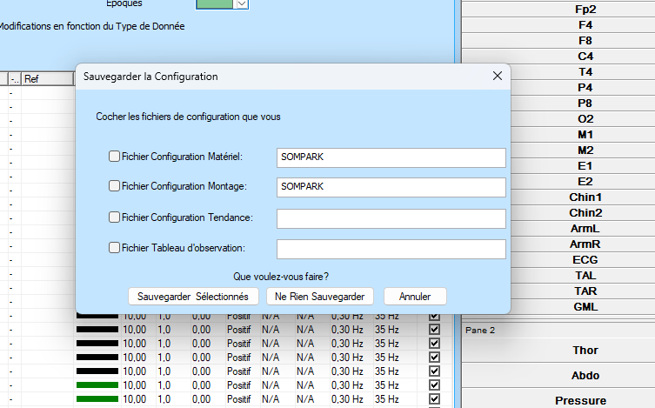

* The configuration or montage is now saved locally on the computer at the address `C:\Programme files\Compumedics\Nexus\ Managed Files\Configs`. It will be deleted after 15 min (when the computer synchronizes with the server)

1. To save permanently your configuration or montage and make it available to other computers you need to copy-paste your configuration or montage file to the server folder. Here are the paths of the server folders:

* \\10.160.24.63\Nexus Managed Files\Configs => to make it available for acquisition
* \\10.160.24.63\Nexus Managed Files\Configs-Rel => to make it available in the reading room (only for montages, for visualization and/or export)
* It will take ~15mins for the copy to show up on all other computers (when the computer synchronizes with the server)

