**Export EEG data as .edf from Profusion**

When exporting EEG data with Profusion, you can choose to export the data as it was originally acquired or as you are visualizing it in Profusion (where you can change some parameters).

Therefore, if you want to export data using parameters different than acquisition, you can manually change the parameters of each channel when reading it in Profusion.

However, if you need to do this for many recordings at a time, it can be a very time-consuming and an error-prone process. In this case, we highly recommend instead using a montage to export your data. [Here is a tutorial to create your own exporting montage](https://instituteicm-my.sharepoint.com/:w:/r/personal/delphine_oudiette_icm-institute_org/_layouts/15/Doc.aspx?sourcedoc=%7B7D043759-664B-4A54-A0F8-E66294EACD37%7D&file=create_EEG_montage_Profusion.docx&action=default&mobileredirect=true) and [here is a tutorial to export your data with a montage](https://instituteicm-my.sharepoint.com/:w:/r/personal/delphine_oudiette_icm-institute_org/_layouts/15/Doc.aspx?sourcedoc=%7B135A2A5D-6A3E-492E-AC89-3DB335F5B5B8%7D&file=export_edf_withmontage_Profusion.docx&action=default&mobileredirect=true).

Note that the team recommends to export with a montage where you defined at least a good dynamic range (“Zoom” parameter) to avoid clipping or bad resolution problem and a high-pass filter of 0.01 Hz to remove the slow drift in long recordings such a whole night (that could end up in clipping as well).

Steps to export your EEG data as .edf and manually adjusting the parameters:

1. Open ProFusion PSG4 Une image contenant texte, capture d’écran, Police, logo

   Le contenu généré par l’IA peut être incorrect.
2. Open a PSG file, by searching for the patient’s name and selecting the period of the recording (e.g., in the last month)

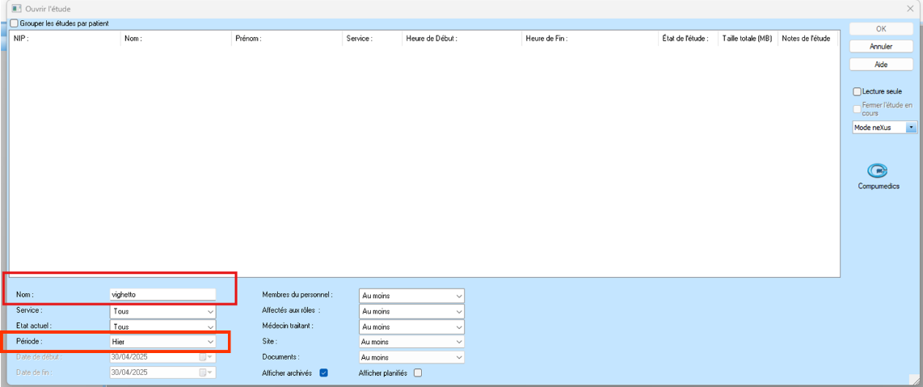

1. The following screen will be shown:

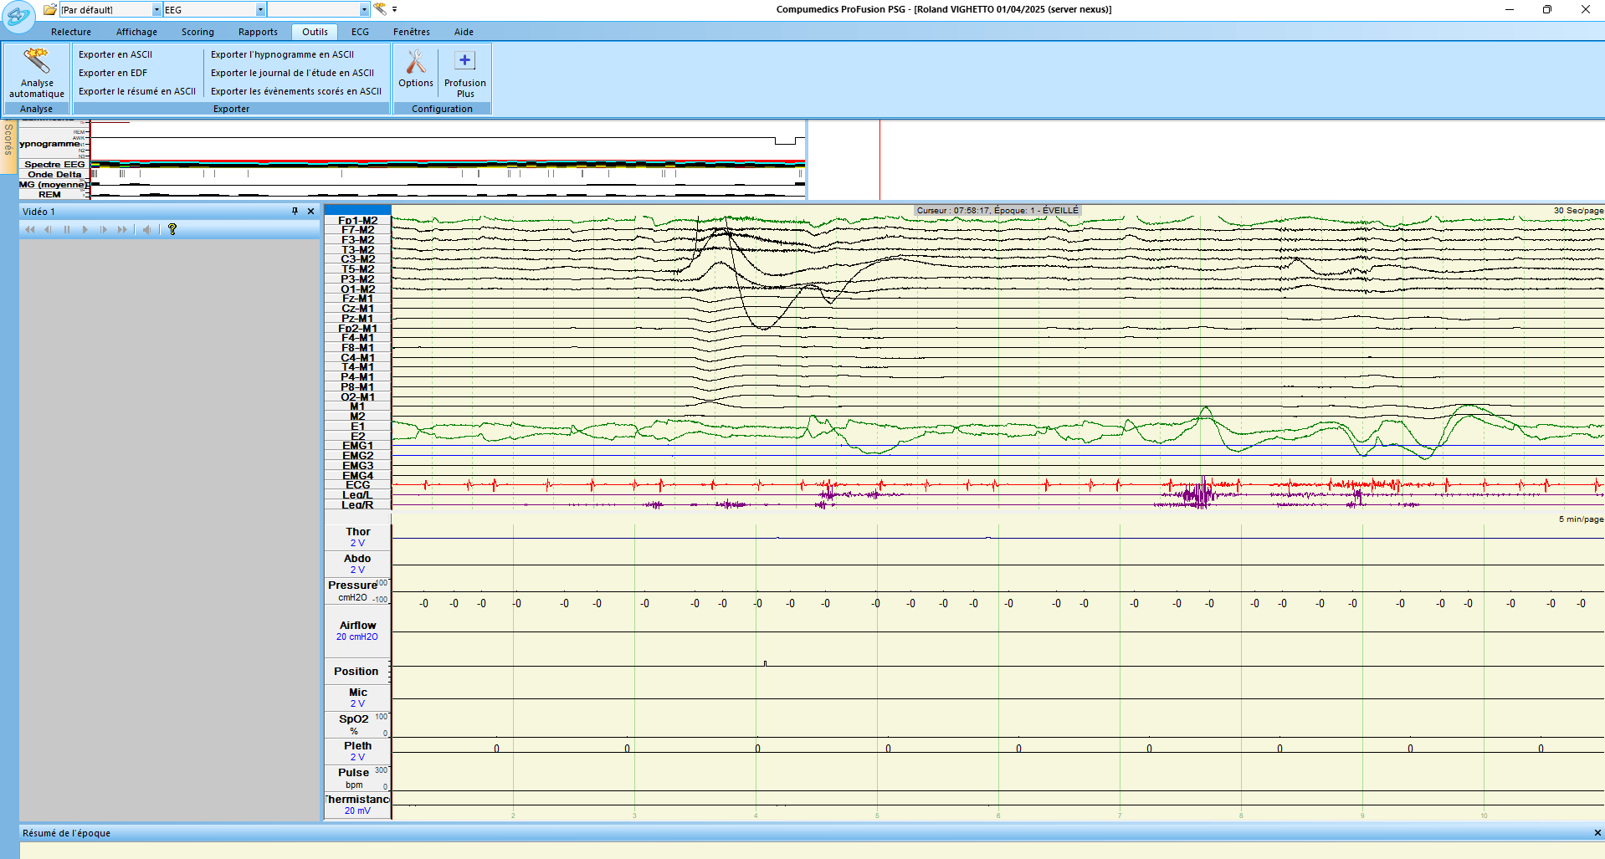

1. Then, for each channel, double click on the label to display the parameters and change them (you can add a channel by right-clicking -> `Ajouter une voie` ).
   * ***Ref***: it corresponds to the reference of the channel

* ***Zoom***: it corresponds to the scale of the data for visualization, but it will also define the dynamic range (upper and lower boundaries in µV) of the data when exported. Zoom and the scale are negatively correlated: when Zoom increases, the scale decreases e.g.:
  + Zoom = 2 ó scale = 1 mV (dynamic range ±500 µV) ;
  + Zoom = 0.2 ó scale = 10 mV (dynamic range ±5000 µV)
* ***Taille***: it corresponds to the size of the box in the display (not really important, use default parameter)
  + ***Polarité***: allows to change the sign of the signal (setting it to negative will multiply the signal by –1)
  + ***Passe-Haut*** (Hz): high-pass filter to remove low frequencies (let pass frequencies only higher than the threshold)
  + ***Passe-Bas*** (Hz): low-pass filter to remove high frequencies (let pass frequencies only lower than the threshold)
  + ***Réjecteur***: Notch filter to remove power line noise
* Recommended parameters in the team:
* Ref: None
* Zoom: 2
* Polarité: positive
* Passe-Haut: 0.01 Hz (to remove slow drift in long recordings such as whole night recordings)
* Passe-Bas: None
* Réjecteur: None

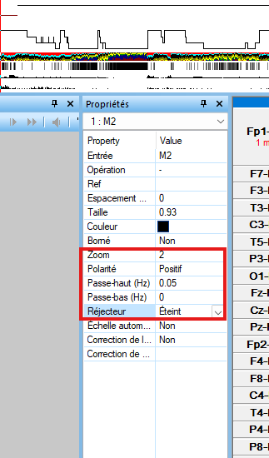

1. Export the EDF : click on “Outils” then “Exporter en EDF”

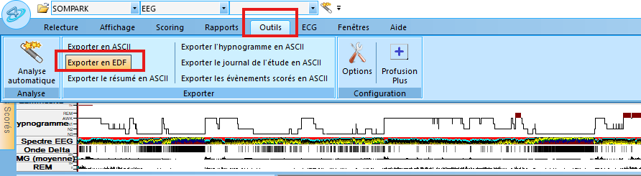

* Check the box « Anonymiser le patient »
* Define the folder and file name with which to save the EDF (three dots)
* To export the data as it was acquired: Choose « Toute »
  + The table you see displayed confirms how the recording will be exported. It corresponds to the parameters with which it was acquired.
* To export the data with the changes you made: Choose « Afficher uniquement »
  + The table you see displayed confirms how the recording will be exported. It corresponds to the parameters you manually defined.
* Click on “Exporter”

1. Export the hypnogram (.txt file)
   * Define the folder and file name with which to save it.

