**Java-8 functionility Interface :**

**Why we we need functionality Interface : ?**

Example code :

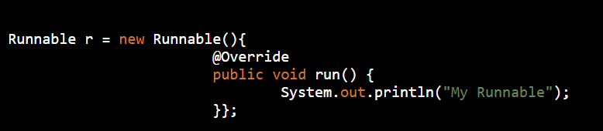

If you look at the above code, the actual part that is of use is the code inside run() method. Rest all of the code is because of the way java programs are structured.

Java 8 Functional Interfaces and Lambda Expressions help us in writing smaller and cleaner code by removing a lot of boiler-plate code.

**What is functionality Interface ?**

An interface with exactly one abstract method is called Functional Interface. @FunctionalInterface annotation is added so that we can mark an interface as functional interface.

It is not mandatory to use it, but it’s best practice to use it with functional interfaces to avoid addition of extra methods accidentally. If the interface is annotated with @FunctionalInterface annotation and we try to have more than one abstract method, it throws compiler error.

The major benefit of java 8 functional interfaces is that we can use lambda expressions to instantiate them and avoid using bulky anonymous class implementation.

Java 8 Collections API has been rewritten and new Stream API is introduced that uses a lot of functional interfaces. Java 8 has defined a lot of functional interfaces in java.util.function package. Some of the useful java 8 functional interfaces are Consumer, Supplier, Function and Predicate.

Example :

java.lang.Runnable is a great example of functional interface with single abstract method run().

Below code snippet provides some guidance for functional interfaces:

**interface** Foo { **boolean** equals(Object obj); }  
*// Not functional because equals is already an implicit member (Object class)***interface** Comparator<T> {  
 **boolean** equals(Object obj);  
 **int** compare(T o1, T o2);  
}  
*// Functional because Comparator has only one abstract non-Object method***interface** Foo {  
 **int** m();  
 Object clone();  
}  
*// Not functional because method Object.clone is not public***interface** X { **int** m(Iterable<String> arg); }  
**interface** Y { **int** m(Iterable<String> arg); }  
**interface** Z **extends** X, Y {}  
*// Functional: two methods, but they have the same signature***interface** X { Iterable m(Iterable<String> arg); }  
**interface** Y { Iterable<String> m(Iterable arg); }  
**interface** Z **extends** X, Y {}  
*// Functional: Y.m is a subsignature & return-type-substitutable***interface** X { **int** m(Iterable<String> arg); }  
**interface** Y { **int** m(Iterable<Integer> arg); }  
**interface** Z **extends** X, Y {}  
*// Not functional: No method has a subsignature of all abstract methods***interface** X { **int** m(Iterable<String> arg, Class c); }  
**interface** Y { **int** m(Iterable arg, Class<?> c); }  
**interface** Z **extends** X, Y {}  
*// Not functional: No method has a subsignature of all abstract methods***interface** X { **long** m(); }  
**interface** Y { **int** m(); }  
**interface** Z **extends** X, Y {}  
*// Compiler error: no method is return type substitutable***interface** Foo<T> { **void** m(T arg); }  
**interface** Bar<T> { **void** m(T arg); }  
**interface** FooBar<X, Y> **extends** Foo<X>, Bar<Y> {}  
*// Compiler error: different signatures, same erasure*

**Lambda Expression**

Lambda Expression are the way through which we can visualize **functional programming** in the java object oriented world. Objects are the base of java programming language and we can never have a function without an Object, that’s why Java language provide support for using lambda expressions only with functional interfaces.

Since there is only one abstract function in the functional interfaces, there is no confusion in applying the lambda expression to the method. Lambda Expressions syntax is **(argument) -> (body)**. Now let’s see how we can write above anonymous Runnable using lambda expression.

**Without Lambda Expression:**



**With Lamba Expression:**

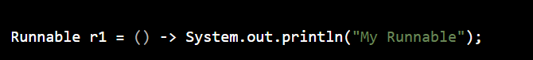

Let’s try to understand what is happening in the lambda expression above.

* Runnable is a functional interface, that’s why we can use lambda expression to create it’s instance.
* Since run() method takes no argument, our lambda expression also have no argument.
* Just like if-else blocks, we can avoid curly braces ({}) since we have a single statement in the method body. For multiple statements, we would have to use curly braces like any other methods.

### Why do we need Lambda Expression ?

1. **Reduced Lines of Code :**

One of the clear benefit of using lambda expression is that the amount of code is reduced, we have already seen that how easily we can create instance of a functional interface using lambda expression rather than using anonymous class.

1. **Sequential and Parallel Execution Support :**

Another benefit of using lambda expression is that we can benefit from the Stream API sequential and parallel operations support.

To explain this, let’s take a simple example where we need to write a method to test if a number passed is prime number or not.

Traditionally we would write it’s code like below. The code is not fully optimized but good for example purpose, so bear with me on this.

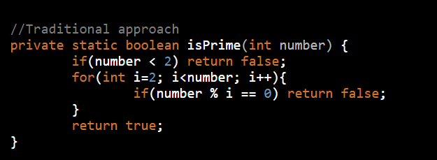

The problem with above code is that it’s sequential in nature, if the number is very huge then it will take significant amount of time. Another problem with code is that there are so many exit points and it’s not readable. Let’s see how we can write the same method using lambda expressions and stream API.

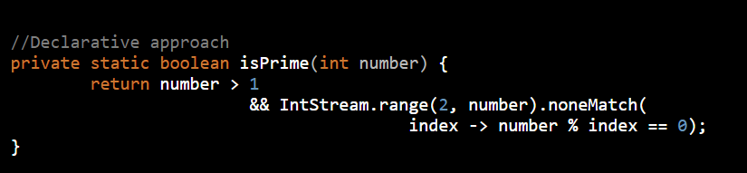

**IntStream** is a sequence of primitive int-valued elements supporting sequential and parallel aggregate operations. This is the int primitive specialization of Stream.

For more readability, we can also write the method like below :

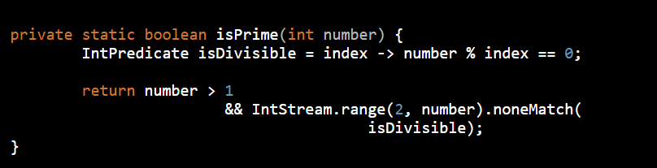

1. If you are not familiar with IntStream, it’s range() method returns a sequential ordered IntStream from startInclusive (inclusive) to endExclusive (exclusive) by an incremental step of 1.

noneMatch() method returns whether no elements of this stream match the provided predicate. It may not evaluate the predicate on all elements if not necessary for determining the result.

1. **Passing Behaviors into methods:**

Let’s see how we can use lambda expressions to pass behavior of a method with a simple example. Let’s say we have to write a method to sum the numbers in a list if they match a given criteria. We can use Predicate and write a method like below.

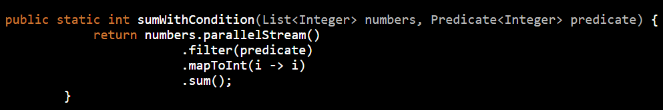

Sample usage:

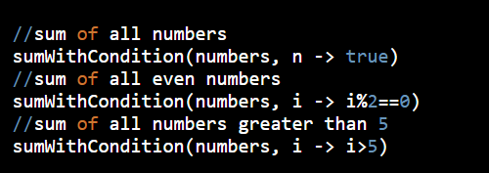

**Higher Efficiency with Laziness**

One more advantage of using lambda expression is the lazy evaluation, for example let’s say we need to write a method to find out the maximum odd number in the range 3 to 11 and return square of it.

Usually we will write code for this method like this:

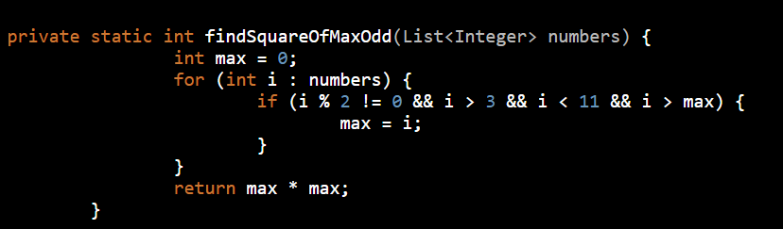

Above program will always run in sequential order but we can use Stream API to achieve this and get benefit of Laziness-seeking. Let’s see how we can rewrite this code in functional programming way using Stream API and lambda expressions.

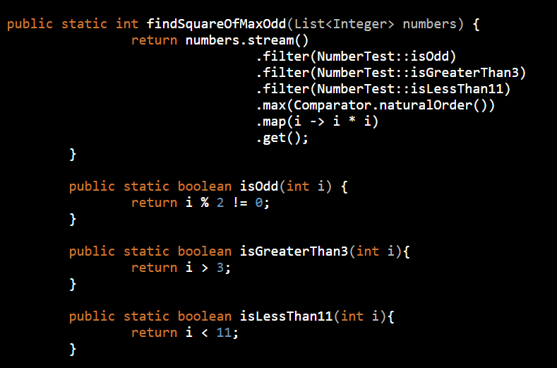

If you are surprised with the double colon (::) operator, it’s introduced in Java 8 and used for method references. Java Compiler takes care of mapping the arguments to the called method. It’s short form of lambda expressions i -> isGreaterThan3(i) or i -> NumberTest.isGreaterThan3(i).

### Lambda Expression Examples

Below I am providing some code snippets for lambda expressions with small comments explaining them.

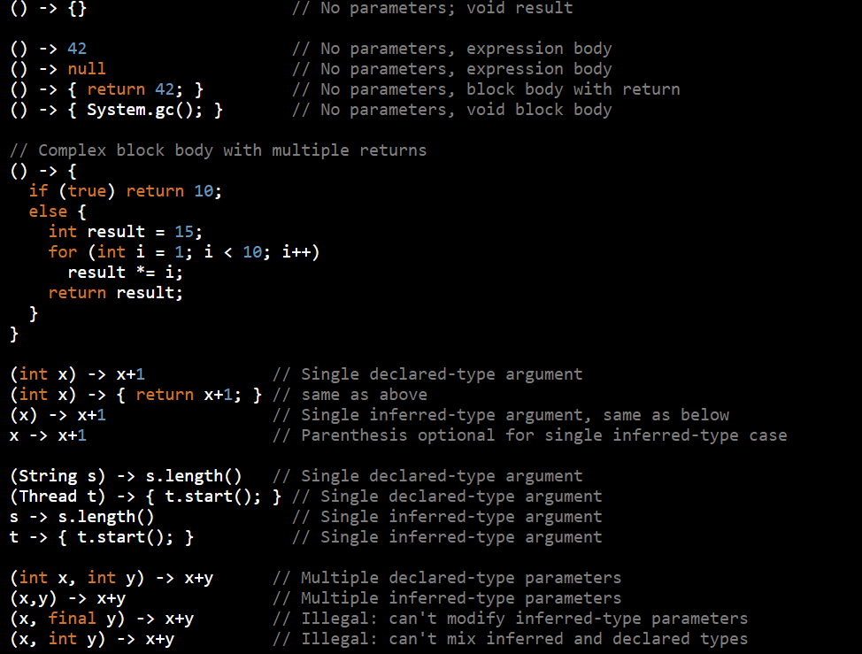

### Method and Constructor References

A method reference is used to refer to a method without invoking it; a constructor reference is similarly used to refer to a constructor without creating a new instance of the named class or array type.

Examples of method and constructor references:

