Test plan for Tadarida-L version 2.1.1 (08/02/2017)

The purpose of this test plan is (1) to check that the software is set up correctly and (2) to provide a non-regression test suite following new developments.

Detection
The detection part of Tadarida-L is very similar to Tadarida-D operation, thus we propose that this part should be tested with exactly the same procedure. Please follow https://github.com/YvesBas/Tadarida-D_forWindows/test_plan-tadaridaD.odt
Test executions are strictly identical except that settings are graphically tuned (see the screenshot below).
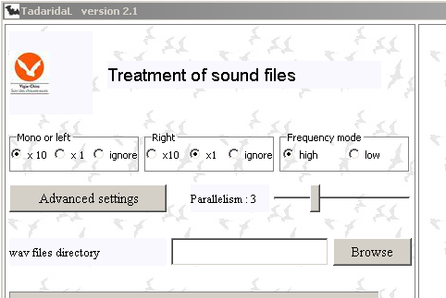
Expected results are also identical, except that .log files are located within “txt” subfolder.

Labelling
Labelling could be tested by “selecting a (previously treated) wav file”. A window should open and deliver following information from top to down:
- Time and frequency axis with black markers
- Time and frequency delimitation between detected sound events (in pink) and background noise (in blue)
- Time and frequency position of the master point of each detected sound event (red, black or green dots, according to sound event status; see manual for details)
- The ratio between time and frequency axis (“r=X”)
- The time and frequency position of the cursor
- The name of the selected file
- The name of the folder containing this file
- The number of detected sound events
- The number of validated labels
- The ID of the selected sound events
- The last record of all label files (blank if never used before)
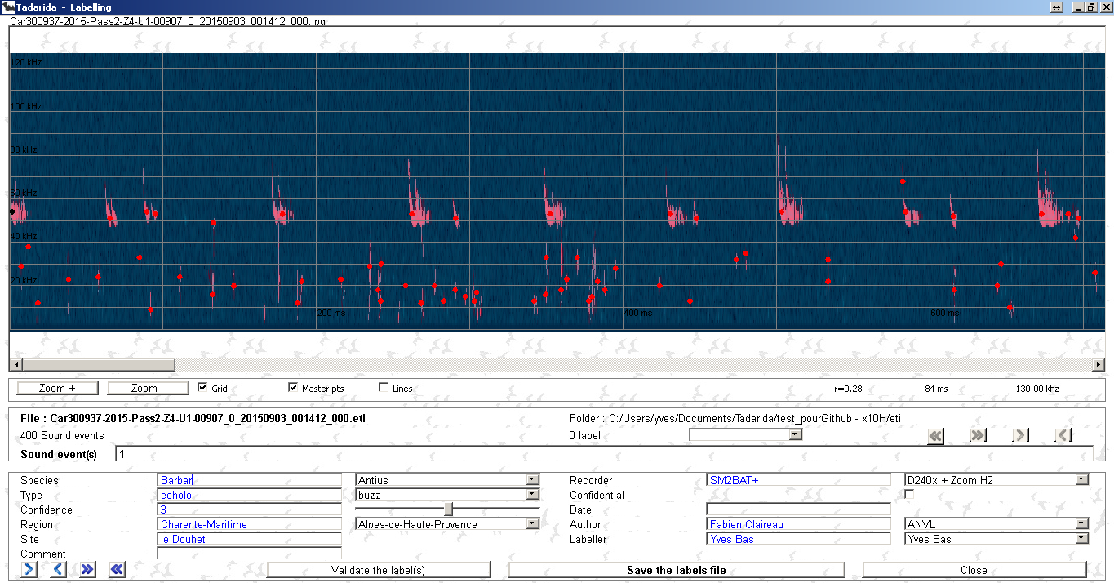
Double-clicking on any position on the spectrogram should open another “Zoom” window and deliver following information from top to down:
- Time and frequency delimitation between detected sound events (in pink) and background noise (in blue)
- Time and frequency position of the master point of each detected sound event (red, black or green dots, according to sound event status; see manual for details)
- The line of maximum energy along time axis of each detected sound event (black if selected, white if not)
- The ratio between time and frequency axis (“r=X”)
- The time and frequency position of the cursor

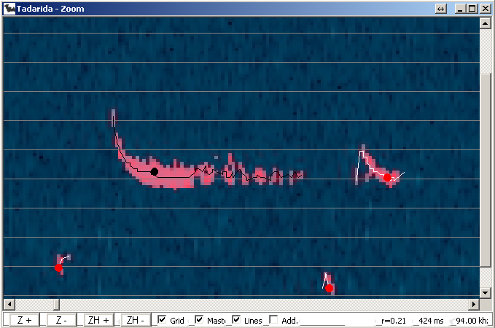

Reference Sound Data Base (RSDB) reprocessing

This test intends to test that RSDB reprocessing works properly. For this purpose, follow this procedure.
- Download RSDB_sample folder from https://github.com/YvesBas/Tadarida-L
- Select it as “database folder” in Tadarida-L.
- Close the software.
- Press the button “Change database folder” and choose the folder: “RSDB_sample“.
- Close TadaridaL.
- Edit install/config/config.ini file by modifying user value, e.g. user=1 instead of user=0 (default).
- Re-open Tadarida-L, a dialog box should ask for reprocessing the RSDB, select “Yes”
The reprocessing should take a short moment and end with the following message:
« ...1512 recovered labels out of 1152 in the main reprocessing ».

Please note that if the RSDB is modified, the number of recovered labels could change, and that if detection settings are modified from default, recovered labels could be less numerous than initially.

