Manual Project testing

# Automatic Test

## BoardTests

**All tests have passed successfully.**

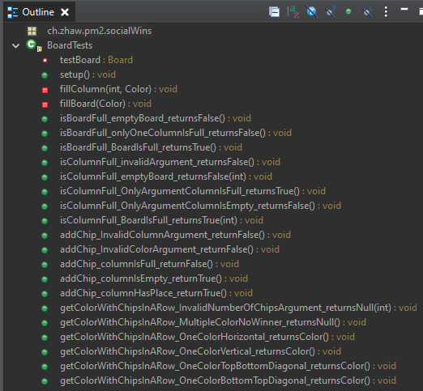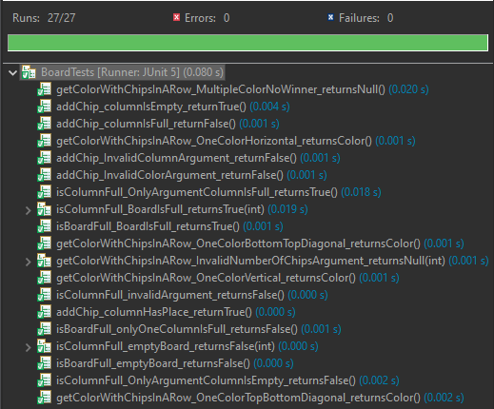

## GameTests

**All test have passed successfully.**

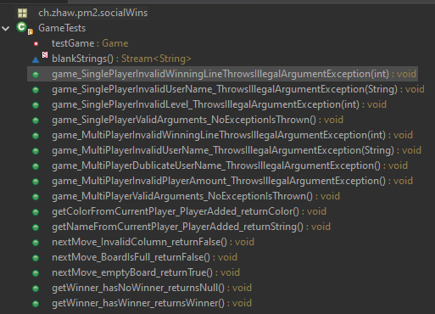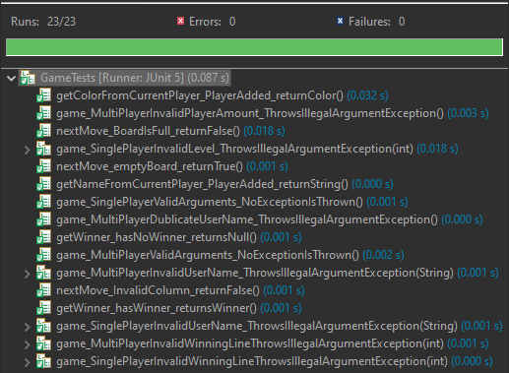

## MoveCalculatorTests

**All tests behave right.**

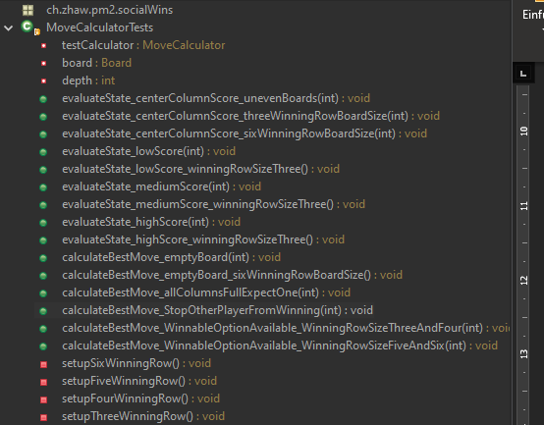 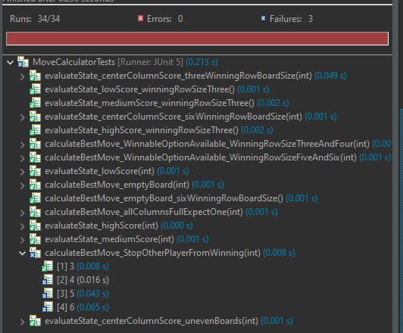

## Manual Gameplay test

* **Help window is shown correctly and with the right text**
  + 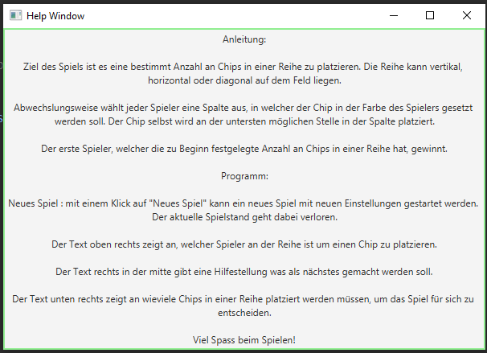

### Singleplayer

* **Setup**
  + **Wrong player name**
    - 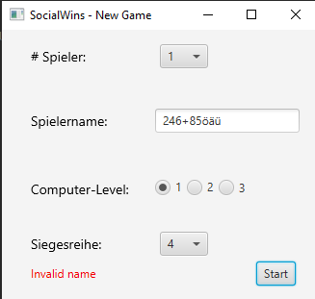
* **Game board is full**
  + 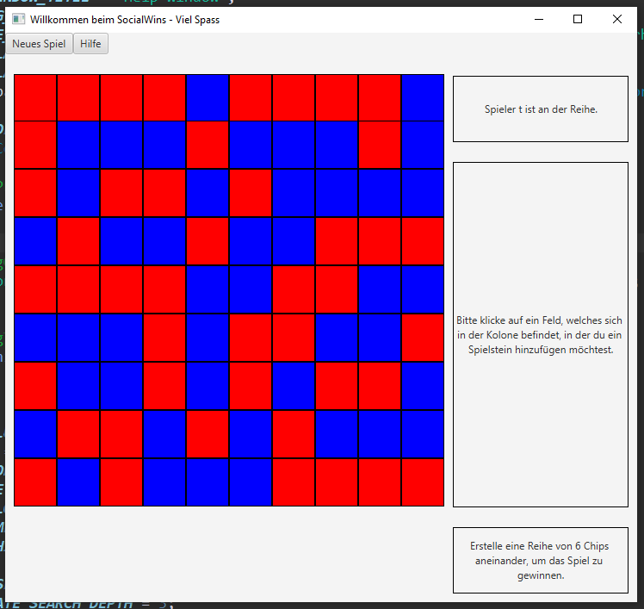
* **ComputerBeginner**
  + **3-WinningRow**
    - **Win**
      * 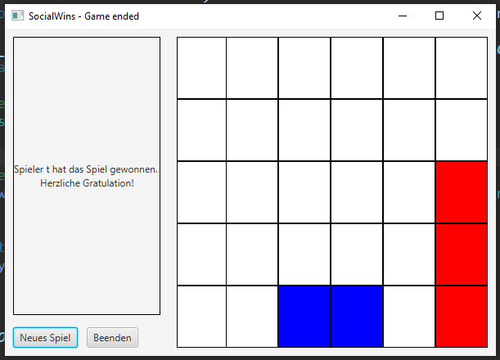
    - **Loss**
      * 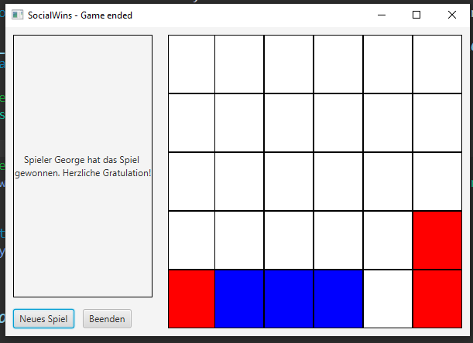
  + **4-WinningRow**
    - **Win**
      * 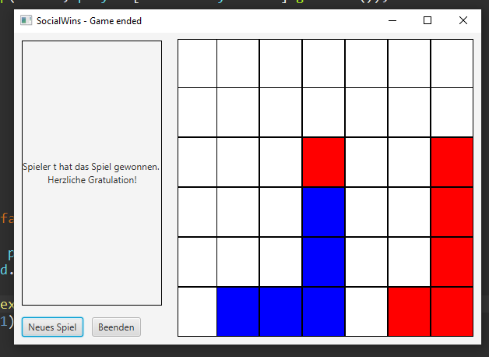
    - **Loss**
      * 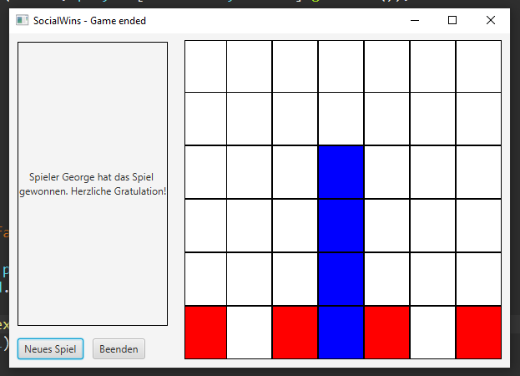
  + **5-WinningRow**
    - **Win**
      * 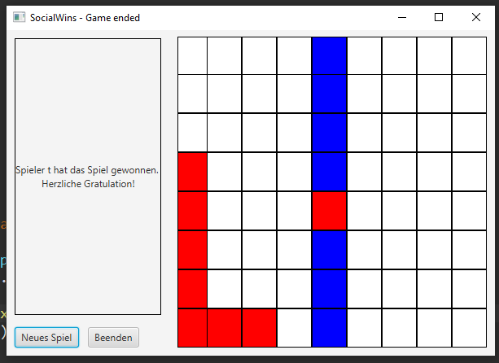
    - **Loss**
      * 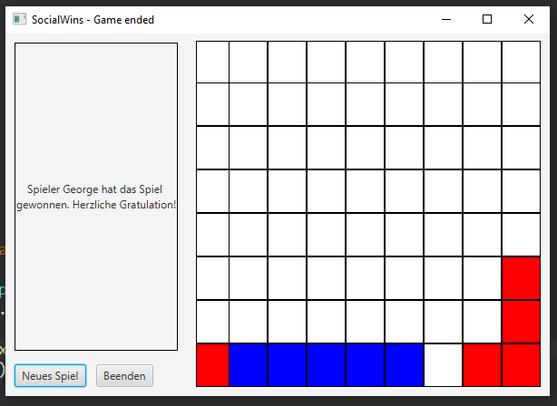
  + **6-WinningRow**
    - **Win**
      * 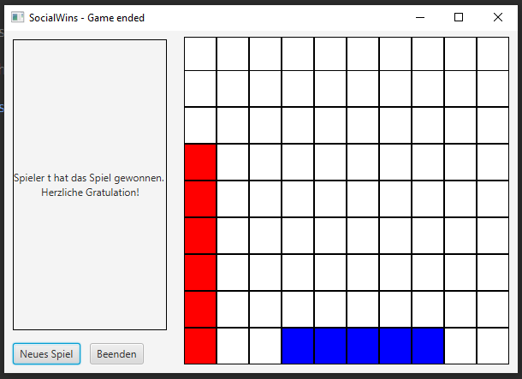
    - **Loss**
      * 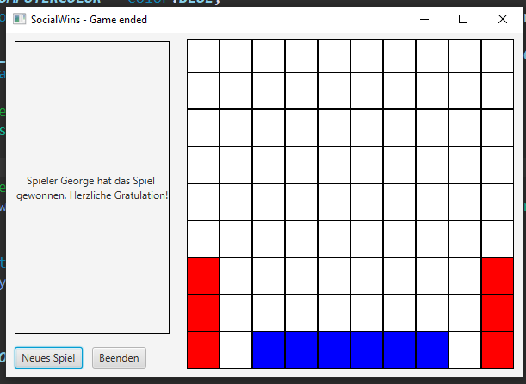
* **ComputerIntermediate**
  + **3-WinningRow**
    - **Win**
      * 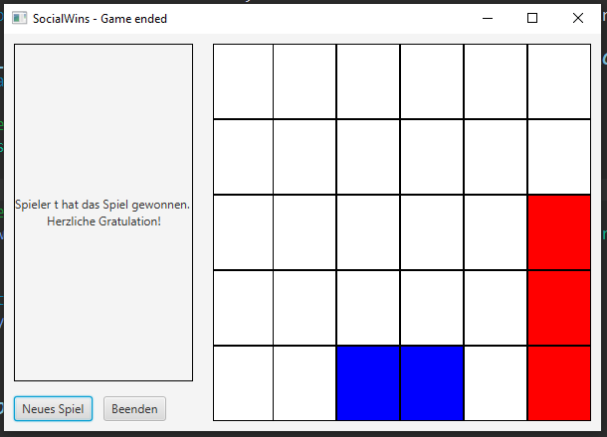
    - **Loss**
      * 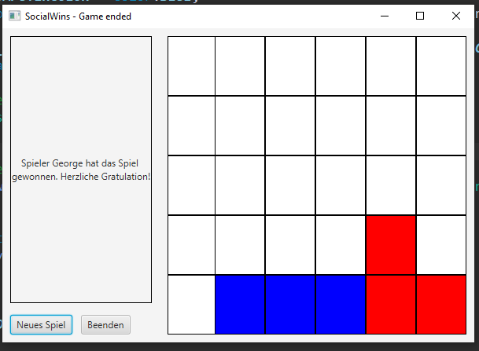
  + **4-WinningRow**
    - **Win**
      * 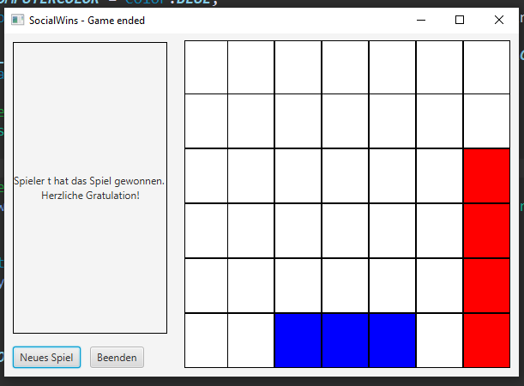
    - **Loss**
      * 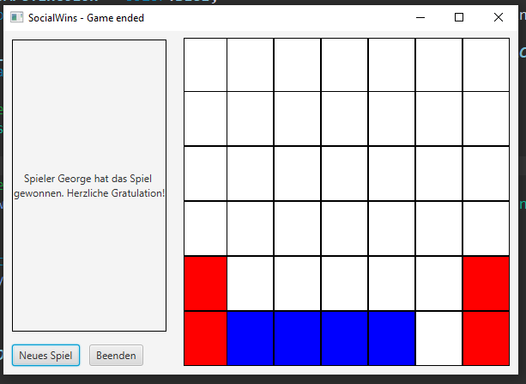
  + **5-WinningRow**
    - **Win**
      * 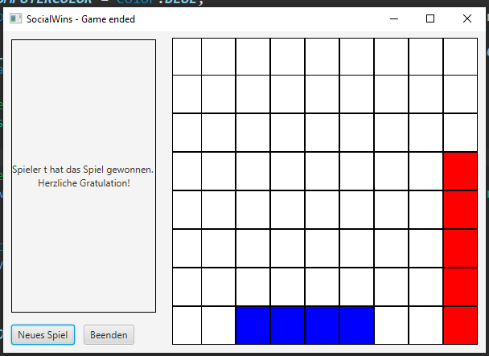
    - **Loss**
      * 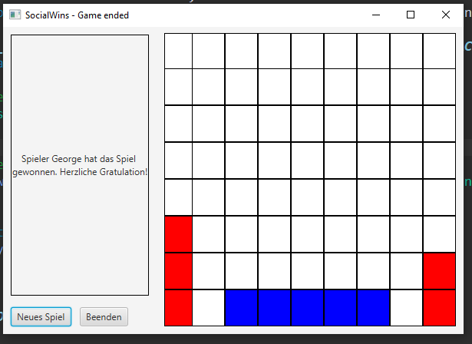
  + **6-WinningRow**
    - **Win**
      * 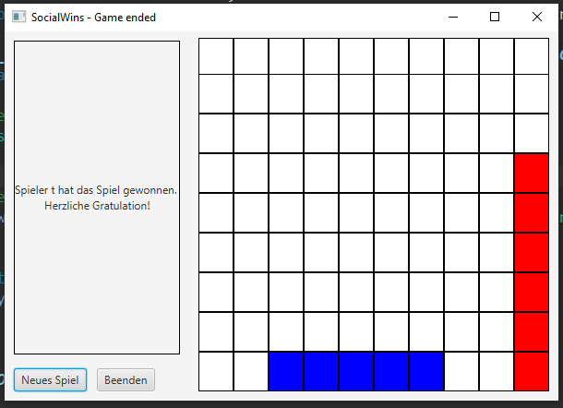
    - **Loss**
      * 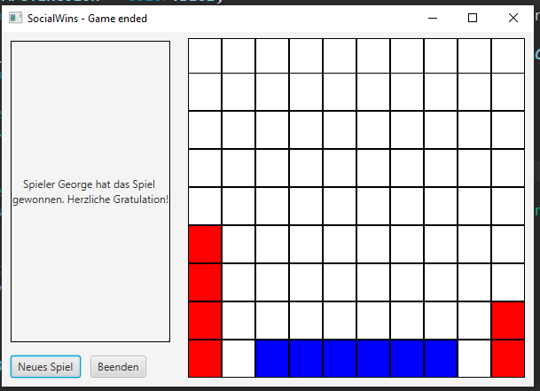
* **ComputerAdvanced**
  + **3-WinningRow**
    - **Win**
      * 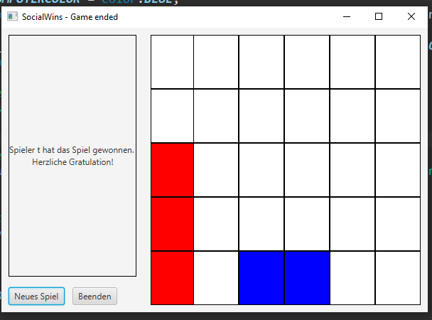
    - **Loss**
      * 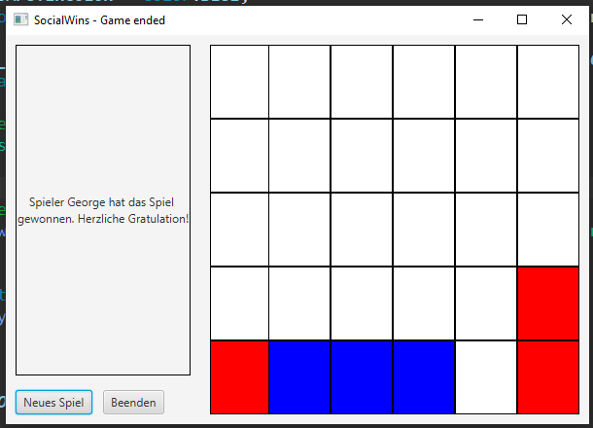
  + **4-WinningRow**
    - **Win**
      * 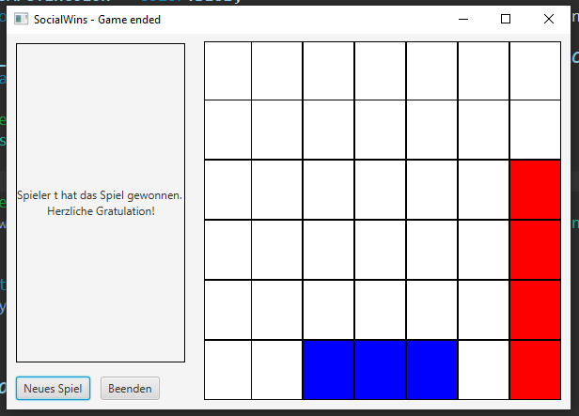
    - **Loss**
      * 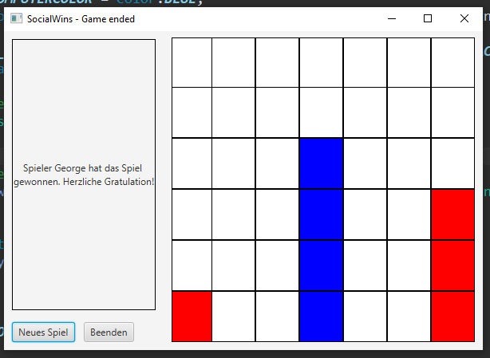
  + **5-WinningRow**
    - **Win**
      * 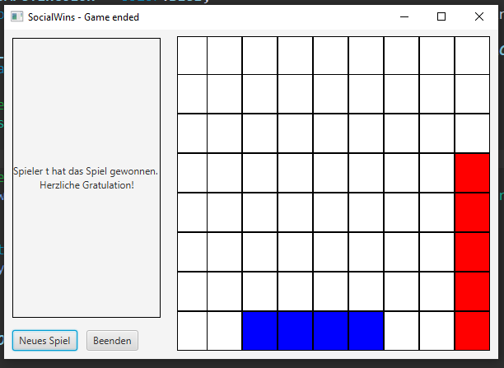
    - **Loss**
      * 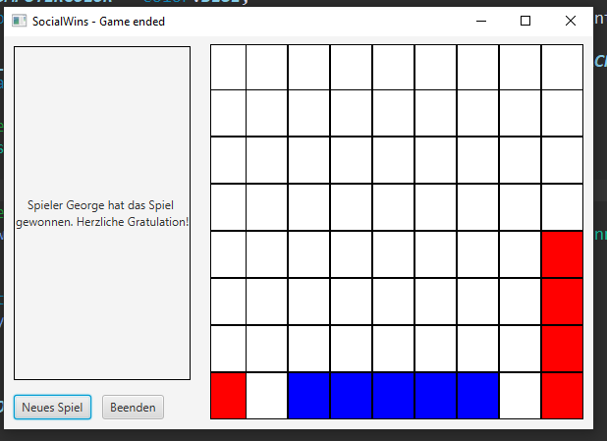
  + **6-WinningRow**
    - **Win**
      * 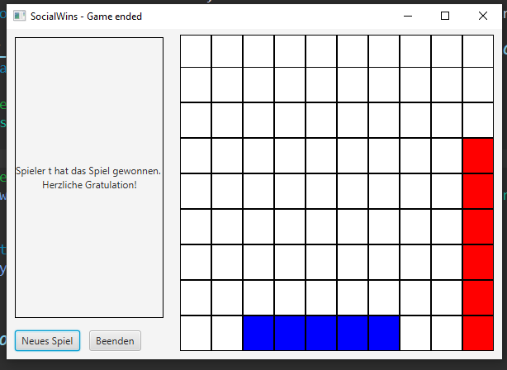
    - **Loss**
      * 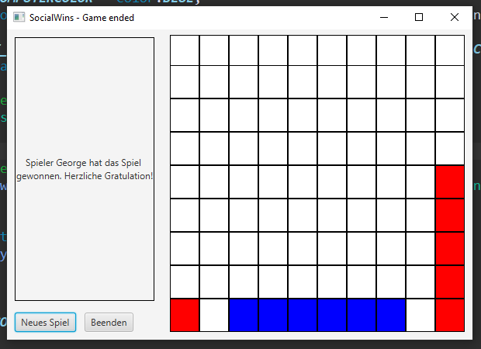

### Multiplayer

* **Setup**
  + **Player name wrong**
    - 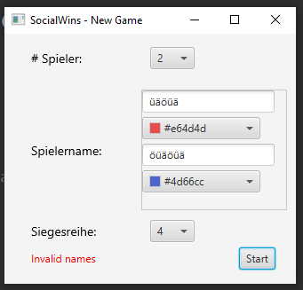
  + **Player color wrong**
    - 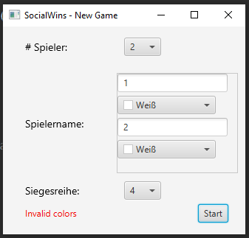
  + **Player name and color wrong**
    - 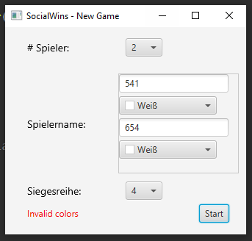
* **Right winner name is shown**
  + 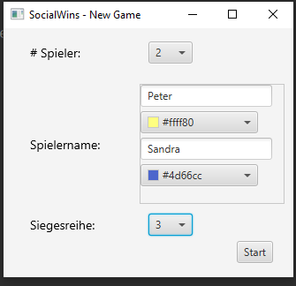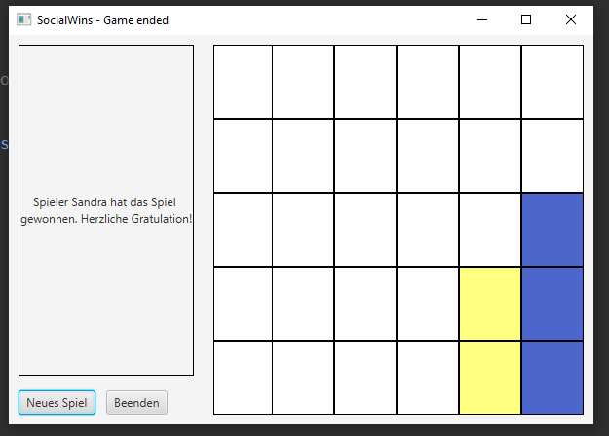
* **Right player name is shown as player prompt**
  + 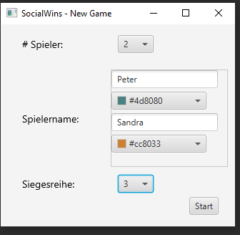
  + 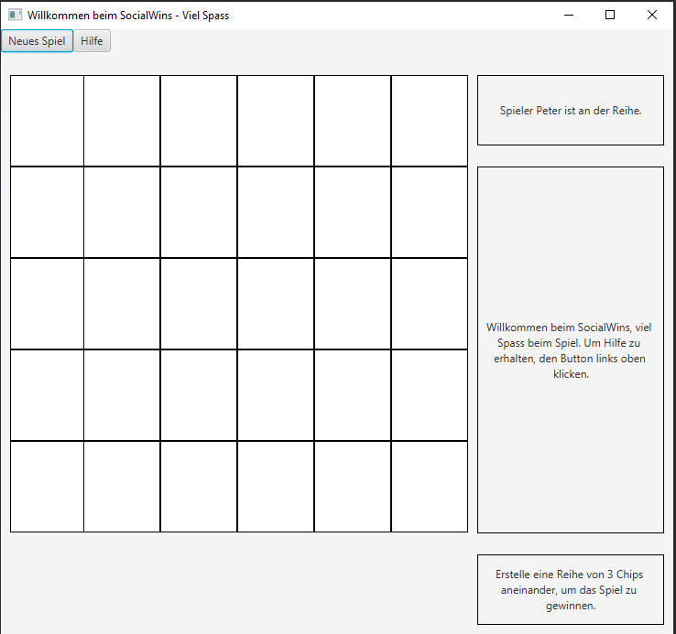
  + 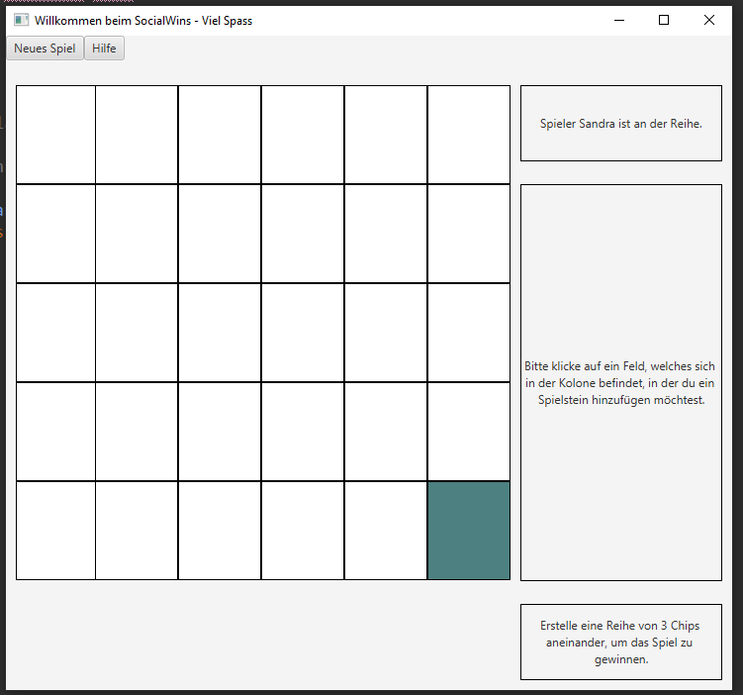
  + 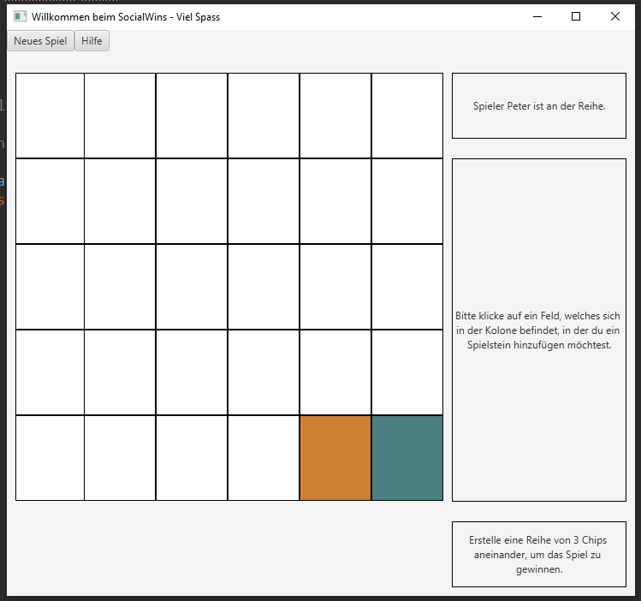
* **Right text is shown, when a column is full an as explanation**
  + 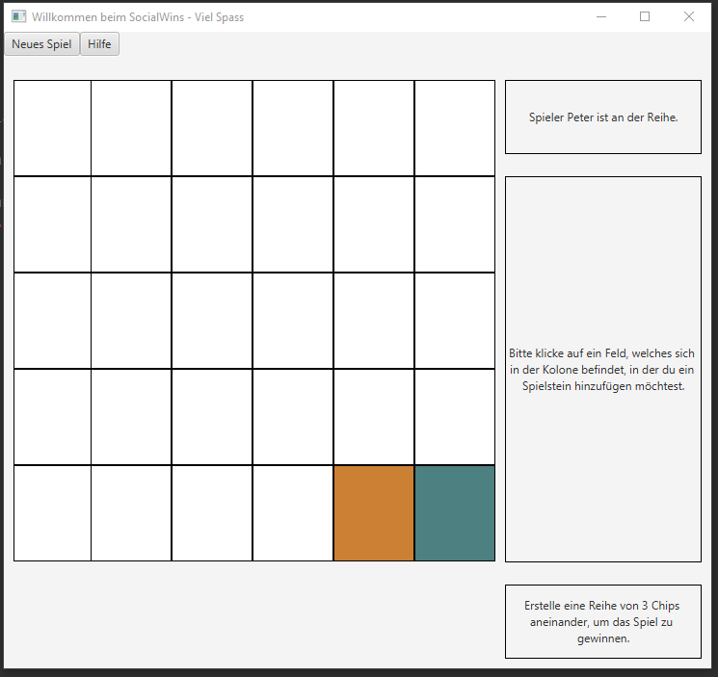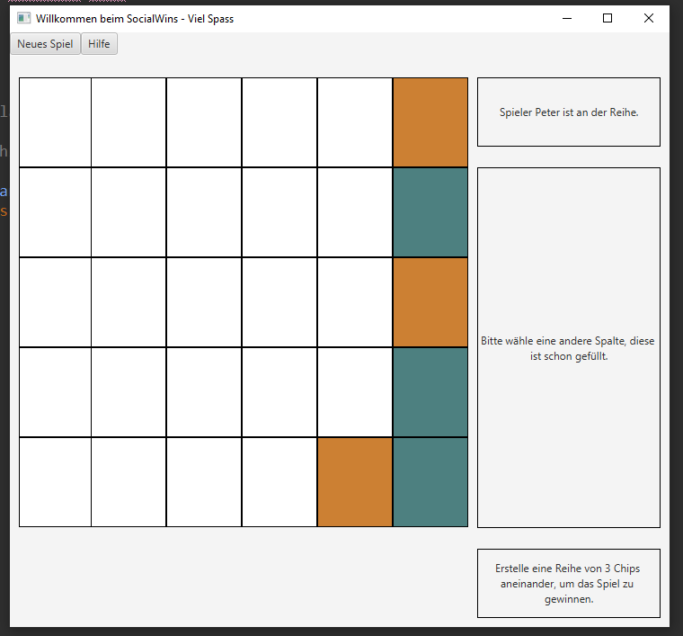
* **2-Players**
  + **3-WinningRow**
    - **Win**
      * 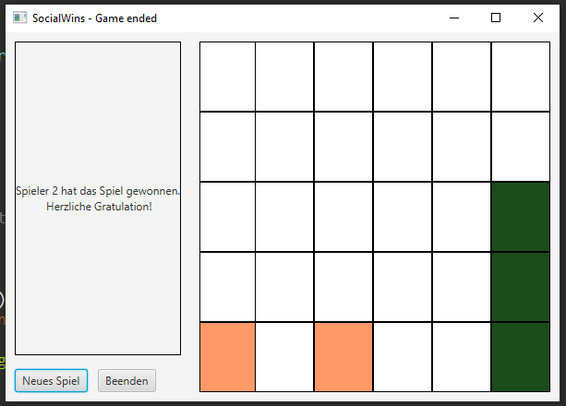
    - **Draw**
      * 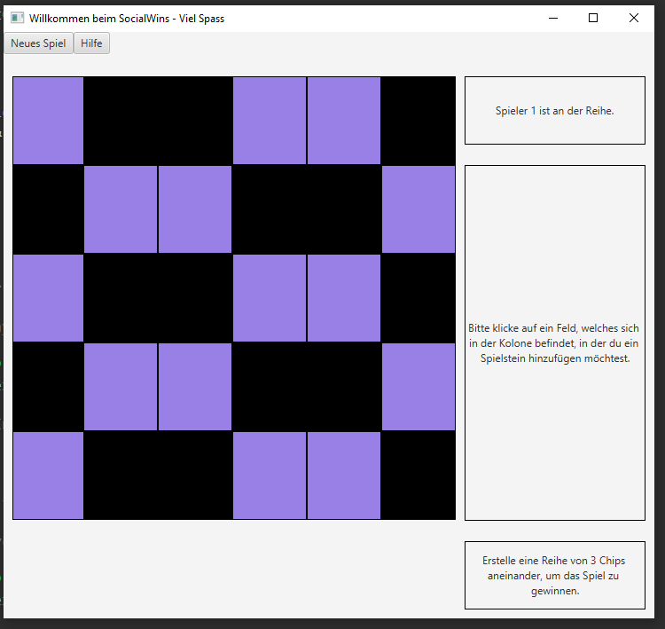
  + **4-WinningRow**
    - **Win**
      * 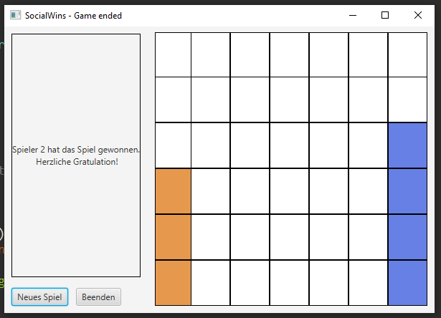
    - **Draw**
      * 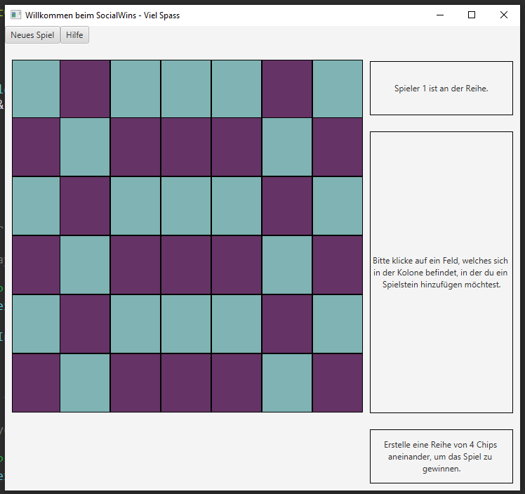
  + **5-WinningRow**
    - **Win**
      * 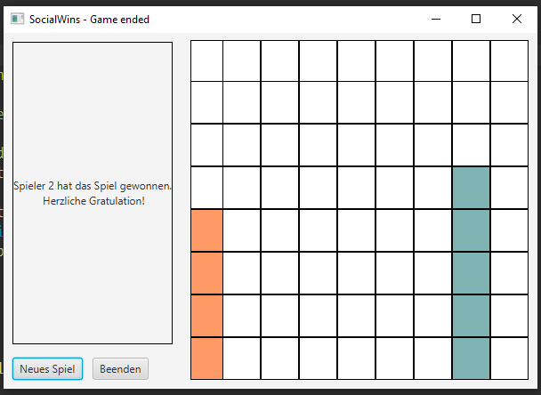
    - **Draw**
      * 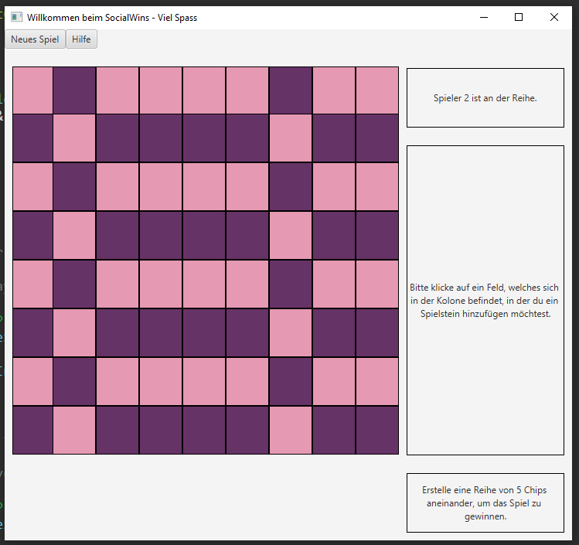
  + **6-WinningRow**
    - **Win**
      * 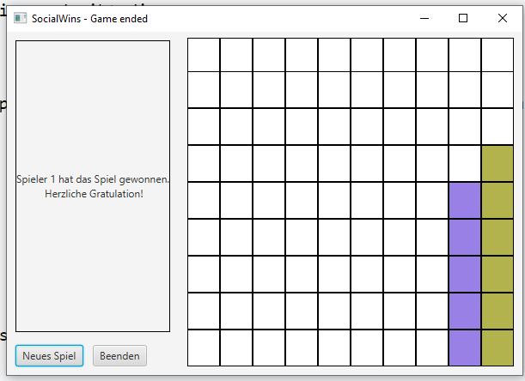
    - **Draw**
      * 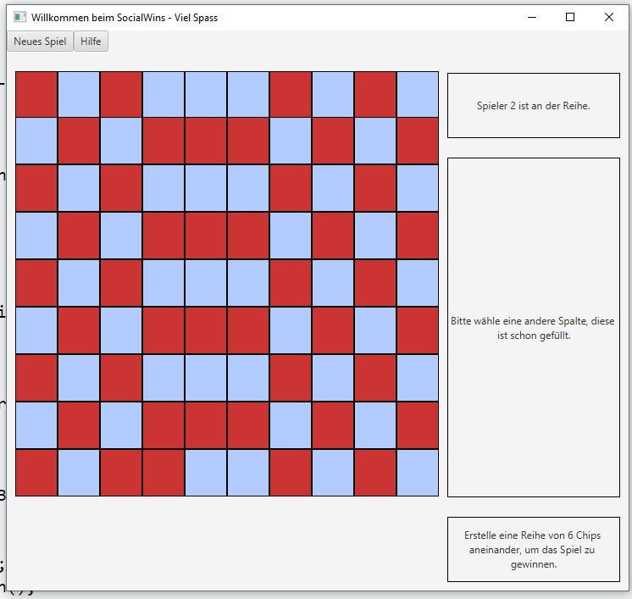
* **3-Players**
  + **3-WinningRow**
    - **Win**
      * 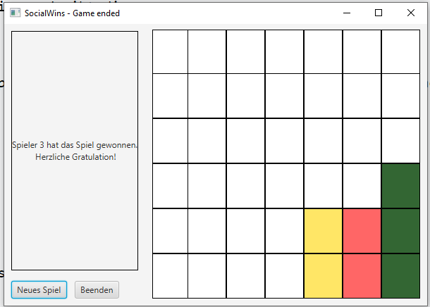
    - **Draw**
      * 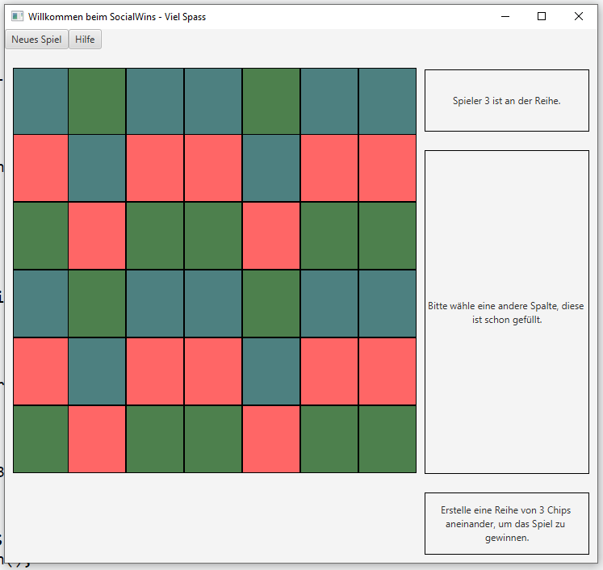
  + **4-WinningRow**
    - **Win**
      * 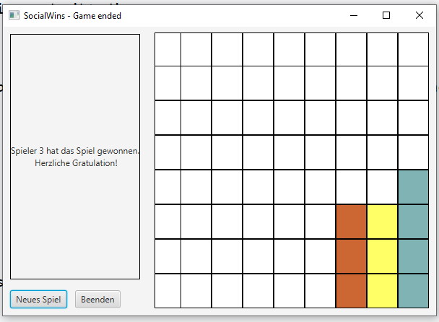
    - **Draw**
      * 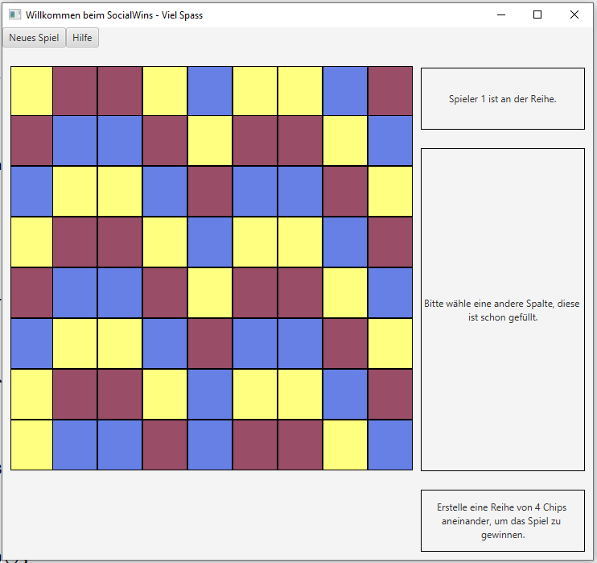
  + **5-WinningRow**
    - **Win**
      * 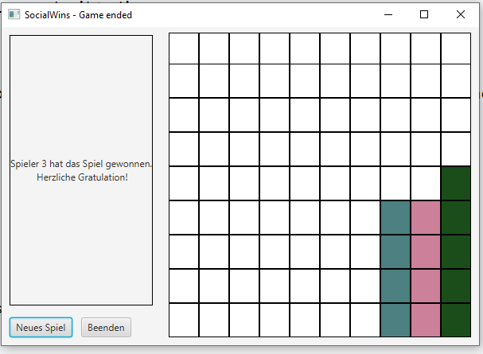
    - **Draw**
      * 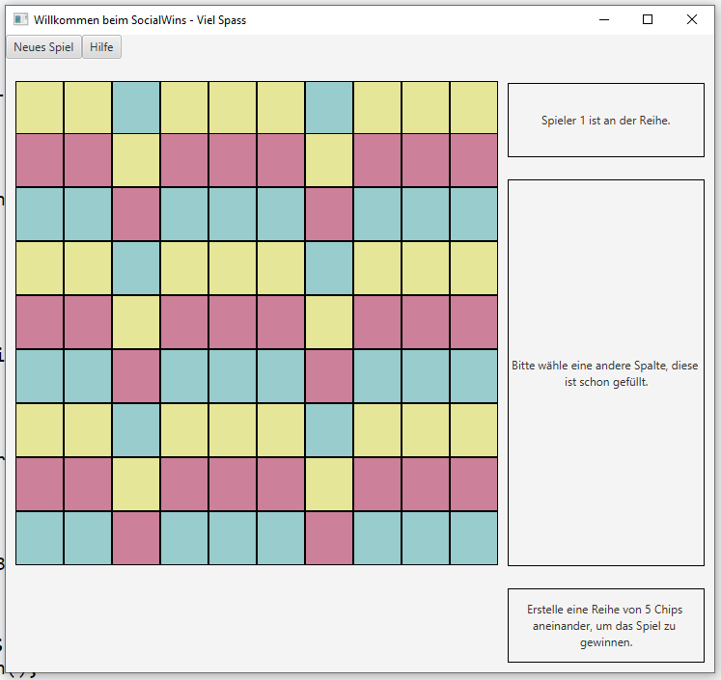
  + **6-WinningRow**
    - **Win**
      * 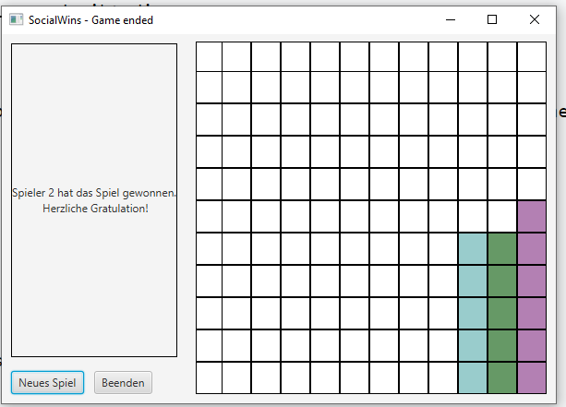
    - **Draw**
      * 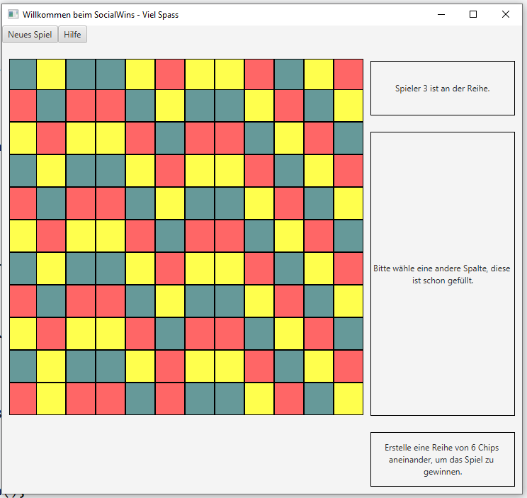
* **4-Players**
  + **3-WinningRow**
    - **Win**
      * 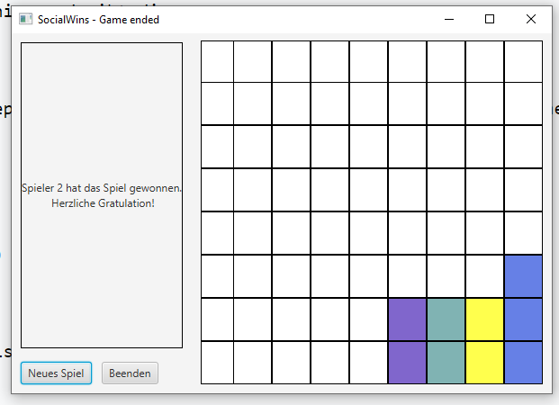
    - **Draw**
      * 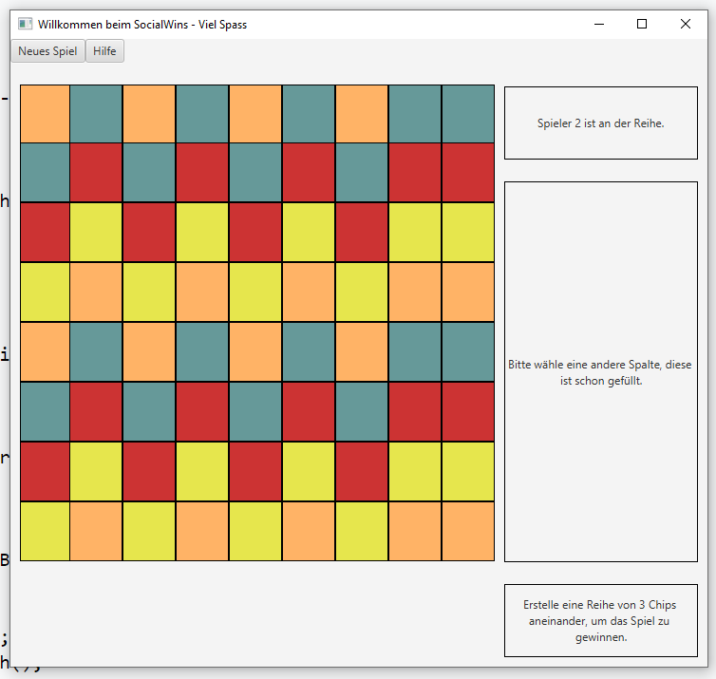
  + **4-WinningRow**
    - **Win**
      * 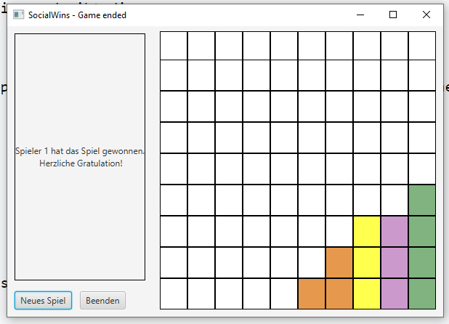
    - **Draw**
      * 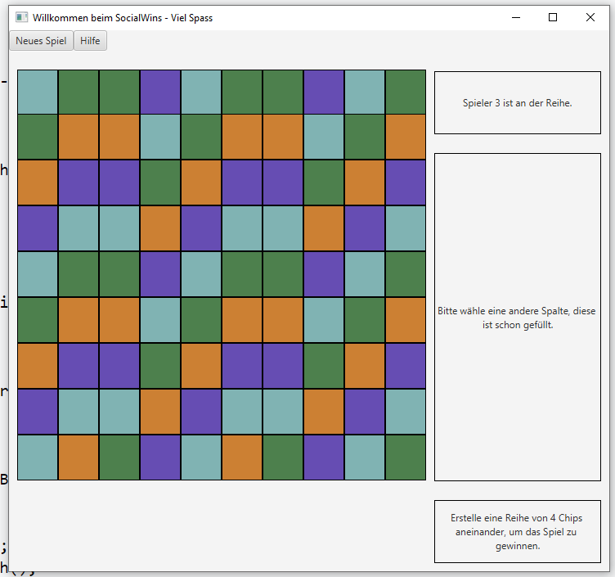
  + **5-WinningRow**
    - **Win**
      * 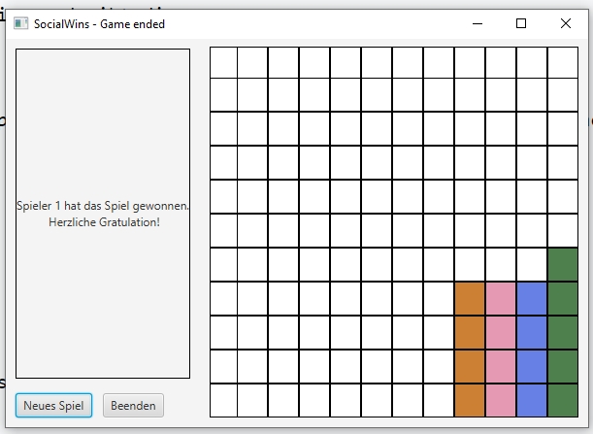
    - **Draw**
      * 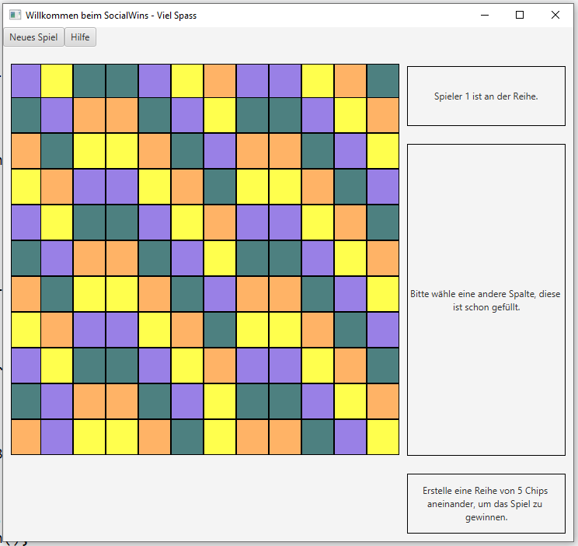
  + **6-WinningRow**
    - **Win**
      * 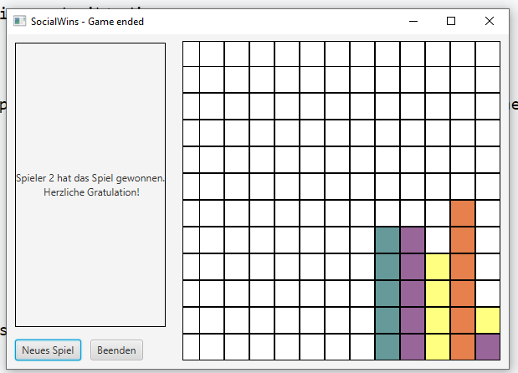
    - **Draw**
      * 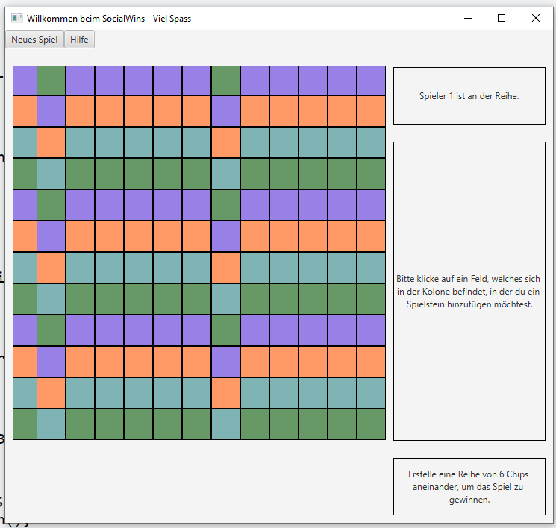
* **5-Players**
  + **3-WinningRow**
    - **Win**
      * 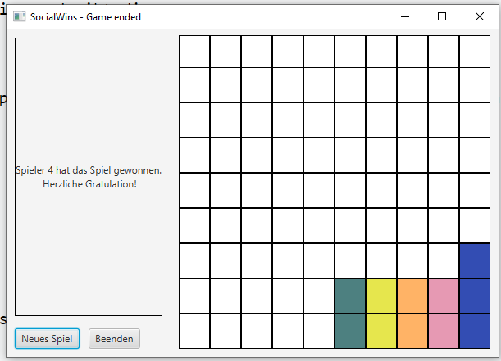
    - **Draw**
      * 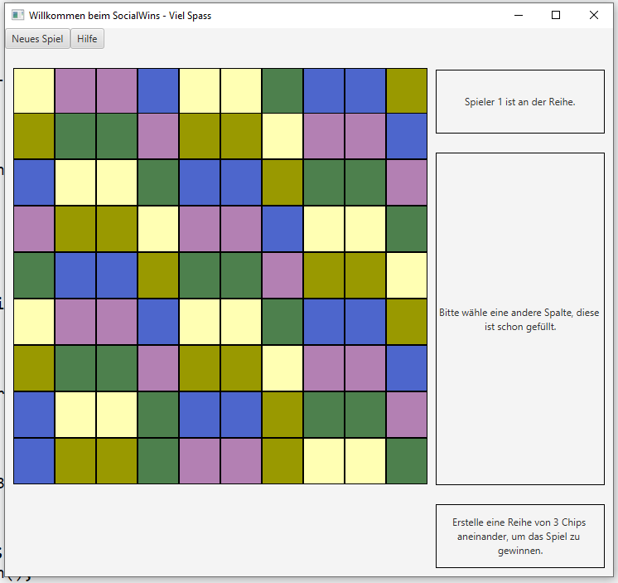
  + **4-WinningRow**
    - **Win**
      * 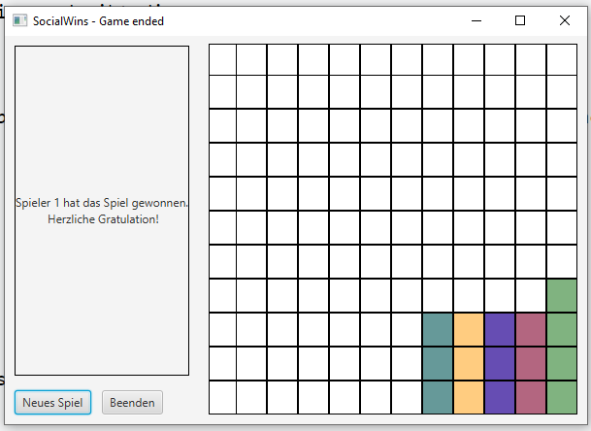
    - **Draw**
      * 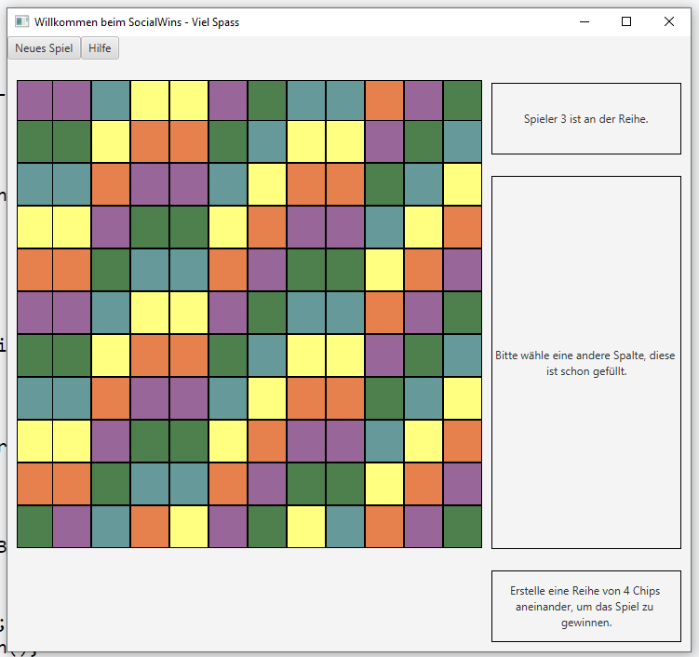
  + **5-WinningRow**
    - **Win**
      * 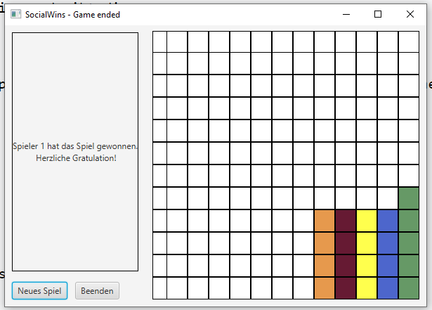
    - **Draw**
      * 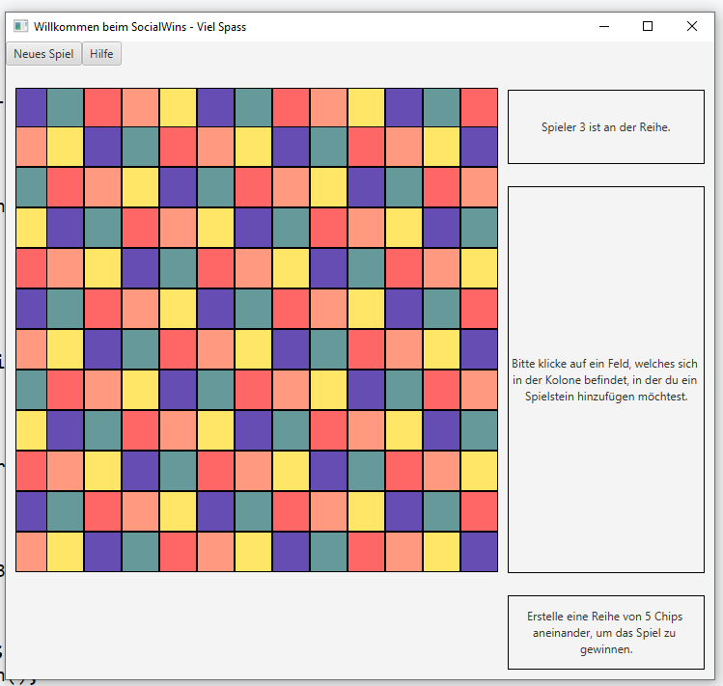
  + **6-WinningRow**
    - **Win**
      * 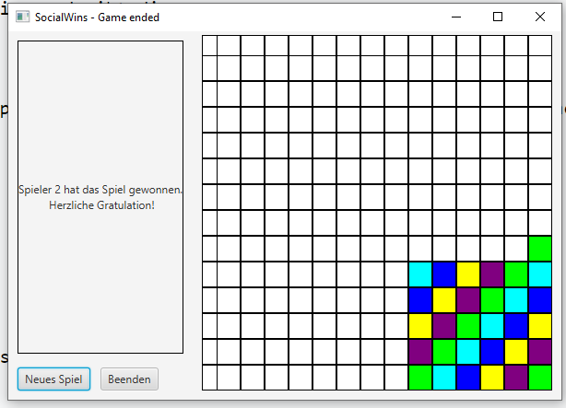
    - **Draw**
      * 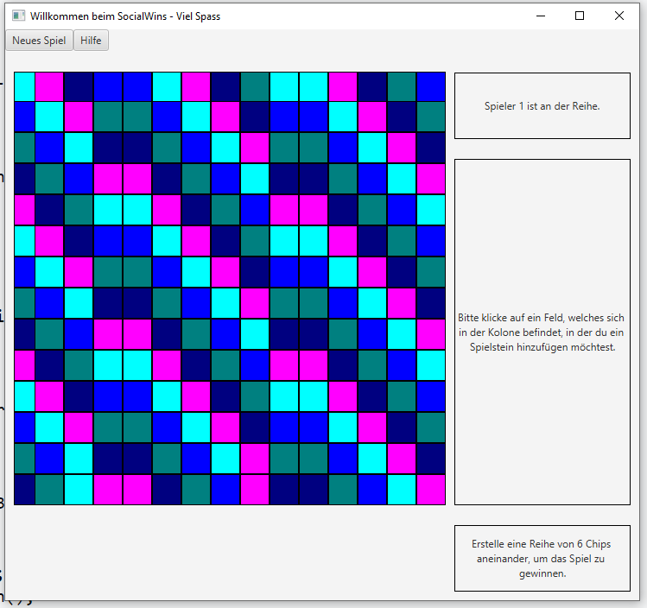
* **6-Players**
  + **3-WinningRow**
    - **Win**
      * 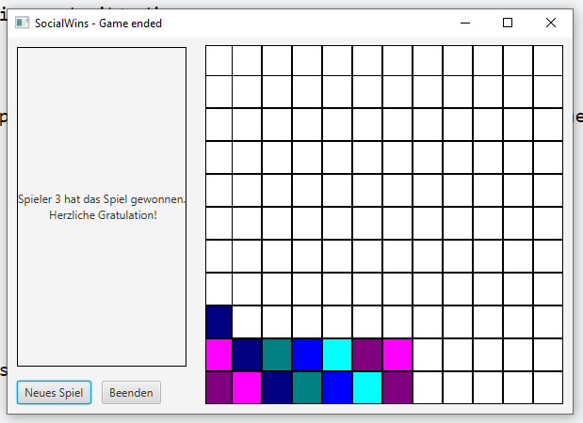
    - **Draw**
      * 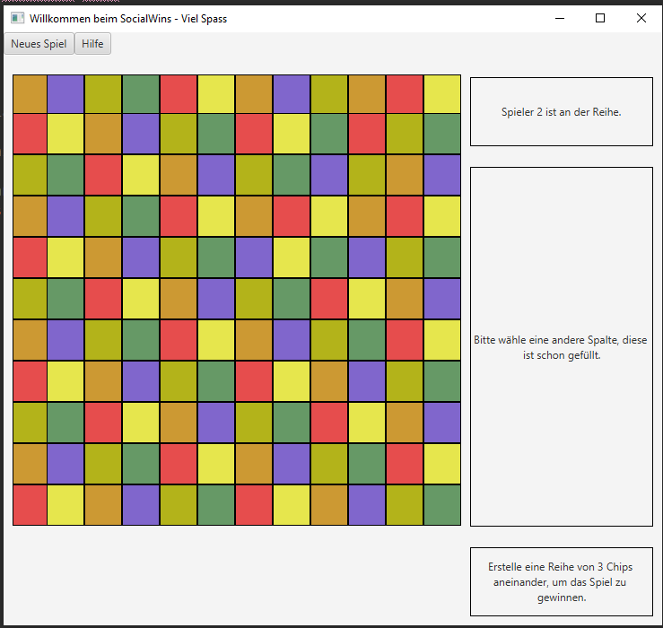
  + **4-WinningRow**
    - **Win**
      * 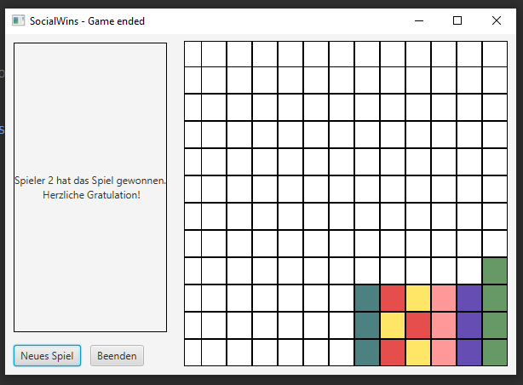
    - **Draw**
      * 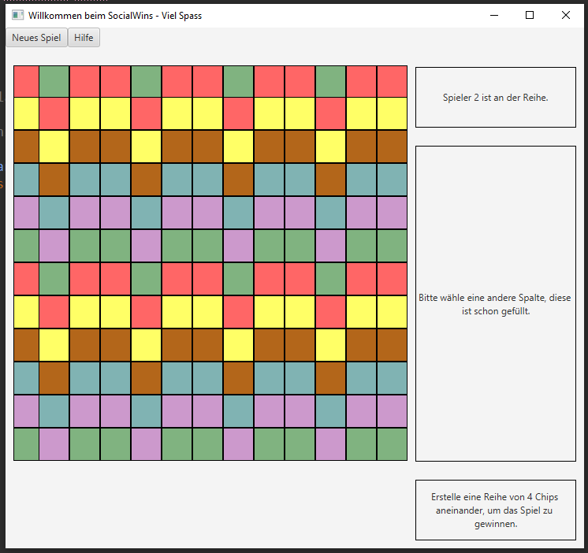
  + **5-WinningRow**
    - **Win**
      * 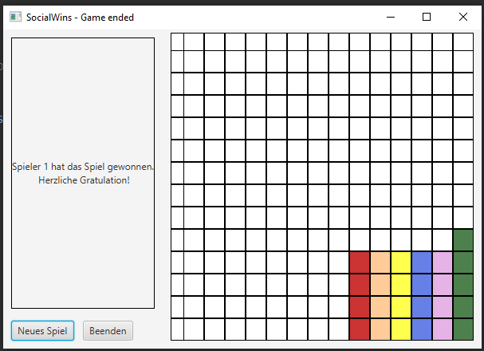
    - **Draw**
      * 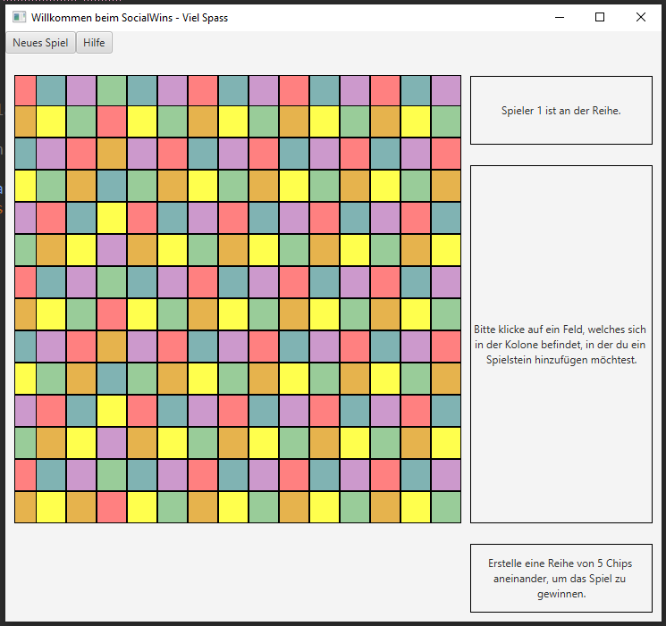
  + **6-WinningRow**
    - **Win**
      * 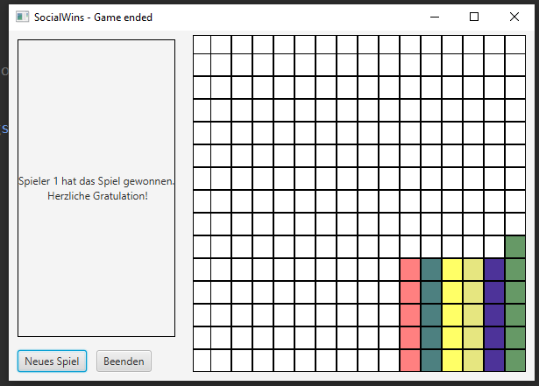
    - **Draw**
      * 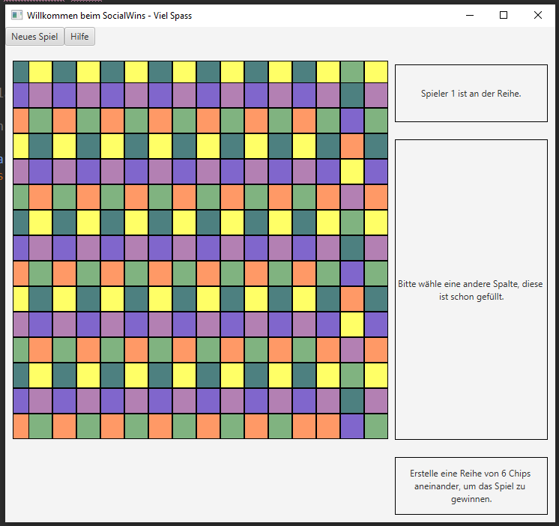
* **7-Players**
  + **3-WinningRow**
    - **Win**
      * 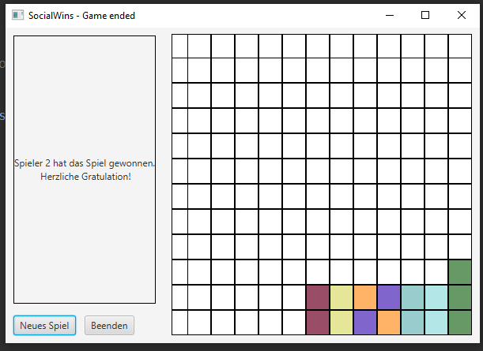
    - **Draw**
      * 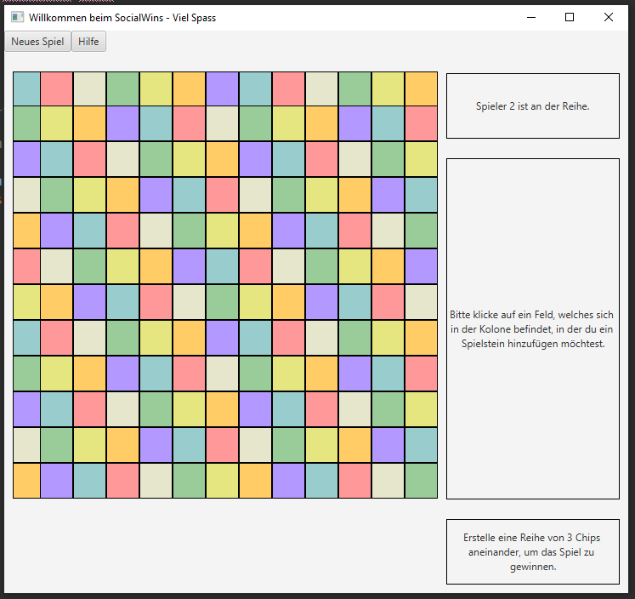
  + **4-WinningRow**
    - **Win**
      * 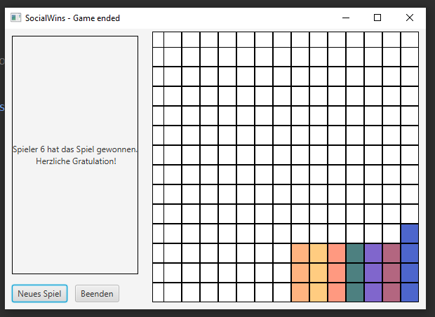
    - **Draw**
      * 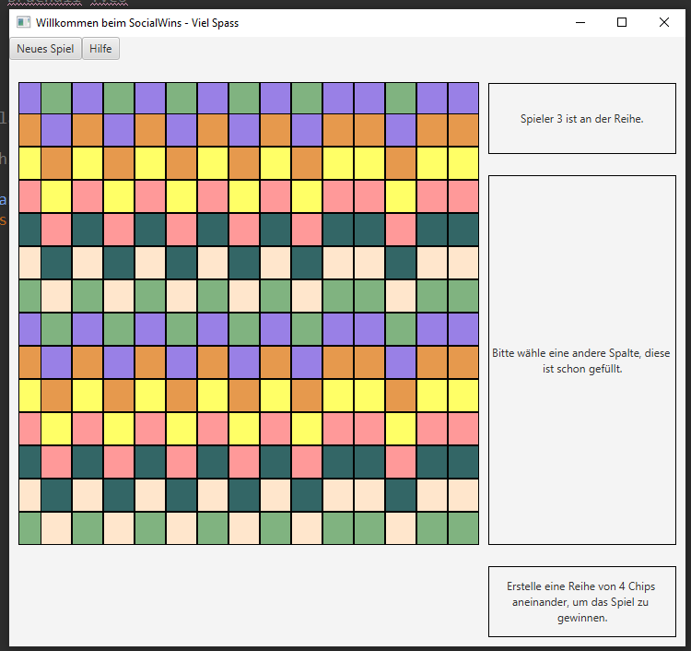
  + **5-WinningRow**
    - **Win**
      * 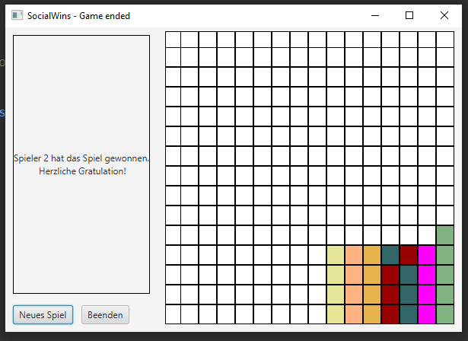
    - **Draw**
      * 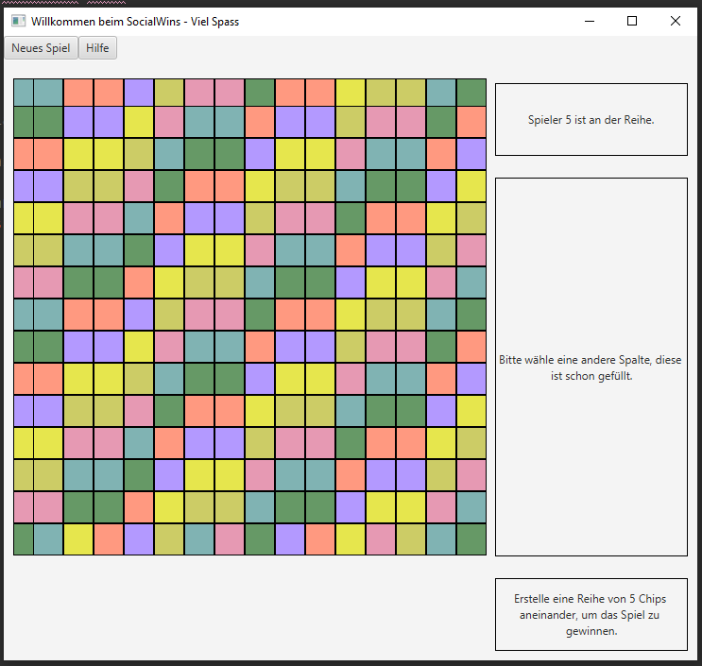
  + **6-WinningRow**
    - **Win**
      * 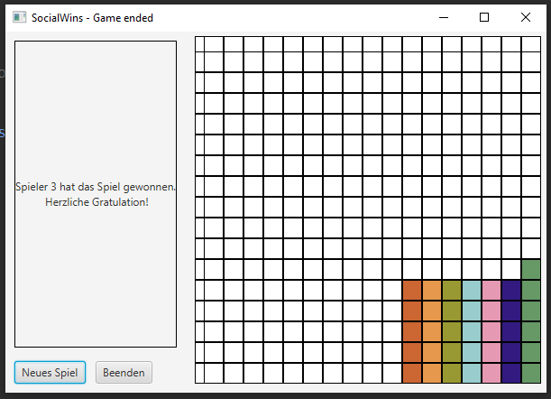
    - **Draw**
      * 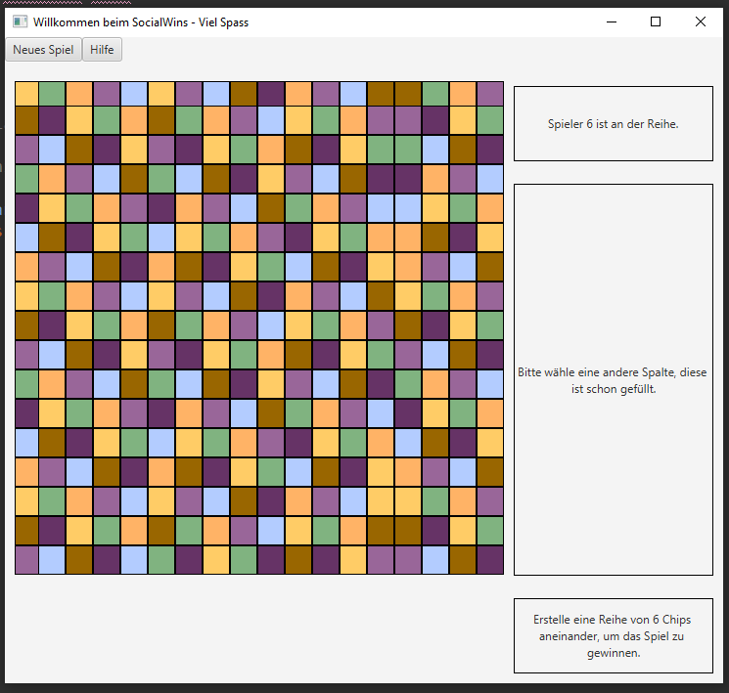
* **8-Players**
  + **3-WinningRow**
    - **Win**
      * 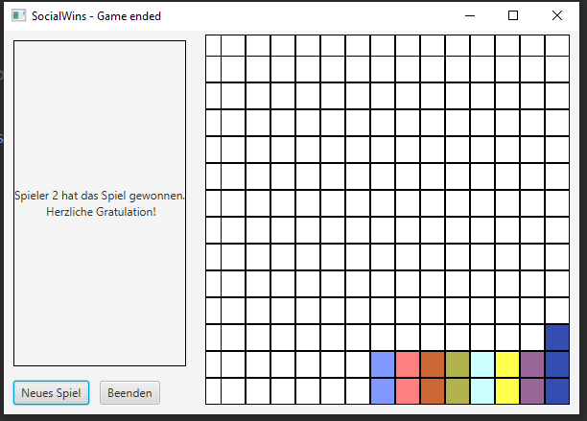
    - **Draw**
      * 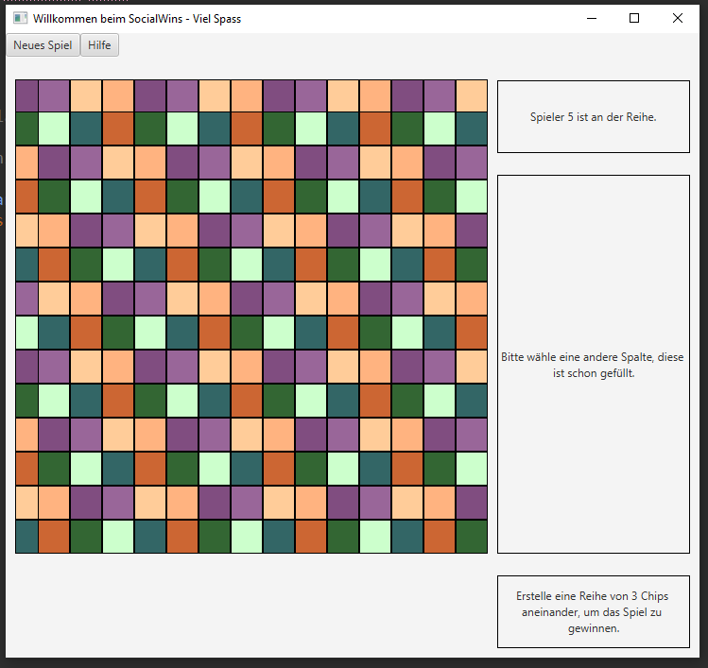
  + **4-WinningRow**
    - **Win**
      * 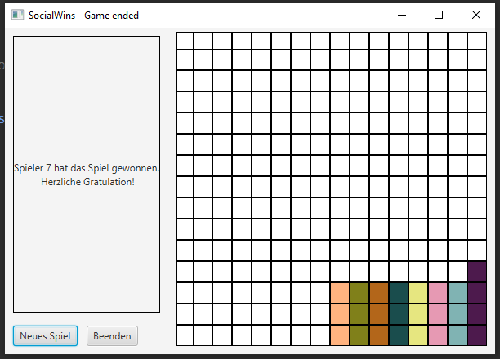
    - **Draw**
      * 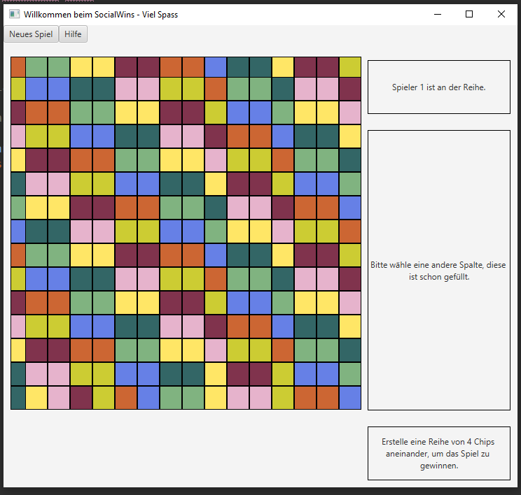
  + **5-WinningRow**
    - **Win**
      * 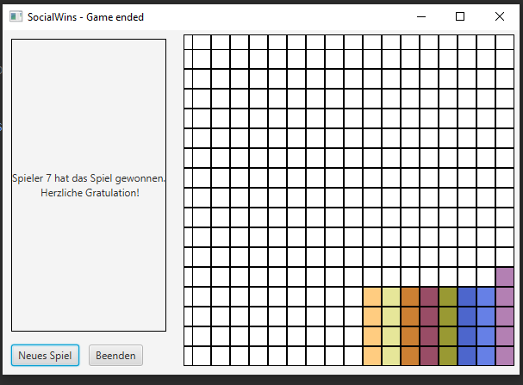
    - **Draw**
      * 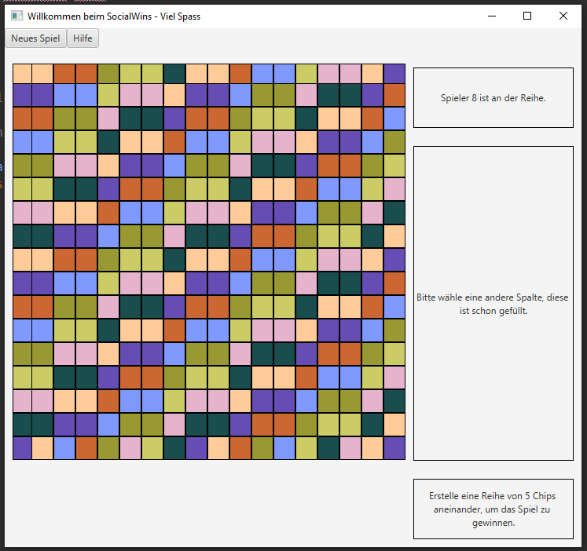
  + **6-WinningRow**
    - **Win**
      * 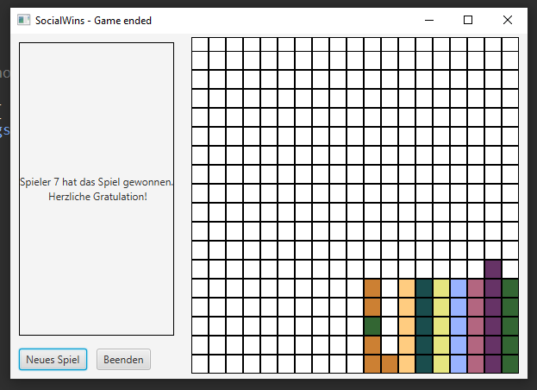
    - **Draw**
      * 