Inhaltsverzeichnis

Testing of evaluateState **2**

Testing of calculateComputerMove **3**

Screenshot

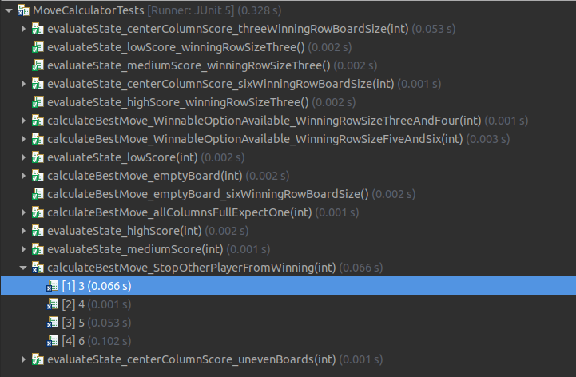

## Testing of evaluateState

**Equivalence Partitioning**

|  |  |
| --- | --- |
| eS1 | Assigning Low Score |
| eS2 | Assigning Medium Score |
| eS3 | Assigning High Score |
| eS4 | Assigning Center Column Score |

**Test log**

|  |  |  |  |
| --- | --- | --- | --- |
| **testcases** | **Expected Score** | **Eqivalence Partititoning** | **Result** |
| **evaluateState_lowScore** | **2** | **eS1** | **Passed** |
| Board with winning row size: 4 | 2 | eS1 | Passed |
| Board with winning row size: 5 | 2 | eS1 | Passed |
| Board with winning row size: 6 | 2 | eS1 | Passed |
| **evaluateState_lowScore_winningRowSizeThree** | **0** | **eS1** |  |
| **evaluateState_mediumScore** | **8** | **eS2** | Passed |
| Board with winning row size: 4 | 8 | eS2 | Passed |
| Board with winning row size: 5 | 8 | eS2 | Passed |
| Board with winning row size: 6 | 8 | eS2 | Passed |
| **evaluateState_mediumScore_winningRowSizeThree** | **6** | **eS2** | **Passed** |
| **evaluateState_highScore** | **508** | **eS3** | **Passed** |
| Board with winning row size: 4 | 508 | eS3 | Passed |
| Board with winning row size: 5 | 508 | eS3 | Passed |
| Board with winning row size: 6 | 508 | eS3 | Passed |
| **evaluateState_highScore_winningRowSizeThree** | **506** | **eS3** | **Passed** |
| **evaluateState_centerColumnScore_unevenBoards** | **4** | **eS4** | Passed |
| Board with winning row size: 4 | 4 | eS4 | Passed |
| Board with winning row size: 5 | 4 | eS4 | Passed |
| **evaluateState_centerColumnScore_threeWinningRowBoardSize** | **4** | **eS4** | **Passed** |
| Center Column: 2 | 4 | eS4 | Passed |
| Center Column: 3 | 4 | eS4 | Passed |
| **evaluateState_centerColumnScore_sixWinningRowBoardSize** | **4** | **eS4** | **Passed** |
| Center Column: 4 | 4 | eS4 | Passed |
| Center Column: 5 | 4 | eS4 | Passed |

## Testing of calculateComputerMove

|  |  |
| --- | --- |
| ccM1 | Ignore Full Columns |
| ccM2 | Other Player can win |
| ccM3 | Computer can win |
| ccM4 | Best Move on empty board |

|  |  |  |  |
| --- | --- | --- | --- |
| **testcases** | **Expected Column** | **Eqivalence Partititoning** | **Result** |
| **calculateBestMove_allColumnsFullExpectOne** | **0** | **ccM1** | Passed |
| Board with winning row size: 3 | 0 | ccM1 | Passed |
| Board with winning row size: 4 | 0 | ccM1 | Passed |
| Board with winning row size: 5 | 0 | ccM1 | Passed |
| Board with winning row size: 6 | 0 | ccM1 | Passed |
| **calculateBestMove_StopOtherPlayerFromWinning** | **3** | **ccM2** |  |
| Board with winning row size: 3 | 3 | ccM2 |  |
| Board with winning row size: 4 | 3 | ccM2 |  |
| Board with winning row size: 5 | 3 | ccM2 |  |
| Board with winning row size: 6 | 3 | ccM2 |  |
| **calculateBestMove_WinnableOptionAvailable_WinningRowSizeThreeAndFour** | **3** | **ccM3** | Passed |
| Board with winning row size: 3 | 3 | ccM3 | Passed |
| Board with winning row size: 4 | 3 | ccM3 | Passed |
| **calculateBestMove_WinnableOptionAvailable_WinningRowSizeFiveAndSix** | **4** | **ccM3** | Passed |
| Board with winning row size: 5 | 4 | ccM3 | Passed |
| Board with winning row size: 6 | 4 | ccM3 | Passed |
| **calculateBestMove_emptyBoard** | **-** | **ccM4** | Passed |
| Board with winning row size: 3 | 2 | ccM4 | Passed |
| Board with winning row size: 4 | 3 | ccM4 | Passed |
| Board with winning row size: 5 | 4 | ccM4 | Passed |
| **calculateBestMove_emptyBoard_sixWinningRowBoardSize** | **4** | **ccM4** | Passed |