Inhaltsverzeichnis

Screenshot 1

Testing of Game isBoardFull & isColumnFull 2

Testing of addChip 2

Testing of getColorWithChipsInARow 3

Screenshot

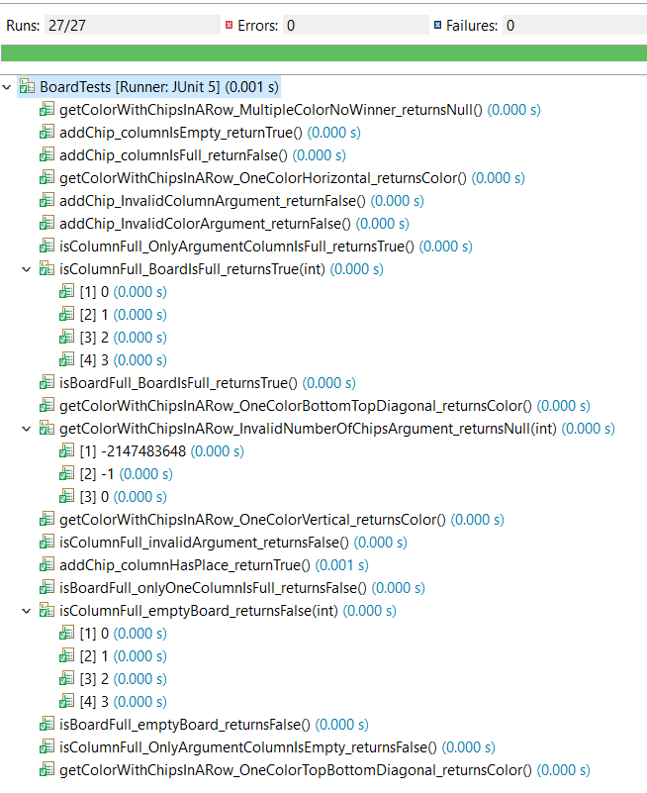

## Testing of Game isBoardFull & isColumnFull

**Equivalence Partitioning**

|  |  |
| --- | --- |
| F1 | Invalid Arguments |
| F2 | Empty Board |
| F3 | Column empty |
|  |  |
| F4 | Valid Arguments |
| F5 | One column full |
| F6 | Full Board |

**Test log**

|  |  |  |  |
| --- | --- | --- | --- |
| **testcases** | **Expected** | **Eqivalence Partititoning** | **Result** |
| isBoardFull_emptyBoard_returnsFalse | false | F2 | passed |
| isBoardFull_onlyOneColumnIsFull_returnsFalse | false | F5 | passed |
| isBoardFull_BoardIsFull_returnsTrue | true | F6 | passed |
|  |  |  |  |
| isColumnFull_invalidArgument_returnsFalse | false | F1 | passed |
| isColumnFull_emptyBoard_returnsFalse | false | F2, F4 | passed |
| isColumnFull_OnlyArgumentColumnIsFull_returnsTrue | true | F4, F5 | passed |
| isColumnFull_OnlyArgumentColumnIsEmpty_returnsFalse | false | F3, F4 | passed |
| isColumnFull_BoardIsFull_returnsTrue | true | F6 | passed |

## Testing of addChip

**Equivalence Partitioning**

|  |  |
| --- | --- |
| C1 | Invalid Argument |
| C2 | Column is full |
|  |  |
| C3 | Valid Argument |
| C4 | Column is empty |
| C5 | Column has space |

**Test log**

|  |  |  |  |
| --- | --- | --- | --- |
| **testcases** | **Expected** | **Eqivalence Partititoning** | **Result** |
| addChip_InvalidColumnArgument_returnFalse | false | C1 | passed |
| addChip_InvalidColorArgument_returnFalse | false | C1 | passed |
| addChip_columnIsFull_returnFalse | false | C2, C3 | passed |
| addChip_columnIsEmpty_returnTrue | true | C3, C4 | passed |
| addChip_columnHasPlace_returnTrue | true | C3, C5 | passed |

## Testing of getColorWithChipsInARow

**Equivalence Partitioning**

|  |  |
| --- | --- |
| G1 | Invalid argument |
| G2 | Has multiple Color in a row |
|  |  |
| G3 | Valid argument |
| G4 | Has one Color in a row |

**Test log**

|  |  |  |  |
| --- | --- | --- | --- |
| **testcases** | **Expected** | **Eqivalence Partititoning** | **Result** |
| getColorWithChipsInARow_InvalidNumberOfChipsArgument_returnsNull | null | G1 | passed |
| getColorWithChipsInARow_MultipleColorNoWinner_returnsNull | null | G2 | passed |
| getColorWithChipsInARow_OneColorHorizontal_returnsColor | Color | G3, G4 | passed |
| getColorWithChipsInARow_OneColorVertical_returnsColor | Color | G3, G4 | passed |
| getColorWithChipsInARow_OneColorTopBottomDiagonal_returnsColor | Color | G3, G4 | passed |
| getColorWithChipsInARow_OneColorBottomTopDiagonal_returnsColor | Color | G3, G4 | passed |