Inhaltsverzeichnis

Screenshot 1

Testing of Game Constructors 2

Screenshot

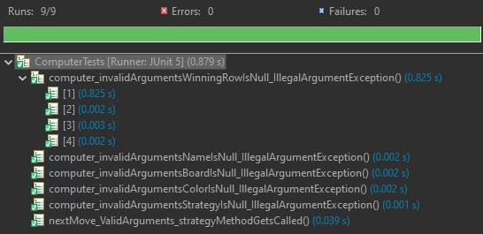

## Testing of Game Constructors

**Equivalence Partitioning**

|  |  |
| --- | --- |
| C1 | Invalid Arguments |
|  |  |
| C2 | Valid Arguments |

**Test log**

|  |  |  |  |
| --- | --- | --- | --- |
| **testcases** | **Expected** | **Eqivalence Partititoning** | **Result** |
| computer_invalidArgumentsNameIsNull_IllegalArgumentException | IllegalArgumentException | C1 | passed |
| computer_invalidArgumentsColorIsNull_IllegalArgumentException | IllegalArgumentException | C1 | passed |
| computer_invalidArgumentsStrategyIsNull_IllegalArgumentException | IllegalArgumentException | C1 | passed |
| computer_invalidArgumentsBoardIsNull_IllegalArgumentException | IllegalArgumentException | C1 | passed |
| computer_invalidArgumentsWinningRowIsNull_IllegalArgumentException | IllegalArgumentException | C1 | passed |
|  |  |  |  |
| nextMove_ValidArguments_strategyMethodGetsCalled | True | C2 | passed |