Inhaltsverzeichnis

Screenshot 1

Testing of addPlayer & addComputer 2

Testing of start 2

Screenshot

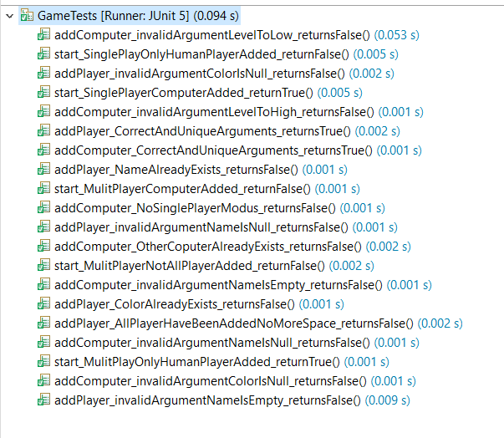

## Testing of addPlayer & addComputer

**Equivalence Partitioning**

|  |  |
| --- | --- |
| A1 | invalid arguments |
| A2 | Already Existing Player |
| A3 | Valid number of players |
|  |  |
| A4 | Valid arguments |
| A5 | Player does not exist yet |

**Test log**

|  |  |  |  |
| --- | --- | --- | --- |
| **testcases** | **Expected** | **Eqivalence Partititoning** | **Result** |
| addPlayer_invalidArgumentNameIsNull_returnsFalse | false | A1 | passed |
| addPlayer_invalidArgumentNameIsEmpty_returnsFalse | false | A1 | passed |
| addPlayer_invalidArgumentColorIsNull_returnsFalse | false | A1 | passed |
| addPlayer_NameAlreadyExists_returnsFalse | false | A2 | passed |
| addPlayer_ColorAlreadyExists_returnsFalse | false | A2 | passed |
| addPlayer_AllPlayerHaveBeenAddedNoMoreSpace_returnsFalse | false | A3 | passed |
| addPlayer_CorrectAndUniqueArguments_returnsTrue | true | A4, A5 | passed |
|  |  |  |  |
| addComputer_invalidArgumentNameIsNull_returnsFalse | false | A1 | passed |
| addComputer_invalidArgumentNameIsEmpty_returnsFalse | false | A1 | passed |
| addComputer_invalidArgumentColorIsNull_returnsFalse | false | A1 | passed |
| addComputer_invalidArgumentLevelToHigh_returnsFalse | false | A1 | passed |
| addComputer_invalidArgumentLevelToLow_returnsFalse | false | A1 | passed |
| addComputer_OtherCoputerAlreadyExists_returnsFalse | false | A2 | passed |
| addComputer_NoSinglePlayerModus_returnsFalse | false | A3 | passed |
| addComputer_CorrectAndUniqueArguments_returnsTrue | true | A4, A5 | passed |

## Testing of start

|  |  |
| --- | --- |
| S1 | Not all players are set |
| S2 | Wrong players are added |
|  |  |
| S3 | All players are set |
| S4 | Correct players are added |

|  |  |  |  |
| --- | --- | --- | --- |
| **testcases** | **Expected** | **Eqivalence Partititoning** | **Result** |
| start_MulitPlayerNotAllPlayerAdded_returnFalse | false | S1 | passed |
| start_SinglePlayOnlyHumanPlayerAdded_returnFalse | false | S2 | passed |
| start_MulitPlayerComputerAdded_returnFalse | false | S2 | passed |
| start_MulitPlayOnlyHumanPlayerAdded_returnTrue | true | S3, S4 | passed |
| start_SinglePlayerComputerAdded_returnTrue | true | S3, S4 | passed |