7. The constraint of the temperature of zone 2 is violated for a significant period of time from the beginning. The reason is that the temperature was initialized very close to the steady state for zone 2. In addition, the LQR controller tends to reduce the cost of the input rather than that of the state as only finite horizon is considered. As a result, T2 violated the constraint even if p2 was not saturated at the beginning.

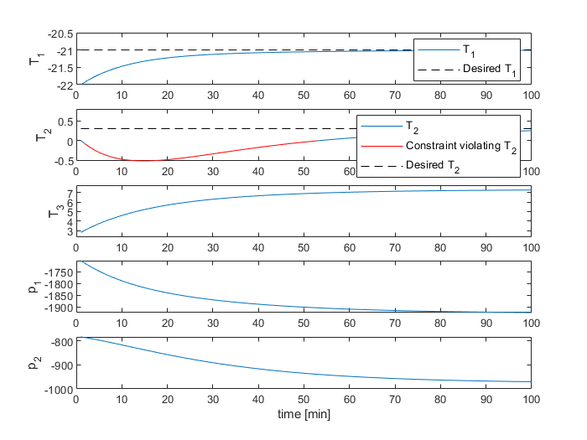

17. It can be seen from the plot that the constraints are violated for a significant period of time.

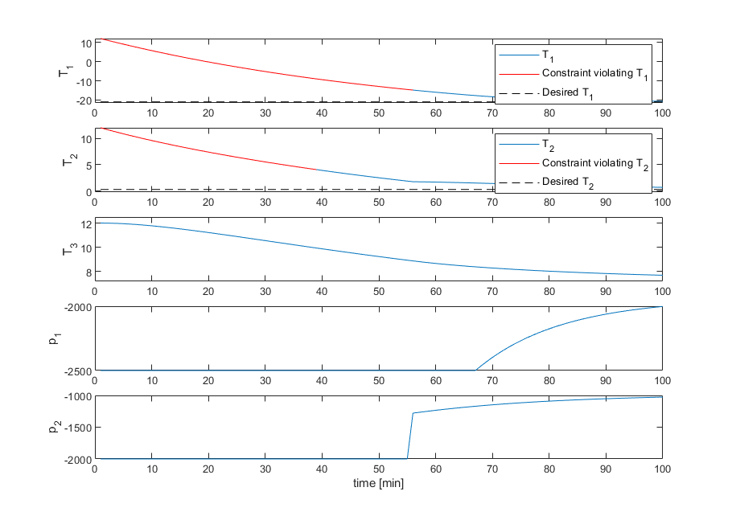

19. 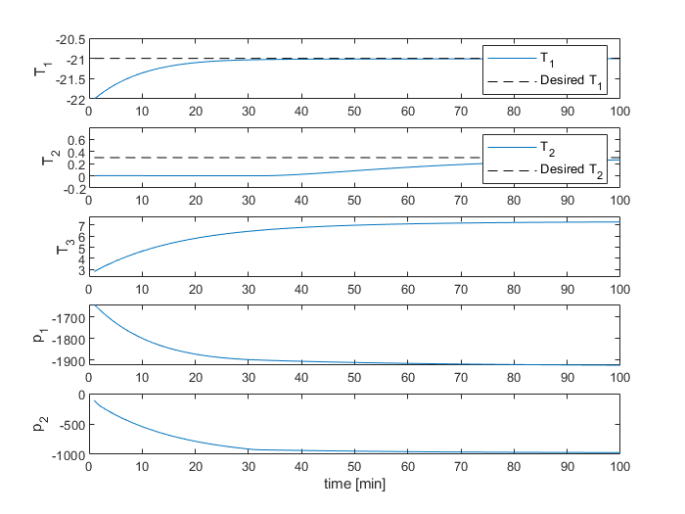

3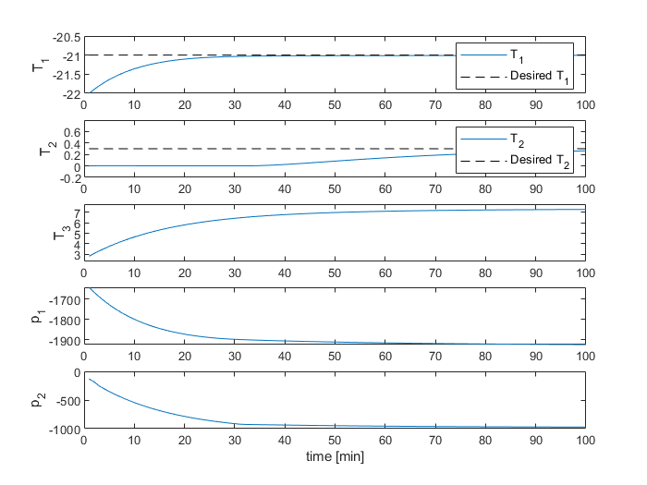

4