Q1

From the differential equations, we have

$$\left[\begin{matrix}\dot{T_{1}^{c}}(t) \\ \dot{T_{2}^{c}}(t) \\ \dot{T_{3}^{c}}(t)\end{matrix}\right]=\left[\begin{matrix}-\frac{1}{m_{1}}(α_{1,0}+α_{1,2}) & \frac{α_{1,2}}{m_{1}} & 0 \\ \frac{α_{1,2}}{m_{2}} & -\frac{1}{m_{2}}(α_{2,3}+α_{1,2}+α_{2,0}) & \frac{α_{2,3}}{m_{2}} \\ 0 & \frac{α_{2,3}}{m_{3}} & -\frac{1}{m_{3}}(α_{2,3}+α_{3,0})\end{matrix}\right]\left[\begin{matrix}T_{1}^{c}(t) \\ T_{2}^{c}(t) \\ T_{3}^{c}(t)\end{matrix}\right]+\left[\begin{matrix}\frac{1}{m_{1}} & 0 \\ 0 & \frac{1}{m_{2}} \\ 0 & 0\end{matrix}\right]\left[\begin{matrix}p_{1}^{c}(t) \\ p_{2}^{c}(t)\end{matrix}\right]+\left[\begin{matrix}\frac{1}{m_{1}} & 0 & 0 \\ 0 & \frac{1}{m_{2}} & 0 \\ 0 & 0 & \frac{1}{m_{3}}\end{matrix}\right]\left[\begin{matrix}α_{1,0}T_{0}+w_{1} \\ α_{2,0}T_{0}+w_{2} \\ α_{3,0}T_{0}+w_{3}\end{matrix}\right]$$

Q2

$$\dot{T^{c}}\left(t\right)=g(x^{c}\left(t\right), p^{c}\left(t\right))$$

After discretizing,

$$T\left(k+1\right)=T\left(k\right)+T_{s}g\left(x^{c}\left(t\right), p^{c}\left(t\right)\right)$$

$$T\left(k+1\right)=\left(I+T_{s}A^{c}\right)T\left(k\right)+T_{s}B^{c}p\left(k\right)+T_{s}B_{d}^{c}d$$

And we define,

$$A≔I+T_{s}A^{c} \\ B≔T_{s}B^{c} \\ B_{d}≔T_{s}B_{d}^{c}$$

Q3

In the steady state,

$$T\left(k+1\right)=T\left(k\right)$$ Considering the discretization formula in last question, we have

$$A^{c}T_{sp}+B^{c}p_{sp}+B_{d}^{c}d=0$$

We define the steady state temperature,

$$T_{sp}=\left[\begin{matrix}T_{1,sp} & T_{2,sp} & T_{3,sp}\end{matrix}\right]'(℃)$$

in which

$$T_{1,sp}=-21℃ \\ T_{2,sp}=0.3℃$$

The equation of the Zone 3,

$$0=α_{2,3}\left(T_{2,sp}-T_{3,sp}\right)+α_{3,0}\left(T_{0}-T_{3,sp}\right)+w_{1}$$

Thus we have

$$T_{3,sp}=\frac{1}{α_{2,3}+α_{3,0}}\left(α_{2,3}T_{2,sp}+α_{3,0}T_{0}+w_{3}\right) ℃$$

which can be derived when the coefficients are given.

On the other hand, the control strategies can be calculated from the differential equations of Zone 1 and 2.

$$p_{sp}=\left[\begin{matrix}p_{1,sp} \\ p_{2,sp}\end{matrix}\right]=\left[\begin{matrix}\left(α_{1,0}+α_{1,2}\right)T_{1,sp}-{α_{1,2}T}_{2,sp}-(α_{1,0}T_{0}+w_{1}) \\ -{α_{1,2}T}_{1,sp}+(α_{2,0}+α_{1,2}+α_{2,3})T_{2,sp}-{α_{2,3}T}_{3,sp}-(α_{2,0}T_{0}+w_{2})\end{matrix}\right]$$

The definition of delta-formulation:

$$\left\{\begin{matrix}∆x\left(k+1\right)=T\left(k+1\right)-T_{sp} \\ ∆x\left(k\right)=T\left(k\right)-T_{sp} \\ ∆u\left(k\right)=p\left(k\right)-p_{sp}\end{matrix}\right.$$

$$∴T\left(k+1\right)-T_{sp}=A\left(T\left(k\right)-T_{sp}\right)+B\left(p\left(k\right)-p_{sp}\right) \\ T\left(k+1\right)=AT\left(k\right)+Bp\left(k\right)-Bp_{sp}+(I-A)T_{sp}$$

Q4

Zone temperatures and cooling units constraints,

$$T_{min}=\left[\begin{matrix}-∞ \\ 0 \\ -∞\end{matrix}\right]≤\left[\begin{matrix}T_{1} \\ T_{2} \\ T_{3}\end{matrix}\right]≤\left[\begin{matrix}-15 \\ 4 \\ +∞\end{matrix}\right]=T_{max} \\ p_{min}=\left[\begin{matrix}-2500 \\ -2000\end{matrix}\right]≤\left[\begin{matrix}p_{1} \\ p_{2}\end{matrix}\right]≤\left[\begin{matrix}0 \\ 0\end{matrix}\right]=T_{max}$$

Delta-formulation constraints:

$$∆x_{min}=T_{min}-T_{sp}=\left[\begin{matrix}-∞ \\ -0.3 \\ -∞\end{matrix}\right] \\ ∆x_{max}=T_{max}-T_{sp}=\left[\begin{matrix}6 \\ 3.7 \\ +∞\end{matrix}\right] \\ ∴ \left[\begin{matrix}-∞ \\ -0.3 \\ -∞\end{matrix}\right] ≤∆x\left(k\right)≤\left[\begin{matrix}6 \\ 3.7 \\ +∞\end{matrix}\right]$$

Similarly,

$$\left[\begin{matrix}-2500-p_{1,sp} \\ -2000-p_{2,sp}\end{matrix}\right] ≤∆u\left(k\right)≤-p_{sp}$$

Q5

The results of our LQR controller running on scene 1 are shown as follows.

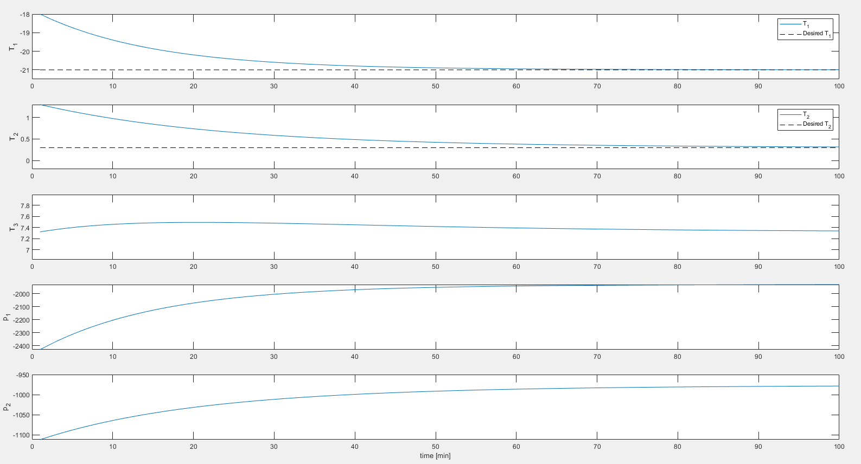

fig. *: inputs and outputs results in Scene 1 of the LQR controller

From the figure, we can see that the temperatures of 3 zones all converge around the desired steady states without violating the state and input constraints.

The LQR controller satisfies two constraints:

1. Not avoiding state and input constraints. This is achieved since there is no warning

when running the simulation.

1. Fast convergence：

$${‖T_{sp}-T(30)‖}_{2}≤0.2{‖x_{0}^{(1)}‖}_{2}$$

From the simulation results,

$$T_{1}\left(30\right)=-20.92 ℃ \\ T_{2}\left(30\right)=0.2525 ℃ \\ T_{3}\left(30\right)=7.411 ℃$$

The temperature set point,

$$T_{sp}={[-21, 0.3, 7,32]}^{T} ℃$$

We have,

$${‖T_{sp}-T(30)‖}_{2}=0.524≤0.2{\left\|x_{0}^{\left(1\right)}\right\|}_{2}=0.632$$

Therefore, all the requirements are met by the designed LQR controller.

Q6

We have the following equations,

$$\left\{\begin{aligned}\begin{matrix}u\left(k\right)=F_{∞}x_{LQR}(k) \\ x_{LQR}\left(0\right)=x(0)\end{matrix} \\ x_{LQR}\left(k\right)=Ax_{LQR}\left(k-1\right)+Bu(k-1) \\ J_{LQR}^{∞}\left(x(0)\right)={x_{LQR}\left(k\right)}^{T}Qx_{LQR}\left(k\right)+{u_{LQR}(k)}^{T}Ru_{LQR}(k)\end{aligned}\right.$$

We could derive,

$$x_{LQR}\left(k\right)=(A+BF_{∞})x_{LQR}\left(k-1\right)$$

$$x_{LQR}\left(k\right)={\left(A+BF_{∞}\right)}^{2}x_{LQR}\left(k-2\right) \\ … \\ x_{LQR}\left(k\right)={\left(A+BF_{∞}\right)}^{k}x_{LQR}\left(0\right) \\ x_{LQR}\left(k\right)={\left(A+BF_{∞}\right)}^{k}x\left(0\right)$$

The cost as a function of x(0),

$$J_{LQR}^{∞}\left(x(0)\right)={x(0)}^{T}[\sum_{k=0}^{∞}{M(k)}]x(0)$$

in which,

$$M\left(k\right)≔{{[\left(A+BF_{∞}\right)}^{k}]}^{T}(Q+{F_{∞}}^{T}RF_{∞}){\left(A+BF_{∞}\right)}^{k}$$

Q9 Discussion:

As we can conclude from the plots, with , the resulted closed-loop systems of LQR and MPC controller are very similar. Both satisfied input and state constraints, and approached the reference reasonably fast. However, with , the MPC controller could still do a good job, with all constraints satisfied and the stable reference state achieved, but the LQR controller failed to satisfy the state constraints. The LQR controller underwent weird changes on state and input, the constraints for  were violated, and the final state was not as stable or satisfying as the MPC controller did. This is probably because that the deviation from the steady-state  is a little larger, and the LQR controller cannot explicitly satisfy state or input constraints, thus constraints were violated and the performance was bad.

Q11

The proof is very similar to what we have done in the lecture. Firstly, it is obvious the origin is an equilibrium point since it satisfies the dynamics  setting inputs to 0. Given that (4) is feasible for x(0), and (4) guarantees that , i.e., terminal constraint at the origin, it corresponds to the case where , and from the proof in the lecture notes 06 P32-35, the system is recursively feasible and Lyapunov stable, thus asymptotically stable.

Q13

Difference:  is less than . This is probably because forcing the terminal state to origin is a stricter requirement to satisfy and results in a trajectory with more stage cost and thus the overall cost in this case is more than that without terminal state being the origin but with an extra terminal cost.

For initial condition, the MPC problem is infeasible and state constraints are violated.

Q14

Choose  where  is the solution to the discrete-time algebraic Riccati equation: 

The proof is the same as in the lecture notes.

Q15

The closed-loop trajectories are very similar to the results from Task 9 despite some tiny differences. Both are feasible, stable, and converge to the reference similarly fast.

Q16

The region of attraction of the MPC controller (5) is much larger than that of (4), since (4) requires the terminal state to be exactly the origin but (5) simply requires it to be in the set . This is why  is infeasible for (4) but could be contained in the region of attraction of (5).

Q20

In the offset free problem, we have augmented state,

$$\left[\begin{matrix}x\left(k+1\right) \\ d\left(k+1\right)\end{matrix}\right]=\left[\begin{matrix}A & B_{d} \\ 0_{3×3} & I_{3×3}\end{matrix}\right]\left[\begin{matrix}x\left(k\right) \\ d\left(k\right)\end{matrix}\right]+\left[\begin{matrix}B \\ 0_{3×2}\end{matrix}\right]u\left(k\right) \\ y(k)=\left[\begin{matrix}I_{3×3} & 0_{3×3}\end{matrix}\right]\left[\begin{matrix}x\left(k\right) \\ d\left(k\right)\end{matrix}\right]+0_{3×2}u\left(k\right)$$

Thus we have,

$$\left\{\begin{aligned}\begin{aligned}A_{aug}=\left[\begin{matrix}A & B_{d} \\ 0_{3×3} & I_{3×3}\end{matrix}\right] \\ B_{aug}=\left[\begin{matrix}B \\ 0_{3×2}\end{matrix}\right]\end{aligned} \\ C_{aug}=\left[\begin{matrix}I_{3×3} & 0_{3×3}\end{matrix}\right] \\ D_{aug}=0_{3×2}\end{aligned}\right.$$

Q21

From the results of parameter tuning,

$$L=0.05×\left[\begin{aligned}\begin{matrix}1 & 1 & 1 \\ 1 & 1 & 1 \\ 1 & 1 & 1\end{matrix} \\ \begin{matrix}1 & 1 & 1 \\ 1 & 1 & 1 \\ 1 & 1 & 1\end{matrix}\end{aligned}\right]$$

In the problem, we track constant reference,

$$r=T_{sp} \\ z\left(k\right)=Hy\left(k\right)→r, for k→∞ \\ H=I_{3}$$

the expression for computing steady-state,

$$\left[\begin{matrix}A-I & B \\ HC & 0\end{matrix}\right]\left[\begin{matrix}x_{s} \\ u_{s}\end{matrix}\right]=\left[\begin{matrix}-B_{d}\hat{d} \\ r\end{matrix}\right]$$

Estimator error dynamics,

$$\left[\begin{matrix}x\left(k+1\right)-\hat{x}\left(k+1\right) \\ d\left(k+1\right)-\hat{d}\left(k+1\right)\end{matrix}\right]=(A_{aug}-LC_{aug})\left[\begin{matrix}x\left(k\right)-\hat{x}\left(k\right) \\ d\left(k\right)-\hat{d}\left(k\right)\end{matrix}\right]$$

Eigenvalues of $(A_{aug}-LC_{aug})$ are,

$${[1, 0.8312, 0.9145,0.9998,0.9628,1 ]}^{T}$$

Q22

We designed an offset-free MPC controller which can be found in controller_mpc_5.m file. The results of running simulation on scene 1 and scene 2 are as follows.

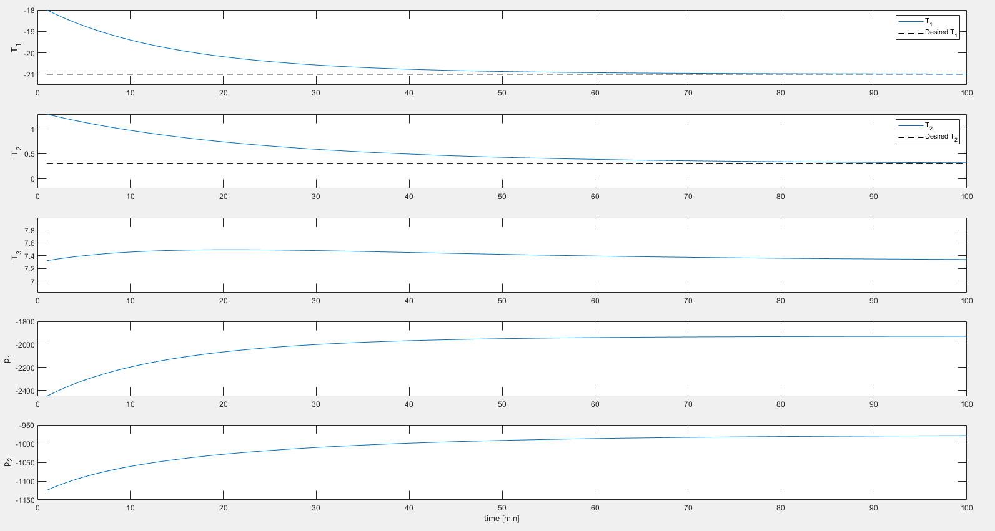

fig. *: inputs and outputs results in Scene 1 of the offset-free MPC controller

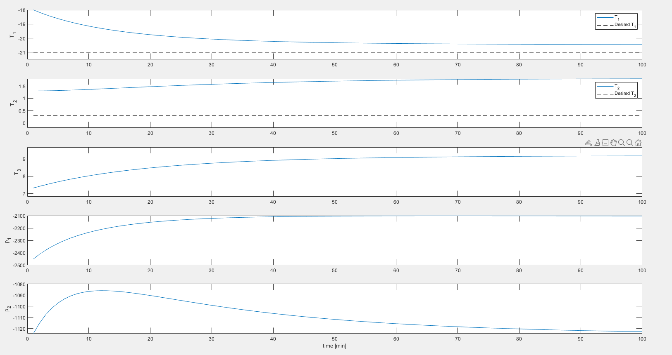

fig. *: inputs and outputs results in Scene 2 of the offset-free MPC controller

From the figures, we can see that the temperatures of 3 zones all converge around the desired steady states without violating the state and input constraints.