Agriculture Senior 2 – Easy & Interactive Learner Workbook

Unit 1: Soil
👉 Look at the diagram below:
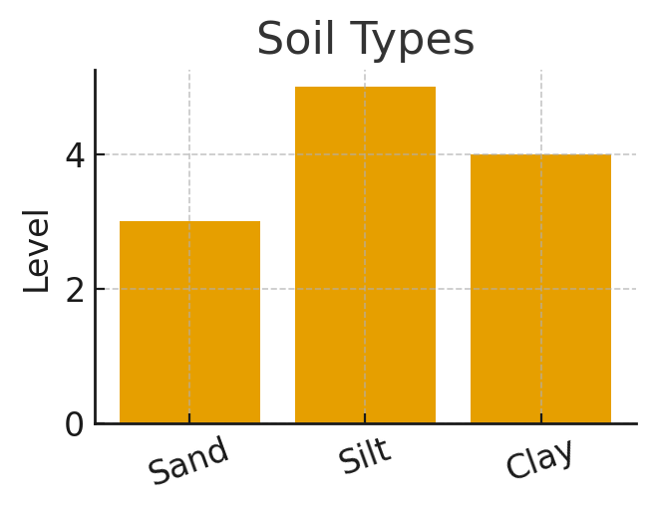
- 📌 Key Ideas:
- Soil is the top layer where plants grow.
- Good soil has water, air, nutrients and organic matter.
- Sand drains fast, clay holds water, silt is smooth.
- Plants grow well in fertile soil.
✏️ Try This Activity:
Question | Your Answer
Write one example.
Draw or describe what you see.
Why is this important?

Unit 1: Soil – Assessment
1. Explain: Good soil has water, air, nutrients and organic matter.
Answer: Students give simple examples.
2. Explain: Sand drains fast, clay holds water, silt is smooth.
Answer: Students give simple examples.
3. Explain: Plants grow well in fertile soil.
Answer: Students give simple examples.
4. Explain: Soil is the top layer where plants grow.
Answer: Students give simple examples.
5. Explain: Good soil has water, air, nutrients and organic matter.
Answer: Students give simple examples.

Unit 2: Mushrooms
👉 Look at the diagram below:
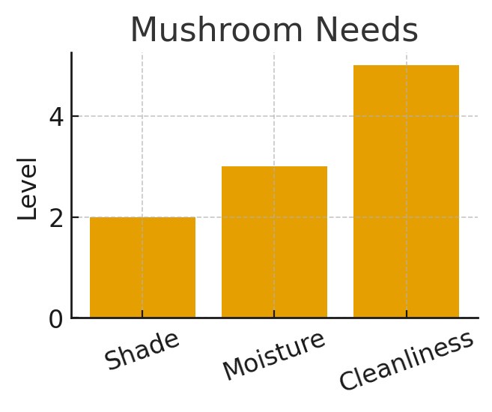
- 📌 Key Ideas:
- Mushrooms are fungi that grow on plant waste.
- They need moisture, shade and a clean place.
- Oyster mushrooms grow fast and are easy to manage.
- They grow on substrates like banana leaves or sawdust.
✏️ Try This Activity:
Question | Your Answer
Write one example.
Draw or describe what you see.
Why is this important?

Unit 2: Mushrooms – Assessment
1. Explain: They need moisture, shade and a clean place.
Answer: Students give simple examples.
2. Explain: Oyster mushrooms grow fast and are easy to manage.
Answer: Students give simple examples.
3. Explain: They grow on substrates like banana leaves or sawdust.
Answer: Students give simple examples.
4. Explain: Mushrooms are fungi that grow on plant waste.
Answer: Students give simple examples.
5. Explain: They need moisture, shade and a clean place.
Answer: Students give simple examples.

Unit 3: Fruits
👉 Look at the diagram below:
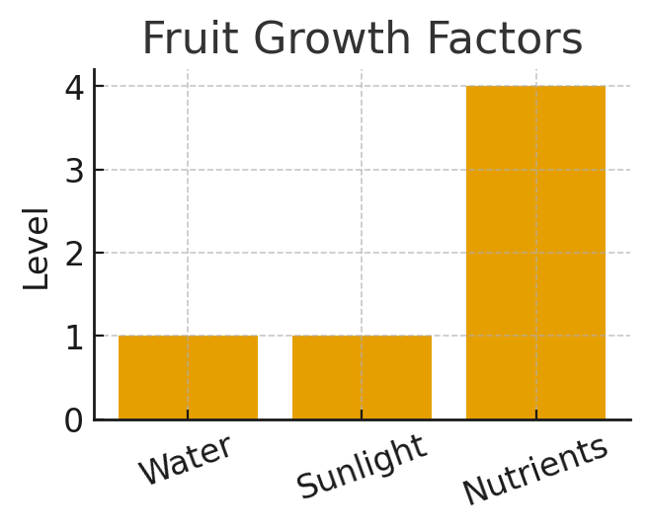
- 📌 Key Ideas:
- Fruits give us vitamins.
- Rwanda grows mangoes, oranges, pawpaw and avocados.
- Fruit trees need watering, mulching and pruning.
- Some fruits grow from seeds; others from grafting.
✏️ Try This Activity:
Question | Your Answer
Write one example.
Draw or describe what you see.
Why is this important?

Unit 3: Fruits – Assessment
1. Explain: Rwanda grows mangoes, oranges, pawpaw and avocados.
Answer: Students give simple examples.
2. Explain: Fruit trees need watering, mulching and pruning.
Answer: Students give simple examples.
3. Explain: Some fruits grow from seeds; others from grafting.
Answer: Students give simple examples.
4. Explain: Fruits give us vitamins.
Answer: Students give simple examples.
5. Explain: Rwanda grows mangoes, oranges, pawpaw and avocados.
Answer: Students give simple examples.

Unit 4: Legumes
👉 Look at the diagram below:
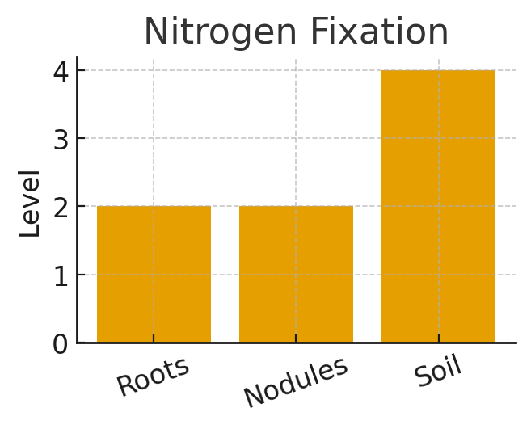
- 📌 Key Ideas:
- Legumes are plants with pods like beans and peas.
- They add nitrogen to the soil.
- They are rich in protein.
- They help improve soil fertility.
✏️ Try This Activity:
Question | Your Answer
Write one example.
Draw or describe what you see.
Why is this important?

Unit 4: Legumes – Assessment
1. Explain: They add nitrogen to the soil.
Answer: Students give simple examples.
2. Explain: They are rich in protein.
Answer: Students give simple examples.
3. Explain: They help improve soil fertility.
Answer: Students give simple examples.
4. Explain: Legumes are plants with pods like beans and peas.
Answer: Students give simple examples.
5. Explain: They add nitrogen to the soil.
Answer: Students give simple examples.

Unit 5: Ruminants
👉 Look at the diagram below:
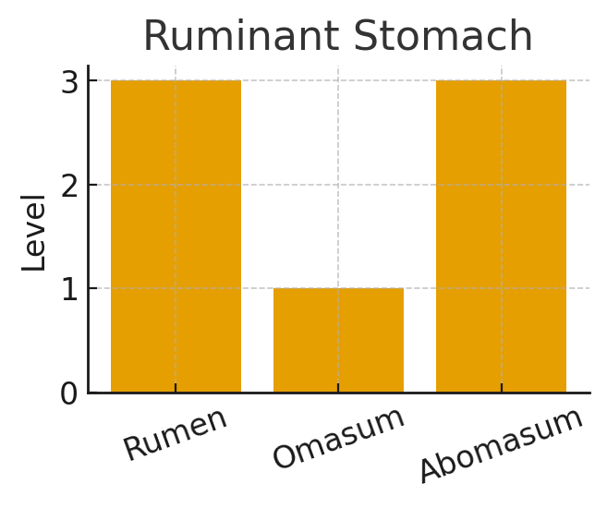
- 📌 Key Ideas:
- Ruminants have four stomach parts.
- Examples: cows, goats and sheep.
- They eat grasses and roughages.
- They need clean housing and water.
✏️ Try This Activity:
Question | Your Answer
Write one example.
Draw or describe what you see.
Why is this important?

Unit 5: Ruminants – Assessment
1. Explain: Examples: cows, goats and sheep.
Answer: Students give simple examples.
2. Explain: They eat grasses and roughages.
Answer: Students give simple examples.
3. Explain: They need clean housing and water.
Answer: Students give simple examples.
4. Explain: Ruminants have four stomach parts.
Answer: Students give simple examples.
5. Explain: Examples: cows, goats and sheep.
Answer: Students give simple examples.

Unit 6: Livestock Products
👉 Look at the diagram below:
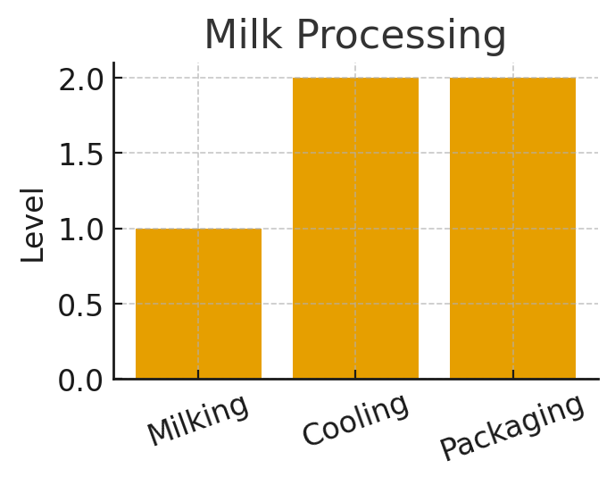
- 📌 Key Ideas:
- Animals give us milk, meat, eggs and hides.
- Milk can be made into yogurt and cheese.
- Clean handling keeps products safe.
- By‑products like manure help crops grow.
✏️ Try This Activity:
Question | Your Answer
Write one example.
Draw or describe what you see.
Why is this important?

Unit 6: Livestock Products – Assessment
1. Explain: Milk can be made into yogurt and cheese.
Answer: Students give simple examples.
2. Explain: Clean handling keeps products safe.
Answer: Students give simple examples.
3. Explain: By‑products like manure help crops grow.
Answer: Students give simple examples.
4. Explain: Animals give us milk, meat, eggs and hides.
Answer: Students give simple examples.
5. Explain: Milk can be made into yogurt and cheese.
Answer: Students give simple examples.

Unit 7: Farm Problems & Solutions
👉 Look at the diagram below:
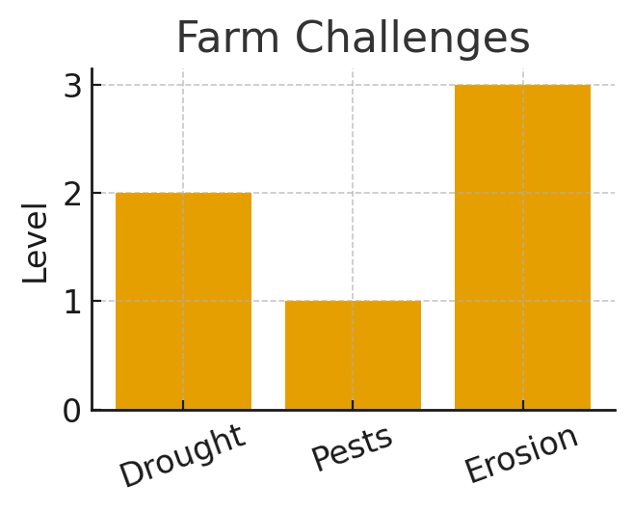
- 📌 Key Ideas:
- Farmers face drought, pests and soil erosion.
- Soil erosion removes important topsoil.
- Pests reduce yields.
- Solutions include terracing, irrigation and pesticides.
✏️ Try This Activity:
Question | Your Answer
Write one example.
Draw or describe what you see.
Why is this important?

Unit 7: Farm Problems & Solutions – Assessment
1. Explain: Soil erosion removes important topsoil.
Answer: Students give simple examples.
2. Explain: Pests reduce yields.
Answer: Students give simple examples.
3. Explain: Solutions include terracing, irrigation and pesticides.
Answer: Students give simple examples.
4. Explain: Farmers face drought, pests and soil erosion.
Answer: Students give simple examples.
5. Explain: Soil erosion removes important topsoil.
Answer: Students give simple examples.

