**关于测试流水线CPU的简单方法**

**1. 测试程序段（汇编代码）**

|  |  |  |  |  |  |  |  |
| --- | --- | --- | --- | --- | --- | --- | --- |
| address | instruction | op | rs | rt | immediate | code | result |
| 0x00000000 | addiu $1,$0,8 | 001001 | 00000 | 00001 | 0000 0000 0000 1000 | 24010008 | $1 = 8 |
| 0x00000004 | ori $2,$0,2 | 001101 | 00000 | 00010 | 0000 0000 0000 0010 | 34020002 | $2 = 2 |

|  |  |  |  |  |  |  |  |  |  |
| --- | --- | --- | --- | --- | --- | --- | --- | --- | --- |
| address | instruction | op | rs | rt | rd | shamt | funct | code | result |
| 0x00000008 | add $3,$2,$1 | 000000 | 00010 | 00001 | 00011 | 00000 | 100000 | 00411820 | $3 = 10 |
| 0x0000000C | sub $5,$3,$2 | 000000 | 00011 | 00010 | 00101 | 00000 | 100010 | 00622822 | $5 = 8 |
| 0x00000010 | and $4,$5,$2 | 000000 | 00101 | 00010 | 00100 | 00000 | 100100 | 00a22024 | $4 = 0 |
| 0x00000014 | or $8,$4,$2 | 000000 | 00100 | 00010 | 01000 | 00000 | 100101 | 00824025 | $8 = 2 |
| 0x00000018 | sll $8,$8,1 | 000000 | 00000 | 01000 | 01000 | 00001 | 000000 | 00084040 | $8 = 4  $8 = 8 |

|  |  |  |  |  |  |  |  |
| --- | --- | --- | --- | --- | --- | --- | --- |
| address | instruction | op | rs | rt | immediate | code | result |
| 0x0000001C | bne $8,$1,-2  (≠,转18) | 000101 | 00001 | 01000 | 1111 1111 1111 1110 | 1501fffe |  |
| 0x00000020 | slti $6,$2,4 | 001010 | 00010 | 00110 | 0000 0000 0000 0100 | 28460004 | $6 = 1 |
| 0x00000024 | sltiu $7,$6,0 | 001011 | 00110 | 00111 | 0000 0000 0000 0000 | 2cc70000 | $7 = 0 |
| 0x00000028 | addiu $7,$7,8 | 001000 | 00111 | 00111 | 0000 0000 0000 1000 | 24e70008 | $7 = 8  $7 = 16 |
| 0x0000002C | beq $7,$1,-2  (=,转28) | 000100 | 00111 | 00001 | 1111 1111 1111 1110 | 10e1fffe |  |
| 0x00000030 | sw $2,4($1) | 101011 | 00001 | 00010 | 0000 0000 0000 0100 | ac220004 | mem[12:15]<=2 |
| 0x00000034 | lw $9,4($1) | 100011 | 00001 | 01001 | 0000 0000 0000 0100 | 8c290004 | $9 = 2 |
| 0x00000038 | addiu $9,$9,0 | 001001 | 01001 | 01001 | 0000 0000 0000 0000 | 25290000 | $9 = 2 |
| 0x00000038 | addiu $10,$0,-2 | 001001 | 00000 | 01010 | 1111 1111 1111 1110 | 240afffe | $10 = -2 |
| 0x0000003C | addiu $10,$10,1 | 001001 | 01010 | 01010 | 0000 0000 0000 0001 | 254a0001 | $10 = -1 |
| 0x00000040 | andi $11,$2,2 | 001100 | 00010 | 01011 | 0000 0000 0000 0010 | 304b0002 | $11 = 2 |

|  |  |  |  |  |  |  |  |  |  |
| --- | --- | --- | --- | --- | --- | --- | --- | --- | --- |
| address | instruction | op | rs | rt | rd | shamt | funct | code | result |
| 0x00000044 | addu $10,$0,$2 | 000000 | 00000 | 00010 | 01010 | 00000 | 100001 | 00025021 | $10 = 2 |
| 0x00000048 | subu $10,$10,$2 | 000000 | 01010 | 00010 | 01010 | 00000 | 100011 | 01425023 | $10 = 0 |
| 0x0000004C | xor $10,$8,$2 | 000000 | 01000 | 00010 | 01010 | 00000 | 100110 | 01025026 | $10 =10 |
| 0x00000050 | nor $10,$8,$2 | 000000 | 01000 | 00010 | 01010 | 00000 | 100111 | 01025027 | $10 = fffffff5 |
| 0x00000054 | sltu $10,$8,$2 | 000000 | 01000 | 00010 | 01010 | 00000 | 101011 | 0102502b | $10 = 0 |
| 0x00000058 | srl $10,$8,1 | 000000 | 00000 | 01000 | 01010 | 00001 | 000010 | 00085042 | $10 = 4 |

|  |  |  |  |  |  |  |  |
| --- | --- | --- | --- | --- | --- | --- | --- |
| address | instruction | op | rs | rt | immediate | code | result |
| 0x00000064 | addi $10,$0,-1 | 001000 | 00000 | 01010 | 1111 1111 1111 1111 | 200affff | $10 = -1 |

|  |  |  |  |  |  |  |  |  |  |
| --- | --- | --- | --- | --- | --- | --- | --- | --- | --- |
| address | instruction | op | rs | rt | rd | shamt | funct | code | result |
| 0x00000068 | sra $11,$10,1 | 000000 | 00000 | 01010 | 01011 | 00001 | 000011 | 000a5843 | $11 = -1 |

|  |  |  |  |  |  |  |  |
| --- | --- | --- | --- | --- | --- | --- | --- |
| address | instruction | op | rs | rt | immediate | code | result |
| 0x000000B8 | haul | 111111 | 00000 | 00000 | 0000000000000000 | fc000000 | haul |

**2. 机器码**

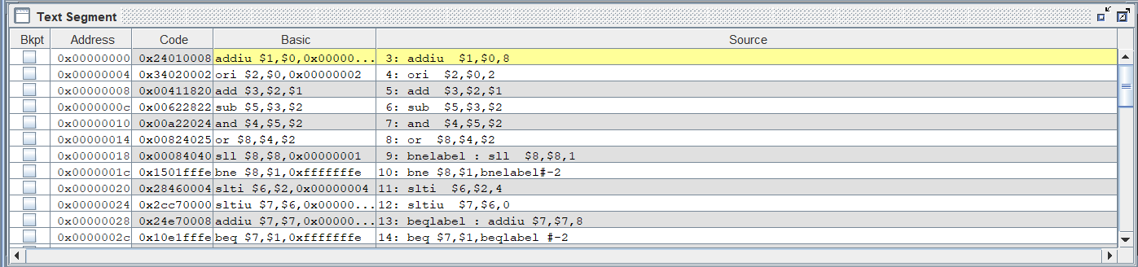

由于寄存器数据宽度为8位，则coe文件的格式为：

MEMORY_INITIALIZATION_RADIX=16;

MEMORY_INITIALIZATION_VECTOR=

24,01,00,08,

34,02,00,02,

00,41,18,20,

00,62,28,22,

00,a2,20,24,

00,82,40,25,

00,08,40,40,

15,01,ff,fe,

28,46,00,04,

2c,c7,00,00,

24,e7,00,08,

10,e1,ff,fe,

ac,22,00,04,

8c,29,00,04,

25,29,00,00,

24,0a,ff,fe,

25,4a,00,01,

30,4b,00,02,

00,02,50,21,

01,42,50,23,

01,02,50,26,

01,02,50,27,

01,02,50,2b,

00,08,50,42,

20,0a,ff,ff,

00,0a,58,43,

fc,00,00,00;