Project 4：Re Schedule



Team member:

Yuhao Bai

YiWen Miao

KanYun Zhan

UTBM Département Informatique

IA51 P19

Mr. Galland

Hui Zhao

1. **Context**
2. Purpose

This application is designed to make the quickest and most convenient adjustments to people's schedule changes. And the newly generated schedule will be as similar as possible to the original schedule.

1. Research areas

Currently, we only focus on individual trips for individual users. The user should be a person who does individual schedule which can’t be affected by other users.

In the future, we will upgrade to a multi-person schedule for individual users. Then the agents could negotiate with each other, and the user could even be a group(family, company)

1. Function

This application permits the users to create a schedule by entering his daily activities. And once he meets some events and has to do some changes for his schedule, it can reschedule intelligently. For example, when an agent planned to go shopping, while he meets a traffic jam on his way to market, usually he has two choices. One of that is to change the start time of doing shopping, the other one is to extend the duration of shopping. What we will do is to let the application do the reschedule by itself according to the origin schedule and the favors of the agent.

1. Use case

用例图

1. **Problems**

Once we decide to reschedule our daily-schedule, there are several problems we need to solve. We could easily find out these problems by using the flow chart. The system will end when all the episodes in the schedule are executed, and the output is the new schedule which is performed in reality.

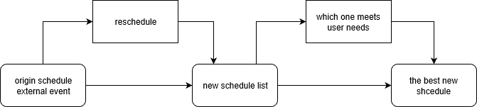

Step 1: Input the planned schedule data, and the external events.

Step 2: Create a new set of schedules.

Step 3: Find out the best schedule.

1. Origin schedule and external event

In daily life, individuals generally have a schedule for a set of activities. While, academic scheduling usually assumes deterministic and known in advance data. This situation is not often met in practice, since data may be subject to uncertainty and it may change over time. This kind of change in reality is called unexpected event, and people need to make rescheduling decisions when faced with this situation. When make rescheduling decisions, there several questions we need to consider:

* Q1. Why did you decide to change the original schedule?
* Q2. When did you decide to change that activity/trip?
* Q3. Did the decision depend on change in a previous activity/trip?
* Q4. How to make the rescheduling decision?
* Q5. Will the decision have an influence on next activity?

To answer Q1, it is necessary to identify the unexpected event that may make people reschedule, if there are changes in reality environment, whether for travel or activities, they will be called as outside events. And people need to rescheduling to deal with these changes. If the rescheduling decision will have an influence on the next activity, this kind of disturbance is called as inside event. This solves the Q2.The rescheduling time depends on aware time of events and events type Q3. As for Q4, in the simulation process, we will just consider the current trip/activity and the next activities/trips, and the final rescheduling decision is made by using activity utility and rescheduling penalty. In order to solve Q5, it is necessary to analyses the rescheduling decision of the current activity, and identify it will affect the next activity or not. These questions are considered when establishing the rescheduling model.

1. Reschedule
2. Rescheduling Process

In the real world, each user will have their own preferences and habits, and depending on each specific attribute, it will result different changes.

For example, if a user wants to drive to the supermarket to shop, then episode is divided into two parts: the on-road driving and the shopping in the supermarket. At that time, an accident is found on the road, which would cause traffic jams. Then this external event will cause the original schedule to change, and there are many different solutions corresponding to this. For example, you could shorten the time of shopping, change the original driving route, and so on.

So how to get to this series of new schedules, we will give detailed answers in the next section.

1. Create internal event

Once we change the origin schedule, there is a possibility that the affected episode’s change will affect the next episode. Internal event occurs during the rescheduling process. It could be classified as follows:

* the end of previous activity is later than the start time of next trip, so it will cause a delay of the next trip
* the location of previous activity is changed to a new location, so that the start of next trip is also change to this new location

So how to create an internal event which is important during the reschedule process.

1. Find out the best new schedule

There are many ways to find out the best new schedule, and what’s the meaning of ‘best’? Here ‘best’ means as similar as possible to the origin schedule. What method is used to determine whether the new one is similar to the original one? At this time, we are going to introduce a new concept, that is penalty.

解决的问题： RESCHEDULE

-event怎么影响episode(递归)，dynamically real-time rescheduling实时的重新排列

-agent反应（feedback）

-Penalty(probability, path, time, location)

1. **Existing solutions**
   1. Matsim
   2. Real-time
   3. Penalty

We could use ‘Penalty Genetic Algorithm’(PGA) to estimate the penalty values for replacing a planned schedule in the new schedule, inserting an external event. Then it could measure the dissimilarity between planned and performed schedule. The sequence alignment technique is used to measure the distance between ant pair of texting string by finding the minimum number of steps required to align two sequences.

We could use decision tree to simulate the re-routing when receiving an external event. It calculates the utility of each decision node. And it can choose to believe the information or not. Id it accepts the information, and then it goes to the next decision node. Il also classifies the users as three type of risk takers. People with different risk will have different utility functions.

* + 1. Utility
    2. Probability

-matsim: reschedule time prediction

-real-time: train, job machine

-penalty: operation

1. **Model(event递归， 决策树)**

We use a recursive approach to reschedule, once we find the next episode would be affected by the change of temporary schedule, we would create the internal event.

1. Ontologie Diagram
2. Definition of Event

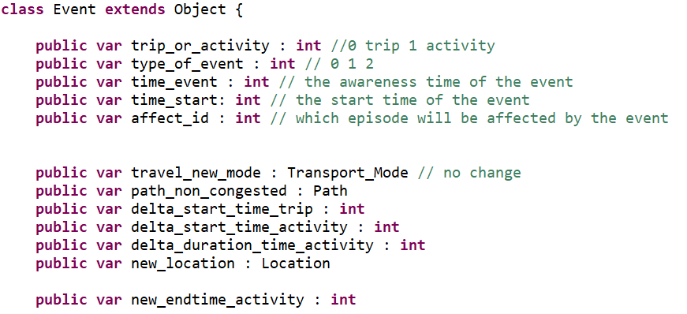

To solve the problem of rescheduling, we have created a very original and useful solution. In the class <<Event>>, there is not only the event but also the solution to solve this event. For instance, if the there is a traffic jam, when we create the object of external event <<traffic­_jam>>, we also put the solutions like the new path we choose, and the new transportation mode like bicycle. Therefore, when we do the rescheduling, the incoming parameters are the original schedule and the event, then we find the episode affected by the event, and we can directly assign the episode with the solutions. So that we get a new schedule if the next episode is not affected. If not, we can create an intern event with the new solutions obtained by the modules to do the recurrence. However, not all the attributes in this class are used. It depends on the activity in the episode affected. For example, if the activity is work, we can have 3 solutions: new mode, new path and the new time. If the activity is social visit, we can have 4 solutions. So, the package module is very important to create the (internal) events. We think it’s the best way to define the class <<Event>> and it can reduce the difficulty of the whole project.

1. **Example**