HW_4

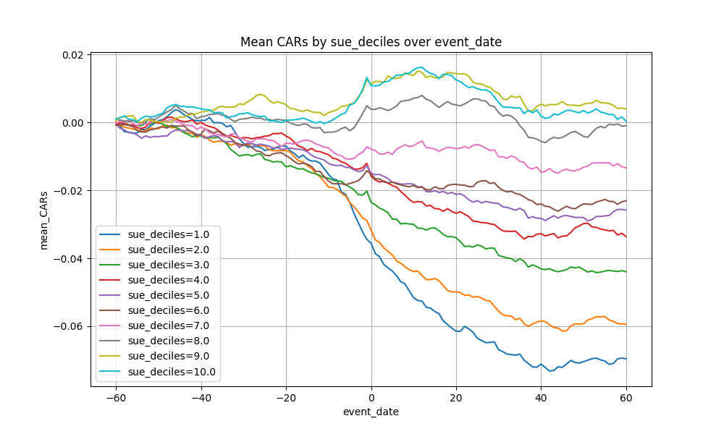

Remark: SUE decile 0 represents the group with the lowest SUE