Paperboat Signal Hub
Product Specification
PSH-06
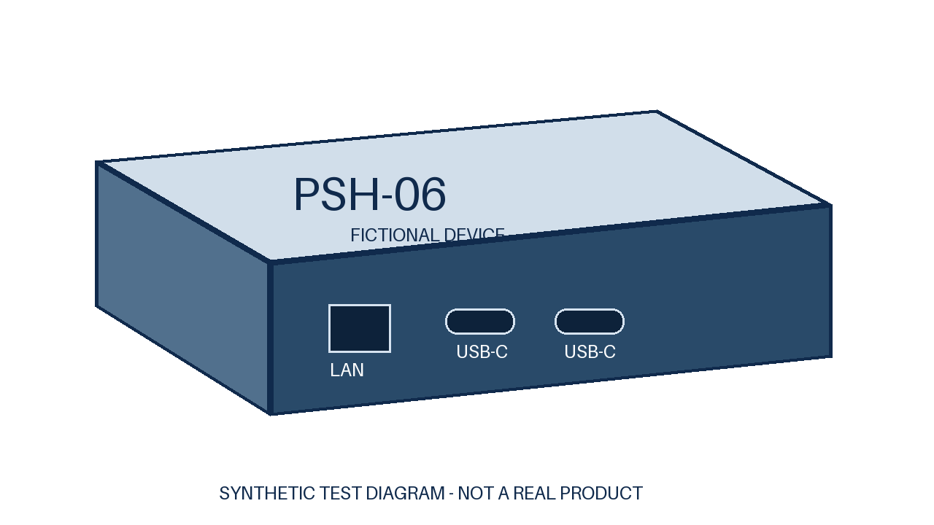
Fictional product diagram for template testing only.

Product Overview
Paperboat Signal Hub is a fictional training device for demonstrating signal recording, status review, and file export. The product, specifications, diagrams, and test conditions in this example are all fictional.
Example recording channels | Example internal storage | Example recording interval
6 channels | 32 GB | 30 s

Ordering Model
PSH-06: the example configuration has 6 recording channels and 32 GB storage; no options are specified.

Hardware and dimensions
PSH-06
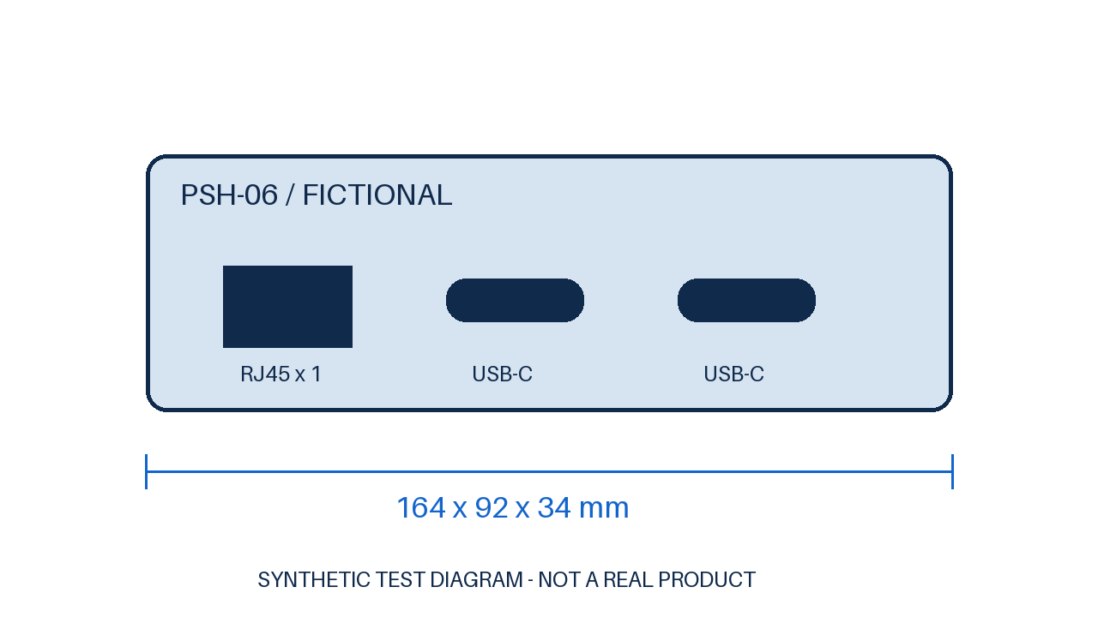
Fictional product diagram for template testing only.

Technical specifications
Parameter | Specification
Recording channels | 6 channels
Internal storage | 32 GB; no options specified
Recording interval | Records every 30 s
Network interface | 1 RJ45 port
USB interfaces | 2 USB-C ports
Record capacity | At most 4096 example records
Power input | 5 V DC / 2 A
Example consumption | 7 W
Operating temperature | 0 °C to 45 °C
Dimensions | 164 mm × 92 mm × 34 mm
Weight | 0.48 kg

Example validation metrics
This page demonstrates the metrics table layout. The values do not represent actual hardware test results.
Item | Example metric
Status display delay | ≤ 1.5 s
Recording interval | 30 s
Fictional conditions: a training demonstration environment. All values on this page are template test data and make no product commitment.

Features and applications

Key Features
• Recording demo: Saves example signals at a fixed interval.
• Status review: Shows recent records and remaining capacity.
• File export: Exports the currently selected records.
• Local operation: Runs offline in a training environment.

Application scenarios
Area | Example applications
Classroom training | Demonstrates the basic recording workflow.
Device workshop | Explains interfaces and storage.
Product demonstration | Shows the fictional device workflow.
Layout testing | Checks bilingual document layouts.

Contact Information
Company: Paperboat Fictional Lab
Website: hardware.example.invalid
Email: docs@hardware.example.invalid

