USER MANUAL

Starleaf Notes Studio
User Manual
Version 0.4.0
For software version 0.4.0
FICTIONAL PRODUCT · TEMPLATE DEMONSTRATION ONLY
Example Lab
docs.example.invalid

Contents
This manual covers organizing, finding, and exporting notes. Bold text identifies interface controls. This product and all parameters are fictional and exist only to test the template.
1 Introduction 3
1.1 Scope 3
2 Before You Begin 3
3 Quick Start 4
3.1 Create a Record 4
4 Operating Instructions 5
4.1 Search and Export 5
4.2 Check Status 5

1 Introduction
Starleaf Notes Studio organizes demonstration notes in a sample workspace. Follow Quick Start to create the first record, then use the operating instructions to find and export records.

1.1 Scope
This document covers record management. The example does not provide device connections, alarm handling, or certification claims.

2 Before You Begin
Open the local demonstration workspace with an authorized sample account. The demonstration organizer supplies the account; this manual contains no fixed password.

3 Quick Start
Confirm that the page displays the fictional-example label before entering data.

3.1 Create a Record
1. Open Library and choose New record.
2. Enter a record title and description, then select Save.
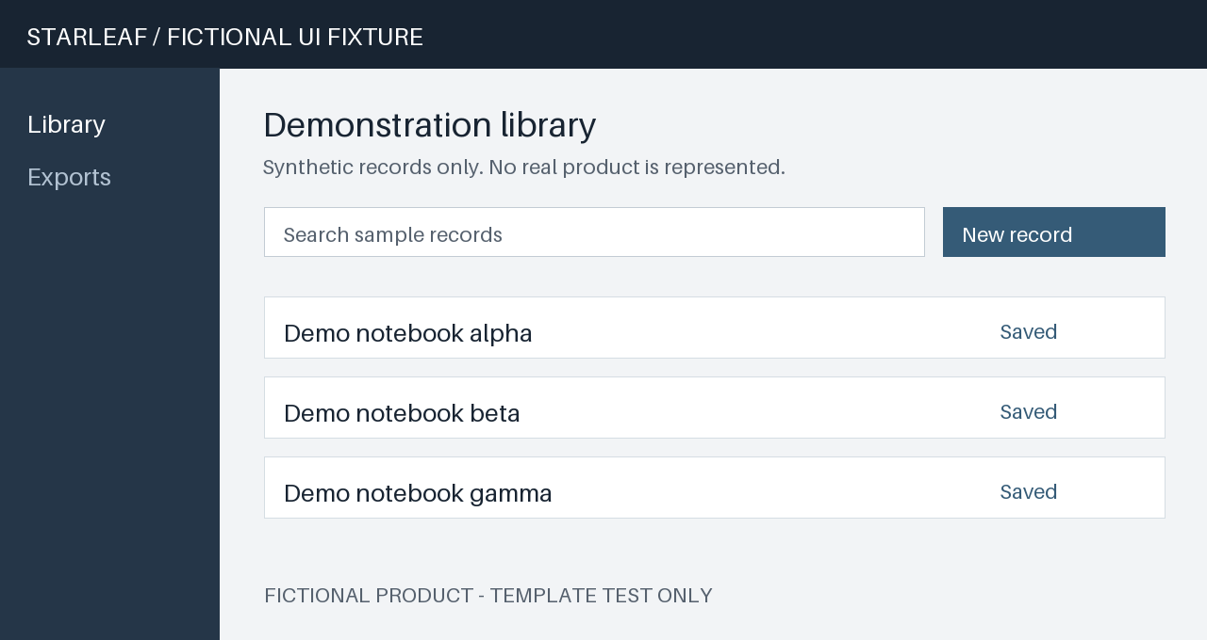
Figure 1 Fictional library interface
3. After saving, confirm that the record appears in the list. The sample list refreshes every 15 s.

4 Operating Instructions
This chapter explains recurring search, export, and status-checking tasks.

4.1 Search and Export
1. Enter a title keyword in Search, then select a matching record.
2. Choose Export to download a text copy of the current records. Each export contains at most 30 demonstration records.
Fictional example parameters
Item | Value | Notes
Demonstration record limit | 120 | Used only to test a capacity-value layout
List refresh interval | 15 s | Tests matching values and units across languages

4.2 Check Status
If an expected record is missing, check the current filter and search again. If the list remains empty, ask the demonstration organizer to verify the sample data.

