附页1：验证马吕斯定律
夹角α/° | 0 | 6 | 12 | 18 | 24 | 30 | 36 | 42 | 48 | 54 | 60 | 66 | 72 | 78 | 84 | 90
cos²(α) | 1 | 0.989 | 0.957 | 0.905 | 0.835 | 0.75 | 0.655 | 0.552 | 0.448 | 0.345 | 0.25 | 0.165 | 0.095 | 0.043 | 0.011 | 0
I/μw | 25.5 | 25.3 | 24.2 | 23.2 | 21.6 | 19.8 | 17.6 | 14.2 | 11.3 | 8.4 | 5.9 | 3.6 | 2.0 | 0.8 | 0.1 | 0

夹角α/° | 90 | 96 | 102 | 108 | 114 | 120 | 126 | 132 | 138 | 144 | 150 | 156 | 162 | 168 | 174 | 180
cos²(α) | 0 | 0.011 | 0.043 | 0.095 | 0.165 | 0.25 | 0.345 | 0.448 | 0.552 | 0.655 | 0.75 | 0.835 | 0.905 | 0.957 | 0.989 | 1
I/μw | 0 | 0.5 | 1.6 | 3.2 | 5.3 | 7.7 | 10.7 | 13.4 | 16.3 | 18.7 | 21.2 | 23.5 | 25.1 | 26.2 | 26.8 | 26.9

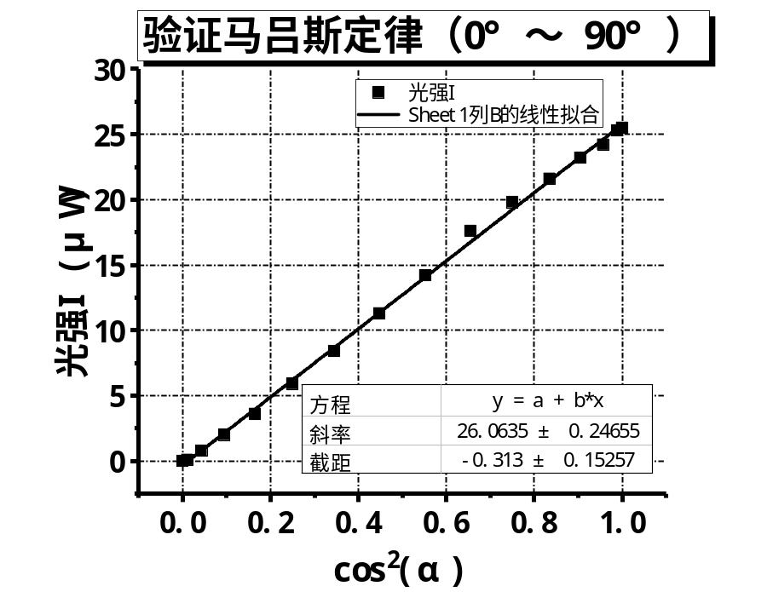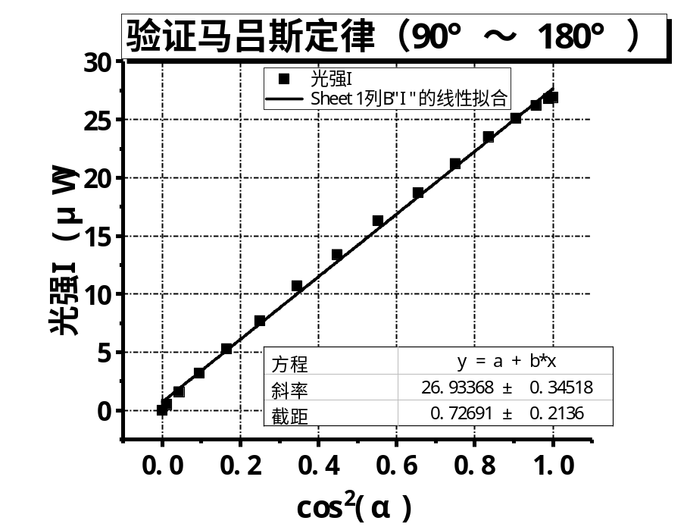
附页2：线偏振光通过1/2偏振片的现象
1/2波片转过角度/° | 0 | 10 | 20 | 30 | 40 | 50 | 60 | 70 | 80 | 90
检偏器转过角度/° | 0 | 20 | 40 | 60.5 | 80.5 | 101 | 120.5 | 143 | 165 | 186

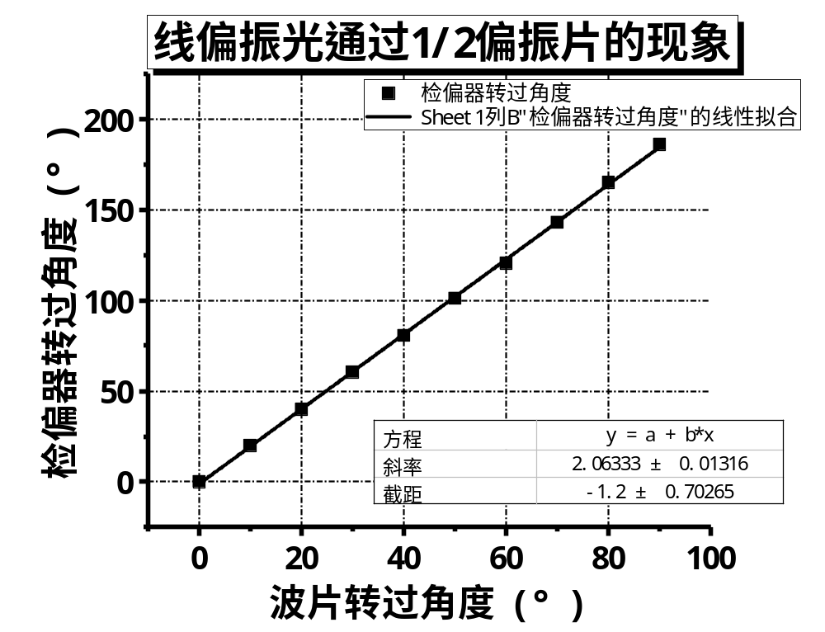

附页3：波片在初始位置、20°和45°时，检偏器不同角度时的出射光强I和振幅A
检偏器角度/° |  | 0 | 10 | 20 | 30 | 40 | 50 | 60 | 70 | 80 | 90 | 100 | 110 | 120
初始 | 光强I | 15.4 | 15.1 | 13.8 | 11.8 | 9.4 | 6.7 | 3.8 | 1.7 | 0.4 | 0 | 0.6 | 2 | 4.3
初始 | 振幅A | 3.924 | 3.886 | 3.715 | 3.435 | 3.066 | 2.588 | 1.949 | 1.304 | 0.632 | 0 | 0.775 | 1.414 | 2.074
20° | 光强I | 10.3 | 12.1 | 12.9 | 13.5 | 13.3 | 12 | 10 | 7.9 | 5.8 | 3.9 | 2.4 | 1.6 | 1.7
20° | 振幅A | 3.209 | 3.479 | 3.592 | 3.674 | 3.647 | 3.464 | 3.162 | 2.811 | 2.408 | 1.975 | 1.549 | 1.265 | 1.304
45° | 光强I | 8 | 8.3 | 8.5 | 8.7 | 9.1 | 9 | 9.2 | 9.3 | 9.3 | 9.2 | 9 | 8.8 | 8.7
45° | 振幅A | 2.828 | 2.881 | 2.915 | 2.95 | 3.017 | 3 | 3.033 | 3.05 | 3.05 | 3.033 | 3 | 2.966 | 2.95

检偏器角度/° |  | 130 | 140 | 150 | 160 | 170 | 180 | 190 | 200 | 210 | 220 | 230 | 240
初始 | 光强I | 6.7 | 9.3 | 11.7 | 14.1 | 15.1 | 16.3 | 15.3 | 13.8 | 11.9 | 9.3 | 6.4 | 3.8
初始 | 振幅A | 2.588 | 3.050 | 3.421 | 3.755 | 3.886 | 4.037 | 3.912 | 3.715 | 3.450 | 3.050 | 2.530 | 1.949
20° | 光强I | 2.2 | 3.9 | 5.7 | 7.3 | 9.2 | 11.4 | 12.8 | 13.7 | 14.3 | 13.5 | 11.8 | 10
20° | 振幅A | 1.483 | 1.975 | 2.387 | 2.702 | 3.033 | 3.376 | 3.578 | 3.701 | 3.782 | 3.674 | 3.435 | 3.162
45° | 光强I | 8.4 | 8.3 | 8.1 | 7.9 | 8.2 | 8.3 | 8.4 | 8.6 | 9.2 | 9.4 | 9.4 | 9.4
45° | 振幅A | 2.898 | 2.881 | 2.846 | 2.811 | 2.864 | 2.881 | 2.898 | 2.933 | 3.033 | 3.066 | 3.066 | 3.066

检偏器角度/° |  | 250 | 260 | 270 | 280 | 290 | 300 | 310 | 320 | 330 | 340 | 350 | 360
初始 | 光强I | 1.8 | 0.5 | 0 | 0.5 | 1.8 | 3.9 | 6.6 | 9.6 | 12.3 | 13.9 | 14.9 | 15.4
初始 | 振幅A | 1.342 | 0.707 | 0 | 0.707 | 1.342 | 1.975 | 2.569 | 3.098 | 3.507 | 3.728 | 3.860 | 3.924
20° | 光强I | 8.3 | 6.1 | 4.3 | 2.8 | 1.8 | 1.8 | 2.1 | 3 | 4.7 | 6.5 | 8.5 | 10.3
20° | 振幅A | 2.881 | 2.470 | 2.074 | 1.673 | 1.342 | 1.342 | 1.449 | 1.732 | 2.168 | 2.550 | 2.915 | 3.209
45° | 光强I | 9.4 | 9.2 | 9.1 | 9 | 8.5 | 8.6 | 8.7 | 8.5 | 8.5 | 8.3 | 8.2 | 8
45° | 振幅A | 3.066 | 3.033 | 3.017 | 3 | 2.915 | 2.933 | 2.950 | 2.915 | 2.915 | 2.881 | 2.864 | 2.828

附页4：检偏器角度α～ A关系图
