附页1：马吕斯定律
测量次数 | 1 | 2 | 3 | 4 | 5 | 6 | 7 | 8 | 9 | 10
θ/度 | 0 | 20 | 40 | 60 | 80 | 100 | 120 | 140 | 160 | 180
照度E/Lux | 187 | 176 | 129 | 61 | 10 | 3 | 27 | 87 | 149 | 186
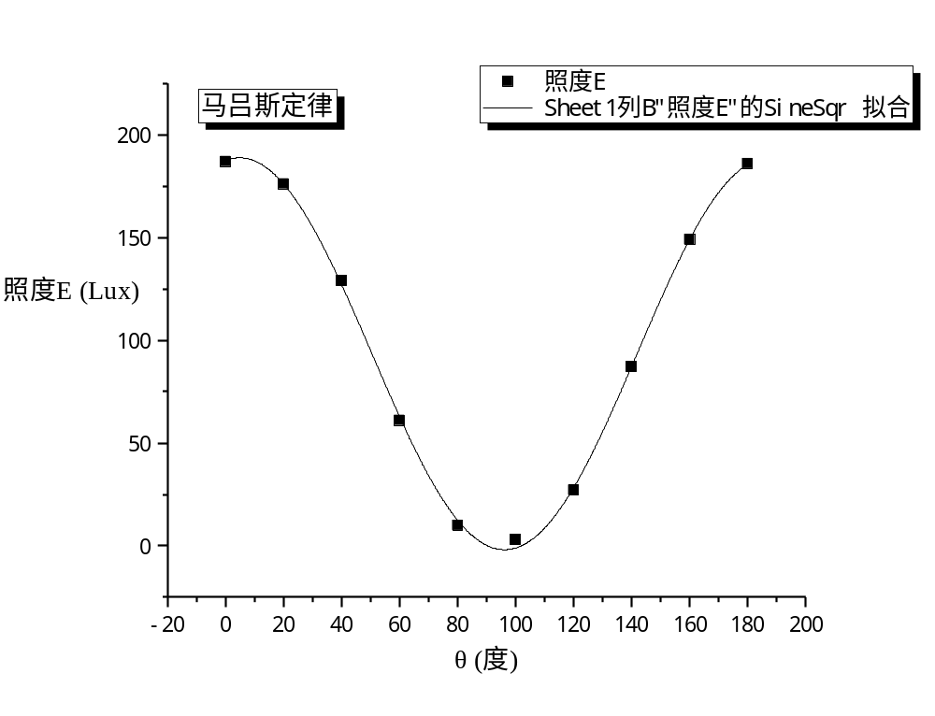
附页2：照度特性数据

短路电流
测量次数 | 1 | 2 | 3 | 4 | 5 | 6 | 7 | 8 | 9 | 10
照度E/Lux | 3 | 10 | 27 | 61 | 87 | 129 | 149 | 176 | 186 | 187
短路电流I/μA | 1.7 | 5.5 | 11 | 20.4 | 28.4 | 39.2 | 46.6 | 52.5 | 56.3 | 55.5

开路电压
测量次数 | 1 | 2 | 3 | 4 | 5 | 6 | 7 | 8 | 9
照度E/Lux | 0.8 | 1.6 | 3 | 3.4 | 4 | 5.1 | 7.5 | 8.9 | 10
开路电压U/V | 0.281 | 0.287 | 0.28 | 0.294 | 0.274 | 0.303 | 0.311 | 0.315 | 0.321

测量次数 | 10 | 11 | 12 | 13 | 14 | 15 | 16 | 17 | 18
照度E/Lux | 22.5 | 27 | 61 | 87 | 129 | 149 | 176 | 186 | 187
开路电压U/V | 0.337 | 0.345 | 0.363 | 0.375 | 0.383 | 0.388 | 0.392 | 0.394 | 0.393

附页3：照度特性
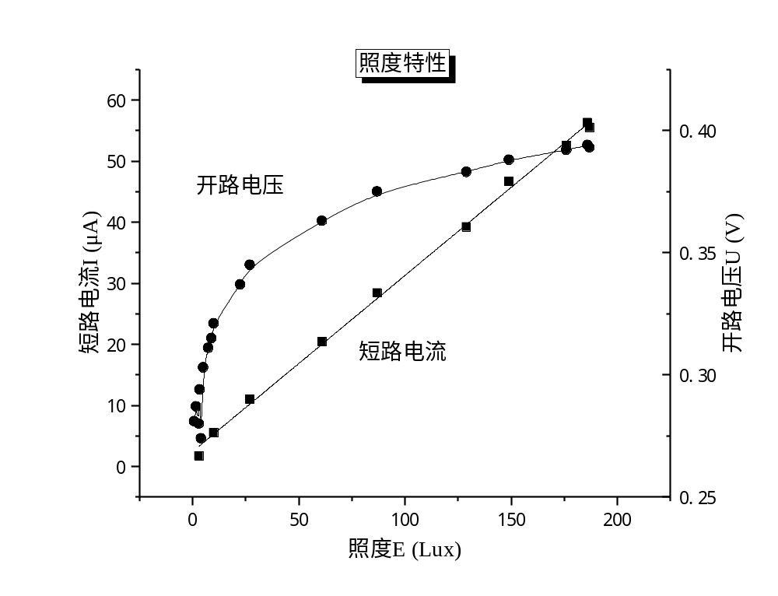
附页4：伏安特性数据

照度最强
测量次数 | 1 | 2 | 3 | 4 | 5 | 6 | 7 | 8 | 9 | 10 | 11 | 12 | 13
U/V | -4.93 | -3.95 | -2.94 | -2.54 | -2.02 | -1.52 | -1.03 | -0.56 | 0 | 0.041 | 0.102 | 0.156 | 0.209
I/μA | -56.1 | -55.9 | -55.8 | -55.7 | -55.6 | -55.5 | -55.5 | -55.4 | -55.5 | -55.2 | -55.1 | -54.8 | -54.1

测量次数 | 14 | 15 | 16 | 17 | 18 | 19 | 20 | 21 | 22 | 23 | 24 | 25 | 26
U/V | 0.251 | 0.303 | 0.311 | 0.32 | 0.331 | 0.341 | 0.347 | 0.352 | 0.357 | 0.365 | 0.372 | 0.377 | 0.383
I/μA | -52.2 | -44.5 | -42.4 | -39.5 | -35.6 | -31.1 | -28.6 | -26.3 | -23.2 | -19.4 | -15.1 | -13 | -8.6

旋转60度
测量次数 | 1 | 2 | 3 | 4 | 5 | 6 | 7 | 8 | 9 | 10 | 11 | 12 | 13
U/V | -4.93 | -3.96 | -2.95 | -2.59 | -2.03 | -1.53 | -1.01 | -0.53 | 0 | 0.049 | 0.096 | 0.157 | 0.219
I/μA | -19.4 | -19.2 | -18.9 | -18.8 | -18.7 | -18.7 | -18.7 | -18.6 | -18.6 | -18.6 | -18.6 | -18.4 | -18

测量次数 | 14 | 15 | 16 | 17 | 18 | 19 | 20 | 21 | 22 | 23 | 24 | 25 | 26
U/V | 0.263 | 0.282 | 0.296 | 0.306 | 0.312 | 0.322 | 0.327 | 0.332 | 0.337 | 0.341 | 0.344 | 0.349 | 0.356
I/μA | -17 | -16.1 | -15.1 | -14.1 | -13.4 | -11.9 | -10.9 | -9.9 | -8.9 | -8 | -7.2 | -5.7 | -3.7

附页5：伏安特性
