附页1：磁滞回线数据

测量次数 | 1 | 2 | 3 | 4 | 5 | 6 | 7 | 8 | 9 | 10
UR1/mV | 144.9 | 131.9 | 88.54 | 66.84 | 54.68 | 43.4 | 20.83 | 0.868 | -21.7 | -44.27
H/A/m | 40.1373 | 36.5363 | 24.52558 | 18.51468 | 15.14636 | 12.0218 | 5.76991 | 0.240436 | -6.0109 | -12.26279
UC/mV | 87.79 | 84.96 | 77.41 | 72.69 | 70.33 | 66.08 | 58.53 | 49.09 | 35.4 | 6.61
B/T | 0.3300904 | 0.3194496 | 0.2910616 | 0.2733144 | 0.2644408 | 0.2484608 | 0.2200728 | 0.1845784 | 0.133104 | 0.0248536

测量次数 | 11 | 12 | 13 | 14 | 15 | 16 | 17 | 18 | 19 | 20
UR1/mV | -46.87 | -49.48 | -54.68 | -67.7 | -86.8 | -129.3 | -143.2 | -131 | -87.67 | -65.1
H/A/m | -12.98299 | -13.70596 | -15.14636 | -18.7529 | -24.0436 | -35.8161 | -39.6664 | -36.287 | -24.28459 | -18.0327
UC/mV | 0.472 | 0 | -22.66 | -47.67 | -66.08 | -83.54 | -89.68 | -87.79 | -80.24 | -74.58
B/T | 0.00177472 | 0 | -0.0852016 | -0.1792392 | -0.2484608 | -0.3141104 | -0.3371968 | -0.3300904 | -0.3017024 | -0.2804208

测量次数 | 21 | 22 | 23 | 24 | 25 | 26 | 27 | 28 | 29 | 30
UR1/mV | -44.27 | -21.7 | 0 | 20.83 | 42.53 | 54.68 | 60.76 | 66.84 | 85.93 | 130.2
H/A/m | -12.26279 | -6.0109 | 0 | 5.76991 | 11.78081 | 15.14636 | 16.83052 | 18.51468 | 23.80261 | 36.0654
UC/mV | -70.33 | -61.83 | -56.17 | -43.9 | -29.26 | -7.08 | 0 | 23.6 | 56.64 | 83.54
B/T | -0.2644408 | -0.2324808 | -0.2111992 | -0.165064 | -0.1100176 | -0.0266208 | 0 | 0.088736 | 0.2129664 | 0.3141104

附页2：磁滞回线
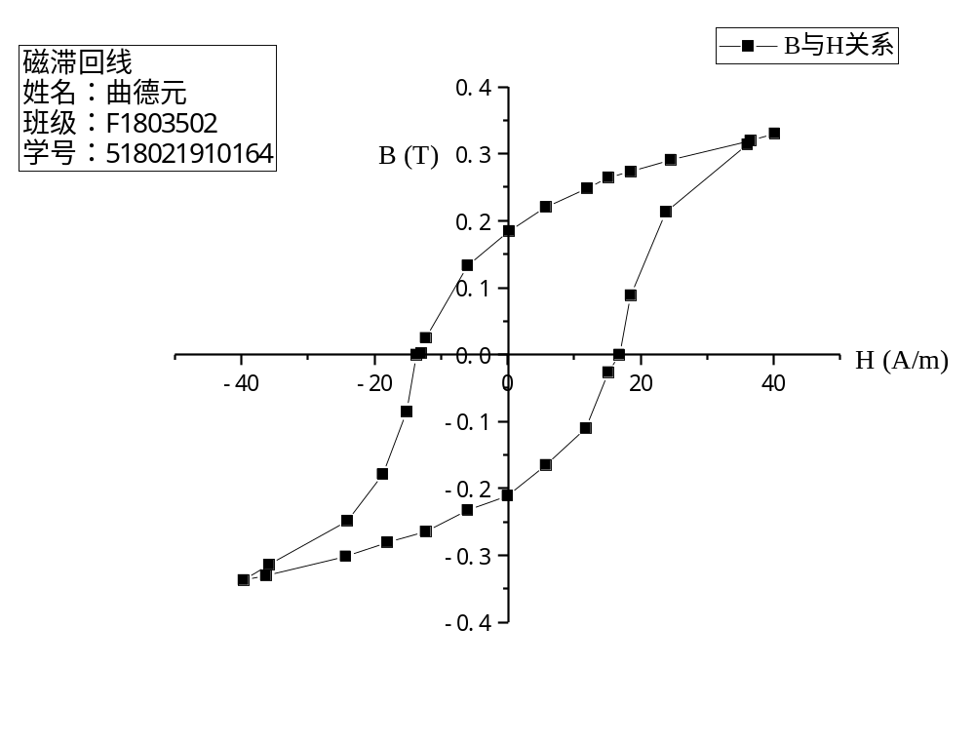
附页3：居里温度数据

测量次数 | 1 | 2 | 3 | 4 | 5 | 6 | 7 | 8 | 9 | 10 | 11 | 12
T/℃ | 30.3 | 35.2 | 40.9 | 45.3 | 50.3 | 55.3 | 60.3 | 65.6 | 70.2 | 75.5 | 80.4 | 82.5
Ucd/mV | 6.411 | 6.423 | 6.439 | 6.447 | 6.442 | 6.402 | 6.373 | 6.346 | 6.333 | 6.349 | 6.326 | 6.327

测量次数 | 13 | 14 | 15 | 16 | 17 | 18 | 19 | 20 | 21 | 22 | 23 | 24
T/℃ | 85.7 | 87.2 | 88.9 | 90.1 | 91.5 | 92.6 | 93 | 93.4 | 93.6 | 93.9 | 95.1 | 95.7
Ucd/mV | 6.316 | 6.307 | 6.282 | 6.248 | 6.132 | 5.975 | 5.867 | 5.773 | 5.663 | 5.507 | 5.21 | 5.09
测量次数 | 25 | 26 | 27 | 28 | 29 | 30 | 31 | 32 | 33 | 34 | 35 | 36
T/℃ | 96.4 | 97 | 97.5 | 98.3 | 98.9 | 99 | 99.4 | 99.8 | 100.3 | 100.8 | 101.2 | 101.7
Ucd/mV | 4.938 | 4.812 | 4.686 | 4.526 | 4.386 | 4.357 | 4.287 | 4.189 | 4.087 | 3.993 | 3.885 | 3.775

测量次数 | 37 | 38 | 39 | 40 | 41 | 42 | 43 | 44 | 45 | 46 | 47 | 48
T/℃ | 102.1 | 102.7 | 103.1 | 103.2 | 103.4 | 103.7 | 104.1 | 104.4 | 104.7 | 105.1 | 105.2 | 105.6
Ucd/mV | 3.664 | 3.535 | 3.416 | 3.38 | 3.286 | 3.189 | 3.064 | 2.96 | 2.853 | 2.733 | 2.653 | 2.527

测量次数 | 49 | 50 | 51 | 52 | 53 | 54 | 55 | 56 | 57 | 58 | 59 | 60
T/℃ | 106.1 | 106.7 | 107.3 | 108.3 | 109.5 | 110.6 | 113 | 117.2 | 124.5 | 129.5 | 133.4 | 140.1
Ucd/mV | 2.397 | 2.255 | 2.138 | 1.997 | 1.892 | 1.794 | 1.793 | 1.811 | 1.812 | 1.773 | 1.834 | 1.81

附页4：居里温度（Ucd-T图像）
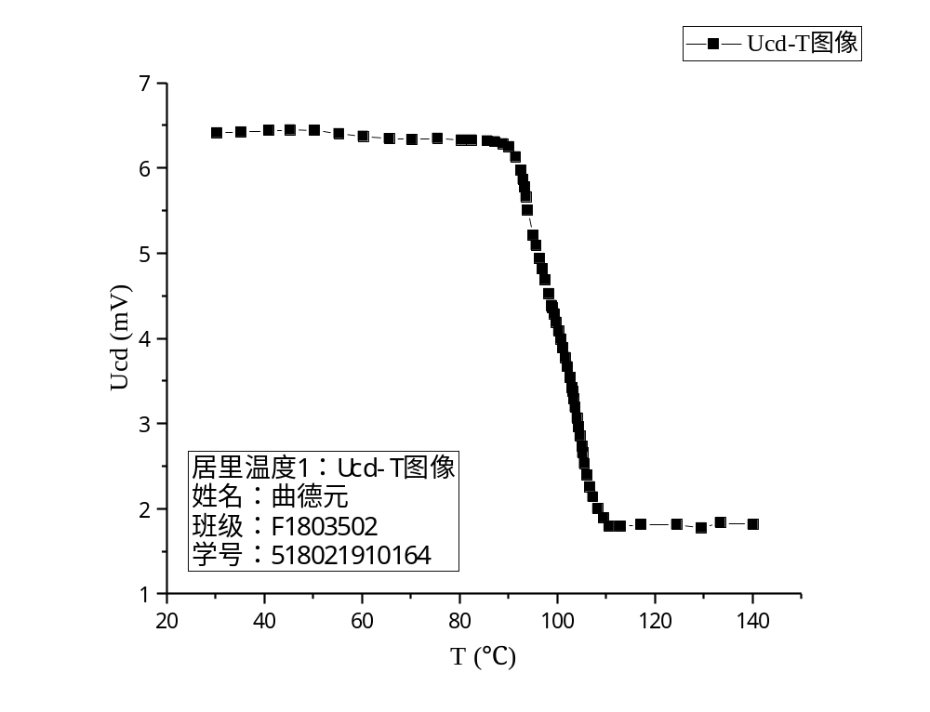

附页5：居里温度（dUcd/dT-T图像）
