附页1：热敏电阻温度计数据及定标图
测量次数 | 1 | 2 | 3 | 4 | 5 | 6 | 7 | 8 | 9 | 10 | 11
U/mV | 0.00 | 29.56 | 39.56 | 49.56 | 58.90 | 65.19 | 74.69 | 84.01 | 90.77 | 94.52 | 99.51
t/℃ | 0.0 | 29.1 | 39.2 | 47.6 | 55.4 | 60.7 | 69.3 | 78.9 | 87.7 | 94.3 | 100.0
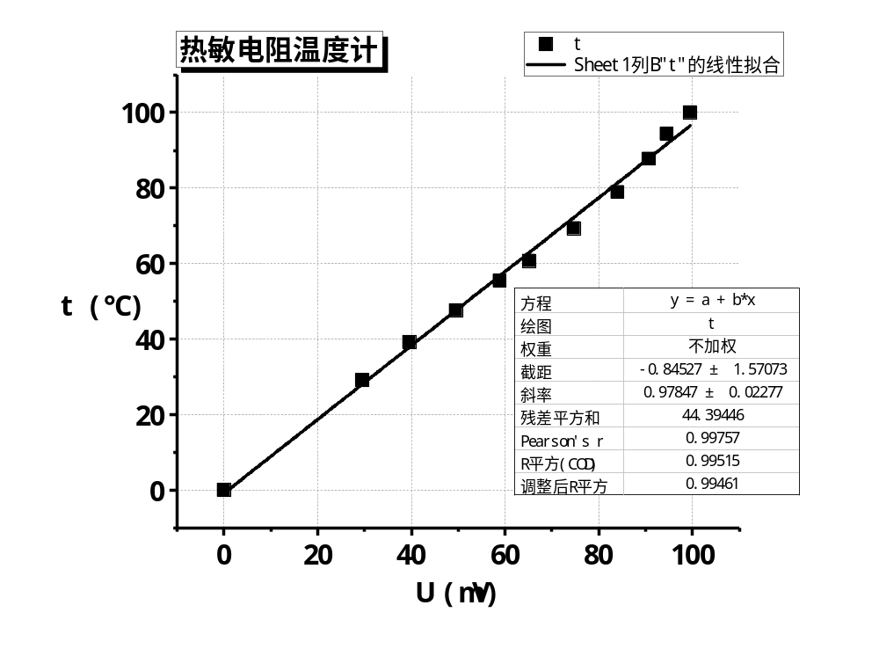

附页2：铂电阻温度计数据及定标图
测量次数 | 1 | 2 | 3 | 4 | 5 | 6 | 7 | 8 | 9 | 10 | 11
U/mV | 0.00 | 15.39 | 18.27 | 23.07 | 27.88 | 32.17 | 35.99 | 40.55 | 43.48 | 46.47 | 49.53
t/℃ | 0.0 | 30.9 | 37.7 | 47.6 | 57.2 | 65.3 | 72.8 | 81.4 | 88.2 | 93.8 | 100.0
