Barkan etal (2012) data analysis using raw data - V1

Yvonne JIN

7/19/2022

df <- read_sav("RRR-Barkan-etal-2012-WITH-order.sav")  
colnames(df)

## [1] "StartDate"   
## [2] "EndDate"   
## [3] "Status"   
## [4] "IPAddress"   
## [5] "Progress"   
## [6] "Duration__in_seconds_"   
## [7] "Finished"   
## [8] "RecordedDate"   
## [9] "ResponseId"   
## [10] "RecipientLastName"   
## [11] "RecipientFirstName"   
## [12] "RecipientEmail"   
## [13] "ExternalReference"   
## [14] "LocationLatitude"   
## [15] "LocationLongitude"   
## [16] "DistributionChannel"   
## [17] "UserLanguage"   
## [18] "Q_RecaptchaScore"   
## [19] "Q_RelevantIDDuplicate"   
## [20] "Q_RelevantIDDuplicateScore"   
## [21] "Q_RelevantIDFraudScore"   
## [22] "Q_RelevantIDLastStartDate"   
## [23] "consentagree_1"   
## [24] "outline1"   
## [25] "outline1_DO_1"   
## [26] "outline1_DO_2"   
## [27] "outline1_DO_3"   
## [28] "outline2"   
## [29] "outline2_DO_1"   
## [30] "outline2_DO_2"   
## [31] "outline2_DO_3"   
## [32] "englishnative"   
## [33] "englishnative_DO_1"   
## [34] "englishnative_DO_2"   
## [35] "writing_check"   
## [36] "RecallComprDissoWri"   
## [37] "RecallTaskDissoWrite"   
## [38] "RecallCheck1DissoWri"   
## [39] "RecallCheck2DissoWri"   
## [40] "RecallComprDissNWri"   
## [41] "RecallTaskDissNWrite"   
## [42] "RecallCheck1DissNWri"   
## [43] "RecallCheck2DissNWri"   
## [44] "RecallComprehWorthy"   
## [45] "Recall_Task_Worthy"   
## [46] "Recall_Check1_Worthy"   
## [47] "Recall_Check2_Worthy"   
## [48] "Recall_Compr_Neutral"   
## [49] "Recall_Task_Neutral"   
## [50] "Recall_Check1_Neutra"   
## [51] "Recall_Check2_neutra"   
## [52] "Recall_Compr_negativ"   
## [53] "RecallTask_Negative"   
## [54] "Recall_Check1_Negati"   
## [55] "Recall_Check2_negati"   
## [56] "ManiCheck_esteem_1"   
## [57] "ManiCheck_esteem_2"   
## [58] "ManiCheck_esteem_3"   
## [59] "ManiCheck_esteem_DO_1"   
## [60] "ManiCheck_esteem_DO_2"   
## [61] "ManiCheck_esteem_DO_3"   
## [62] "Exp1_check"   
## [63] "Exp1_check_DO_1"   
## [64] "Exp1_check_DO_2"   
## [65] "Exp1_check_DO_3"   
## [66] "Exp1_prob_hiring"   
## [67] "Exp1_loyalty"   
## [68] "Exp1_honesty"   
## [69] "Exp2_S1_check"   
## [70] "Exp2_S1_seen_wrong"   
## [71] "Exp2_S1_self_action"   
## [72] "Exp2_S1_guide_other"   
## [73] "Exp2_S2F_check"   
## [74] "Exp2_S2F_seen_wrong"   
## [75] "Exp2_S2F_self_action"   
## [76] "Exp2_S2F_guide_other"   
## [77] "Exp2_S2M_check"   
## [78] "Exp2_S2M_seen_wrong"   
## [79] "Exp2_S2M_self_action"   
## [80] "Exp2_S2M_guide_other"   
## [81] "MASC_set1_1"   
## [82] "MASC_set1_2"   
## [83] "MASC_set1_3"   
## [84] "MASC_set1_4"   
## [85] "MASC_set1_5"   
## [86] "MASC_set1_6"   
## [87] "MASC_set1_7"   
## [88] "MASC_set1_8"   
## [89] "MASC_set1_DO_1"   
## [90] "MASC_set1_DO_2"   
## [91] "MASC_set1_DO_3"   
## [92] "MASC_set1_DO_4"   
## [93] "MASC_set1_DO_5"   
## [94] "MASC_set1_DO_6"   
## [95] "MASC_set1_DO_7"   
## [96] "MASC_set1_DO_8"   
## [97] "MASC_set2_1"   
## [98] "MASC_set2_2"   
## [99] "MASC_set2_3"   
## [100] "MASC_set2_4"   
## [101] "MASC_set2_5"   
## [102] "MASC_set2_6"   
## [103] "MASC_set2_DO_1"   
## [104] "MASC_set2_DO_2"   
## [105] "MASC_set2_DO_3"   
## [106] "MASC_set2_DO_4"   
## [107] "MASC_set2_DO_5"   
## [108] "MASC_set2_DO_6"   
## [109] "MASC_set3_1"   
## [110] "MASC_set3_2"   
## [111] "BIDR_Self_deceptive_1"   
## [112] "BIDR_Self_deceptive_2"   
## [113] "BIDR_Self_deceptive_3"   
## [114] "BIDR_Self_deceptive_4"   
## [115] "BIDR_Self_deceptive_5"   
## [116] "BIDR_Self_deceptive_6"   
## [117] "BIDR_Self_deceptive_7"   
## [118] "BIDR_Self_deceptive_8"   
## [119] "BIDR_Self_deceptive_9"   
## [120] "BIDR_Self_deceptive_10"   
## [121] "BIDR_Self_deceptive_11"   
## [122] "BIDR_Self_deceptive_12"   
## [123] "BIDR_Self_deceptive_13"   
## [124] "BIDR_Self_deceptive_14"   
## [125] "BIDR_Self_deceptive_15"   
## [126] "BIDR_Self_deceptive_16"   
## [127] "BIDR_Self_deceptive_17"   
## [128] "BIDR_Self_deceptive_18"   
## [129] "BIDR_Self_deceptive_19"   
## [130] "BIDR_Self_deceptive_20"   
## [131] "BIDR_Self_deceptive_DO_1"   
## [132] "BIDR_Self_deceptive_DO_2"   
## [133] "BIDR_Self_deceptive_DO_3"   
## [134] "BIDR_Self_deceptive_DO_4"   
## [135] "BIDR_Self_deceptive_DO_5"   
## [136] "BIDR_Self_deceptive_DO_6"   
## [137] "BIDR_Self_deceptive_DO_7"   
## [138] "BIDR_Self_deceptive_DO_8"   
## [139] "BIDR_Self_deceptive_DO_9"   
## [140] "BIDR_Self_deceptive_DO_10"   
## [141] "BIDR_Self_deceptive_DO_11"   
## [142] "BIDR_Self_deceptive_DO_12"   
## [143] "BIDR_Self_deceptive_DO_13"   
## [144] "BIDR_Self_deceptive_DO_14"   
## [145] "BIDR_Self_deceptive_DO_15"   
## [146] "BIDR_Self_deceptive_DO_16"   
## [147] "BIDR_Self_deceptive_DO_17"   
## [148] "BIDR_Self_deceptive_DO_18"   
## [149] "BIDR_Self_deceptive_DO_19"   
## [150] "BIDR_Self_deceptive_DO_20"   
## [151] "BIDR_Impre_manage_1"   
## [152] "BIDR_Impre_manage_2"   
## [153] "BIDR_Impre_manage_3"   
## [154] "BIDR_Impre_manage_4"   
## [155] "BIDR_Impre_manage_5"   
## [156] "BIDR_Impre_manage_6"   
## [157] "BIDR_Impre_manage_7"   
## [158] "BIDR_Impre_manage_8"   
## [159] "BIDR_Impre_manage_9"   
## [160] "BIDR_Impre_manage_10"   
## [161] "BIDR_Impre_manage_11"   
## [162] "BIDR_Impre_manage_12"   
## [163] "BIDR_Impre_manage_13"   
## [164] "BIDR_Impre_manage_14"   
## [165] "BIDR_Impre_manage_15"   
## [166] "BIDR_Impre_manage_16"   
## [167] "BIDR_Impre_manage_17"   
## [168] "BIDR_Impre_manage_18"   
## [169] "BIDR_Impre_manage_19"   
## [170] "BIDR_Impre_manage_20"   
## [171] "BIDR_Impre_manage_DO_1"   
## [172] "BIDR_Impre_manage_DO_2"   
## [173] "BIDR_Impre_manage_DO_3"   
## [174] "BIDR_Impre_manage_DO_4"   
## [175] "BIDR_Impre_manage_DO_5"   
## [176] "BIDR_Impre_manage_DO_6"   
## [177] "BIDR_Impre_manage_DO_7"   
## [178] "BIDR_Impre_manage_DO_8"   
## [179] "BIDR_Impre_manage_DO_9"   
## [180] "BIDR_Impre_manage_DO_10"   
## [181] "BIDR_Impre_manage_DO_11"   
## [182] "BIDR_Impre_manage_DO_12"   
## [183] "BIDR_Impre_manage_DO_13"   
## [184] "BIDR_Impre_manage_DO_14"   
## [185] "BIDR_Impre_manage_DO_15"   
## [186] "BIDR_Impre_manage_DO_16"   
## [187] "BIDR_Impre_manage_DO_17"   
## [188] "BIDR_Impre_manage_DO_18"   
## [189] "BIDR_Impre_manage_DO_19"   
## [190] "BIDR_Impre_manage_DO_20"   
## [191] "funnel_time_First_Click"   
## [192] "funnel_time_Last_Click"   
## [193] "funnel_time_Page_Submit"   
## [194] "funnel_time_Click_Count"   
## [195] "serious"   
## [196] "seen"   
## [197] "seen_2_TEXT"   
## [198] "funnel_purpose"   
## [199] "funnel_improve"   
## [200] "age"   
## [201] "gender"   
## [202] "origcount"   
## [203] "residence"   
## [204] "soc_class"   
## [205] "engunder"   
## [206] "funnel_pay"   
## [207] "assignmentId"   
## [208] "hitId"   
## [209] "CountryCode"   
## [210] "CountryName"   
## [211] "STUDY_ID"   
## [212] "SESSION_ID"   
## [213] "PROLIFIC_PID"   
## [214] "Q_BallotBoxStuffing"   
## [215] "FL_9_DO_RecallManipulation_EthicalDissonancebyWriting_UnethicalB"  
## [216] "FL_9_DO_RecallManipulation_EthicalDissonanceWithoutWriting"   
## [217] "FL_9_DO_RecallManipulation_WorthyConduct"   
## [218] "FL_9_DO_RecallManipulation_Neutral"   
## [219] "FL_9_DO_RecallManipulation_NegativeValence"   
## [220] "FL_11_DO_Experiment1_HiringDecisionasHR"   
## [221] "FL_11_DO_FL_25"   
## [222] "FL_25_DO_Experiment2scenario1_JobInterviewAdvice"   
## [223] "FL_25_DO_FL_27"   
## [224] "FL_27_DO_Experiment2scenario2_ExchangingProductAdvice_Female"   
## [225] "FL_27_DO_Experiment2scenario2_ExchangingProductAdvice_Male"   
## [226] "FL_38_DO_MultiAspectScaleofCheatingMASC_Set1"   
## [227] "FL_38_DO_MultiAspectScaleofCheatingMASC_Set2"   
## [228] "FL_38_DO_MultiAspectScaleofCheatingMASC_Set3"   
## [229] "FL_38_DO_BalancedInventoryofDesirableRespondingBIDR_SelfDeceptiv"  
## [230] "FL_38_DO_BalancedInventoryofDesirableRespondingBIDR_ImpressionMa"  
## [231] "Experiment1_HiringDecisionasHR_DO_Exp1_honesty"   
## [232] "Experiment1_HiringDecisionasHR_DO_Exp1_loyalty"   
## [233] "Experiment1_HiringDecisionasHR_DO_Exp1_prob_hiring"   
## [234] "Experiment1_HiringDecisionasHR_DO_Exp1_check"   
## [235] "Experiment1_HiringDecisionasHR_DO_Exp1_text"   
## [236] "Experiment2scenario1_JobInterviewAdvice_DO_Exp2_S1_self_action"   
## [237] "Experiment2scenario1_JobInterviewAdvice_DO_Exp2_S1_seen_wrong"   
## [238] "Experiment2scenario1_JobInterviewAdvice_DO_Exp2_S1_check"   
## [239] "Experiment2scenario1_JobInterviewAdvice_DO_Exp2_scenario1"   
## [240] "Experiment2scenario1_JobInterviewAdvice_DO_Exp2_S1_guide_other"   
## [241] "Experiment2scenario2_ExchangingProductAdvice_Female_DO_Exp2_S2F_"  
## [242] "Experiment2scenario2_ExchangingProductAdvice_Female_DO_Exp2_S2F"   
## [243] "Experiment2scenario2_ExchangingProductAdvice_Female_DO_Exp2_S2"   
## [244] "Experiment2scenario2_ExchangingProductAdvice_Female_DO_Exp2_S2.0"  
## [245] "Experiment2scenario2_ExchangingProductAdvice_Female_DO_Exp2_S2Fe"  
## [246] "Experiment2scenario2_ExchangingProductAdvice_Male_DO_Exp2_S2M_gu"  
## [247] "Experiment2scenario2_ExchangingProductAdvice_Male_DO_Exp2_S2M_se"  
## [248] "Experiment2scenario2_ExchangingProductAdvice_Male_DO_Exp2_S2M_s"   
## [249] "Experiment2scenario2_ExchangingProductAdvice_Male_DO_Exp2_S2M_ch"  
## [250] "Experiment2scenario2_ExchangingProductAdvice_Male_DO_Exp2_S2Male"  
## [251] "MultiAspectScaleofCheatingMASC_Set3_DO_MASC_set3_2"   
## [252] "MultiAspectScaleofCheatingMASC_Set3_DO_MASC_set3_1"   
## [253] "MultiAspectScaleofCheatingMASC_Set3_DO_MASC_set3_int"

df_recall <- df %>% dplyr::select("RecallComprDissoWri":"Recall_Check2_negati")

# Study response processing

## participant screening

Screen out those not met the pre-survey validation questions.

# screen out the participants flagged as likely to be bots or duplicates  
# criteria provided by Qualtrics: https://www.qualtrics.com/support/survey-platform/survey-module/survey-checker/fraud-detection/  
df <- df %>% filter(Q_RecaptchaScore >= 0.5 & Q_RelevantIDDuplicate != "true" & Q_RelevantIDDuplicateScore < 75 & Q_RelevantIDFraudScore <30)  
#1050 -> 986  
  
# screen out the participants not agreed to the validation questions before survey  
df <- df %>% filter(consentagree_1 == 1 & outline1 == 1 & outline2 == 1 & englishnative == 1 & writing_check == 1)  
# 986 -> 930  
  
# check distribution of survey duration  
hist(df$Duration__in_seconds_)

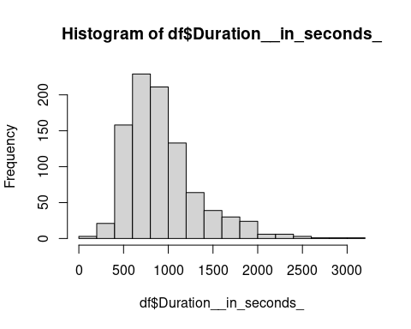

summary(df$Duration__in_seconds_)

## Min. 1st Qu. Median Mean 3rd Qu. Max.   
## 146 645 834 928 1104 3084

# will screen out the partcipants that fail to answer the validation question of recall manipulation in the "Condition marking" section below.

General measurements score calculation: Manipulation check and MASC uses averaged score of individual items.

## Manipulation Check - Self Esteem Scale

df$ManiCheck <- df %>% dplyr::select(starts_with("ManiCheck")) %>% rowMeans()  
# Add package name before function "select"   
# to prevent confusion with same name functions in other packages

## Study 3 MASC - Multi Aspect Scale of Cheating

df$MASC_set1 <- df %>% dplyr::select(starts_with("MASC_set1")) %>% rowMeans()  
df$MASC_set2 <- df %>% dplyr::select(starts_with("MASC_set2")) %>% rowMeans()  
df$MASC_set3 <- df %>% dplyr::select(starts_with("MASC_set3")) %>% rowMeans()

## Study 3 BIDR - The Balanced Inventory of Desirable Responding

Scoring: Respondents are asked to rate the 40-items on a 7 point scale according to their level of agreement with the item (stated as propositions). The scoring key is balanced. All even number statements of self-deceptive positivity (former 20 statements) are negatively keyed. All odd number statements of impression management (latter 20 statements) are negatively keyed. After reversing the negatively keyed items, one point is added for each extreme response (6 or 7). Total scores on the both constructs can range from 0 to 20. Thus, high scores are only attained by respondents who give exaggeratedly desirable responses. All 40 items may be summed to give an overall measure of social desirable responding.

#-------------------------------#  
### self deceptive positivity  
  
# positively keyed statements  
BIDR_self_deceptive_odd <- df %>%   
 dplyr::select("BIDR_Self_deceptive_2","BIDR_Self_deceptive_4","BIDR_Self_deceptive_6",  
 "BIDR_Self_deceptive_8","BIDR_Self_deceptive_10","BIDR_Self_deceptive_12",  
 "BIDR_Self_deceptive_14","BIDR_Self_deceptive_16","BIDR_Self_deceptive_18",  
 "BIDR_Self_deceptive_20")  
# iterate the item to avoid counting variables like"BIDR_Self_deceptive_DO_20"  
  
BIDR_self_deceptive_odd_recode <- as.data.frame(ifelse(BIDR_self_deceptive_odd > 5, 1,0))  
  
# negatively keyed statements  
BIDR_self_deceptive_even <- df %>%   
 dplyr::select("BIDR_Self_deceptive_1","BIDR_Self_deceptive_3","BIDR_Self_deceptive_5",  
 "BIDR_Self_deceptive_7","BIDR_Self_deceptive_9","BIDR_Self_deceptive_11",  
 "BIDR_Self_deceptive_13","BIDR_Self_deceptive_15","BIDR_Self_deceptive_17",  
 "BIDR_Self_deceptive_19")  
  
BIDR_self_deceptive_even_recode <- as.data.frame(ifelse(BIDR_self_deceptive_even < 3, 1,0))  
  
#----------------------------#  
### impression management  
  
# positively keyed statements  
BIDR_impre_manage_even <- df %>%   
 dplyr::select("BIDR_Impre_manage_2","BIDR_Impre_manage_4","BIDR_Impre_manage_6",  
 "BIDR_Impre_manage_8","BIDR_Impre_manage_10","BIDR_Impre_manage_12",  
 "BIDR_Impre_manage_14","BIDR_Impre_manage_16","BIDR_Impre_manage_18",  
 "BIDR_Impre_manage_20")  
  
BIDR_impre_manage_even_recode <- as.data.frame(ifelse(BIDR_impre_manage_even > 5, 1,0))  
  
# negatively keyed statements   
BIDR_impre_manage_odd <- df %>%   
 dplyr::select("BIDR_Impre_manage_1","BIDR_Impre_manage_3","BIDR_Impre_manage_5",  
 "BIDR_Impre_manage_7","BIDR_Impre_manage_9","BIDR_Impre_manage_11",  
 "BIDR_Impre_manage_13","BIDR_Impre_manage_15","BIDR_Impre_manage_17",  
 "BIDR_Impre_manage_19")   
# iterate the item to avoid counting variables like"BIDR_Impre_manage_DO_11"  
  
BIDR_impre_manage_odd_recode <- as.data.frame(ifelse(BIDR_impre_manage_odd < 3, 1,0))  
  
  
#------------------------------------------#  
# merge all recoded score into one dataframe  
  
recode_BIDR_self_deceptive <- BIDR_self_deceptive_odd_recode %>%   
 cbind(BIDR_self_deceptive_even_recode)   
  
recode_BIDR_impre_manage <- BIDR_impre_manage_odd_recode %>%  
 cbind(BIDR_impre_manage_even_recode)   
  
# add up recoded score to form an overall score, add to main dataframe  
df$BIDR_self_deceptive <- recode_BIDR_self_deceptive %>% rowSums()  
df$BIDR_impre_manage <- recode_BIDR_impre_manage %>% rowSums()

## Condition marking

Conditions allocated for each participants and the order of experiments presented are marked in Qualtrics by variables starting with “FL”.

# find block order of conditions  
block_order <- df %>% dplyr::select(starts_with("FL"))  
colnames(block_order)

## [1] "FL_9_DO_RecallManipulation_EthicalDissonancebyWriting_UnethicalB"  
## [2] "FL_9_DO_RecallManipulation_EthicalDissonanceWithoutWriting"   
## [3] "FL_9_DO_RecallManipulation_WorthyConduct"   
## [4] "FL_9_DO_RecallManipulation_Neutral"   
## [5] "FL_9_DO_RecallManipulation_NegativeValence"   
## [6] "FL_11_DO_Experiment1_HiringDecisionasHR"   
## [7] "FL_11_DO_FL_25"   
## [8] "FL_25_DO_Experiment2scenario1_JobInterviewAdvice"   
## [9] "FL_25_DO_FL_27"   
## [10] "FL_27_DO_Experiment2scenario2_ExchangingProductAdvice_Female"   
## [11] "FL_27_DO_Experiment2scenario2_ExchangingProductAdvice_Male"   
## [12] "FL_38_DO_MultiAspectScaleofCheatingMASC_Set1"   
## [13] "FL_38_DO_MultiAspectScaleofCheatingMASC_Set2"   
## [14] "FL_38_DO_MultiAspectScaleofCheatingMASC_Set3"   
## [15] "FL_38_DO_BalancedInventoryofDesirableRespondingBIDR_SelfDeceptiv"  
## [16] "FL_38_DO_BalancedInventoryofDesirableRespondingBIDR_ImpressionMa"

# Mark study presentation order  
df$study_order = ifelse(df$FL_11_DO_Experiment1_HiringDecisionasHR == 1,"Exp1First","Exp2First")

Slicing dataframe into five recall conditions.

## ethical dissonance & writing response   
ethi_dis_write <- df %>% filter(FL_9_DO_RecallManipulation_EthicalDissonancebyWriting_UnethicalB == 1) %>%  
 dplyr::select(RecallComprDissoWri:RecallCheck2DissoWri, # recall manipulation and comprehension check  
 "study_order",  
 "ManiCheck", # precalculated average  
 starts_with("Exp1"),  
 starts_with("Exp2"),  
 "MASC_set1", "MASC_set2", "MASC_set3", # precalculated average  
 "BIDR_self_deceptive","BIDR_impre_manage", # precalculated  
 age:CountryName, Duration__in_seconds_) %>% #demographic data and condition marker  
 mutate(condition = "Dissonance_write")  
  
ethi_dis_write <- ethi_dis_write %>% filter(RecallComprDissoWri == 1 & RecallCheck2DissoWri == 1)  
  
## ethical dissonance & writing response   
ethi_dis_nowrite <- df %>% filter(FL_9_DO_RecallManipulation_EthicalDissonanceWithoutWriting == 1) %>%  
 dplyr::select(RecallComprDissNWri:RecallCheck2DissNWri,  
 "study_order",  
 "ManiCheck",   
 starts_with("Exp1"),  
 starts_with("Exp2"),  
 "MASC_set1", "MASC_set2", "MASC_set3",   
 "BIDR_self_deceptive","BIDR_impre_manage",   
 age:CountryName, Duration__in_seconds_) %>%   
 mutate(condition = "Dissonance_no_write")  
  
ethi_dis_nowrite <- ethi_dis_nowrite %>% filter(RecallComprDissNWri == 1 & RecallCheck2DissNWri == 1)  
  
## control: worthy conduct  
con_worthy <- df %>% filter(FL_9_DO_RecallManipulation_WorthyConduct == 1) %>%  
 dplyr::select(RecallComprehWorthy:Recall_Check2_Worthy,  
 "study_order",  
 "ManiCheck",  
 starts_with("Exp1"),  
 starts_with("Exp2"),  
 "MASC_set1", "MASC_set2", "MASC_set3",  
 "BIDR_self_deceptive","BIDR_impre_manage",  
 age:CountryName, Duration__in_seconds_) %>%  
 mutate(condition = "Worthy") # control condition: worthy conduct  
  
con_worthy <- con_worthy %>% filter(RecallComprehWorthy == 4 & Recall_Check2_Worthy == 2)  
  
## control: neutral event  
con_neutral <- df %>% filter(FL_9_DO_RecallManipulation_Neutral == 1) %>%  
 dplyr::select(Recall_Compr_Neutral:Recall_Check2_neutra,  
 "study_order",  
 "ManiCheck",  
 starts_with("Exp1"),  
 starts_with("Exp2"),  
 "MASC_set1", "MASC_set2", "MASC_set3",  
 "BIDR_self_deceptive","BIDR_impre_manage",  
 age:CountryName, Duration__in_seconds_) %>%   
 mutate(condition = "Neutral") # control condition: Neutral behavior  
  
hist(con_neutral$Recall_Check2_neutra)

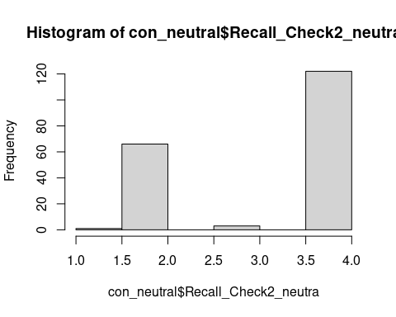

# more than 70 participants chose 2: Happy / Fulfilled / Wholesome instead of 4: Normal / Peaceful / As usual  
#con_neutral <- con_neutral %>% filter(Recall_Compr_Neutral == 2 & (Recall_Check2_neutra == 4 | Recall_Check2_neutra == 2) )  
  
con_neutral <- con_neutral %>% filter(Recall_Compr_Neutral == 2 & Recall_Check2_neutra == 4 )  
  
## control: negative event  
con_nega <- df %>% filter(FL_9_DO_RecallManipulation_NegativeValence ==1) %>%  
 dplyr::select(Recall_Compr_negativ:Recall_Check2_negati,  
 "study_order",  
 "ManiCheck",  
 starts_with("Exp1"),  
 starts_with("Exp2"),  
 "MASC_set1", "MASC_set2", "MASC_set3",  
 "BIDR_self_deceptive","BIDR_impre_manage",  
 age:CountryName, Duration__in_seconds_) %>%  
 mutate(condition = "Negative") # control condition: negative valence  
  
con_nega <- con_nega %>% filter(Recall_Compr_negativ == 3 & Recall_Check2_negati == 3)  
# overlap between 1 (unethical) and 3 (negative emotions)?

Combine data segments with condition marking.

cleaned_df <- ethi_dis_write[5:43] %>%   
 rbind(ethi_dis_nowrite[5:43]) %>%  
 rbind(con_worthy[5:43]) %>%  
 rbind(con_neutral[5:43]) %>%  
 rbind(con_nega[5:43])   
# 930 -> 765  
colnames(cleaned_df)

## [1] "study_order" "ManiCheck" "Exp1_check"   
## [4] "Exp1_check_DO_1" "Exp1_check_DO_2" "Exp1_check_DO_3"   
## [7] "Exp1_prob_hiring" "Exp1_loyalty" "Exp1_honesty"   
## [10] "Exp2_S1_check" "Exp2_S1_seen_wrong" "Exp2_S1_self_action"   
## [13] "Exp2_S1_guide_other" "Exp2_S2F_check" "Exp2_S2F_seen_wrong"   
## [16] "Exp2_S2F_self_action" "Exp2_S2F_guide_other" "Exp2_S2M_check"   
## [19] "Exp2_S2M_seen_wrong" "Exp2_S2M_self_action" "Exp2_S2M_guide_other"   
## [22] "MASC_set1" "MASC_set2" "MASC_set3"   
## [25] "BIDR_self_deceptive" "BIDR_impre_manage" "age"   
## [28] "gender" "origcount" "residence"   
## [31] "soc_class" "engunder" "funnel_pay"   
## [34] "assignmentId" "hitId" "CountryCode"   
## [37] "CountryName" "Duration__in_seconds_" "condition"

# check distribution of survey duration in the cleaned dataset   
hist(cleaned_df$Duration__in_seconds_)

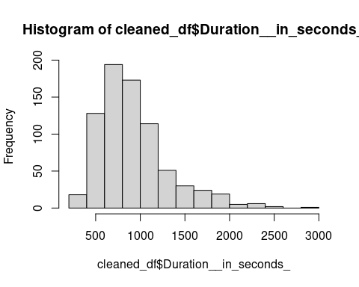

summary(cleaned_df$Duration__in_seconds_)

## Min. 1st Qu. Median Mean 3rd Qu. Max.   
## 253 649 833 923 1098 2942

# Response formatting for study 1 and study 2 DVs

Change the data type of DVs to numeric, so the ANOVA test and ggstatsplot works properly.

DVs <- c("Exp1_prob_hiring", "Exp1_loyalty","Exp1_honesty", "Exp2_S1_seen_wrong", "Exp2_S1_self_action", "Exp2_S1_guide_other", "Exp2_S2F_seen_wrong", "Exp2_S2F_self_action", "Exp2_S2F_guide_other", "Exp2_S2M_seen_wrong", "Exp2_S2M_self_action","Exp2_S2M_guide_other")  
cleaned_df[DVs] <- sapply(cleaned_df[DVs],as.numeric)

Merge study 2 scenario 2, female and male case together.

cleaned_df$Exp2_S2_seen_wrong_T2 = coalesce(cleaned_df$Exp2_S2F_seen_wrong,cleaned_df$Exp2_S2M_seen_wrong)  
cleaned_df$Exp2_S2_self_action_T2 = coalesce(cleaned_df$Exp2_S2F_self_action,cleaned_df$Exp2_S2M_self_action)  
cleaned_df$Exp2_S2_guide_other_T2 = coalesce(cleaned_df$Exp2_S2F_guide_other,cleaned_df$Exp2_S2M_guide_other)

# output cleaned data  
write.csv(cleaned_df, "cleaned_data_0719_screened_812.csv",fileEncoding = "UTF-8")

# Descriptive data

# Manipulation Check  
## overall  
jmv::descriptives(data = cleaned_df, vars = vars(ManiCheck))

##   
## DESCRIPTIVES  
##   
## Descriptives   
## ───────────────────────────────────   
## ManiCheck   
## ───────────────────────────────────   
## N 765   
## Missing 0   
## Mean 3.4305   
## Median 3.5000   
## Standard deviation 0.77983   
## Minimum 1.5000   
## Maximum 4.5000   
## ───────────────────────────────────

## by condition  
jmv::descriptives(  
 formula = ManiCheck ~ condition,  
 data = cleaned_df,  
 missing = FALSE,  
 median = FALSE,  
 variance = TRUE,  
 min = FALSE,  
 max = FALSE,  
 ci = TRUE)

##   
## DESCRIPTIVES  
##   
## Descriptives   
## ───────────────────────────────────────────────────────────────   
## condition ManiCheck   
## ───────────────────────────────────────────────────────────────   
## N Dissonance_no_write 156   
## Dissonance_write 152   
## Negative 157   
## Neutral 122   
## Worthy 178   
## Mean Dissonance_no_write 3.0203   
## Dissonance_write 3.2160   
## Negative 3.4565   
## Neutral 3.6762   
## Worthy 3.7818   
## 95% CI mean lower bound Dissonance_no_write 2.8872   
## Dissonance_write 3.0950   
## Negative 3.3353   
## Neutral 3.5675   
## Worthy 3.6937   
## 95% CI mean upper bound Dissonance_no_write 3.1534   
## Dissonance_write 3.3371   
## Negative 3.5777   
## Neutral 3.7850   
## Worthy 3.8700   
## Standard deviation Dissonance_no_write 0.84801   
## Dissonance_write 0.76143   
## Negative 0.77491   
## Neutral 0.61295   
## Worthy 0.60027   
## Variance Dissonance_no_write 0.71912   
## Dissonance_write 0.57978   
## Negative 0.60048   
## Neutral 0.37571   
## Worthy 0.36033   
## ───────────────────────────────────────────────────────────────

# Study 1  
## total  
jmv::descriptives(data = cleaned_df, vars = vars(Exp1_prob_hiring, Exp1_loyalty, Exp1_honesty))

##   
## DESCRIPTIVES  
##   
## Descriptives   
## ──────────────────────────────────────────────────────────────────────────   
## Exp1_prob_hiring Exp1_loyalty Exp1_honesty   
## ──────────────────────────────────────────────────────────────────────────   
## N 765 765 765   
## Missing 0 0 0   
## Mean 2.1869 2.2340 2.3922   
## Median 1.0000 2.0000 2.0000   
## Standard deviation 1.7132 1.5940 1.6901   
## Minimum 1.0000 1.0000 1.0000   
## Maximum 9.0000 9.0000 9.0000   
## ──────────────────────────────────────────────────────────────────────────

## by condition  
jmv::descriptives(  
 formula = Exp1_prob_hiring + Exp1_loyalty + Exp1_honesty ~ condition,  
 data = cleaned_df,  
 missing = FALSE, median = FALSE)

##   
## DESCRIPTIVES  
##   
## Descriptives   
## ─────────────────────────────────────────────────────────────────────────────────────────────────   
## condition Exp1_prob_hiring Exp1_loyalty Exp1_honesty   
## ─────────────────────────────────────────────────────────────────────────────────────────────────   
## N Dissonance_no_write 156 156 156   
## Dissonance_write 152 152 152   
## Negative 157 157 157   
## Neutral 122 122 122   
## Worthy 178 178 178   
## Mean Dissonance_no_write 2.2692 2.2564 2.4487   
## Dissonance_write 2.1908 2.2303 2.2895   
## Negative 2.1911 2.3185 2.3567   
## Neutral 2.0082 2.0246 2.4426   
## Worthy 2.2303 2.2865 2.4270   
## Standard deviation Dissonance_no_write 1.5754 1.5319 1.6512   
## Dissonance_write 1.7444 1.5546 1.5638   
## Negative 1.8506 1.7396 1.6641   
## Neutral 1.4965 1.4458 1.8766   
## Worthy 1.8220 1.6474 1.7297   
## Minimum Dissonance_no_write 1.0000 1.0000 1.0000   
## Dissonance_write 1.0000 1.0000 1.0000   
## Negative 1.0000 1.0000 1.0000   
## Neutral 1.0000 1.0000 1.0000   
## Worthy 1.0000 1.0000 1.0000   
## Maximum Dissonance_no_write 7.0000 7.0000 8.0000   
## Dissonance_write 9.0000 9.0000 8.0000   
## Negative 9.0000 8.0000 8.0000   
## Neutral 9.0000 9.0000 9.0000   
## Worthy 9.0000 9.0000 9.0000   
## ─────────────────────────────────────────────────────────────────────────────────────────────────

# Study 2 scenario 1  
## total  
jmv::descriptives(  
 data = cleaned_df,  
 vars = vars(Exp2_S1_seen_wrong, Exp2_S1_self_action, Exp2_S1_guide_other),  
 missing = FALSE, median = FALSE)

##   
## DESCRIPTIVES  
##   
## Descriptives   
## ──────────────────────────────────────────────────────────────────────────────────────────   
## Exp2_S1_seen_wrong Exp2_S1_self_action Exp2_S1_guide_other   
## ──────────────────────────────────────────────────────────────────────────────────────────   
## N 765 765 765   
## Mean 7.3922 2.3163 2.2170   
## Standard deviation 2.0008 2.0750 1.9643   
## Minimum 1.0000 1.0000 1.0000   
## Maximum 9.0000 9.0000 9.0000   
## ──────────────────────────────────────────────────────────────────────────────────────────

## by condition  
jmv::descriptives(  
 formula = Exp2_S1_seen_wrong + Exp2_S1_self_action + Exp2_S1_guide_other ~ condition,  
 data = cleaned_df,  
 missing = FALSE, median = FALSE)

##   
## DESCRIPTIVES  
##   
## Descriptives   
## ─────────────────────────────────────────────────────────────────────────────────────────────────────────────────   
## condition Exp2_S1_seen_wrong Exp2_S1_self_action Exp2_S1_guide_other   
## ─────────────────────────────────────────────────────────────────────────────────────────────────────────────────   
## N Dissonance_no_write 156 156 156   
## Dissonance_write 152 152 152   
## Negative 157 157 157   
## Neutral 122 122 122   
## Worthy 178 178 178   
## Mean Dissonance_no_write 7.0962 2.4679 2.4423   
## Dissonance_write 7.2303 2.7961 2.4737   
## Negative 7.5796 2.1401 2.1911   
## Neutral 7.5738 1.9590 1.9508   
## Worthy 7.5000 2.1742 2.0056   
## Standard deviation Dissonance_no_write 2.2020 2.1595 2.2121   
## Dissonance_write 2.0376 2.3228 2.1591   
## Negative 1.8644 1.8378 1.7836   
## Neutral 2.0120 1.8560 1.7715   
## Worthy 1.8693 2.0524 1.8024   
## Minimum Dissonance_no_write 1.0000 1.0000 1.0000   
## Dissonance_write 1.0000 1.0000 1.0000   
## Negative 1.0000 1.0000 1.0000   
## Neutral 1.0000 1.0000 1.0000   
## Worthy 1.0000 1.0000 1.0000   
## Maximum Dissonance_no_write 9.0000 9.0000 9.0000   
## Dissonance_write 9.0000 9.0000 9.0000   
## Negative 9.0000 9.0000 9.0000   
## Neutral 9.0000 9.0000 9.0000   
## Worthy 9.0000 9.0000 9.0000   
## ─────────────────────────────────────────────────────────────────────────────────────────────────────────────────

# Study scenario 2  
## total   
jmv::descriptives(  
 data = cleaned_df,  
 vars = vars(Exp2_S2_seen_wrong_T2, Exp2_S2_self_action_T2, Exp2_S2_guide_other_T2),  
 missing = FALSE, median = FALSE)

##   
## DESCRIPTIVES  
##   
## Descriptives   
## ───────────────────────────────────────────────────────────────────────────────────────────────────   
## Exp2_S2_seen_wrong_T2 Exp2_S2_self_action_T2 Exp2_S2_guide_other_T2   
## ───────────────────────────────────────────────────────────────────────────────────────────────────   
## N 765 765 765   
## Mean 4.7111 3.9647 3.7961   
## Standard deviation 2.5157 2.6841 2.5071   
## Minimum 1.0000 1.0000 1.0000   
## Maximum 9.0000 9.0000 9.0000   
## ───────────────────────────────────────────────────────────────────────────────────────────────────

## by condition  
jmv::descriptives(  
 formula = Exp2_S2_seen_wrong_T2 + Exp2_S2_self_action_T2 + Exp2_S2_guide_other_T2 ~ condition,  
 data = cleaned_df,  
 missing = FALSE, median = FALSE)

##   
## DESCRIPTIVES  
##   
## Descriptives   
## ──────────────────────────────────────────────────────────────────────────────────────────────────────────────────────────   
## condition Exp2_S2_seen_wrong_T2 Exp2_S2_self_action_T2 Exp2_S2_guide_other_T2   
## ──────────────────────────────────────────────────────────────────────────────────────────────────────────────────────────   
## N Dissonance_no_write 156 156 156   
## Dissonance_write 152 152 152   
## Negative 157 157 157   
## Neutral 122 122 122   
## Worthy 178 178 178   
## Mean Dissonance_no_write 4.5064 4.2692 4.0064   
## Dissonance_write 4.3553 4.4145 4.3158   
## Negative 4.9299 3.7707 3.7197   
## Neutral 5.0000 3.6639 3.3361   
## Worthy 4.8034 3.6910 3.5506   
## Standard deviation Dissonance_no_write 2.4029 2.5535 2.4429   
## Dissonance_write 2.5693 2.9576 2.7487   
## Negative 2.6094 2.5941 2.4880   
## Neutral 2.4596 2.5925 2.2768   
## Worthy 2.4976 2.6404 2.4449   
## Minimum Dissonance_no_write 1.0000 1.0000 1.0000   
## Dissonance_write 1.0000 1.0000 1.0000   
## Negative 1.0000 1.0000 1.0000   
## Neutral 1.0000 1.0000 1.0000   
## Worthy 1.0000 1.0000 1.0000   
## Maximum Dissonance_no_write 9.0000 9.0000 9.0000   
## Dissonance_write 9.0000 9.0000 9.0000   
## Negative 9.0000 9.0000 9.0000   
## Neutral 9.0000 9.0000 9.0000   
## Worthy 9.0000 9.0000 9.0000   
## ──────────────────────────────────────────────────────────────────────────────────────────────────────────────────────────

# Study 3  
## total  
jmv::descriptives(  
 data = cleaned_df,  
 vars = vars(MASC_set1, MASC_set2, MASC_set3, BIDR_self_deceptive, BIDR_impre_manage))

##   
## DESCRIPTIVES  
##   
## Descriptives   
## ─────────────────────────────────────────────────────────────────────────────────────────────────────────   
## MASC_set1 MASC_set2 MASC_set3 BIDR_self_deceptive BIDR_impre_manage   
## ─────────────────────────────────────────────────────────────────────────────────────────────────────────   
## N 765 765 765 765 765   
## Missing 0 0 0 0 0   
## Mean 3.9742 3.8778 5.2464 3.5739 7.3359   
## Median 4.0000 3.8333 5.5000 3.0000 7.0000   
## Standard deviation 0.68778 0.47102 1.3218 3.1183 4.5592   
## Minimum 2.7500 2.2500 1.0000 0.0000 0.0000   
## Maximum 5.7500 5.2500 7.0000 17.000 20.000   
## ─────────────────────────────────────────────────────────────────────────────────────────────────────────

## condition  
jmv::descriptives(  
 formula = MASC_set1 + MASC_set2 + MASC_set3 + BIDR_self_deceptive + BIDR_impre_manage ~ condition,  
 data = cleaned_df,  
 missing = FALSE, median = FALSE)

##   
## DESCRIPTIVES  
##   
## Descriptives   
## ────────────────────────────────────────────────────────────────────────────────────────────────────────────────────────────────   
## condition MASC_set1 MASC_set2 MASC_set3 BIDR_self_deceptive BIDR_impre_manage   
## ────────────────────────────────────────────────────────────────────────────────────────────────────────────────────────────────   
## N Dissonance_no_write 156 156 156 156 156   
## Dissonance_write 152 152 152 152 152   
## Negative 157 157 157 157 157   
## Neutral 122 122 122 122 122   
## Worthy 178 178 178 178 178   
## Mean Dissonance_no_write 4.0136 3.8526 5.3205 3.3718 7.0128   
## Dissonance_write 3.9885 3.8969 5.1842 4.2500 6.7303   
## Negative 3.9391 3.8270 5.1943 3.3567 7.4204   
## Neutral 3.9728 3.9337 5.4713 3.5410 8.1967   
## Worthy 3.9593 3.8900 5.1264 3.3876 7.4719   
## Standard deviation Dissonance_no_write 0.68385 0.49176 1.4401 3.1072 4.4359   
## Dissonance_write 0.65216 0.44971 1.3783 3.2312 4.4065   
## Negative 0.70615 0.49306 1.2476 3.0551 4.5364   
## Neutral 0.68804 0.42974 1.1594 3.0752 4.5321   
## Worthy 0.70957 0.47681 1.3243 3.0682 4.7754   
## Minimum Dissonance_no_write 2.7500 2.2500 1.0000 0.0000 0.0000   
## Dissonance_write 2.7500 2.2500 1.0000 0.0000 0.0000   
## Negative 2.7500 2.3333 1.5000 0.0000 0.0000   
## Neutral 2.7500 2.2500 3.0000 0.0000 0.0000   
## Worthy 2.7500 2.2500 1.0000 0.0000 0.0000   
## Maximum Dissonance_no_write 5.4375 5.2500 7.0000 17.000 18.000   
## Dissonance_write 5.5625 5.2500 7.0000 15.000 18.000   
## Negative 5.7500 5.2500 7.0000 13.000 19.000   
## Neutral 5.7500 5.0000 7.0000 16.000 18.000   
## Worthy 5.7500 5.2500 7.0000 14.000 20.000   
## ────────────────────────────────────────────────────────────────────────────────────────────────────────────────────────────────

# Age and Gender distribution  
jmv::descriptives(  
 data = cleaned_df,  
 vars = vars(age, gender))

##   
## DESCRIPTIVES  
##   
## Descriptives   
## ───────────────────────────────────────────   
## age gender   
## ───────────────────────────────────────────   
## N 765 765   
## Missing 0 0   
## Mean 45.267 1.5582   
## Median 42.000 2.0000   
## Standard deviation 13.298 0.56125   
## Minimum 20.000 1.0000   
## Maximum 79.000 4.0000   
## ───────────────────────────────────────────

# plot descriptive table  
#tableby.control()  
#table_one <- tableby(age ~ ., data = cleaned_df)   
#table_one  
#summary(table_one, title = "Descriptive Data")

# Planned Analysis - Main Analysis

## Manipulation check - ANOVA

jmv::ANOVA(  
 formula = ManiCheck ~ condition,  
 data = cleaned_df,  
 effectSize = "eta",  
 modelTest = TRUE,  
 homo = TRUE,  
 postHocES = "d",  
 postHocEsCi = TRUE,  
 #emMeans = ~ condition,  
 emmTables = TRUE)

##   
## ANOVA  
##   
## ANOVA - ManiCheck   
## ──────────────────────────────────────────────────────────────────────────────────────────   
## Sum of Squares df Mean Square F p η²   
## ──────────────────────────────────────────────────────────────────────────────────────────   
## Overall model 62.687 4 15.67166 29.634 < .00001   
## condition 62.687 4 15.67166 29.634 < .00001 0.13492   
## Residuals 401.924 760 0.52885   
## ──────────────────────────────────────────────────────────────────────────────────────────   
##   
##   
## ASSUMPTION CHECKS  
##   
## Homogeneity of Variances Test (Levene's)   
## ────────────────────────────────────────   
## F df1 df2 p   
## ────────────────────────────────────────   
## 9.1668 4 760 < .00001   
## ────────────────────────────────────────

# plot the APA style table   
ANOVA_mani_check <- lm(ManiCheck ~ condition, data = cleaned_df)  
  
# plot ggstatsplot and save  
ggstatsplot::ggbetweenstats(  
 data = cleaned_df,  
 y = ManiCheck,  
 x = condition,  
 originaltheme = TRUE,  
 ylab = "Manipulation Check",  
 xlab = "Conditions")

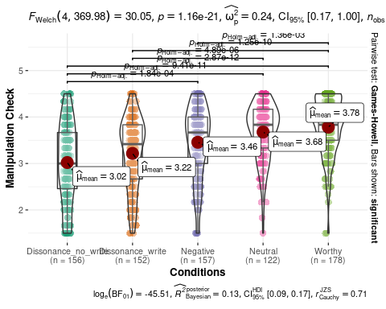

# save the table and plot to local folder. Might interrupt with knitting, hence disabled after export.  
  
apa.aov.table(ANOVA_mani_check, filename = "Manipulation check ANOVA.doc",table.number = 1)  
ggsave(  
 "ManipulationCheck_plot.png",  
 plot = last_plot(),  
 width = 9, height = 5.5,  
 dpi = 600)

## Study 1 - ANOVA

Study 1 DV1 - Likelihood of Hiring the canditate with ethically questionable behavior.

jmv::ANOVA(  
 formula = Exp1_prob_hiring ~ condition,  
 data = cleaned_df,  
 effectSize = "eta",  
 modelTest = TRUE,  
 homo = TRUE,  
 postHocES = "d",  
 postHocEsCi = TRUE,  
 emmTables = TRUE)

##   
## ANOVA  
##   
## ANOVA - Exp1_prob_hiring   
## ──────────────────────────────────────────────────────────────────────────────────────────   
## Sum of Squares df Mean Square F p η²   
## ──────────────────────────────────────────────────────────────────────────────────────────   
## Overall model 5.2944 4 1.3236 0.44968 0.77267   
## condition 5.2944 4 1.3236 0.44968 0.77267 0.00236   
## Residuals 2236.9749 760 2.9434   
## ──────────────────────────────────────────────────────────────────────────────────────────   
##   
##   
## ASSUMPTION CHECKS  
##   
## Homogeneity of Variances Test (Levene's)   
## ────────────────────────────────────────   
## F df1 df2 p   
## ────────────────────────────────────────   
## 1.4838 4 760 0.20520   
## ────────────────────────────────────────

ANOVA_Study1_DV1 <- lm(Exp1_prob_hiring ~ condition, data = cleaned_df)  
  
# plot ggstatsplot and save  
ggstatsplot::ggbetweenstats(  
 data = cleaned_df,  
 y = Exp1_prob_hiring,  
 x = condition,  
 originaltheme = TRUE,  
 ylab = "Study 1 Likelihood of hiring",  
 xlab = "Conditions")

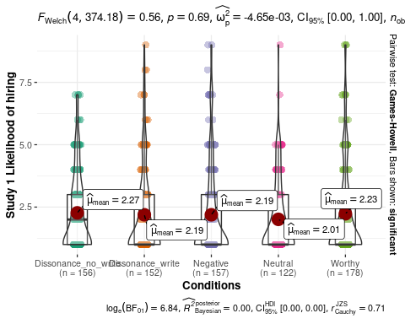

apa.aov.table(ANOVA_Study1_DV1, filename = "Exp1 DV1 ANOVA.doc",table.number = 2)  
ggsave(  
 "Study1DV1Hiring.png", plot = last_plot(),  
 width = 9, height = 5.5, dpi = 600)

Study 1 DV2 - Perceived Loyalty to company if the candidate is hired.

jmv::ANOVA(  
 formula = Exp1_loyalty ~ condition,  
 data = cleaned_df,  
 effectSize = "eta",  
 modelTest = TRUE,  
 homo = TRUE,  
 postHocES = "d",  
 postHocEsCi = TRUE,  
 emmTables = TRUE)

##   
## ANOVA  
##   
## ANOVA - Exp1_loyalty   
## ──────────────────────────────────────────────────────────────────────────────────────────   
## Sum of Squares df Mean Square F p η²   
## ──────────────────────────────────────────────────────────────────────────────────────────   
## Overall model 7.0417 4 1.7604 0.69176 0.59778   
## condition 7.0417 4 1.7604 0.69176 0.59778 0.00363   
## Residuals 1934.0747 760 2.5448   
## ──────────────────────────────────────────────────────────────────────────────────────────   
##   
##   
## ASSUMPTION CHECKS  
##   
## Homogeneity of Variances Test (Levene's)   
## ────────────────────────────────────────   
## F df1 df2 p   
## ────────────────────────────────────────   
## 1.9986 4 760 0.09294   
## ────────────────────────────────────────

ANOVA_exp1_DV2 <- lm(Exp1_loyalty ~ condition, data = cleaned_df)  
  
# plot ggstatsplot and save  
ggstatsplot::ggbetweenstats(  
 data = cleaned_df,  
 y = Exp1_loyalty,  
 x = condition,  
 originaltheme = TRUE,  
 ylab = "Study 1 Perceived Loyalty",  
 xlab = "Conditions")

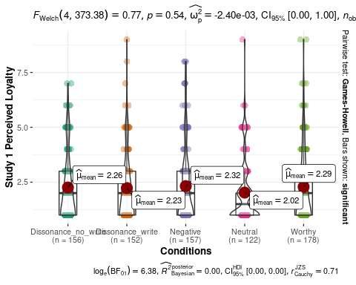

apa.aov.table(ANOVA_exp1_DV2, filename = "Exp1 DV2 ANOVA.doc",table.number = 3)  
ggsave(  
 "Study1DV2Loyalty.png", plot = last_plot(),  
 width = 9, height = 5.5, dpi = 600)

Study 1 DV3 - Perceived honesty of the candidate.

jmv::ANOVA(  
 formula = Exp1_honesty ~ condition,  
 data = cleaned_df,  
 effectSize = "eta",  
 modelTest = TRUE,  
 homo = TRUE,  
 postHocES = "d",  
 postHocEsCi = TRUE,  
 emmTables = TRUE)

##   
## ANOVA  
##   
## ANOVA - Exp1_honesty   
## ──────────────────────────────────────────────────────────────────────────────────────────   
## Sum of Squares df Mean Square F p η²   
## ──────────────────────────────────────────────────────────────────────────────────────────   
## Overall model 2.8256 4 0.70641 0.24632 0.91192   
## condition 2.8256 4 0.70641 0.24632 0.91192 0.00129   
## Residuals 2179.5273 760 2.86780   
## ──────────────────────────────────────────────────────────────────────────────────────────   
##   
##   
## ASSUMPTION CHECKS  
##   
## Homogeneity of Variances Test (Levene's)   
## ────────────────────────────────────────   
## F df1 df2 p   
## ────────────────────────────────────────   
## 0.87954 4 760 0.47565   
## ────────────────────────────────────────

ANOVA_exp1_DV3 <- lm(Exp1_honesty ~ condition, data = cleaned_df)  
  
# plot ggstatsplot and save  
ggstatsplot::ggbetweenstats(  
 data = cleaned_df,  
 y = Exp1_honesty,  
 x = condition,  
 originaltheme = TRUE,  
 ylab = "Study 1 Perceived Honesty",  
 xlab = "Conditions")

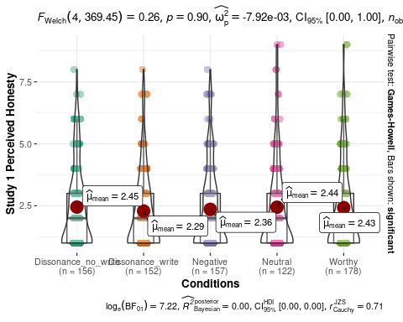

apa.aov.table(ANOVA_exp1_DV3, filename = "Exp1 DV3 ANOVA.doc",table.number = 4)  
ggsave(  
 "Study1DV3Honesty.png", plot = last_plot(),  
 width = 9, height = 5.5, dpi = 600)

## Study 2 - Repeated ANOVA

Pivot to long format for ggstatsplot.

# add a column of unique participant ID  
cleaned_df <- dplyr::mutate(cleaned_df, ID = row_number())  
  
#pivot longer  
df_s2DV1 <- pivot_longer(cleaned_df, cols = c(Exp2_S1_seen_wrong, Exp2_S2_seen_wrong_T2),names_to = "scenario",values_to = "Exp2_seen_wrong")   
df_s2DV2 <- pivot_longer(cleaned_df, cols = c(Exp2_S1_self_action, Exp2_S2_self_action_T2),names_to = "scenario",values_to = "Exp2_self_action")   
df_s2DV3<- pivot_longer(cleaned_df, cols = c(Exp2_S1_guide_other, Exp2_S2_guide_other_T2),names_to = "scenario",values_to = "Exp2_guide_other")   
  
# combine three DVs  
df_s2long <- df_s2DV1 %>% dplyr::select("ID","condition","scenario","Exp2_seen_wrong") %>% dplyr::mutate(Exp2_seen_wrong = as.numeric(Exp2_seen_wrong)) %>%  
 cbind(Exp2_self_action = as.numeric(df_s2DV2$Exp2_self_action)) %>%  
 cbind(Exp2_guide_other = as.numeric(df_s2DV3$Exp2_guide_other))  
  
# rename the scenario variable for plotting   
df_s2long <- df_s2long %>%   
 mutate(scenario = case_when(  
 scenario == "Exp2_S1_seen_wrong" ~ "Scenario 1 Leaking interview questions",  
 scenario == "Exp2_S2_seen_wrong_T2" ~ "Scenario 2 Changing used product"))

Study 2 DV2 - Perception of suggested actions as wrong.

jmv::anovaRM(  
 data = cleaned_df,  
 rm = list(  
 list(  
 label="scenario",  
 levels=c("S1", "S2"))),  
 rmCells = list(  
 list(  
 measure="Exp2_S1_seen_wrong",  
 cell="S1"),  
 list(  
 measure="Exp2_S2_seen_wrong_T2",  
 cell="S2")),  
 bs = condition,  
 effectSize = "eta",  
 rmTerms = ~ scenario,  
 bsTerms = ~ condition,  
 leveneTest = TRUE,  
 #emMeans = ~ scenario:condition,  
 emmTables = TRUE,  
 groupSumm = TRUE)

##   
## REPEATED MEASURES ANOVA  
##   
## Within Subjects Effects   
## ──────────────────────────────────────────────────────────────────────────────────────────────────   
## Sum of Squares df Mean Square F p η²   
## ──────────────────────────────────────────────────────────────────────────────────────────────────   
## scenario 2700.2646 1 2700.2646 853.74003 < .00001 0.25489   
## scenario:condition 4.3100 4 1.0775 0.34067 0.85055 0.00041   
## Residual 2403.7776 760 3.1629   
## ──────────────────────────────────────────────────────────────────────────────────────────────────   
## Note. Type 3 Sums of Squares  
##   
##   
## Between Subjects Effects   
## ─────────────────────────────────────────────────────────────────────────────────────   
## Sum of Squares df Mean Square F p η²   
## ─────────────────────────────────────────────────────────────────────────────────────   
## condition 69.952 4 17.4881 2.4543 0.04454 0.00660   
## Residual 5415.468 760 7.1256   
## ─────────────────────────────────────────────────────────────────────────────────────   
## Note. Type 3 Sums of Squares  
##   
##   
## ASSUMPTIONS  
##   
## Homogeneity of Variances Test (Levene's)   
## ─────────────────────────────────────────────────────────────   
## F df1 df2 p   
## ─────────────────────────────────────────────────────────────   
## Exp2_S1_seen_wrong 1.10681 4 760 0.35212   
## Exp2_S2_seen_wrong_T2 0.52831 4 760 0.71497   
## ─────────────────────────────────────────────────────────────   
##   
##   
## Group Summary   
## ──────────────────────────────────────────   
## condition N Excluded   
## ──────────────────────────────────────────   
## Dissonance_no_write 156 0   
## Dissonance_write 152 0   
## Negative 157 0   
## Neutral 122 0   
## Worthy 178 0   
## ──────────────────────────────────────────

# ggstatsplot for condition comparisons in between-subjects designs repeated across all levels of a grouping variable.  
# link to tutorial: https://indrajeetpatil.github.io/ggstatsplot/reference/grouped_ggbetweenstats.html  
  
ggstatsplot::grouped_ggbetweenstats(  
 data = df_s2long,  
 y = Exp2_seen_wrong,  
 x = condition,  
 grouping.var = scenario,  
 ylab = "Perceived unethicality",  
 xlab = "Conditions"  
 )

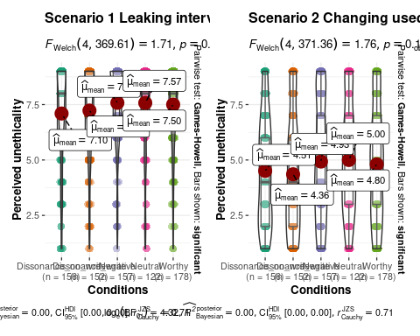

ggsave(  
 "Study2DV1SeenWrong.png", plot = last_plot(),  
 width = 11.8, height = 6, dpi = 600)

Study 2 DV2 - Likelihood of the self conducting similar behavior.

jmv::anovaRM(  
 data = cleaned_df,  
 rm = list(  
 list(  
 label="scenario",  
 levels=c("S1", "S2"))),  
 rmCells = list(  
 list(  
 measure="Exp2_S1_self_action",  
 cell="S1"),  
 list(  
 measure="Exp2_S2_self_action_T2",  
 cell="S2")),  
 bs = condition,  
 effectSize = "eta",  
 rmTerms = ~ scenario,  
 bsTerms = ~ condition,  
 leveneTest = TRUE,  
 #emMeans = ~ scenario:condition,  
 emmTables = TRUE,  
 groupSumm = TRUE)

##   
## REPEATED MEASURES ANOVA  
##   
## Within Subjects Effects   
## ──────────────────────────────────────────────────────────────────────────────────────────────────   
## Sum of Squares df Mean Square F p η²   
## ──────────────────────────────────────────────────────────────────────────────────────────────────   
## scenario 1031.3524 1 1031.35236 291.00134 < .00001 0.10497   
## scenario:condition 3.6513 4 0.91282 0.25756 0.90508 0.00037   
## Residual 2693.5540 760 3.54415   
## ──────────────────────────────────────────────────────────────────────────────────────────────────   
## Note. Type 3 Sums of Squares  
##   
##   
## Between Subjects Effects   
## ─────────────────────────────────────────────────────────────────────────────────────   
## Sum of Squares df Mean Square F p η²   
## ─────────────────────────────────────────────────────────────────────────────────────   
## condition 134.46 4 33.6145 4.2851 0.00196 0.01369   
## Residual 5961.83 760 7.8445   
## ─────────────────────────────────────────────────────────────────────────────────────   
## Note. Type 3 Sums of Squares  
##   
##   
## ASSUMPTIONS  
##   
## Homogeneity of Variances Test (Levene's)   
## ─────────────────────────────────────────────────────────────   
## F df1 df2 p   
## ─────────────────────────────────────────────────────────────   
## Exp2_S1_self_action 6.8193 4 760 0.00002   
## Exp2_S2_self_action_T2 3.0229 4 760 0.01726   
## ─────────────────────────────────────────────────────────────   
##   
##   
## Group Summary   
## ──────────────────────────────────────────   
## condition N Excluded   
## ──────────────────────────────────────────   
## Dissonance_no_write 156 0   
## Dissonance_write 152 0   
## Negative 157 0   
## Neutral 122 0   
## Worthy 178 0   
## ──────────────────────────────────────────

ggstatsplot::grouped_ggbetweenstats(  
 data = df_s2long,  
 y = Exp2_self_action,  
 x = condition,  
 grouping.var = scenario,  
 ylab = "Likelihood of the self conducting suggested behavior",  
 xlab = "Conditions"  
 )

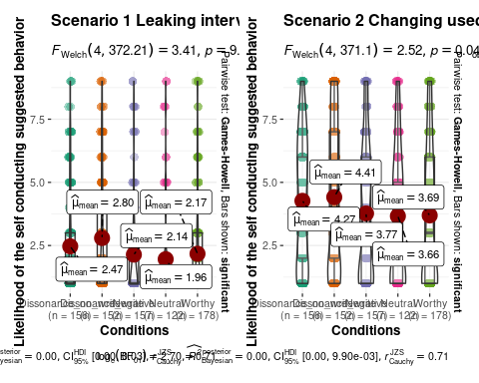

ggsave(  
 "Study2DV2SelfAction.png", plot = last_plot(),  
 width = 11.8, height = 6, dpi = 600)

Study 2 DV3 - Likelihood of advising others to perform unethical but self-benefiting behavior.

jmv::anovaRM(  
 data = cleaned_df,  
 rm = list(  
 list(  
 label="scenario",  
 levels=c("S1", "S2"))),  
 rmCells = list(  
 list(  
 measure="Exp2_S1_guide_other",  
 cell="S1"),  
 list(  
 measure="Exp2_S2_guide_other_T2",  
 cell="S2")),  
 bs = condition,  
 effectSize = "eta",  
 rmTerms = ~ scenario,  
 bsTerms = ~ condition,  
 leveneTest = TRUE,  
 #emMeans = ~ scenario:condition,  
 emmTables = TRUE,  
 groupSumm = TRUE)

##   
## REPEATED MEASURES ANOVA  
##   
## Within Subjects Effects   
## ──────────────────────────────────────────────────────────────────────────────────────────────────   
## Sum of Squares df Mean Square F p η²   
## ──────────────────────────────────────────────────────────────────────────────────────────────────   
## scenario 932.3630 1 932.3630 308.17061 < .00001 0.10738   
## scenario:condition 7.8705 4 1.9676 0.65035 0.62676 0.00091   
## Residual 2299.3622 760 3.0255   
## ──────────────────────────────────────────────────────────────────────────────────────────────────   
## Note. Type 3 Sums of Squares  
##   
##   
## Between Subjects Effects   
## ─────────────────────────────────────────────────────────────────────────────────────   
## Sum of Squares df Mean Square F p η²   
## ─────────────────────────────────────────────────────────────────────────────────────   
## condition 112.18 4 28.0459 3.9985 0.00323 0.01292   
## Residual 5330.75 760 7.0141   
## ─────────────────────────────────────────────────────────────────────────────────────   
## Note. Type 3 Sums of Squares  
##   
##   
## ASSUMPTIONS  
##   
## Homogeneity of Variances Test (Levene's)   
## ─────────────────────────────────────────────────────────────   
## F df1 df2 p   
## ─────────────────────────────────────────────────────────────   
## Exp2_S1_guide_other 4.8288 4 760 0.00075   
## Exp2_S2_guide_other_T2 2.7456 4 760 0.02750   
## ─────────────────────────────────────────────────────────────   
##   
##   
## Group Summary   
## ──────────────────────────────────────────   
## condition N Excluded   
## ──────────────────────────────────────────   
## Dissonance_no_write 156 0   
## Dissonance_write 152 0   
## Negative 157 0   
## Neutral 122 0   
## Worthy 178 0   
## ──────────────────────────────────────────

ggstatsplot::grouped_ggbetweenstats(  
 data = df_s2long,  
 y = Exp2_guide_other,  
 x = condition,  
 grouping.var = scenario,  
 ylab = "Likelihood of advising others to behave unethically",  
 xlab = "Conditions"  
 )

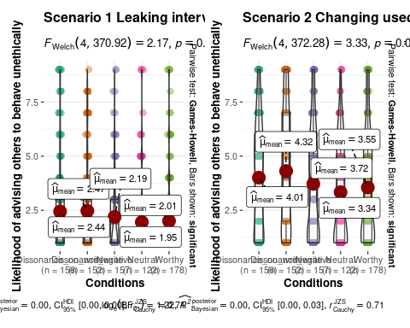

ggsave(  
 "Study2DV3AdviseOthers.png", plot = last_plot(),  
 width = 11.8, height = 6, dpi = 600)

## Study 3 - MASC

Calculate ANOVA, generate APA style ANOVA table, and plot ggstatsplot.

# Overall measurements for all participants.  
  
## MASC set 1  
jmv::ANOVA(  
 formula = MASC_set1 ~ condition,  
 data = cleaned_df,  
 effectSize = "eta",  
 modelTest = TRUE,  
 homo = TRUE,  
 postHocES = "d",  
 postHocEsCi = TRUE,  
 #emMeans = ~ condition,  
 emmTables = TRUE)

##   
## ANOVA  
##   
## ANOVA - MASC_set1   
## ──────────────────────────────────────────────────────────────────────────────────────────   
## Sum of Squares df Mean Square F p η²   
## ──────────────────────────────────────────────────────────────────────────────────────────   
## Overall model 0.50687 4 0.12672 0.26685 0.89931   
## condition 0.50687 4 0.12672 0.26685 0.89931 0.00140   
## Residuals 360.89730 760 0.47486   
## ──────────────────────────────────────────────────────────────────────────────────────────   
##   
##   
## ASSUMPTION CHECKS  
##   
## Homogeneity of Variances Test (Levene's)   
## ────────────────────────────────────────   
## F df1 df2 p   
## ────────────────────────────────────────   
## 0.49187 4 760 0.74174   
## ────────────────────────────────────────

ANOVA_study3_MASC1 <- lm(MASC_set1 ~ condition, data = cleaned_df)  
  
ggstatsplot::ggbetweenstats(  
 data = cleaned_df,  
 y = MASC_set1,  
 x = condition,  
 originaltheme = TRUE,  
 ylab = "MASC - Perceived dishonesty",  
 xlab = "Conditions",  
 title = "Multi Aspect Scale of Cheating (MASC) - Likelihood of others to behave dishonestly")

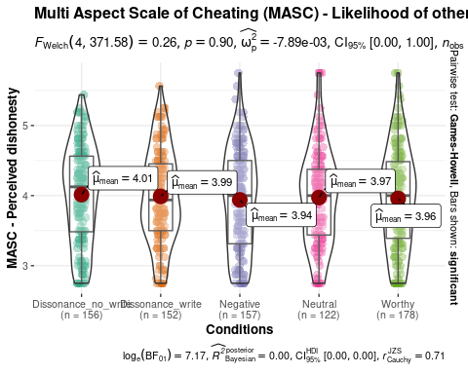

apa.aov.table(ANOVA_study3_MASC1, filename = "Exp3 MASC set1 ANOVA.doc",table.number = 5)  
ggsave(  
 "MASC1_Dishonesty_plot.png", plot = last_plot(),   
 width = 9, height = 5.5, dpi = 600)

## MASC set 2  
jmv::ANOVA(  
 formula = MASC_set2 ~ condition,  
 data = cleaned_df,  
 effectSize = "eta",  
 modelTest = TRUE,  
 homo = TRUE,  
 postHocES = "d",  
 postHocEsCi = TRUE,  
 #emMeans = ~ condition,  
 emmTables = TRUE)

##   
## ANOVA  
##   
## ANOVA - MASC_set2   
## ─────────────────────────────────────────────────────────────────────────────────────────   
## Sum of Squares df Mean Square F p η²   
## ─────────────────────────────────────────────────────────────────────────────────────────   
## Overall model 0.96894 4 0.24223 1.0924 0.35915   
## condition 0.96894 4 0.24223 1.0924 0.35915 0.00572   
## Residuals 168.53384 760 0.22176   
## ─────────────────────────────────────────────────────────────────────────────────────────   
##   
##   
## ASSUMPTION CHECKS  
##   
## Homogeneity of Variances Test (Levene's)   
## ────────────────────────────────────────   
## F df1 df2 p   
## ────────────────────────────────────────   
## 0.67700 4 760 0.60804   
## ────────────────────────────────────────

ANOVA_study3_MASC2 <- lm(MASC_set2 ~ condition, data = cleaned_df)  
  
ggstatsplot::ggbetweenstats(  
 data = cleaned_df,  
 y = MASC_set2,  
 x = condition,  
 originaltheme = TRUE,  
 ylab = "MASC - Lie detection",  
 xlab = "Conditions",  
 title = "Multi Aspect Scale of Cheating (MASC) - Interpreting common excuses as a lie")

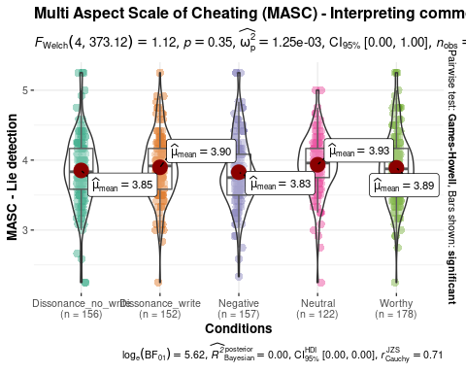

apa.aov.table(ANOVA_study3_MASC2, filename = "Exp3 MASC set2 ANOVA.doc",table.number = 6)  
ggsave(  
 "MASC2_Lie_plot.png", plot = last_plot(),   
 width = 9, height = 5.5, dpi = 600)

## MASC set 3  
jmv::ANOVA(  
 formula = MASC_set3 ~ condition,  
 data = cleaned_df,  
 effectSize = "eta",  
 modelTest = TRUE,  
 homo = TRUE,  
 postHocES = "d",  
 postHocEsCi = TRUE,  
 #emMeans = ~ condition,  
 emmTables = TRUE)

##   
## ANOVA  
##   
## ANOVA - MASC_set3   
## ─────────────────────────────────────────────────────────────────────────────────────────   
## Sum of Squares df Mean Square F p η²   
## ─────────────────────────────────────────────────────────────────────────────────────────   
## Overall model 10.606 4 2.6515 1.5218 0.19393   
## condition 10.606 4 2.6515 1.5218 0.19393 0.00795   
## Residuals 1324.197 760 1.7424   
## ─────────────────────────────────────────────────────────────────────────────────────────   
##   
##   
## ASSUMPTION CHECKS  
##   
## Homogeneity of Variances Test (Levene's)   
## ────────────────────────────────────────   
## F df1 df2 p   
## ────────────────────────────────────────   
## 1.8344 4 760 0.12028   
## ────────────────────────────────────────

ANOVA_study3_MASC3 <- lm(MASC_set3 ~ condition, data = cleaned_df)  
  
ggstatsplot::ggbetweenstats(  
 data = cleaned_df,  
 y = MASC_set3,  
 x = condition,  
 originaltheme = TRUE,  
 ylab = "MASC - Predict action in dillemmas",  
 xlab = "Conditions",  
 title = "Multi Aspect Scale of Cheating (MASC) - Likelihood of actors to behave dishonestly in dilemmas")

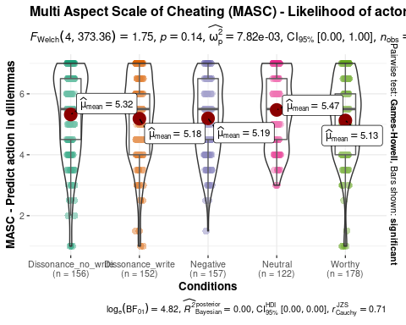

apa.aov.table(ANOVA_study3_MASC3, filename = "Exp3 MASC set3 ANOVA.doc",table.number = 7)  
ggsave(  
 "MASC3_dilemmas_plot.png", plot = last_plot(),   
 width = 9, height = 5.5, dpi = 600)

## Study 3 - BIDR

Calculate ANOVA, generate APA style ANOVA table, and plot ggstatsplot.

## BIDR - self deceptive  
jmv::ANOVA(  
 formula = BIDR_self_deceptive ~ condition,  
 data = cleaned_df,  
 effectSize = "eta",  
 modelTest = TRUE,  
 homo = TRUE,  
 postHocES = "d",  
 postHocEsCi = TRUE,  
 #emMeans = ~ condition,  
 emmTables = TRUE)

##   
## ANOVA  
##   
## ANOVA - BIDR_self_deceptive   
## ─────────────────────────────────────────────────────────────────────────────────────────   
## Sum of Squares df Mean Square F p η²   
## ─────────────────────────────────────────────────────────────────────────────────────────   
## Overall model 89.568 4 22.3920 2.3187 0.05559   
## condition 89.568 4 22.3920 2.3187 0.05559 0.01206   
## Residuals 7339.509 760 9.6572   
## ─────────────────────────────────────────────────────────────────────────────────────────   
##   
##   
## ASSUMPTION CHECKS  
##   
## Homogeneity of Variances Test (Levene's)   
## ────────────────────────────────────────   
## F df1 df2 p   
## ────────────────────────────────────────   
## 0.51664 4 760 0.72354   
## ────────────────────────────────────────

ANOVA_study3_BIDR1 <- lm(BIDR_self_deceptive ~ condition, data = cleaned_df)  
  
ggstatsplot::ggbetweenstats(  
 data = cleaned_df,  
 y = BIDR_self_deceptive,  
 x = condition,  
 originaltheme = TRUE,  
 ylab = "BIDR - self deceptive",  
 xlab = "Conditions",  
 title = "Balanced Inventory of Desirable Responding - Self Deceptive Score")

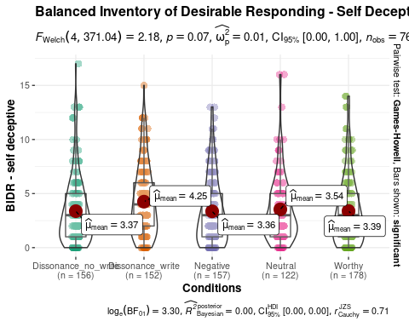

apa.aov.table(ANOVA_study3_BIDR1, filename = "Exp3 BIDR1 ANOVA.doc",table.number = 8)  
ggsave(  
 "BIDR_SelfDeceptive_plot.png", plot = last_plot(),   
 width = 9, height = 5.5, dpi = 600)

## BIDR - impression management  
jmv::ANOVA(  
 formula = BIDR_impre_manage ~ condition,  
 data = cleaned_df,  
 effectSize = "eta",  
 modelTest = TRUE,  
 homo = TRUE,  
 postHocES = "d",  
 postHocEsCi = TRUE,  
 #emMeans = ~ condition,  
 emmTables = TRUE)

##   
## ANOVA  
##   
## ANOVA - BIDR_impre_manage   
## ─────────────────────────────────────────────────────────────────────────────────────────   
## Sum of Squares df Mean Square F p η²   
## ─────────────────────────────────────────────────────────────────────────────────────────   
## Overall model 166.85 4 41.713 2.0175 0.09020   
## condition 166.85 4 41.713 2.0175 0.09020 0.01051   
## Residuals 15713.81 760 20.676   
## ─────────────────────────────────────────────────────────────────────────────────────────   
##   
##   
## ASSUMPTION CHECKS  
##   
## Homogeneity of Variances Test (Levene's)   
## ────────────────────────────────────────   
## F df1 df2 p   
## ────────────────────────────────────────   
## 0.33881 4 760 0.85184   
## ────────────────────────────────────────

ANOVA_study3_BIDR2 <- lm(BIDR_impre_manage ~ condition, data = cleaned_df)  
  
ggstatsplot::ggbetweenstats(  
 data = cleaned_df,  
 y = BIDR_impre_manage,  
 x = condition,  
 originaltheme = TRUE,  
 ylab = "BIDR - impression management",  
 xlab = "Conditions",  
 title = "Balanced Inventory of Desirable Responding - Impression Management Score")

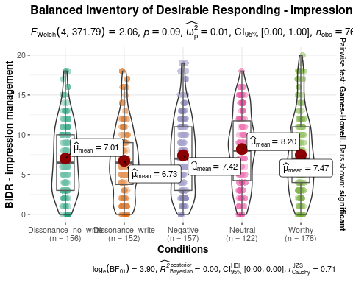

apa.aov.table(ANOVA_study3_BIDR2, filename = "Exp3 BIDR2 ANOVA.doc",table.number = 9)  
ggsave(  
 "BIDR_ImpressionManagement_plot.png", plot = last_plot(),   
 width = 9, height = 5.5, dpi = 600)

# Robustness check - planned contrasts for recall conditions

## Study 1 - planned contrast for ANOVA

contrast1 = c(3, 3,-2,-2,-2)  
contrast2 = c(1,-1, 0, 0, 0)  
# comprehensive data  
cleaned_df$condition=factor(cleaned_df$condition)  
contrasts(cleaned_df$condition) = cbind(contrast1, contrast2)  
  
#Check  
contrasts(cleaned_df$condition)

## contrast1 contrast2   
## Dissonance_no_write 3 1 -0.000000000000000041633  
## Dissonance_write 3 -1 -0.000000000000000026743  
## Negative -2 0 -0.577350269189625731059  
## Neutral -2 0 0.788675134594812865529  
## Worthy -2 0 -0.211324865405187106715  
##   
## Dissonance_no_write -0.000000000000000055511  
## Dissonance_write -0.000000000000000017154  
## Negative -0.577350269189625731059  
## Neutral -0.211324865405187134471  
## Worthy 0.788675134594812865529

# ANOVA command  
# result in the form of regression  
#summary.lm(aov1)  
  
ANOVA_mani_check <- lm(ManiCheck ~ condition, data = cleaned_df)  
summary.lm(ANOVA_mani_check)

##   
## Call:  
## lm(formula = ManiCheck ~ condition, data = cleaned_df)  
##   
## Residuals:  
## Min 1Q Median 3Q Max   
## -2.282 -0.457 0.146 0.543 1.480   
##   
## Coefficients:  
## Estimate Std. Error t value Pr(>|t|)   
## (Intercept) 3.4302 0.0265 129.49 <0.0000000000000002 ***  
## conditioncontrast1 -0.1040 0.0108 -9.65 <0.0000000000000002 ***  
## conditioncontrast2 -0.0979 0.0414 -2.36 0.0185 *   
## condition 0.1046 0.0629 1.66 0.0967 .   
## condition 0.2102 0.0563 3.74 0.0002 ***  
## ---  
## Signif. codes: 0 '***' 0.001 '**' 0.01 '*' 0.05 '.' 0.1 ' ' 1  
##   
## Residual standard error: 0.727 on 760 degrees of freedom  
## Multiple R-squared: 0.135, Adjusted R-squared: 0.13   
## F-statistic: 29.6 on 4 and 760 DF, p-value: <0.0000000000000002

ANOVA_exp1_DV1 <- lm(Exp1_prob_hiring ~ condition, data = cleaned_df)  
summary.lm(ANOVA_exp1_DV1)

##   
## Call:  
## lm(formula = Exp1_prob_hiring ~ condition, data = cleaned_df)  
##   
## Residuals:  
## Min 1Q Median 3Q Max   
## -1.27 -1.19 -1.01 0.77 6.99   
##   
## Coefficients:  
## Estimate Std. Error t value Pr(>|t|)   
## (Intercept) 2.1779 0.0625 34.85 <0.0000000000000002 ***  
## conditioncontrast1 0.0174 0.0254 0.68 0.49   
## conditioncontrast2 0.0392 0.0978 0.40 0.69   
## condition -0.1525 0.1483 -1.03 0.30   
## condition 0.0696 0.1327 0.52 0.60   
## ---  
## Signif. codes: 0 '***' 0.001 '**' 0.01 '*' 0.05 '.' 0.1 ' ' 1  
##   
## Residual standard error: 1.72 on 760 degrees of freedom  
## Multiple R-squared: 0.00236, Adjusted R-squared: -0.00289   
## F-statistic: 0.45 on 4 and 760 DF, p-value: 0.773

ANOVA_exp1_DV2 <- lm(Exp1_loyalty ~ condition, data = cleaned_df)  
summary.lm(ANOVA_exp1_DV2)

##   
## Call:  
## lm(formula = Exp1_loyalty ~ condition, data = cleaned_df)  
##   
## Residuals:  
## Min 1Q Median 3Q Max   
## -1.318 -1.256 -0.287 0.713 6.975   
##   
## Coefficients:  
## Estimate Std. Error t value Pr(>|t|)   
## (Intercept) 2.2233 0.0581 38.26 <0.0000000000000002 ***  
## conditioncontrast1 0.0067 0.0236 0.28 0.78   
## conditioncontrast2 0.0131 0.0909 0.14 0.89   
## condition -0.2250 0.1379 -1.63 0.10   
## condition 0.0369 0.1234 0.30 0.76   
## ---  
## Signif. codes: 0 '***' 0.001 '**' 0.01 '*' 0.05 '.' 0.1 ' ' 1  
##   
## Residual standard error: 1.6 on 760 degrees of freedom  
## Multiple R-squared: 0.00363, Adjusted R-squared: -0.00162   
## F-statistic: 0.692 on 4 and 760 DF, p-value: 0.598

ANOVA_exp1_DV3 <- lm(Exp1_honesty ~ condition, data = cleaned_df)  
summary.lm(ANOVA_exp1_DV3)

##   
## Call:  
## lm(formula = Exp1_honesty ~ condition, data = cleaned_df)  
##   
## Residuals:  
## Min 1Q Median 3Q Max   
## -1.449 -1.357 -0.427 0.643 6.573   
##   
## Coefficients:  
## Estimate Std. Error t value Pr(>|t|)   
## (Intercept) 2.39289 0.06169 38.79 <0.0000000000000002 ***  
## conditioncontrast1 -0.00793 0.02510 -0.32 0.75   
## conditioncontrast2 0.07962 0.09650 0.83 0.41   
## condition 0.05292 0.14639 0.36 0.72   
## condition 0.03727 0.13100 0.28 0.78   
## ---  
## Signif. codes: 0 '***' 0.001 '**' 0.01 '*' 0.05 '.' 0.1 ' ' 1  
##   
## Residual standard error: 1.69 on 760 degrees of freedom  
## Multiple R-squared: 0.00129, Adjusted R-squared: -0.00396   
## F-statistic: 0.246 on 4 and 760 DF, p-value: 0.912

ANOVA_exp3_MASC1 <- lm(MASC_set1 ~ condition, data = cleaned_df)  
summary.lm(ANOVA_exp3_MASC1)

##   
## Call:  
## lm(formula = MASC_set1 ~ condition, data = cleaned_df)  
##   
## Residuals:  
## Min 1Q Median 3Q Max   
## -1.2636 -0.5218 0.0407 0.5115 1.8109   
##   
## Coefficients:  
## Estimate Std. Error t value Pr(>|t|)   
## (Intercept) 3.97466 0.02510 158.34 <0.0000000000000002 ***  
## conditioncontrast1 0.00880 0.01021 0.86 0.39   
## conditioncontrast2 0.01257 0.03927 0.32 0.75   
## condition 0.02236 0.05957 0.38 0.71   
## condition 0.00878 0.05330 0.16 0.87   
## ---  
## Signif. codes: 0 '***' 0.001 '**' 0.01 '*' 0.05 '.' 0.1 ' ' 1  
##   
## Residual standard error: 0.689 on 760 degrees of freedom  
## Multiple R-squared: 0.0014, Adjusted R-squared: -0.00385   
## F-statistic: 0.267 on 4 and 760 DF, p-value: 0.899

ANOVA_exp3_MASC2 <- lm(MASC_set2 ~ condition, data = cleaned_df)  
summary.lm(ANOVA_exp3_MASC2)

##   
## Call:  
## lm(formula = MASC_set2 ~ condition, data = cleaned_df)  
##   
## Residuals:  
## Min 1Q Median 3Q Max   
## -1.6837 -0.2692 -0.0171 0.2767 1.4230   
##   
## Coefficients:  
## Estimate Std. Error t value Pr(>|t|)   
## (Intercept) 3.88004 0.01715 226.19 <0.0000000000000002 ***  
## conditioncontrast1 -0.00176 0.00698 -0.25 0.801   
## conditioncontrast2 -0.02218 0.02683 -0.83 0.409   
## condition 0.07090 0.04071 1.74 0.082 .   
## condition 0.02714 0.03643 0.74 0.457   
## ---  
## Signif. codes: 0 '***' 0.001 '**' 0.01 '*' 0.05 '.' 0.1 ' ' 1  
##   
## Residual standard error: 0.471 on 760 degrees of freedom  
## Multiple R-squared: 0.00572, Adjusted R-squared: 0.000483   
## F-statistic: 1.09 on 4 and 760 DF, p-value: 0.359

ANOVA_exp3_MASC3 <- lm(MASC_set3 ~ condition, data = cleaned_df)  
summary.lm(ANOVA_exp3_MASC3)

##   
## Call:  
## lm(formula = MASC_set3 ~ condition, data = cleaned_df)  
##   
## Residuals:  
## Min 1Q Median 3Q Max   
## -4.321 -0.971 0.179 1.179 1.874   
##   
## Coefficients:  
## Estimate Std. Error t value Pr(>|t|)   
## (Intercept) 5.25934 0.04808 109.38 <0.0000000000000002 ***  
## conditioncontrast1 -0.00233 0.01956 -0.12 0.905   
## conditioncontrast2 0.06815 0.07522 0.91 0.365   
## condition 0.23284 0.11410 2.04 0.042 *   
## condition -0.11207 0.10211 -1.10 0.273   
## ---  
## Signif. codes: 0 '***' 0.001 '**' 0.01 '*' 0.05 '.' 0.1 ' ' 1  
##   
## Residual standard error: 1.32 on 760 degrees of freedom  
## Multiple R-squared: 0.00795, Adjusted R-squared: 0.00272   
## F-statistic: 1.52 on 4 and 760 DF, p-value: 0.194

ANOVA_exp3_BIDR1 <- lm(BIDR_self_deceptive ~ condition, data = cleaned_df)  
summary.lm(ANOVA_exp3_BIDR1)

##   
## Call:  
## lm(formula = BIDR_self_deceptive ~ condition, data = cleaned_df)  
##   
## Residuals:  
## Min 1Q Median 3Q Max   
## -4.250 -2.372 -0.388 1.628 13.628   
##   
## Coefficients:  
## Estimate Std. Error t value Pr(>|t|)   
## (Intercept) 3.5814 0.1132 31.64 <0.0000000000000002 ***  
## conditioncontrast1 0.0765 0.0461 1.66 0.097 .   
## conditioncontrast2 -0.4391 0.1771 -2.48 0.013 *   
## condition 0.1388 0.2686 0.52 0.606   
## condition -0.0145 0.2404 -0.06 0.952   
## ---  
## Signif. codes: 0 '***' 0.001 '**' 0.01 '*' 0.05 '.' 0.1 ' ' 1  
##   
## Residual standard error: 3.11 on 760 degrees of freedom  
## Multiple R-squared: 0.0121, Adjusted R-squared: 0.00686   
## F-statistic: 2.32 on 4 and 760 DF, p-value: 0.0556

ANOVA_exp3_BIDR2 <- lm(BIDR_impre_manage ~ condition, data = cleaned_df)  
summary.lm(ANOVA_exp3_BIDR2)

##   
## Call:  
## lm(formula = BIDR_impre_manage ~ condition, data = cleaned_df)  
##   
## Residuals:  
## Min 1Q Median 3Q Max   
## -8.20 -4.01 -0.42 3.27 12.53   
##   
## Coefficients:  
## Estimate Std. Error t value Pr(>|t|)   
## (Intercept) 7.3664 0.1656 44.47 <0.0000000000000002 ***  
## conditioncontrast1 -0.1650 0.0674 -2.45 0.015 *   
## conditioncontrast2 0.1413 0.2591 0.55 0.586   
## condition 0.6014 0.3931 1.53 0.126   
## condition -0.1234 0.3517 -0.35 0.726   
## ---  
## Signif. codes: 0 '***' 0.001 '**' 0.01 '*' 0.05 '.' 0.1 ' ' 1  
##   
## Residual standard error: 4.55 on 760 degrees of freedom  
## Multiple R-squared: 0.0105, Adjusted R-squared: 0.0053   
## F-statistic: 2.02 on 4 and 760 DF, p-value: 0.0902

## Study 2 - planned contrast for repeated ANOVA

# Repeated-measures ANOVA with the afex package  
library("afex")

## Loading required package: lme4

## Loading required package: Matrix

##   
## Attaching package: 'Matrix'

## The following objects are masked from 'package:tidyr':  
##   
## expand, pack, unpack

## ************  
## Welcome to afex. For support visit: http://afex.singmann.science/

## - Functions for ANOVAs: aov_car(), aov_ez(), and aov_4()  
## - Methods for calculating p-values with mixed(): 'S', 'KR', 'LRT', and 'PB'  
## - 'afex_aov' and 'mixed' objects can be passed to emmeans() for follow-up tests  
## - NEWS: emmeans() for ANOVA models now uses model = 'multivariate' as default.  
## - Get and set global package options with: afex_options()  
## - Set orthogonal sum-to-zero contrasts globally: set_sum_contrasts()  
## - For example analyses see: browseVignettes("afex")  
## ************

##   
## Attaching package: 'afex'

## The following object is masked from 'package:lme4':  
##   
## lmer

# using the long format "df_s2long" created in main analysis:  
  
# planned contrast notation  
contrast1 = c(3, 3,-2,-2,-2)  
contrast2 = c(1,-1, 0, 0, 0)  
df_s2long$condition <- as.factor(df_s2long$condition)  
contrasts(df_s2long$condition) = cbind(contrast1, contrast2)  
  
#Check  
contrasts(df_s2long$condition)

## contrast1 contrast2   
## Dissonance_no_write 3 1 -0.000000000000000041633  
## Dissonance_write 3 -1 -0.000000000000000026743  
## Negative -2 0 -0.577350269189625731059  
## Neutral -2 0 0.788675134594812865529  
## Worthy -2 0 -0.211324865405187106715  
##   
## Dissonance_no_write -0.000000000000000055511  
## Dissonance_write -0.000000000000000017154  
## Negative -0.577350269189625731059  
## Neutral -0.211324865405187134471  
## Worthy 0.788675134594812865529

# ANOVA command  
ANOVA_Exp2_DV1 <- afex::aov_car(Exp2_seen_wrong ~ condition*scenario + Error(ID/scenario), data=df_s2DV1)

## Converting to factor: condition

ANOVA_Exp2_DV2 <- afex::aov_car(Exp2_self_action ~ condition*scenario + Error(ID/scenario), data=df_s2DV2)

## Converting to factor: condition

ANOVA_Exp2_DV3 <- afex::aov_car(Exp2_guide_other ~ condition*scenario + Error(ID/scenario), data=df_s2DV3)

## Converting to factor: condition

summary(ANOVA_Exp2_DV1)

##   
## Univariate Type III Repeated-Measures ANOVA Assuming Sphericity  
##   
## Sum Sq num Df Error SS den Df F value Pr(>F)  
## (Intercept) 55305 1 5415 760 7761.44 <0.0000000000000002  
## condition 70 4 5415 760 2.45 0.045  
## scenario 2700 1 2404 760 853.74 <0.0000000000000002  
## condition:scenario 4 4 2404 760 0.34 0.851  
##   
## (Intercept) ***  
## condition *   
## scenario ***  
## condition:scenario   
## ---  
## Signif. codes: 0 '***' 0.001 '**' 0.01 '*' 0.05 '.' 0.1 ' ' 1

summary(ANOVA_Exp2_DV2)

##   
## Univariate Type III Repeated-Measures ANOVA Assuming Sphericity  
##   
## Sum Sq num Df Error SS den Df F value Pr(>F)  
## (Intercept) 14810 1 5962 760 1887.98 <0.0000000000000002  
## condition 134 4 5962 760 4.29 0.002  
## scenario 1031 1 2694 760 291.00 <0.0000000000000002  
## condition:scenario 4 4 2694 760 0.26 0.905  
##   
## (Intercept) ***  
## condition **   
## scenario ***  
## condition:scenario   
## ---  
## Signif. codes: 0 '***' 0.001 '**' 0.01 '*' 0.05 '.' 0.1 ' ' 1

summary(ANOVA_Exp2_DV3)

##   
## Univariate Type III Repeated-Measures ANOVA Assuming Sphericity  
##   
## Sum Sq num Df Error SS den Df F value Pr(>F)  
## (Intercept) 13558 1 5331 760 1932.94 <0.0000000000000002  
## condition 112 4 5331 760 4.00 0.0032  
## scenario 932 1 2299 760 308.17 <0.0000000000000002  
## condition:scenario 8 4 2299 760 0.65 0.6268  
##   
## (Intercept) ***  
## condition **   
## scenario ***  
## condition:scenario   
## ---  
## Signif. codes: 0 '***' 0.001 '**' 0.01 '*' 0.05 '.' 0.1 ' ' 1

# Planned Additional Analysis

Investigate the order effect if we fail to find support for the original’s analyses.

## Study 1 - ANOVA

Only include participants that saw study 1 before study 2.

df_s1 <- cleaned_df %>% filter(study_order == "Exp1First")  
write.csv(df_s1, "stimulated_cleaned_study1.csv",fileEncoding = "UTF-8")  
  
# DV1 Probability of hiring the candicate  
jmv::ANOVA(  
 formula = Exp1_prob_hiring ~ condition,  
 data = df_s1,  
 effectSize = "eta",  
 modelTest = TRUE,  
 homo = TRUE,  
 postHocES = "d",  
 postHocEsCi = TRUE,  
 #emMeans = ~ condition, # using ggstatsplot instead  
 emmTables = TRUE)

##   
## ANOVA  
##   
## ANOVA - Exp1_prob_hiring   
## ─────────────────────────────────────────────────────────────────────────────────────────   
## Sum of Squares df Mean Square F p η²   
## ─────────────────────────────────────────────────────────────────────────────────────────   
## Overall model 13.632 4 3.4080 1.1098 0.35149   
## condition 13.632 4 3.4080 1.1098 0.35149 0.01140   
## Residuals 1182.227 385 3.0707   
## ─────────────────────────────────────────────────────────────────────────────────────────   
##   
##   
## ASSUMPTION CHECKS  
##   
## Homogeneity of Variances Test (Levene's)   
## ────────────────────────────────────────   
## F df1 df2 p   
## ────────────────────────────────────────   
## 3.1426 4 385 0.01460   
## ────────────────────────────────────────

ANOVA_exp1_DV1 <- lm(Exp1_prob_hiring ~ condition, data = df_s1)  
#apa.aov.table(ANOVA_exp1_DV1, filename = "Exp1 DV1 ANOVA.doc",table.number = 10)  
  
# plot ggstatsplot  
ggstatsplot::ggbetweenstats(  
 data = df_s1,  
 y = Exp1_prob_hiring,  
 x = condition,  
 originaltheme = TRUE,  
 ylab = "Study 1 Likelihood of hiring",  
 xlab = "Conditions")

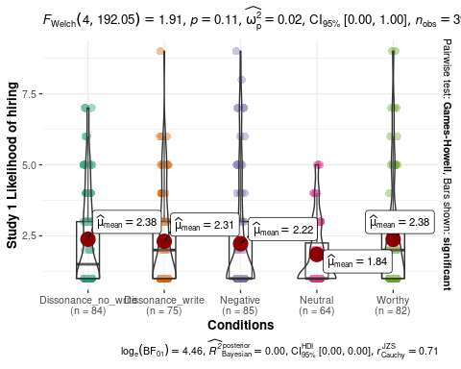

# DV2 Perceived loyalty of the candidate  
jmv::ANOVA(  
 formula = Exp1_loyalty ~ condition,  
 data = df_s1,  
 effectSize = "eta",  
 modelTest = TRUE,  
 homo = TRUE,  
 postHocES = "d",  
 postHocEsCi = TRUE,  
 #emMeans = ~ condition,  
 emmTables = TRUE)

##   
## ANOVA  
##   
## ANOVA - Exp1_loyalty   
## ─────────────────────────────────────────────────────────────────────────────────────────   
## Sum of Squares df Mean Square F p η²   
## ─────────────────────────────────────────────────────────────────────────────────────────   
## Overall model 25.371 4 6.3426 2.4904 0.04285   
## condition 25.371 4 6.3426 2.4904 0.04285 0.02522   
## Residuals 980.529 385 2.5468   
## ─────────────────────────────────────────────────────────────────────────────────────────   
##   
##   
## ASSUMPTION CHECKS  
##   
## Homogeneity of Variances Test (Levene's)   
## ────────────────────────────────────────   
## F df1 df2 p   
## ────────────────────────────────────────   
## 7.3369 4 385 0.00001   
## ────────────────────────────────────────

ANOVA_exp1_DV2 <- lm(Exp1_loyalty ~ condition, data = df_s1)  
#apa.aov.table(ANOVA_exp1_DV2, filename = "Exp1 DV2 ANOVA.doc",table.number = 11)  
  
# plot ggstatsplot  
ggstatsplot::ggbetweenstats(  
 data = df_s1,  
 y = Exp1_loyalty,  
 x = condition,  
 originaltheme = TRUE,  
 ylab = "Study 1 Perceived Loyalty",  
 xlab = "Conditions")

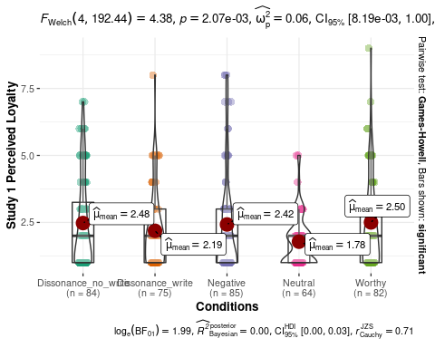

# DV3 Perceived honesty of the candidate  
jmv::ANOVA(  
 formula = Exp1_honesty ~ condition,  
 data = df_s1,  
 effectSize = "eta",  
 modelTest = TRUE,  
 homo = TRUE,  
 postHocES = "d",  
 postHocEsCi = TRUE,  
 #emMeans = ~ condition,  
 emmTables = TRUE)

##   
## ANOVA  
##   
## ANOVA - Exp1_honesty   
## ──────────────────────────────────────────────────────────────────────────────────────────   
## Sum of Squares df Mean Square F p η²   
## ──────────────────────────────────────────────────────────────────────────────────────────   
## Overall model 8.9133 4 2.2283 0.73272 0.57006   
## condition 8.9133 4 2.2283 0.73272 0.57006 0.00756   
## Residuals 1170.8534 385 3.0412   
## ──────────────────────────────────────────────────────────────────────────────────────────   
##   
##   
## ASSUMPTION CHECKS  
##   
## Homogeneity of Variances Test (Levene's)   
## ────────────────────────────────────────   
## F df1 df2 p   
## ────────────────────────────────────────   
## 1.8221 4 385 0.12379   
## ────────────────────────────────────────

ANOVA_exp1_DV3 <- lm(Exp1_honesty ~ condition, data = df_s1)  
#apa.aov.table(ANOVA_exp1_DV3, filename = "Exp1 DV3 ANOVA.doc",table.number = 12)  
  
# plot ggstatsplot   
ggstatsplot::ggbetweenstats(  
 data = df_s1,  
 y = Exp1_honesty,  
 x = condition,  
 originaltheme = TRUE,  
 ylab = "Study 1 Perceived Honesty",  
 xlab = "Conditions")

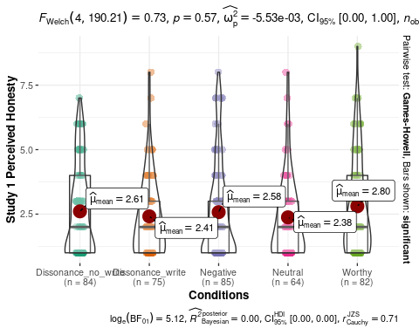

## Study 2 - Repeated ANOVA

Only include participants that saw study 2 before study 1.

Pivot to long format for ggstatsplot.

# add a column of unique participant ID  
cleaned_df <- dplyr::mutate(cleaned_df, ID = row_number())  
  
df_s2 <- cleaned_df %>% filter(study_order == "Exp2First")  
#write.csv(df_s2, "stimulated_cleaned_study2.csv",fileEncoding = "UTF-8")  
  
#pivot longer  
df_s2DV1A <- pivot_longer(df_s2, cols = c(Exp2_S1_seen_wrong, Exp2_S2_seen_wrong_T2),names_to = "scenario",values_to = "Exp2_seen_wrong")   
df_s2DV2A <- pivot_longer(df_s2, cols = c(Exp2_S1_self_action, Exp2_S2_self_action_T2),names_to = "scenario",values_to = "Exp2_self_action")   
df_s2DV3A <- pivot_longer(df_s2, cols = c(Exp2_S1_guide_other, Exp2_S2_guide_other_T2),names_to = "scenario",values_to = "Exp2_guide_other")   
  
# combine three DVs  
df_s2longA <- df_s2DV1A %>% dplyr::select("ID","condition","scenario","Exp2_seen_wrong") %>% dplyr::mutate(Exp2_seen_wrong = as.numeric(Exp2_seen_wrong)) %>%  
 cbind(Exp2_self_action = as.numeric(df_s2DV2A$Exp2_self_action)) %>%  
 cbind(Exp2_guide_other = as.numeric(df_s2DV3A$Exp2_guide_other))  
  
# rename the scenario variable for plotting   
df_s2longA <- df_s2longA %>%   
 mutate(scenario = case_when(  
 scenario == "Exp2_S1_seen_wrong" ~ "Scenario 1 Leaking interview questions",  
 scenario == "Exp2_S2_seen_wrong_T2" ~ "Scenario 2 Changing used product"))

Study 2 DV1 - Perception of suggested actions as wrong.

jmv::anovaRM(  
 data = df_s2,  
 rm = list(  
 list(  
 label="scenario",  
 levels=c("S1", "S2"))),  
 rmCells = list(  
 list(  
 measure="Exp2_S1_seen_wrong",  
 cell="S1"),  
 list(  
 measure="Exp2_S2_seen_wrong_T2",  
 cell="S2")),  
 bs = condition,  
 effectSize = "eta",  
 rmTerms = ~ scenario,  
 bsTerms = ~ condition,  
 leveneTest = TRUE,  
 #emMeans = ~ scenario:condition,  
 emmTables = TRUE,  
 groupSumm = TRUE)

##   
## REPEATED MEASURES ANOVA  
##   
## Within Subjects Effects   
## ─────────────────────────────────────────────────────────────────────────────────────────────────   
## Sum of Squares df Mean Square F p η²   
## ─────────────────────────────────────────────────────────────────────────────────────────────────   
## scenario 1316.245 1 1316.2446 417.4895 < .00001 0.25972   
## scenario:condition 15.150 4 3.7876 1.2014 0.30982 0.00299   
## Residual 1166.522 370 3.1528   
## ─────────────────────────────────────────────────────────────────────────────────────────────────   
## Note. Type 3 Sums of Squares  
##   
##   
## Between Subjects Effects   
## ──────────────────────────────────────────────────────────────────────────────────────   
## Sum of Squares df Mean Square F p η²   
## ──────────────────────────────────────────────────────────────────────────────────────   
## condition 24.767 4 6.1917 0.90007 0.46395 0.00489   
## Residual 2545.252 370 6.8791   
## ──────────────────────────────────────────────────────────────────────────────────────   
## Note. Type 3 Sums of Squares  
##   
##   
## ASSUMPTIONS  
##   
## Homogeneity of Variances Test (Levene's)   
## ─────────────────────────────────────────────────────────────   
## F df1 df2 p   
## ─────────────────────────────────────────────────────────────   
## Exp2_S1_seen_wrong 1.07926 4 370 0.36647   
## Exp2_S2_seen_wrong_T2 0.28074 4 370 0.89040   
## ─────────────────────────────────────────────────────────────   
##   
##   
## Group Summary   
## ─────────────────────────────────────────   
## condition N Excluded   
## ─────────────────────────────────────────   
## Dissonance_no_write 72 0   
## Dissonance_write 77 0   
## Negative 72 0   
## Neutral 58 0   
## Worthy 96 0   
## ─────────────────────────────────────────

# ggstatsplot for condition comparisons in between-subjects designs repeated across all levels of a grouping variable.  
# link to tutorial: https://indrajeetpatil.github.io/ggstatsplot/reference/grouped_ggbetweenstats.html  
  
ggstatsplot::grouped_ggbetweenstats(  
 data = df_s2longA,  
 y = Exp2_seen_wrong,  
 x = condition,  
 grouping.var = scenario,  
 ylab = "Perceived unethicality",  
 xlab = "Conditions"  
 )

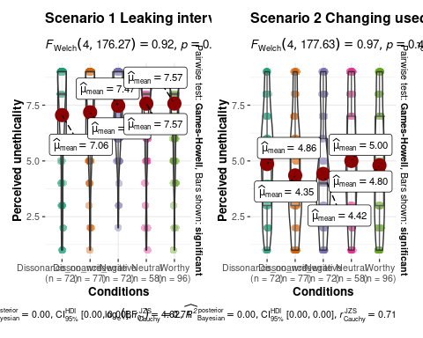

ggsave(  
 "Study2DV1SeenWrong.png", plot = last_plot(),  
 width = 11.8, height = 6, dpi = 600)

Study 2 DV2 - Likelihood of the self conducting similar behavior.

jmv::anovaRM(  
 data = df_s2,  
 rm = list(  
 list(  
 label="scenario",  
 levels=c("S1", "S2"))),  
 rmCells = list(  
 list(  
 measure="Exp2_S1_self_action",  
 cell="S1"),  
 list(  
 measure="Exp2_S2_self_action_T2",  
 cell="S2")),  
 bs = condition,  
 effectSize = "eta",  
 rmTerms = ~ scenario,  
 bsTerms = ~ condition,  
 leveneTest = TRUE,  
 #emMeans = ~ scenario:condition,  
 emmTables = TRUE,  
 groupSumm = TRUE)

##   
## REPEATED MEASURES ANOVA  
##   
## Within Subjects Effects   
## ──────────────────────────────────────────────────────────────────────────────────────────────────   
## Sum of Squares df Mean Square F p η²   
## ──────────────────────────────────────────────────────────────────────────────────────────────────   
## scenario 604.773 1 604.7731 166.08004 < .00001 0.12032   
## scenario:condition 13.440 4 3.3600 0.92271 0.45068 0.00267   
## Residual 1347.339 370 3.6415   
## ──────────────────────────────────────────────────────────────────────────────────────────────────   
## Note. Type 3 Sums of Squares  
##   
##   
## Between Subjects Effects   
## ─────────────────────────────────────────────────────────────────────────────────────   
## Sum of Squares df Mean Square F p η²   
## ─────────────────────────────────────────────────────────────────────────────────────   
## condition 41.929 4 10.4823 1.2848 0.27544 0.00834   
## Residual 3018.706 370 8.1587   
## ─────────────────────────────────────────────────────────────────────────────────────   
## Note. Type 3 Sums of Squares  
##   
##   
## ASSUMPTIONS  
##   
## Homogeneity of Variances Test (Levene's)   
## ─────────────────────────────────────────────────────────────   
## F df1 df2 p   
## ─────────────────────────────────────────────────────────────   
## Exp2_S1_self_action 3.0649 4 370 0.01667   
## Exp2_S2_self_action_T2 1.2384 4 370 0.29415   
## ─────────────────────────────────────────────────────────────   
##   
##   
## Group Summary   
## ─────────────────────────────────────────   
## condition N Excluded   
## ─────────────────────────────────────────   
## Dissonance_no_write 72 0   
## Dissonance_write 77 0   
## Negative 72 0   
## Neutral 58 0   
## Worthy 96 0   
## ─────────────────────────────────────────

ggstatsplot::grouped_ggbetweenstats(  
 data = df_s2longA,  
 y = Exp2_self_action,  
 x = condition,  
 grouping.var = scenario,  
 ylab = "Likelihood of the self conducting suggested behavior",  
 xlab = "Conditions"  
 )

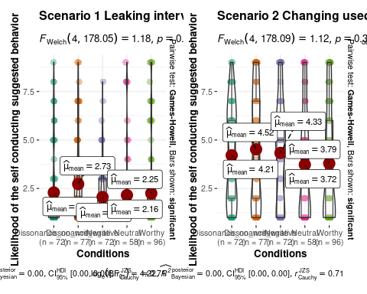

ggsave(  
 "Study2DV2SelfAction.png", plot = last_plot(),  
 width = 11.8, height = 6, dpi = 600)

Study 2 DV3 - Likelihood of advising others to perform unethical but self-benefiting behavior.

jmv::anovaRM(  
 data = cleaned_df,  
 rm = list(  
 list(  
 label="scenario",  
 levels=c("S1", "S2"))),  
 rmCells = list(  
 list(  
 measure="Exp2_S1_guide_other",  
 cell="S1"),  
 list(  
 measure="Exp2_S2_guide_other_T2",  
 cell="S2")),  
 bs = condition,  
 effectSize = "eta",  
 rmTerms = ~ scenario,  
 bsTerms = ~ condition,  
 leveneTest = TRUE,  
 #emMeans = ~ scenario:condition,  
 emmTables = TRUE,  
 groupSumm = TRUE)

##   
## REPEATED MEASURES ANOVA  
##   
## Within Subjects Effects   
## ──────────────────────────────────────────────────────────────────────────────────────────────────   
## Sum of Squares df Mean Square F p η²   
## ──────────────────────────────────────────────────────────────────────────────────────────────────   
## scenario 932.3630 1 932.3630 308.17061 < .00001 0.10738   
## scenario:condition 7.8705 4 1.9676 0.65035 0.62676 0.00091   
## Residual 2299.3622 760 3.0255   
## ──────────────────────────────────────────────────────────────────────────────────────────────────   
## Note. Type 3 Sums of Squares  
##   
##   
## Between Subjects Effects   
## ─────────────────────────────────────────────────────────────────────────────────────   
## Sum of Squares df Mean Square F p η²   
## ─────────────────────────────────────────────────────────────────────────────────────   
## condition 112.18 4 28.0459 3.9985 0.00323 0.01292   
## Residual 5330.75 760 7.0141   
## ─────────────────────────────────────────────────────────────────────────────────────   
## Note. Type 3 Sums of Squares  
##   
##   
## ASSUMPTIONS  
##   
## Homogeneity of Variances Test (Levene's)   
## ─────────────────────────────────────────────────────────────   
## F df1 df2 p   
## ─────────────────────────────────────────────────────────────   
## Exp2_S1_guide_other 4.8288 4 760 0.00075   
## Exp2_S2_guide_other_T2 2.7456 4 760 0.02750   
## ─────────────────────────────────────────────────────────────   
##   
##   
## Group Summary   
## ──────────────────────────────────────────   
## condition N Excluded   
## ──────────────────────────────────────────   
## Dissonance_no_write 156 0   
## Dissonance_write 152 0   
## Negative 157 0   
## Neutral 122 0   
## Worthy 178 0   
## ──────────────────────────────────────────

ggstatsplot::grouped_ggbetweenstats(  
 data = df_s2long,  
 y = Exp2_guide_other,  
 x = condition,  
 grouping.var = scenario,  
 ylab = "Likelihood of advising others to behave unethically",  
 xlab = "Conditions"  
 )

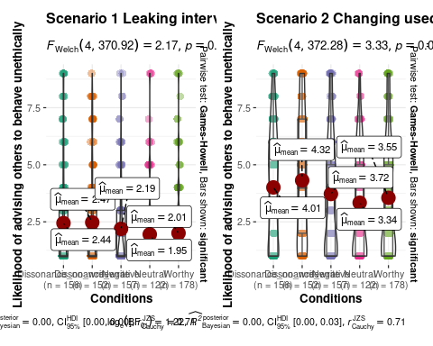

ggsave(  
 "Study2DV3AdviseOthers.png", plot = last_plot(),  
 width = 11.8, height = 6, dpi = 600)

## Testing order effect as a moderator

note: the moderator pacakge is not yet available for the current version of R, hence we pasted all code on running moderation analysis from JAMOVI, but will provide the analysis and result in a separate .omv file.

study 1

install.packages("medmod")  
library(medmod)  
medmod::mod(  
 data = cleaned_df,  
 dep = Exp1_prob_hiring,  
 mod = study_order_n,  
 pred = Condition_n,  
 ci = TRUE,  
 simpleSlopeEst = TRUE,  
 simpleSlopePlot = TRUE)  
  
medmod::mod(  
 data = cleaned_df,  
 dep = Exp1_honesty,  
 mod = study_order_n,  
 pred = Condition_n,  
 ci = TRUE,  
 simpleSlopeEst = TRUE,  
 simpleSlopePlot = TRUE,  
 duplicate = 2)  
  
medmod::mod(  
 data = cleaned_df,  
 dep = Exp1_loyalty,  
 mod = study_order_n,  
 pred = Condition_n,  
 ci = TRUE,  
 simpleSlopeEst = TRUE,  
 simpleSlopePlot = TRUE,  
 duplicate = 2)

study 2

medmod::mod(  
 data = cleaned_df,  
 dep = Exp2_S1_seen_wrong,  
 mod = study_order_n,  
 pred = Condition_n,  
 ci = TRUE,  
 simpleSlopeEst = TRUE,  
 simpleSlopePlot = TRUE,  
 duplicate = 2)  
  
medmod::mod(  
 data = cleaned_df,  
 dep = Exp2_S1_self_action,  
 mod = study_order_n,  
 pred = Condition_n,  
 ci = TRUE,  
 simpleSlopeEst = TRUE,  
 simpleSlopePlot = TRUE,  
 duplicate = 2)  
  
medmod::mod(  
 data = cleaned_df,  
 dep = Exp2_S1_guide_other,  
 mod = study_order_n,  
 pred = Condition_n,  
 ci = TRUE,  
 simpleSlopeEst = TRUE,  
 simpleSlopePlot = TRUE,  
 duplicate = 2)  
  
medmod::mod(  
 data = cleaned_df,  
 dep = Exp2_S2_seen_wrong_T2,  
 mod = study_order_n,  
 pred = Condition_n,  
 ci = TRUE,  
 simpleSlopeEst = TRUE,  
 simpleSlopePlot = TRUE,  
 duplicate = 2)  
  
medmod::mod(  
 data = cleaned_df,  
 dep = Exp2_S2_self_action_T2,  
 mod = study_order_n,  
 pred = Condition_n,  
 ci = TRUE,  
 simpleSlopeEst = TRUE,  
 simpleSlopePlot = TRUE,  
 duplicate = 2)  
  
medmod::mod(  
 data = cleaned_df,  
 dep = Exp2_S2_guide_other_T2,  
 mod = study_order_n,  
 pred = Condition_n,  
 ci = TRUE,  
 simpleSlopeEst = TRUE,  
 simpleSlopePlot = TRUE,  
 duplicate = 2)