***Output***



Figure 1 Login page of the app

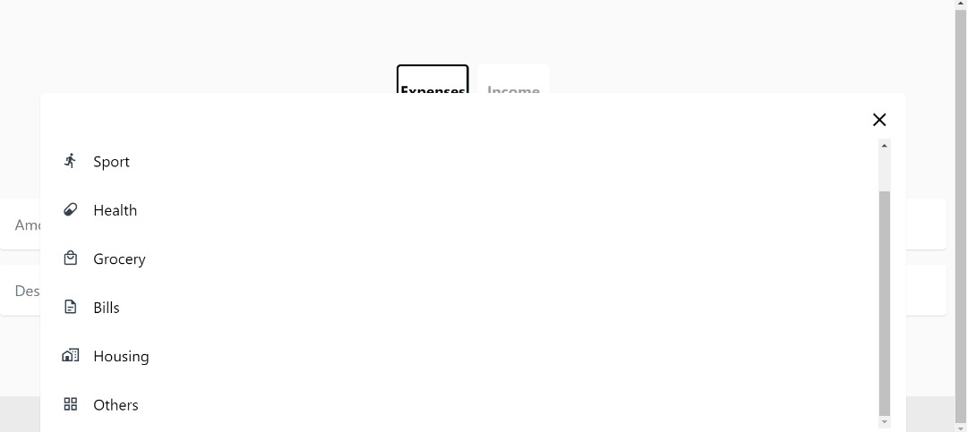

Figure 2.1

To record a transaction, users will first need to select a category of the transaction. E.g., sport, health, grocery and others.

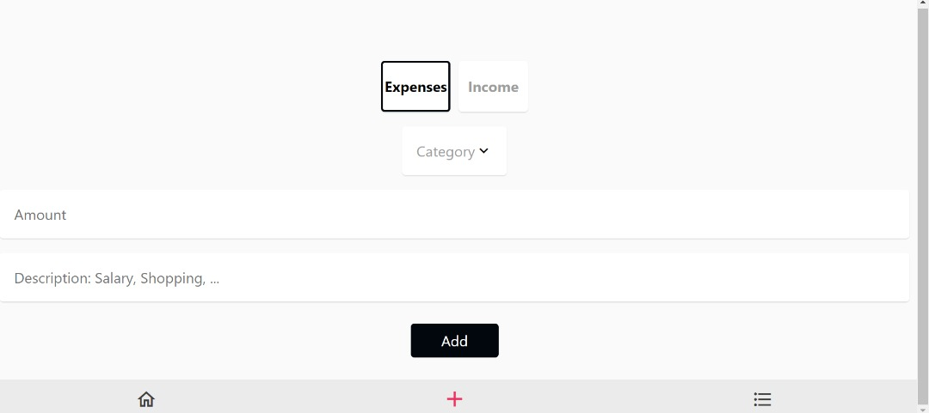

Figure 2.2

User will then select if the transaction is an expense or income. Continue with entering the amount of the transaction and also add in some details. E.g., in the health category, users can enter the name of the medicine they spend on (vitamin C) and also the price (50).

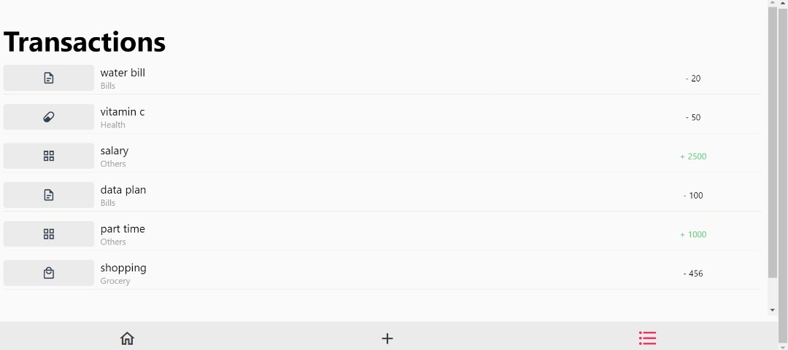

Figure 3

Then, all transactions including income and expense will be recorded in the transaction page.

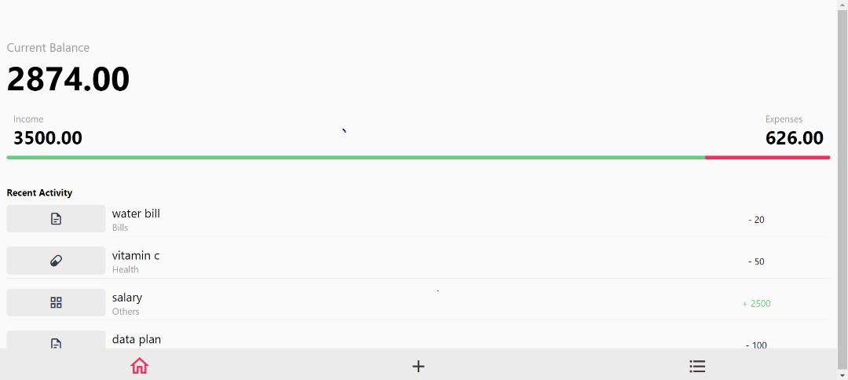

Figure 4

At the home page, the app will show the balance(total income - total expense), total income and total expense for a user. Other than that, the app  will show the latest transaction as a list of recent activity.