**CHAPTER 4**

**SYSTEM IMPLEMENTATION, TESTING, AND CONCLUSIONS**

**4.1 Introduction**

This chapter details the implementation, testing strategies, and conclusions of the AI powered fraud detection system for insuarance claims.

**4.2 Implementation Environment and Tools**

* **Programming Languages**: Python (backend), JavaScript (frontend)
* **Frameworks**: FastAPI for the backend API, React for UI
* **Libraries**: Scikit Learn, Pandas, Matplotlib for AI development
* **Cloud Deployment**: Hugging Face for model hosting, Github for web application deployment

**4.3 System Code Generation**

Key implementation components include:

* **Data Preprocessing Module**: Cleans and prepares motor insurance claim data by handling missing values, encoding categorical features, and normalizing numerical inputs to improve model performance.
* **ML Model Module**: Loads and utilizes the trained Random Forest machine learning model to classify claims as either fraudulent or legitimate.
* **API Module**: Manages communication between the frontend and backend using RESTful APIs, enabling secure and efficient data exchange.
* **User Interface Module**: Offers a web-based interface that allows users to submit insurance claim details and receive real-time fraud classification results.

Link to the website: <https://yvonnekinaka.github.io/claims/>

**4.4 Testing**

The testing phase follows the training of the fraud detection model and focuses on evaluating its accuracy in identifying fraudulent insurance claims. The trained model was assessed using an real life dataset and various performance metrics. It achieved an accuracy score of 56%, indicating its potential effectiveness in distinguishing between genuine and fraudulent motor insurance claims.

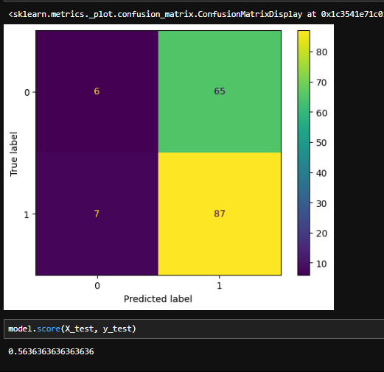

**4.5 User Guide**

Users can access the fraud detection system through a web-based platform. The steps to use the system are:

**Website Home page:**



**Log in/Register account** either as a client, officer or manager

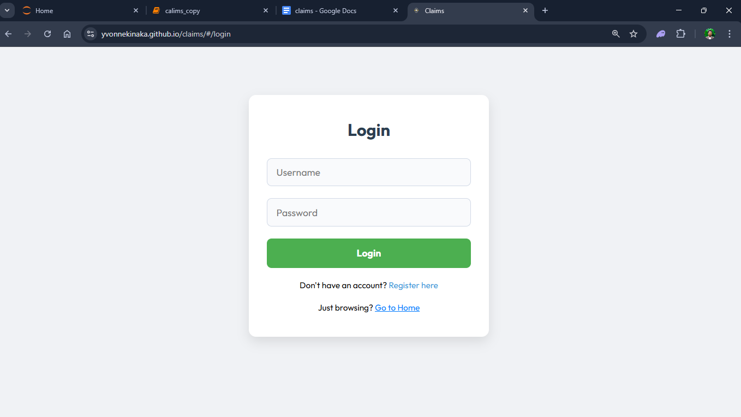

**As a client:** Fill in Details and Hit Submit

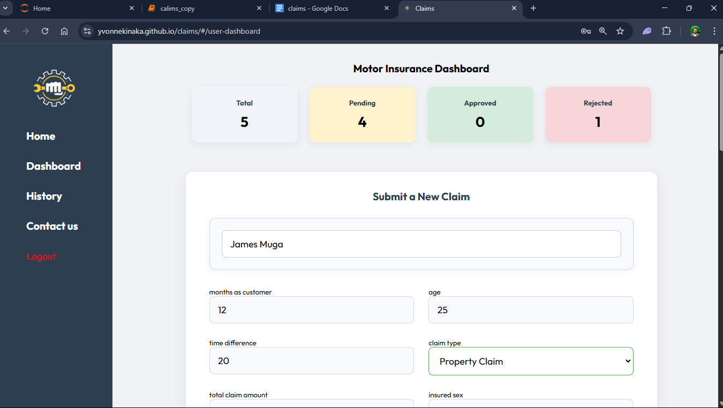

**As an Officer:**

Review submitted claim

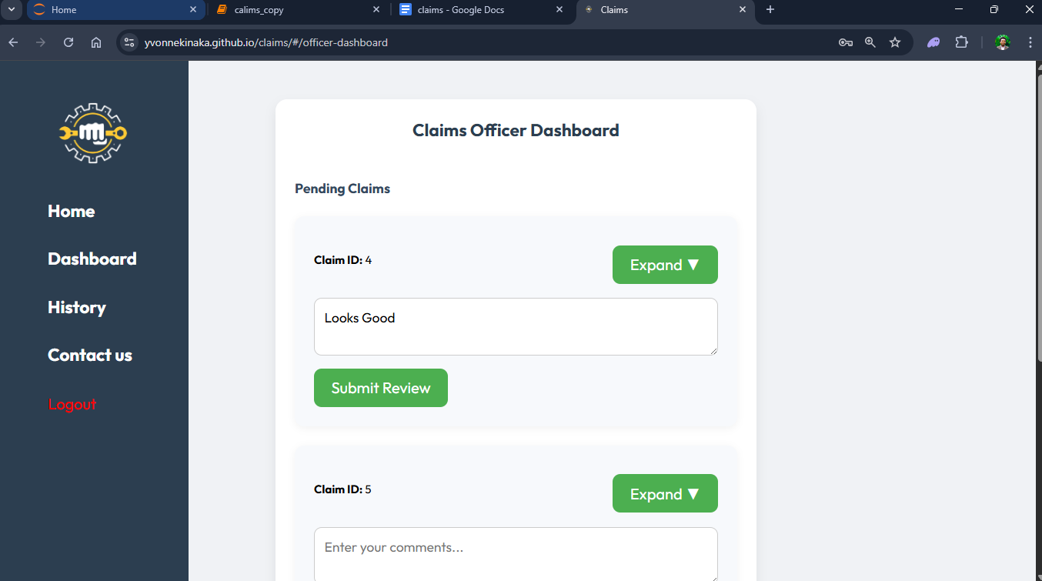

**As a manager**

Approve or reject the claim

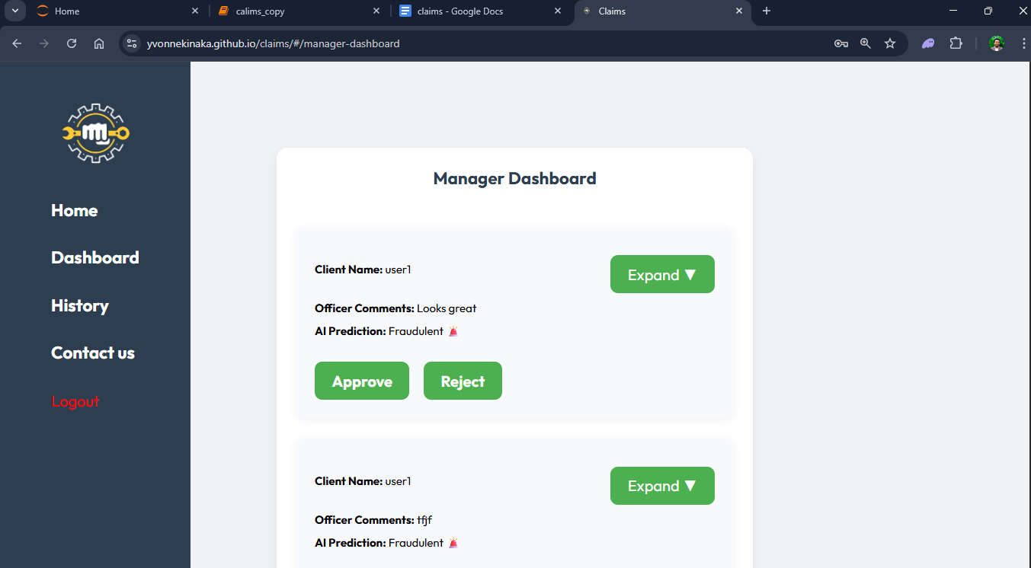

**History tab:**

**Client:** The client will see progress of the pending claim

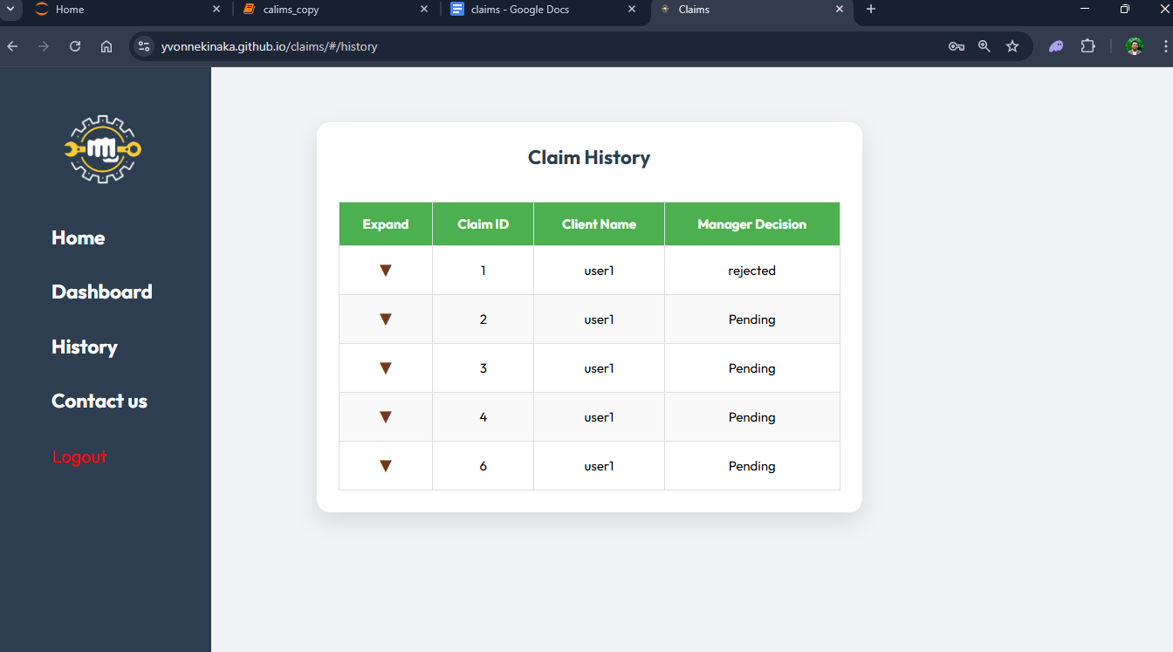

**Officer and Manager:** Both the manager and officer share will see a similar history tab which includes AI prediction result

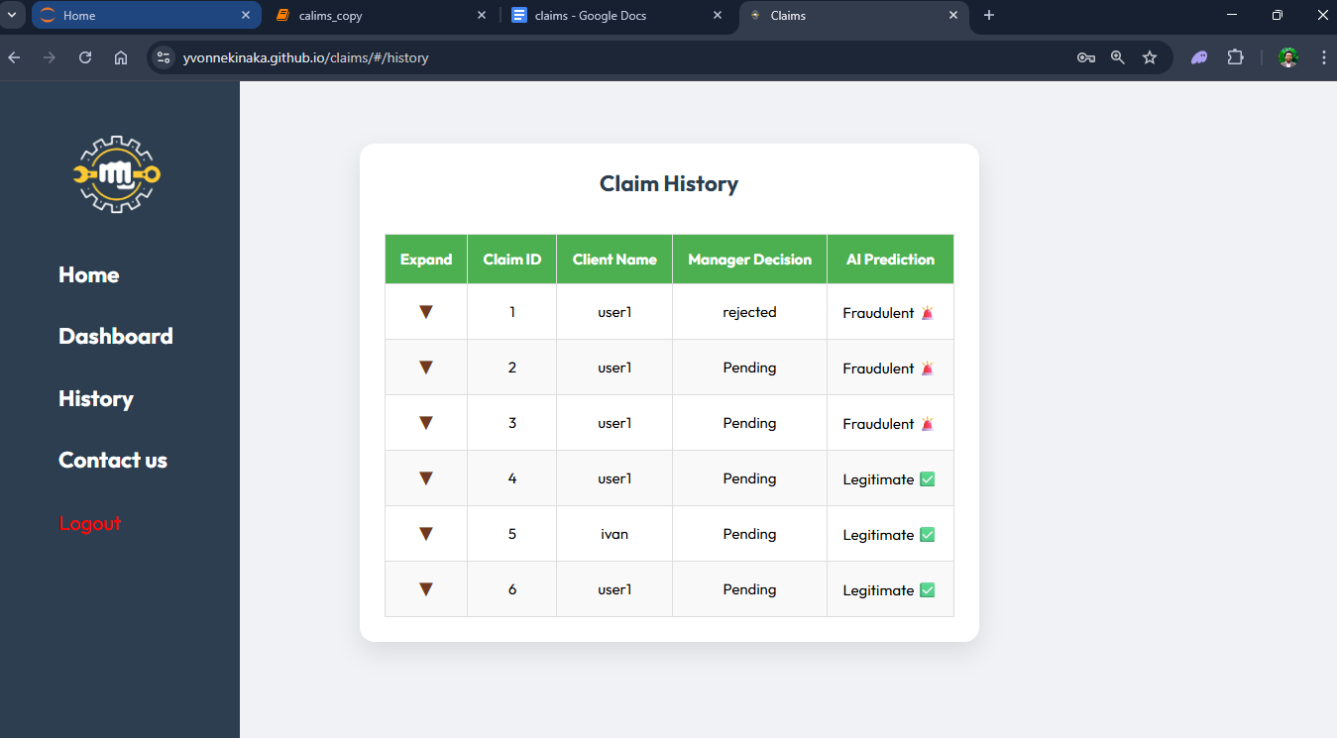

**4.6 Conclusions**

The system effectively classifies motor insurance claims as either fraudulent or genuine with reasonable accuracy and usability. However, further validation using real-world insurance claim data and integration with existing insurance company workflows are recommended to enhance its practical applicability.