How to add affiliate Tracking Code & GA codes?

Step1. Start with static page upload MSR

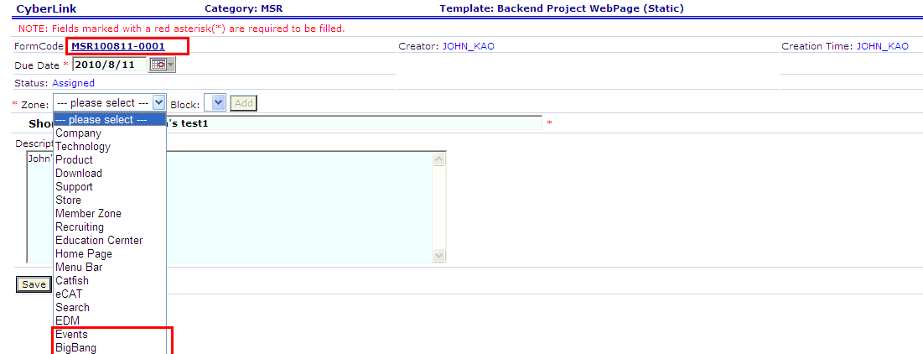

Step2. Modify Syntax of Affiliate Tracking Code
<jsp:include page="/prog/util/affid.jsp">
<jsp:param name="affid" value="2581_0_524_MSR100506-0002_0" />
</jsp:include>

Affiliate ID structure:
Ex: 2581_0_524_MSR100506-0002_0_Description
➔ Affiliate ID is composed by Customer ID, Product Version Id, Affiliate Source, MSR Code , Profit Sharing & Description. (Separated by underline)

- Replace the MSR No. above with the newly created MSR No. (required)
- Replace the Affiliate Source with the respect zone ID (required)
  - 557 = Events
  - 524 = Bigbang
- Set up Product version ID if needed (optional)
  - You may use the product ID mainly related to this page
  - Please see the product ID list in the backend system

Step 3. Copy the modified affiliate code and paste to your file
Switch to “Code” mode in Dreamweaver, and find the TAG “<head>”
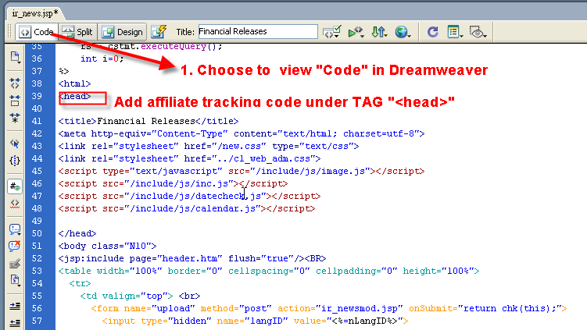

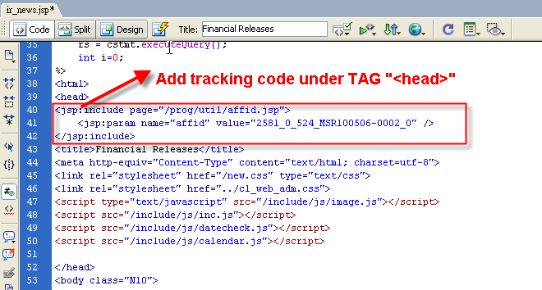
- If you did not include the affiliate tracking code into the page, the MSR will display error message “No affiliate code”.
- If you input the wrong affiliate source ID or MSR No, the MSR will display error message “affiliate code error”.

Step4. Check if GA code is on the page
Be sure that “<jsp:include page="/prog/util/_tracking.jsp" flush="true"/>” is between “<body>” and “</body>” tags.

MSR will show “No GA code”, if you didn’t include GA tracking code into the page.

Step5. Commit the file and use SVN upload to finish

