# 计算机图形学作业

|  |  |  |  |
| --- | --- | --- | --- |
| **姓名:** | 孙涵 | **学号:** | 10215102481 |
| **内容:** | 计算机图形学大作业 | **日期:** | 2022/10/20 |

## 效果展示

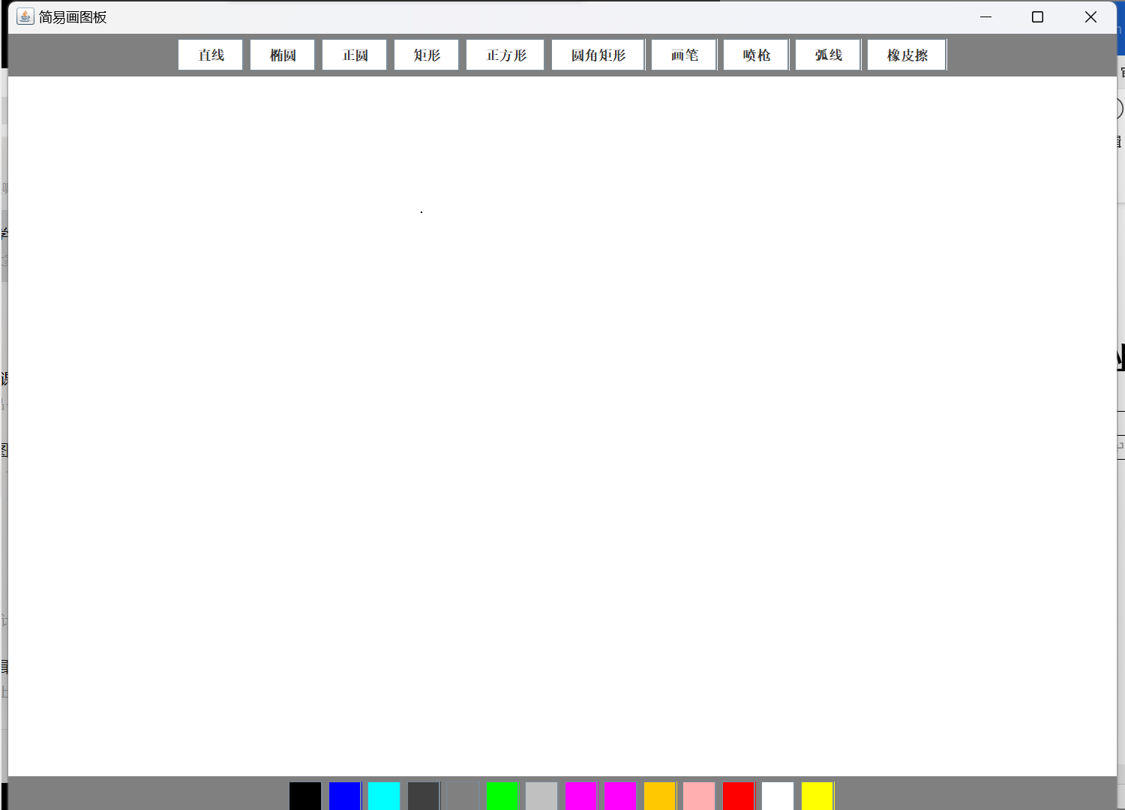

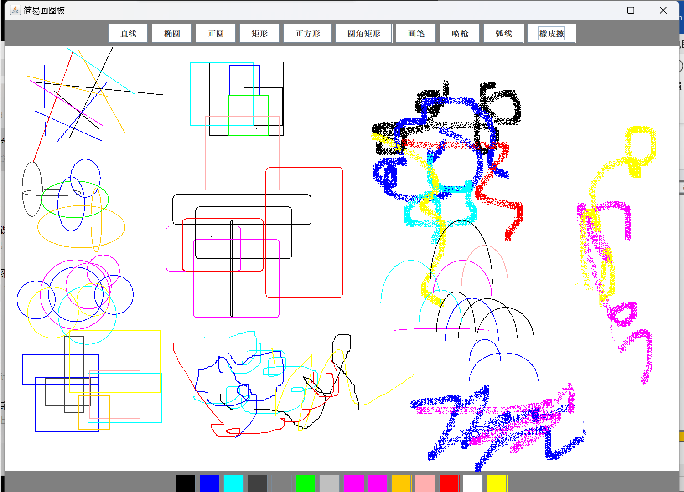

## 代码部分

1.构建窗体,按钮,面板

1. import javax.swing.*;
2. import java.awt.*;
3. import java.awt.event.KeyEvent;
4. import java.awt.event.KeyListener;
6. **public** **class** Prepare {
7. JFrame jf;
8. JPanel jp1;
9. JPanel jp2;
10. JPanel jp3;
11. JButton [] drawButton;
12. JButton [] colorButton;
13. Graphics g;
14. ButtonListener buttonListener;
15. DrawListener drawListener;
17. **public** Prepare(JFrame jf, JPanel jp1,JPanel jp2, JPanel jp3, JButton[] drawButton, JButton[] colorButton, ButtonListener buttonListener, DrawListener drawListener) {
18. **this**.jf = jf;
19. **this**.jp1 = jp1;
20. **this**.jp2 = jp2;
21. **this**.jp3 = jp3;
22. **this**.drawButton = drawButton;
23. **this**.colorButton = colorButton;
24. **this**.buttonListener = buttonListener;
25. **this**.drawListener = drawListener;
27. }
29. **public** **void** prepareJf(){
30. jf.setVisible(**true**);
31. jf.setTitle("简易画图板");
32. jf.setSize(1000,1000);
33. jf.setLayout(**new** BorderLayout());
34. jf.setDefaultCloseOperation(3);
35. jf.addMouseListener(drawListener);
36. }
38. **public** **void** preparePanel(){
39. jp1.setBackground(Color.BLACK);
40. jp1.setLayout(**new** FlowLayout(FlowLayout.CENTER));
41. jp1.setBackground(Color.GRAY);
42. jf.add(jp1,BorderLayout.NORTH);
44. jp2.setBackground(Color.WHITE);
45. jp2.addMouseListener(drawListener);
46. jp2.addMouseMotionListener(drawListener);
47. jp2.setVisible(**true**);
48. g = jp2.getGraphics();
49. drawListener.g = g;
50. jf.add(jp2,BorderLayout.CENTER);
52. jp3.setLayout(**new** FlowLayout((FlowLayout.CENTER)));
53. jp3.setBackground(Color.black);
54. jp3.setLayout(**new** FlowLayout(FlowLayout.CENTER));
55. jp3.setBackground(Color.gray);
56. jf.add(jp3,BorderLayout.SOUTH);
57. }
59. **public** **void** prepareButton(){
60. String [] shape = {"直线","椭圆","正圆","矩形","正方形","圆角矩形","画笔","喷枪","弧线","橡皮擦"};
61. **for**(**int** i = 0; i < shape.length; i++){
62. drawButton[i] = **new** JButton(shape[i]);
63. drawButton[i].setBackground(Color.WHITE);
64. drawButton[i].addActionListener(buttonListener);
65. jp1.add(drawButton[i]);
66. }

69. Color[] colorList = {Color.BLACK,Color.BLUE,Color.CYAN,Color.DARK_GRAY,Color.GRAY,Color.GREEN,Color.LIGHT_GRAY,Color.MAGENTA,Color.magenta,Color.ORANGE,Color.PINK,Color.RED,Color.WHITE,Color.YELLOW};
70. **for**(**int** i = 0; i < colorList.length; i++){
71. colorButton[i] = **new** JButton();
72. colorButton[i].setBackground(colorList[i]);
73. colorButton[i].setPreferredSize(**new** Dimension(30,30));
74. colorButton[i].addActionListener(buttonListener);
75. jp3.add(colorButton[i]);
76. }
78. }
80. **public** **void** prepareDraw(){
81. jp2.setVisible(**true**);
82. g = jp2.getGraphics();
83. drawListener.g = g;
84. }

87. }

2.创建监听器(按钮监听器)

1. import javax.swing.*;
2. import java.awt.*;
3. import java.awt.event.ActionEvent;
4. import java.awt.event.ActionListener;
6. //获取形状和颜色
8. **public** **class** ButtonListener implements ActionListener {
9. Color color;
10. String shape;
11. DrawListener drawListener;
13. **public** ButtonListener(DrawListener drawListener) {
14. **this**.drawListener = drawListener;
15. }
17. @Override
18. **public** **void** actionPerformed(ActionEvent actionEvent) {
19. **if**(actionEvent.getActionCommand().equals("")){
20. JButton btn = (JButton) actionEvent.getSource();
21. color = btn.getBackground();
22. drawListener.setColor(color);
23. System.out.println(color.toString());
24. }**else** {
25. JButton btn = (JButton) actionEvent.getSource();
26. shape = btn.getActionCommand();
27. drawListener.setShape(shape);
28. System.out.println(shape.toString());
29. }
30. }
32. **public** Color getColor() {
33. **return** color;
34. }
36. **public** String getShape() {
37. **return** shape;
38. }

41. }

3.创建监听器(画板监听器)

1. import javax.swing.*;
2. import java.awt.*;
3. import java.awt.event.MouseEvent;
4. import java.awt.event.MouseListener;
5. import java.awt.event.MouseMotionListener;
6. import java.util.Random;

9. **public** **class** DrawListener extends JFrame implements MouseListener, MouseMotionListener {

12. Color color = Color.black;
13. String shape = "直线";
14. Graphics g;
15. JPanel jp2;
16. **int** x0,x1,x2,y0,y1,y2,newx1,newy1,newx2,newy2;
17. boolean flag = **true**;



22. @Override
23. **public** **void** mouseClicked(MouseEvent e) {
24. }

27. @Override
28. **public** **void** mousePressed(MouseEvent e) {
29. Graphics2D g2 = (Graphics2D) g;
30. g2.setStroke(**new** BasicStroke(1));
31. System.out.println("mousePressed");
32. x1 = e.getX();
33. y1 = e.getY();
34. }

37. @Override
38. **public** **void** mouseReleased(MouseEvent e) {
39. Graphics2D g2 = (Graphics2D) g;
40. g2.setStroke(**new** BasicStroke(1));
41. System.out.println("mouseReleased");
42. x2 = e.getX();
43. y2 = e.getY();
44. **int** w = x2-x1;
45. **int** h = y2-y1;
47. //绘制图形
48. **if** (shape.equals("直线")){
49. System.out.println("2");
50. g.drawLine(x1,y1,x2,y2);
51. }**else** **if** (shape.equals("矩形")){
52. g.drawRect(Math.min(x1,x2),Math.min(y1,y2),Math.abs(w),Math.abs(h));
53. }**else** **if** (shape.equals("椭圆")){
54. g.drawOval(Math.min(x1,x2),Math.min(y1,y2),Math.abs(w),Math.abs(h));
55. }**else** **if**(shape.equals("弧线")){
56. g.drawArc(Math.min(x1,x2), Math.min(y1,y2), Math.abs(x2-x1), Math.abs(y2-y1), 0, 180);
57. }**else** **if** (shape.equals("正圆")){
58. g.drawOval(Math.min(x1,x2),Math.min(y1,y2),Math.abs(w),Math.abs(w));
59. }**else** **if** (shape.equals("正方形")){
60. g.drawRect(Math.min(x1,x2),Math.min(y1,y2),Math.abs(w),Math.abs(w));
61. }**else** **if**(shape.equals("圆角矩形")){
62. g.drawRoundRect(Math.min(x1,x2),Math.min(y1,y2),Math.abs(w),Math.abs(h),10,10);
63. }
64. }

67. @Override
68. **public** **void** mouseDragged(MouseEvent e) {
69. Graphics2D g2 = (Graphics2D) g;
70. g2.setStroke(**new** BasicStroke(1));
71. System.out.println("mouseDragged");
72. x2 = e.getX();
73. y2 = e.getY();
74. **if** (shape.equals("画笔")) {
75. g.drawLine(x1, y1, x2, y2);
76. x1 = x2;
77. y1 = y2;
78. }**else** **if**(shape.equals("橡皮擦")){
79. g2.setStroke(**new** BasicStroke(80));
80. g2.setRenderingHint(RenderingHints.KEY_ANTIALIASING, RenderingHints.VALUE_ANTIALIAS_ON);
81. g.setColor(Color.WHITE);
82. g.drawLine(x1, y1, x2, y2);
83. x1 = x2;
84. y1 = y2;
85. }**else** **if**(shape.equals("喷枪")){
86. **for**(**int** k=0;k<20;k++){
87. Random i=**new** Random();
88. **int** a=i.nextInt(8);
89. **int** b=i.nextInt(10);
90. g.drawLine(x2+a, y2+b, x2+a, y2+b);
91. }
92. }
93. }

96. @Override
97. **public** **void** mouseMoved(MouseEvent mouseEvent) {
99. }
101. @Override
102. **public** **void** mouseEntered(MouseEvent mouseEvent) {
104. }
106. @Override
107. **public** **void** mouseExited(MouseEvent mouseEvent) {
109. }
111. **public** **void** setColor(Color color) {
112. **this**.color = color;
113. g.setColor(color);
114. }
116. **public** **void** setShape(String shape) {
117. Graphics2D g2 = (Graphics2D) g;
118. **if**(**this**.shape.equals("橡皮擦")){
119. g.setColor(Color.black);
120. }**else** {
121. **this**.shape = shape;
122. }
123. }
125. }

4.打包放进main函数

1. import javax.swing.*;
2. import java.awt.*;
3. import java.awt.event.KeyEvent;
4. import java.awt.event.KeyListener;
6. **public** **class** Prepare {
7. JFrame jf;
8. JPanel jp1;
9. JPanel jp2;
10. JPanel jp3;
11. JButton [] drawButton;
12. JButton [] colorButton;
13. Graphics g;
14. ButtonListener buttonListener;
15. DrawListener drawListener;
17. **public** Prepare(JFrame jf, JPanel jp1,JPanel jp2, JPanel jp3, JButton[] drawButton, JButton[] colorButton, ButtonListener buttonListener, DrawListener drawListener) {
18. **this**.jf = jf;
19. **this**.jp1 = jp1;
20. **this**.jp2 = jp2;
21. **this**.jp3 = jp3;
22. **this**.drawButton = drawButton;
23. **this**.colorButton = colorButton;
24. **this**.buttonListener = buttonListener;
25. **this**.drawListener = drawListener;
27. }
29. **public** **void** prepareJf(){
30. jf.setVisible(**true**);
31. jf.setTitle("简易画图板");
32. jf.setSize(1000,1000);
33. jf.setLayout(**new** BorderLayout());
34. jf.setDefaultCloseOperation(3);
35. jf.addMouseListener(drawListener);
36. }
38. **public** **void** preparePanel(){
39. jp1.setBackground(Color.BLACK);
40. jp1.setLayout(**new** FlowLayout(FlowLayout.CENTER));
41. jp1.setBackground(Color.GRAY);
42. jf.add(jp1,BorderLayout.NORTH);
44. jp2.setBackground(Color.WHITE);
45. jp2.addMouseListener(drawListener);
46. jp2.addMouseMotionListener(drawListener);
47. jp2.setVisible(**true**);
48. g = jp2.getGraphics();
49. drawListener.g = g;
50. jf.add(jp2,BorderLayout.CENTER);
52. jp3.setLayout(**new** FlowLayout((FlowLayout.CENTER)));
53. jp3.setBackground(Color.black);
54. jp3.setLayout(**new** FlowLayout(FlowLayout.CENTER));
55. jp3.setBackground(Color.gray);
56. jf.add(jp3,BorderLayout.SOUTH);
57. }
59. **public** **void** prepareButton(){
60. String [] shape = {"直线","椭圆","正圆","矩形","正方形","圆角矩形","画笔","喷枪","弧线","橡皮擦"};
61. **for**(**int** i = 0; i < shape.length; i++){
62. drawButton[i] = **new** JButton(shape[i]);
63. drawButton[i].setBackground(Color.WHITE);
64. drawButton[i].addActionListener(buttonListener);
65. jp1.add(drawButton[i]);
66. }

69. Color[] colorList = {Color.BLACK,Color.BLUE,Color.CYAN,Color.DARK_GRAY,Color.GRAY,Color.GREEN,Color.LIGHT_GRAY,Color.MAGENTA,Color.magenta,Color.ORANGE,Color.PINK,Color.RED,Color.WHITE,Color.YELLOW};
70. **for**(**int** i = 0; i < colorList.length; i++){
71. colorButton[i] = **new** JButton();
72. colorButton[i].setBackground(colorList[i]);
73. colorButton[i].setPreferredSize(**new** Dimension(30,30));
74. colorButton[i].addActionListener(buttonListener);
75. jp3.add(colorButton[i]);
76. }
78. }
80. **public** **void** prepareDraw(){
81. jp2.setVisible(**true**);
82. g = jp2.getGraphics();
83. drawListener.g = g;
84. }

87. }